1. 新建项目，练习教材上相关例子Hello.java文件，P29。并练习如何在Tomcat服务器上发布该文件（）

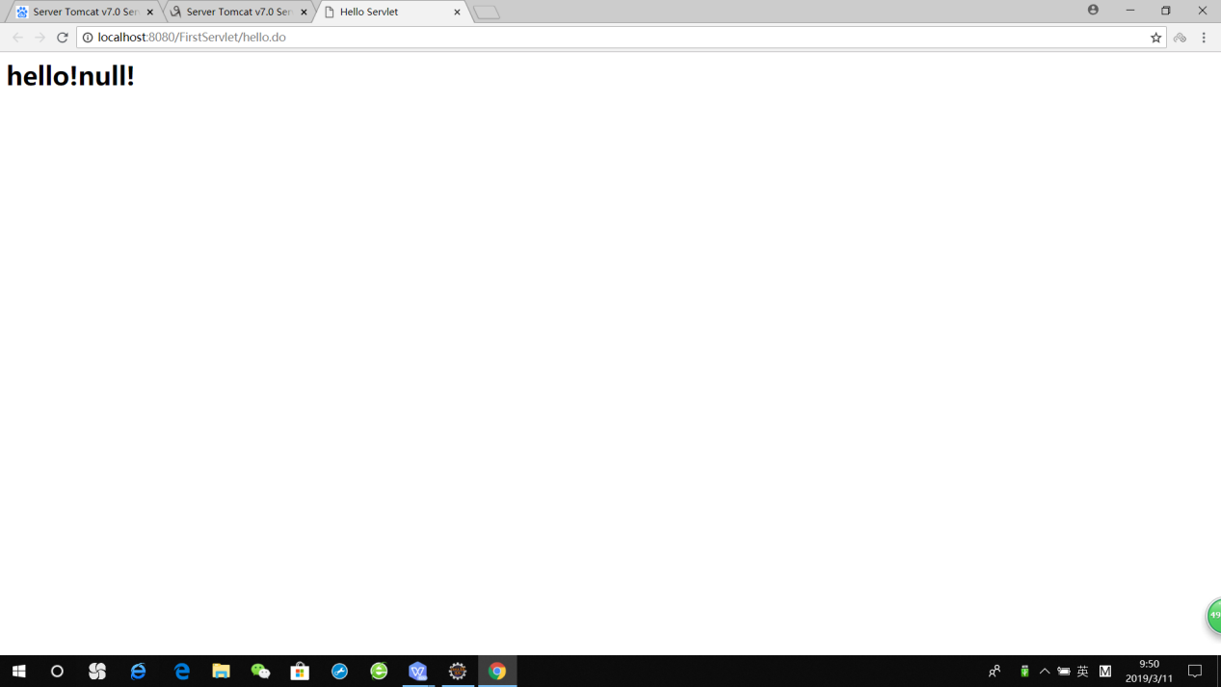

package cc.openhome;

import java.io.IOException;

import java.io.PrintWriter;

import javax.servlet.ServletException;

import javax.servlet.annotation.WebServlet;

import javax.servlet.http.HttpServlet;

import javax.servlet.http.HttpServletRequest;

import javax.servlet.http.HttpServletResponse;

/**

* Servlet implementation class HelloServlet

*/

@WebServlet("/hello.do")

public class HelloServlet extends HttpServlet {

private static final long serialVersionUID = 1L;

/**

* @see HttpServlet#HttpServlet()

*/

public HelloServlet() {

super();

// TODO Auto-generated constructor stub

}

/**

* @see HttpServlet#doGet(HttpServletRequest request, HttpServletResponse response)

*/

protected void doGet(HttpServletRequest request, HttpServletResponse response) throws ServletException, IOException {

// TODO Auto-generated method stub

response.setContentType("text/html;charset=UTF-8");

PrintWriter out =response.getWriter();

String name = request.getParameter("name");

out.println("<html>");

out.println("<head>");

out.println("<title>Hello Servlet</title>");

out.println("</head>");

out.println("<body>");

out.println("<h1>hello!"+name+"!</h1>");

out.println("</body>");

out.println("</html>");

out.close();

}

/**

* @see HttpServlet#doPost(HttpServletRequest request, HttpServletResponse response)

*/

protected void doPost(HttpServletRequest request, HttpServletResponse response) throws ServletException, IOException {

// TODO Auto-generated method stub

doGet(request, response);

}

}

1. 2.HelloServlet文件内容

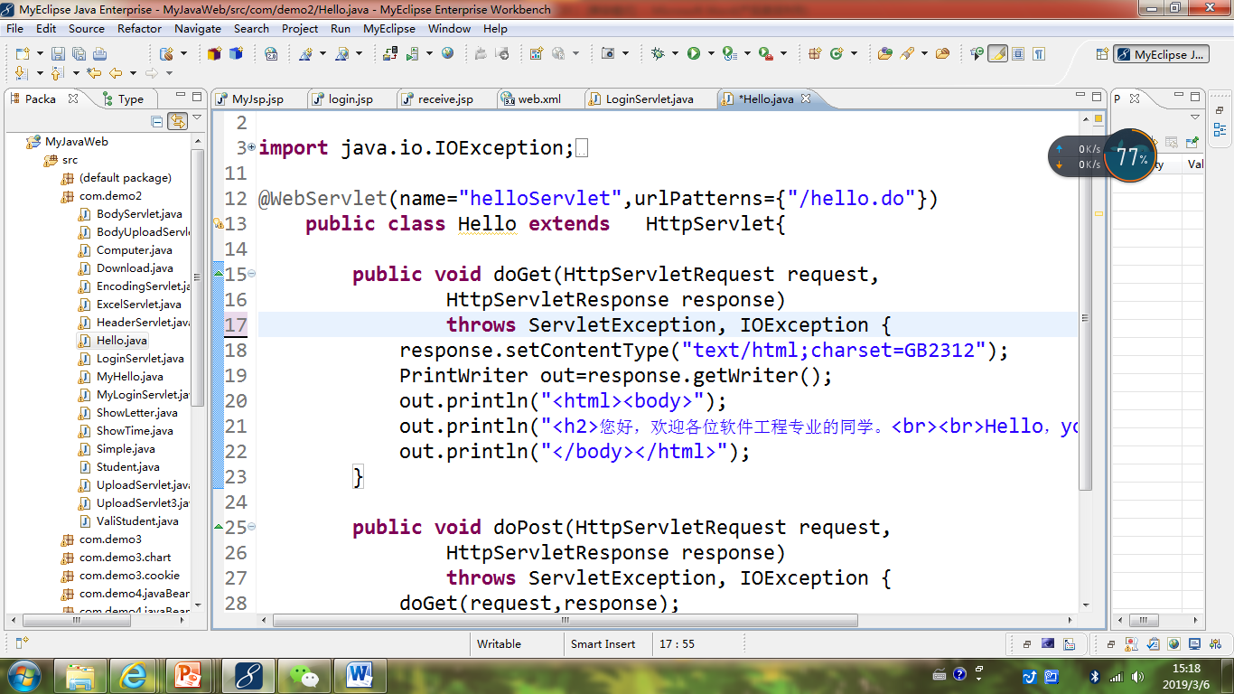

1. 请分别用注释法和文件配置法（web.xml）来完成对HelloServlet文件的发布。

注释法访问的地址是 <http://127.0.0.1:8080/项目工程名/test2/hello.view>（请注意要根据题目要求修改代码中的注释内容）

文件配置法的地址是http://127.0.0.1:8080/项目工程名/test2/hello.do

注释法：

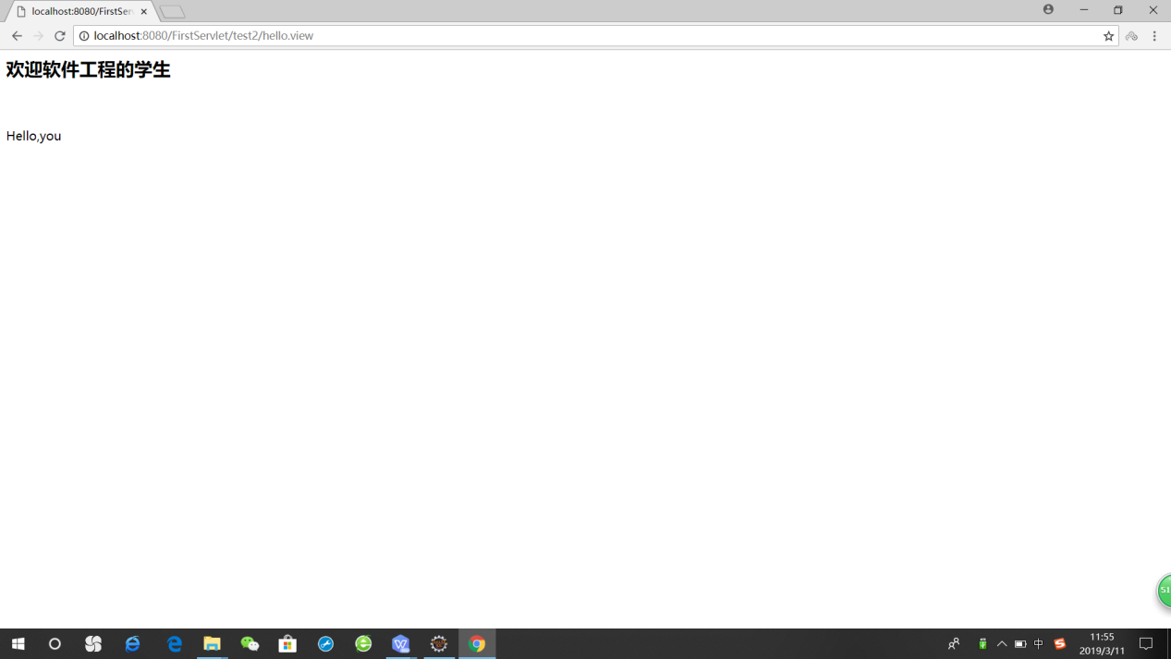

配置法：

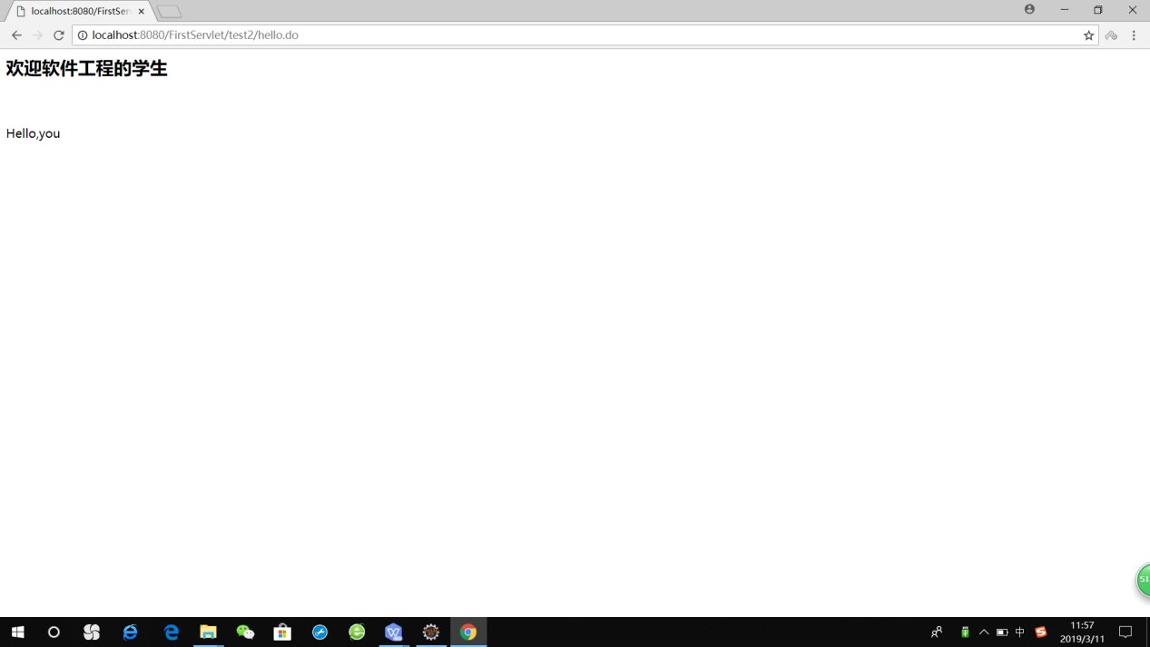

package test2;

import java.io.IOException;

import java.io.PrintWriter;

import javax.servlet.ServletException;

import javax.servlet.annotation.WebServlet;

import javax.servlet.http.HttpServlet;

import javax.servlet.http.HttpServletRequest;

import javax.servlet.http.HttpServletResponse;

/**

* Servlet implementation class Welcome

*/

//@WebServlet(name="helloServlet",urlPatterns={"/hello.do"})

public class Welcome extends HttpServlet {

private static final long serialVersionUID = 1L;

/**

* @see HttpServlet#HttpServlet()

*/

public Welcome() {

super();

// TODO Auto-generated constructor stub

}

/**

* @see HttpServlet#doGet(HttpServletRequest request, HttpServletResponse response)

*/

protected void doGet(HttpServletRequest request, HttpServletResponse response) throws ServletException, IOException {

// TODO Auto-generated method stub

response.setContentType("text/html;charset=UTF-8");

PrintWriter out = response.getWriter();

out.println("<html><body>");

out.println("<h2>欢迎软件工程的学生</h2><br><br>Hello,you");

out.println("</body></html>");

out.close();

}

/**

* @see HttpServlet#doPost(HttpServletRequest request, HttpServletResponse response)

*/

protected void doPost(HttpServletRequest request, HttpServletResponse response) throws ServletException, IOException {

// TODO Auto-generated method stub

doGet(request, response);

}

}

<?xml version=*"1.0"* encoding=*"ISO-8859-1"*?>

<!--

Licensed to the Apache Software Foundation (ASF) under one or more

contributor license agreements. See the NOTICE file distributed with

this work for additional information regarding copyright ownership.

The ASF licenses this file to You under the Apache License, Version 2.0

(the "License"); you may not use this file except in compliance with

the License. You may obtain a copy of the License at

http://www.apache.org/licenses/LICENSE-2.0

Unless required by applicable law or agreed to in writing, software

distributed under the License is distributed on an "AS IS" BASIS,

WITHOUT WARRANTIES OR CONDITIONS OF ANY KIND, either express or implied.

See the License for the specific language governing permissions and

limitations under the License.

-->

<web-app xmlns=*"http://java.sun.com/xml/ns/javaee"*

xmlns:xsi=*"http://www.w3.org/2001/XMLSchema-instance"*

xsi:schemaLocation=*"http://java.sun.com/xml/ns/javaee*

*http://java.sun.com/xml/ns/javaee/web-app_3_0.xsd"*

version=*"3.0"*

metadata-complete=*"true"*>

<display-name>Welcome to Tomcat</display-name>

<servlet>

<servlet-name>Welcome</servlet-name>

<servlet-class>test2.Welcome</servlet-class>

<load-on-startup>2</load-on-startup>

</servlet>

<servlet-mapping>

<servlet-name>Welcome</servlet-name>

<url-pattern>test2/hello.do</url-pattern>

</servlet-mapping>

<description>

Welcome to Tomcat

</description>

</web-app>

1. 请编写WelcomeYou.java文件，代码内容如下图，

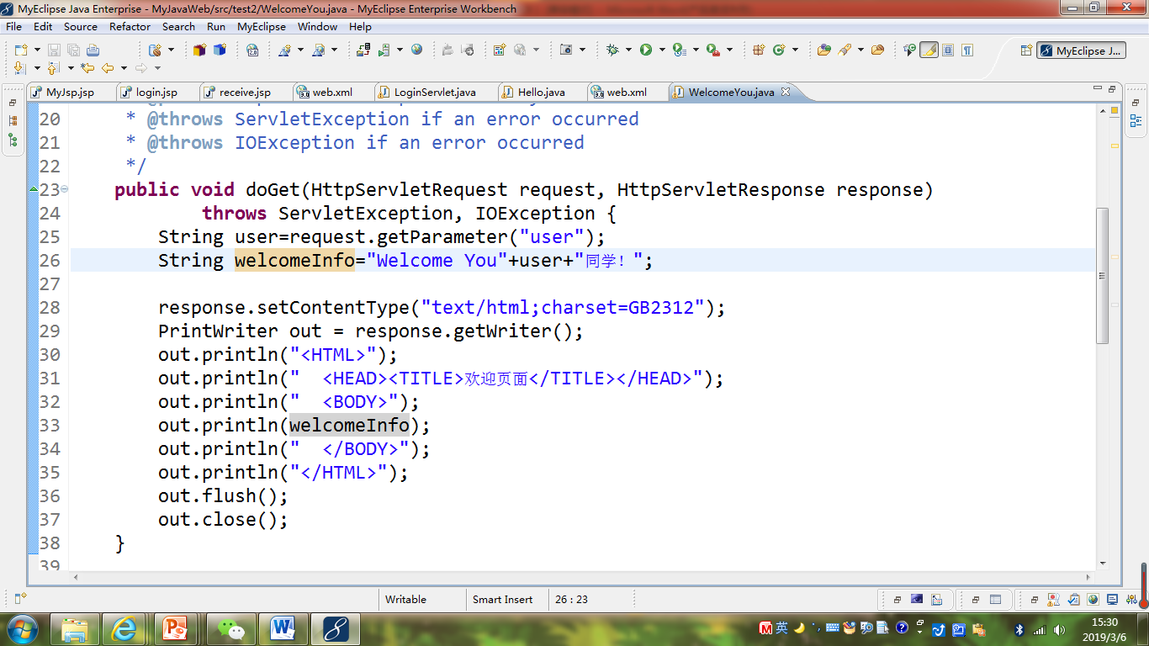

* 1. 图中第25行是何意思？

获取用户发送的请求参数值

* 1. 编写好之后请用如下两个地址来分别访问该文件：

http://127.0.0.1:8080/项目工程名/test2/welcome?user=‘李华’

http://127.0.0.1:8080/项目工程名/test2/welcome?user=‘Lihua’

记录下浏览器的显示内容，并分析其原因。

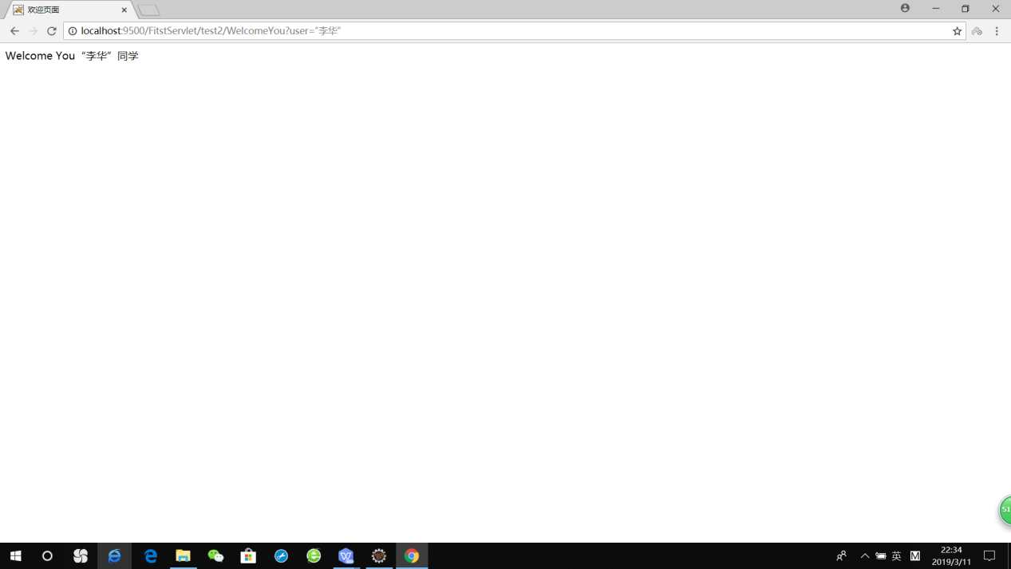

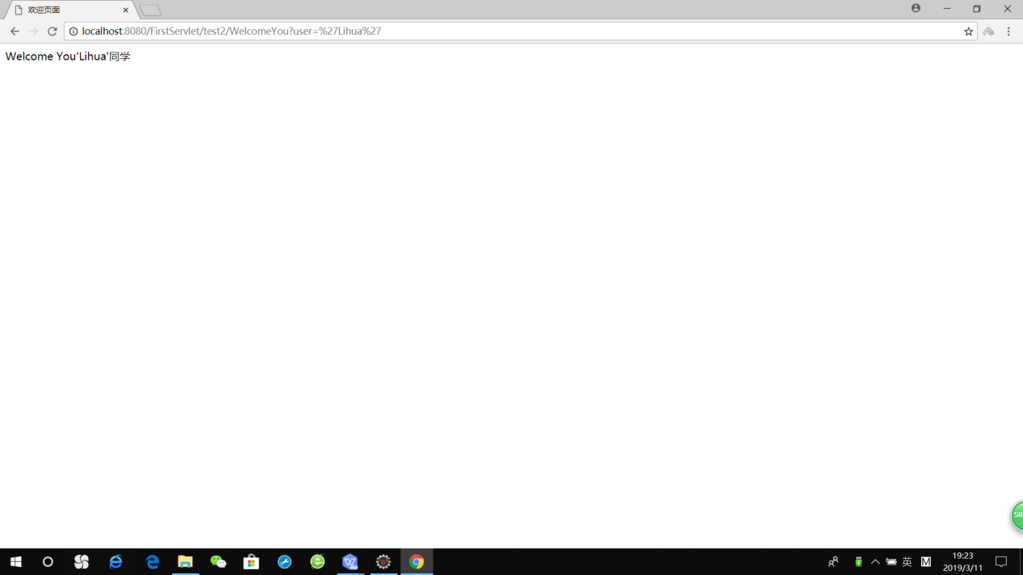

User传递的值不一样

1. 请编写程序，完成以下功能：
2. 一个邮箱注册表单register.html文件，具体见图。

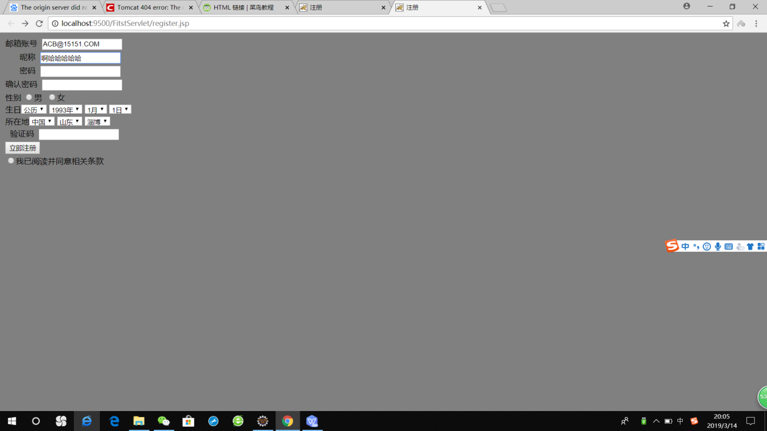

1. 自行编写两个html文件，一个success.jsp成功页面，一个fail.jsp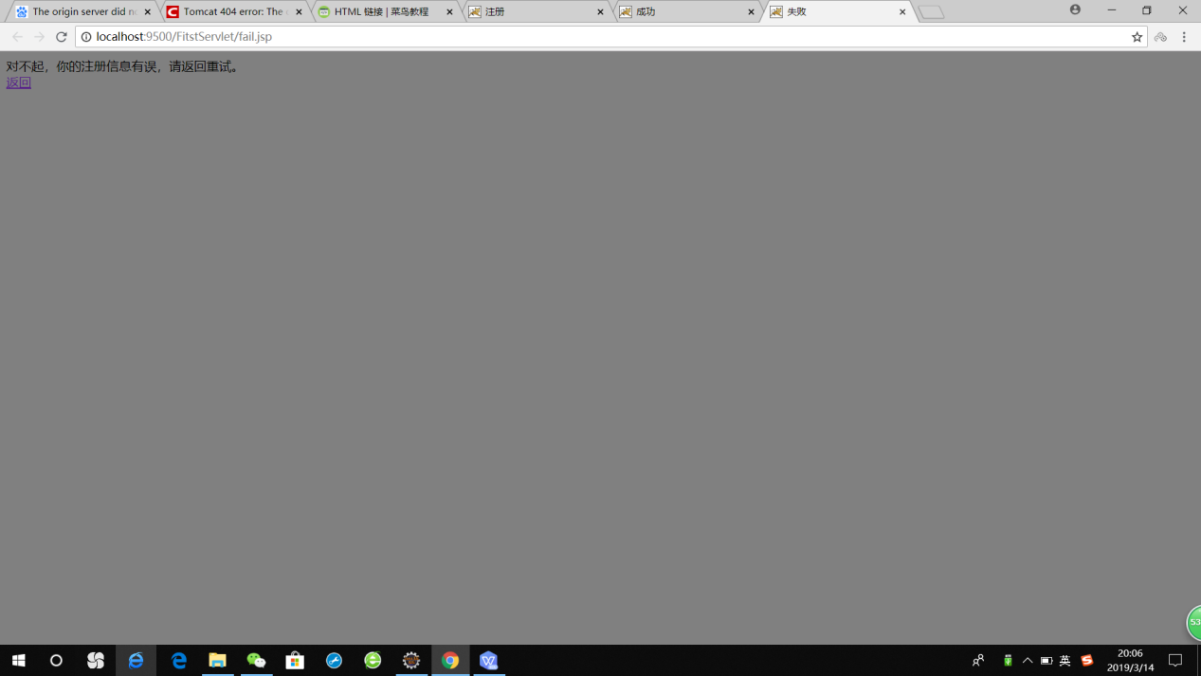
2. 点击注册按钮后，跳转到成功页面success.jsp。
3. 尝试：能否在成功页面显示该用户的昵称，邮箱名称？比如“开心，恭喜你！你的happyToday@163.com”

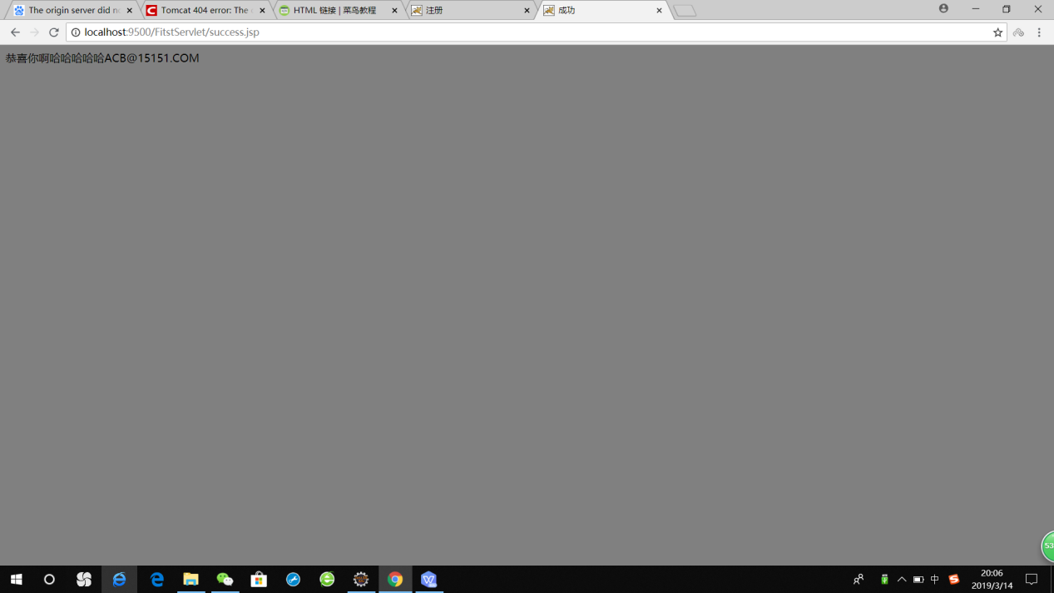

1. 注意注册页面的表单应当提交什么请求方式

Post

1. 如果下一步，我还希望能把失败页面加上去，怎么办？

在script语句里判断