**Java Web开发**

**实验一**

**作业报告**

|  |  |
| --- | --- |
| 学 院 | 计算机 |
| 所在系 班 级 | 2017软件工程系14班 |
| 学 号 姓 名 | 04171430周妍蓉 |
| 指 导 教 师 | 郭晓燕 |
| 完 成 时 间 | 2018年5月- |

# 实验题目

1. 新建项目，练习教材上相关例子，P29、P39

# 关键源码（部分）

package main;

import java.io.IOException;

import java.io.PrintWriter;

import javax.servlet.ServletException;

import javax.servlet.annotation.WebServlet;

import javax.servlet.http.HttpServlet;

import javax.servlet.http.HttpServletRequest;

import javax.servlet.http.HttpServletResponse;

/**

* Servlet implementation class HelloServlet

*/

@WebServlet("/Hello1.view")

public class HelloServlet extends HttpServlet {

private static final long serialVersionUID = 1L;

/**

* @see HttpServlet#HttpServlet()

*/

public HelloServlet() {

super();

// TODO Auto-generated constructor stub

}

/**

* @see HttpServlet#doGet(HttpServletRequest request, HttpServletResponse response)

*/

protected void doGet(HttpServletRequest request, HttpServletResponse response) throws ServletException, IOException {

// TODO Auto-generated method stub

response.setContentType("text/html;charset=utf-8");

response.setCharacterEncoding("utf-8");

response.getWriter().append("Served at: ").append(request.getContextPath());

PrintWriter out = response.getWriter();

String name = request.getParameter("name");

out.println("<html>");

out.println("<head>");

out.println("<title>Hello Servlet</title>");

out.println("</head>");

out.println("<body>");

out.println("<h1>您好！欢迎个位软件工程专业的同学</h1>");

out.println("</body>");

out.println("</html>");

out.close();

}

/**

* @see HttpServlet#doPost(HttpServletRequest request, HttpServletResponse response)

*/

protected void doPost(HttpServletRequest request, HttpServletResponse response) throws ServletException, IOException {

// TODO Auto-generated method stub

doGet(request, response);

}

}

（配置法

<?xml version="1.0" encoding="UTF-8"?>

<web-app xmlns:xsi="http://www.w3.org/2001/XMLSchema-instance" xmlns="http://xmlns.jcp.org/xml/ns/javaee" xsi:schemaLocation="http://xmlns.jcp.org/xml/ns/javaee http://xmlns.jcp.org/xml/ns/javaee/web-app_4_0.xsd" version="4.0">

<display-name>java_web</display-name>

<welcome-file-list>

<welcome-file>index.html</welcome-file>

</welcome-file-list>

<servlet>

<servlet-name>hello</servlet-name>

<servlet-class>main.HelloServlet</servlet-class>

</servlet>

<servlet-mapping>

<servlet-name>hello</servlet-name>

<url-pattern>/hello.view</url-pattern>

</servlet-mapping>

</web-app>

# 运行效果图

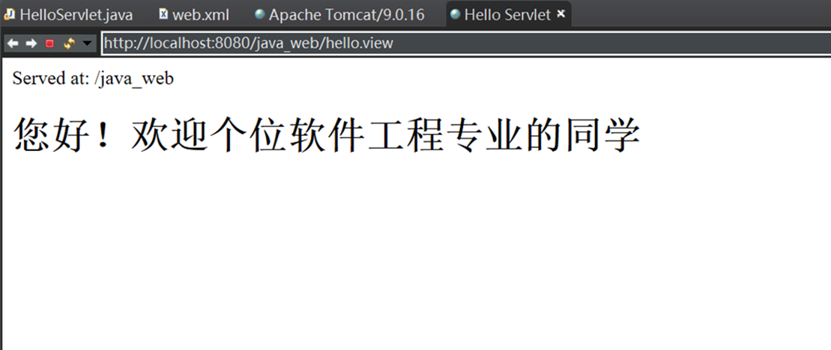

# 实验题目（第二题）

1. 完成实训题P46的第2题；

# 关键源码

1） 得到名字为user的参数

2）

package main;

import java.io.IOException;

import java.io.PrintWriter;

import javax.servlet.ServletException;

import javax.servlet.annotation.WebServlet;

import javax.servlet.http.HttpServlet;

import javax.servlet.http.HttpServletRequest;

import javax.servlet.http.HttpServletResponse;

/**

* Servlet implementation class HelloServlet

*/

@WebServlet("/Hello1.view")

public class HelloServlet extends HttpServlet {

private static final long serialVersionUID = 1L;

/**

* @see HttpServlet#HttpServlet()

*/

public HelloServlet() {

super();

// TODO Auto-generated constructor stub

}

/**

* @see HttpServlet#doGet(HttpServletRequest request, HttpServletResponse response)

*/

protected void doGet(HttpServletRequest request, HttpServletResponse response) throws ServletException, IOException {

// TODO Auto-generated method stub

response.setContentType("text/html;charset=utf-8");

response.setCharacterEncoding("utf-8");

request.setCharacterEncoding("utf-8");

response.encodeUrl("utf-8");

PrintWriter out = response.getWriter();

String user = request.getParameter("user");

String welcomeInfo = "Welcome You"+user+"同学";

out.println("<html>");

out.println("<head>");

out.println("<title>欢迎页面</title>");

out.println("</head>");

out.println("<body>");

out.println(welcomeInfo);

out.println("</body>");

out.println("</html>");

out.close();

}

/**

* @see HttpServlet#doPost(HttpServletRequest request, HttpServletResponse response)

*/

protected void doPost(HttpServletRequest request, HttpServletResponse response) throws ServletException, IOException {

doGet(request, response);

}

}

------------------------------------------------------------------------------------------------------

<!DOCTYPE html PUBLIC "-//W3C//DTD HTML 4.01 Transitional//EN" "http://www.w3.org/TR/html4/loose.dtd">

<html>

<head>

<meta http-equiv="Content-Type" content="text/html; charset=UTF-8">

<title></title>

</head>

<body>

<h1>会员注册</h1>

<form method='post' action='h'>

<table>

<tr>

<td>邮件地址：</td>

<td><input type='text' name='email'>

</td>

</tr>

<tr>

<td>名称：</td>

<td><input type='text' name='username' size='25'>

</td>

</tr>

<tr>

<td>密码：</td>

<td><input type='password' name='password'>

</td>

</tr>

<tr>

<td colspan='2' align='center'><input type='submit' value='注册'>

</td>

</tr>

</table>

</form>

</body>

</html>

<%@ page language="java"

pageEncoding="utf-8"%>

<!DOCTYPE html>

<html>

<head>

<meta charset="utf-8">

<title>Insert title here</title>

</head>

<body>

开心，恭喜你！

</body>

</html>

<%@ page language="java" contentType="text/html; charset=ISO-8859-1"

pageEncoding="ISO-8859-1"%>

<!DOCTYPE html>

<html>

<head>

<meta charset="ISO-8859-1">

<title>Insert title here</title>

</head>

<body>

登录失败

</body>

</html>

# 运行效果

