**Java Web开发**

**实验二**

**作业报告**

|  |  |
| --- | --- |
| 学院 | 计算机 |
| 所在系班级 | 2017软件工程系8班 |
| 学号姓名 | 04171627柯晓君 |
| 指导教师 | 郭晓燕 |
| 完成时间 | 2019年3月15日 |

# 实验题目

1. 新建项目，练习教材上相关例子Hello.java文件，P29。并练习如何在Tomcat服务器上发布该文件
2. 新建项目，练习教材上相关例子Hello.java文件，P29。并练习如何在Tomcat服务器上发布该文件

# 分析与设计

# 关键源码

package ch2bag;

import java.io.IOException;

import java.io.PrintWriter;

import javax.servlet.ServletException;

import javax.servlet.http.HttpServlet;

import javax.servlet.http.HttpServletRequest;

import javax.servlet.http.HttpServletResponse;

public class wow extends HttpServlet {

/**

* Constructor of the object.

*/

public wow() {

super();

}

/**

* Destruction of the servlet. <br>

*/

public void destroy() {

super.destroy(); // Just puts "destroy" string in log

// Put your code here

}

/**

* The doGet method of the servlet. <br>

*

* This method is called when a form has its tag value method equals to get.

*

* @param request the request send by the client to the server

* @param response the response send by the server to the client

* @throws ServletException if an error occurred

* @throws IOException if an error occurred

*/

public void doGet(HttpServletRequest request, HttpServletResponse response)

throws ServletException, IOException {

response.setContentType("text/html");

PrintWriter out = response.getWriter();

out.println("<html><body>");

out.println("<h2>您好，欢迎各位软件工程专业的同学.<br><br>Hello world!This is doget");

out.println("</body></html>");

}

/**

* The doPost method of the servlet. <br>

*

* This method is called when a form has its tag value method equals to post.

*

* @param request the request send by the client to the server

* @param response the response send by the server to the client

* @throws ServletException if an error occurred

* @throws IOException if an error occurred

*/

public void doPost(HttpServletRequest request, HttpServletResponse response)

throws ServletException, IOException {

response.setContentType("text/html");

PrintWriter out = response.getWriter();

out.println("<html><body>");

out.println("<h2>您好，欢迎各位软件工程专业的同学.<br><br>Hello world!This is dopost");

out.println("</body></html>");

}

/**

* Initialization of the servlet. <br>

*

* @throws ServletException if an error occurs

*/

public void init() throws ServletException {

// Put your code here

}

}

第二题：

package ch2bag;

import java.io.IOException;

import java.io.PrintWriter;

import javax.servlet.ServletException;

import javax.servlet.http.HttpServlet;

import javax.servlet.http.HttpServletRequest;

import javax.servlet.http.HttpServletResponse;

public class welcomeYou extends HttpServlet {

/**

* Constructor of the object.

*/

public welcomeYou() {

super();

}

/**

* Destruction of the servlet. <br>

*/

public void destroy() {

super.destroy(); // Just puts "destroy" string in log

// Put your code here

}

/**

* The doGet method of the servlet. <br>

*

* This method is called when a form has its tag value method equals to get.

*

* @param request the request send by the client to the server

* @param response the response send by the server to the client

* @throws ServletException if an error occurred

* @throws IOException if an error occurred

*/

public void doGet(HttpServletRequest request, HttpServletResponse response)

throws ServletException, IOException {

String user=request.getParameter("user");

String welcomeInfo="welcome You"+user+"同学";

response.setContentType("text/html;chatset=GB2312");

PrintWriter out=response.getWriter();

out.println("<HTML>");

out.println("<head><title>欢迎页面</title></head>");

out.println("<body>");

out.println(welcomeInfo);

out.println("</body>");

out.println("</html>");

out.flush();

out.close();

}

/**

* The doPost method of the servlet. <br>

*

* This method is called when a form has its tag value method equals to post.

*

* @param request the request send by the client to the server

* @param response the response send by the server to the client

* @throws ServletException if an error occurred

* @throws IOException if an error occurred

*/

public void doPost(HttpServletRequest request, HttpServletResponse response)

throws ServletException, IOException {

response.setContentType("text/html");

PrintWriter out = response.getWriter();

out.println("<!DOCTYPE HTML PUBLIC \"-//W3C//DTD HTML 4.01 Transitional//EN\">");

out.println("<HTML>");

out.println(" <HEAD><TITLE>A Servlet</TITLE></HEAD>");

out.println(" <BODY>");

out.print(" This is ");

out.print(this.getClass());

out.println(", using the POST method");

out.println(" </BODY>");

out.println("</HTML>");

out.flush();

out.close();

}

/**

* Initialization of the servlet. <br>

*

* @throws ServletException if an error occurs

*/

public void init() throws ServletException {

// Put your code here

}

}

# 运行效果图

搜索

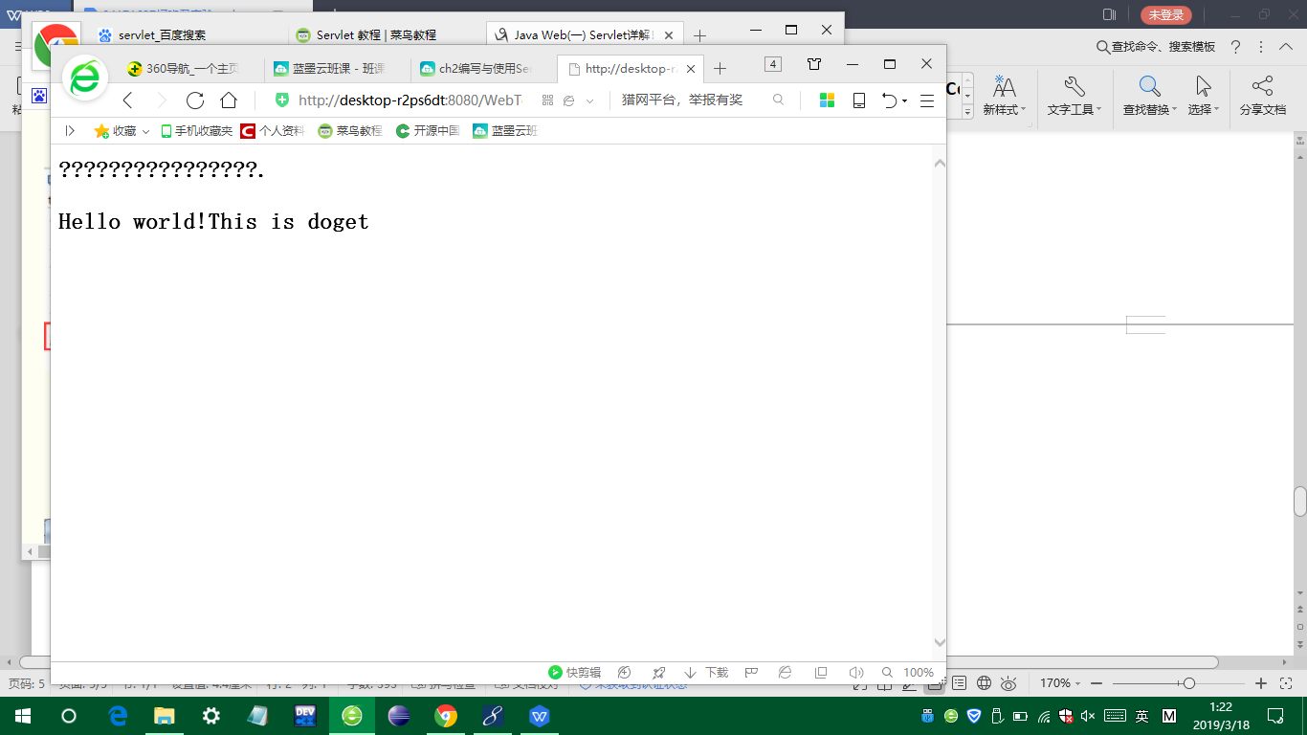

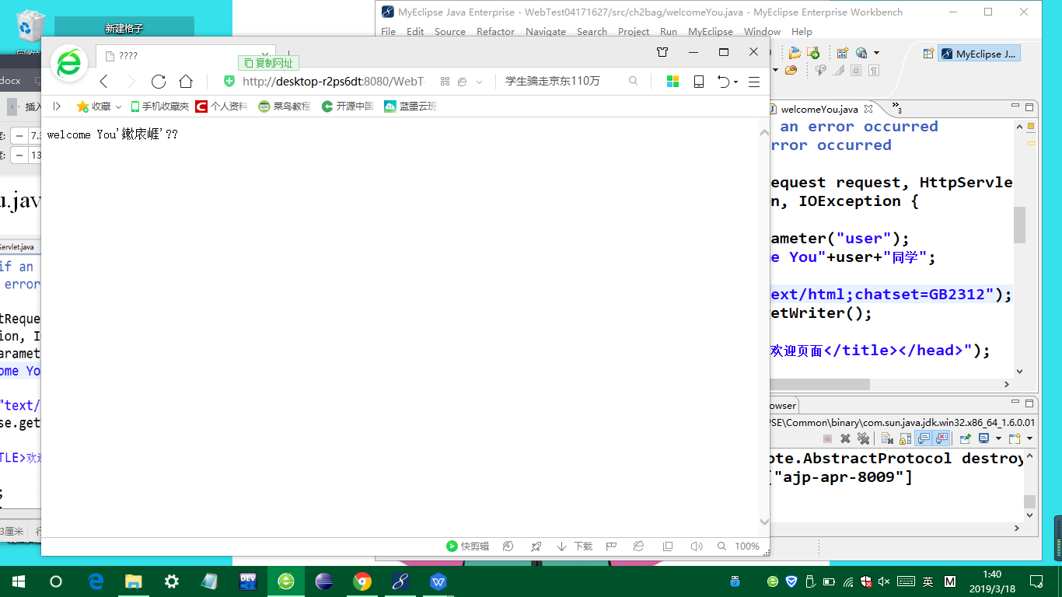

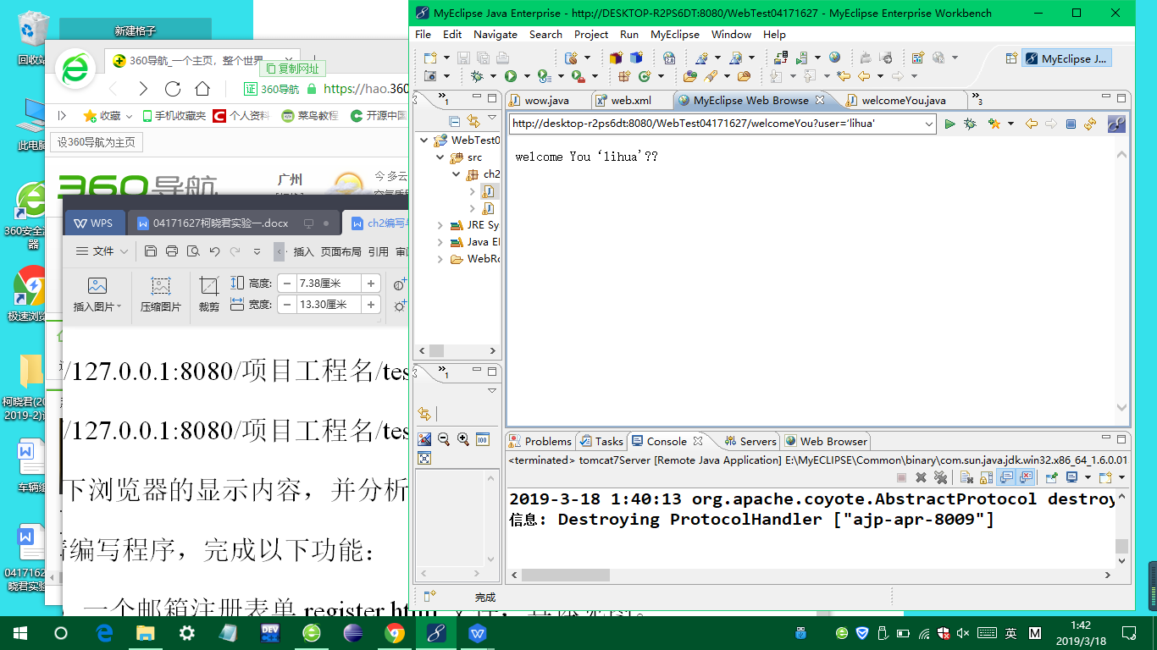

# 收获与问题