**Java Web开发**

**实验三**

**作业报告**

|  |  |
| --- | --- |
| 学 院 | 计算机 |
| 所在系 班 级 | 2017软件工程系14班 |
| 学 号 姓 名 | 04171327 |
| 指 导 教 师 | 罗永生 |
| 完 成 时 间 | 2019年3月- |

# 实验题目

一）必做。

* 将第二章实训题的第二题，登录页面，提交用户名、密码，若用户名不为空字符串且长度在6-8位间，密码不为，空长度为6位，则登录成功，显示“***（用户名）登录成功！”，否则显示“***登录失败”。

；

# 关键源码（部分）

1

—————————————————————————————

**package** cc.one;

**import** java.io.IOException;

**import** java.io.PrintWriter;

**import** javax.servlet.ServletException;

**import** javax.servlet.annotation.WebServlet;

**import** javax.servlet.http.HttpServlet;

**import** javax.servlet.http.HttpServletRequest;

**import** javax.servlet.http.HttpServletResponse;

@WebServlet("/success.view")

**public** **class** success **extends** HttpServlet {

/**

* Constructor of the object.

*/

**public** success() {

**super**();

}

/**

* Destruction of the servlet. <br>

*/

**public** **void** destroy() {

**super**.destroy(); // Just puts "destroy" string in log

// Put your code here

}

/**

* The doGet method of the servlet. <br>

*

* This method is called when a form has its tag value method equals to get.

*

* **@param** request the request send by the client to the server

* **@param** response the response send by the server to the client

* **@throws** ServletException if an error occurred

* **@throws** IOException if an error occurred

*/

**public** **void** doGet(HttpServletRequest request, HttpServletResponse response)

**throws** ServletException, IOException {

response.setContentType("text/html");

PrintWriter out = response.getWriter();

out.println("<!DOCTYPE HTML PUBLIC \"-//W3C//DTD HTML 4.01 Transitional//EN\">");

out.println("<HTML>");

out.println(" <HEAD><TITLE>A Servlet</TITLE></HEAD>");

out.println(" <BODY>");

out.print(" This is ");

out.print(**this**.getClass());

out.println(", using the GET method");

out.println(" </BODY>");

out.println("</HTML>");

out.flush();

out.close();

}

/**

* The doPost method of the servlet. <br>

*

* This method is called when a form has its tag value method equals to post.

*

* **@param** request the request send by the client to the server

* **@param** response the response send by the server to the client

* **@throws** ServletException if an error occurred

* **@throws** IOException if an error occurred

*/

**public** **void** doPost(HttpServletRequest request, HttpServletResponse response)

**throws** ServletException, IOException {

response.setContentType("text/html;charset=UTF-8");

PrintWriter out = response.getWriter();

out.println("<HTML>");

out.println(" <HEAD><TITLE>登陆成功</TITLE></HEAD>");

out.println(" <BODY>");

out.print("<h2>恭喜 "+request.getParameter("username")+" 登陆成功！！</h2>");

out.println(" </BODY>");

out.println("</HTML>");

out.flush();

out.close();

}

/**

* Initialization of the servlet. <br>

*

* **@throws** ServletException if an error occurs

*/

**public** **void** init() **throws** ServletException {

// Put your code here

}

**}**

**package** cc.one;

**import** java.io.IOException;

**import** java.io.PrintWriter;

**import** javax.servlet.ServletException;

**import** javax.servlet.annotation.WebServlet;

**import** javax.servlet.http.HttpServlet;

**import** javax.servlet.http.HttpServletRequest;

**import** javax.servlet.http.HttpServletResponse;

@WebServlet("/register.do")

**public** **class** R **extends** HttpServlet {

**private** **final** String SUCCESS_VIEW = "success.view";

**private** **final** String ERROR_VIEW = "fail.jsp";

**public** R() {

**super**();

}

/**

* Destruction of the servlet. <br>

*/

**public** **void** destroy() {

**super**.destroy(); // Just puts "destroy" string in log

// Put your code here

}

/**

* The doGet method of the servlet. <br>

*

* This method is called when a form has its tag value method equals to get.

*

* **@param** request the request send by the client to the server

* **@param** response the response send by the server to the client

* **@throws** ServletException if an error occurred

* **@throws** IOException if an error occurred

*/

**public** **void** doGet(HttpServletRequest request, HttpServletResponse response)

**throws** ServletException, IOException {

response.setContentType("text/html");

PrintWriter out = response.getWriter();

out.println("<!DOCTYPE HTML PUBLIC \"-//W3C//DTD HTML 4.01 Transitional//EN\">");

out.println("<HTML>");

out.println(" <HEAD><TITLE>A Servlet</TITLE></HEAD>");

out.println(" <BODY>");

out.print(" This is ");

out.print(**this**.getClass());

out.println(", using the GET method");

out.println(" </BODY>");

out.println("</HTML>");

out.flush();

out.close();

}

/**

* The doPost method of the servlet. <br>

*

* This method is called when a form has its tag value method equals to post.

*

* **@param** request the request send by the client to the server

* **@param** response the response send by the server to the client

* **@throws** ServletException if an error occurred

* **@throws** IOException if an error occurred

*/

**public** **void** doPost(HttpServletRequest request, HttpServletResponse response)

**throws** ServletException, IOException {

response.setContentType("text/html;charset=UTF-8");

String username = request.getParameter("username");

String password = request.getParameter("password");

**if**(username!=**null**&&username.length()>=6&&username.length()<=8&&password!=**null**&&password.length()==6){

request.getRequestDispatcher(SUCCESS_VIEW).forward(request, response);

}**else**{

response.sendRedirect(ERROR_VIEW);

}

}

/**

* Initialization of the servlet. <br>

*

* **@throws** ServletException if an error occurs

*/

**public** **void** init() **throws** ServletException {

// Put your code here

}

}

<!DOCTYPE HTML PUBLIC "-//W3C//DTD HTML 4.01 Transitional//EN">

<html>

<head>

<base href=*"*<%=basePath%>*"*>

<title>登陆失败</title>

<meta http-equiv=*"pragma"* content=*"no-cache"*>

<meta http-equiv=*"cache-control"* content=*"no-cache"*>

<meta http-equiv=*"expires"* content=*"0"*>

<meta http-equiv=*"keywords"* content=*"keyword1,keyword2,keyword3"*>

<meta http-equiv=*"description"* content=*"This is my page"*>

<!--

<link rel="stylesheet" type="text/css" href="styles.css">

-->

</head>

<body bgcolor=*pink*>

<fond size = *16*>

< a href=" ">回到首页</ a><br/><br/>

<h2>登陆失败 ！！<br></h2>

</body>

</html>

<!DOCTYPE html>

<html>

<head>

<title>登录界面</title>

<meta http-equiv=*"keywords"* content=*"keyword1,keyword2,keyword3"*>

<meta http-equiv=*"description"* content=*"this is my page"*>

<meta http-equiv=*"content-type"* content=*"text/html; charset=UTF-8"*>

<!--<link rel="stylesheet" type="text/css" href="./styles.css">-->

</head>

<body>

<form method = *'post'* action = *'register.do'*>

用户名：<input type = *'text'* name = *'username'* size = *'25'* maxlength = *'20'*><br/><br/>

密码：<input type = *'password'* name = *'password'* size = *'25'* maxlength = *'20'*><br/><br/>

<input type=*"submit"* value=*"提交"* name = *"submit"*>

</form>

</body>

</html>

# 运行效果图

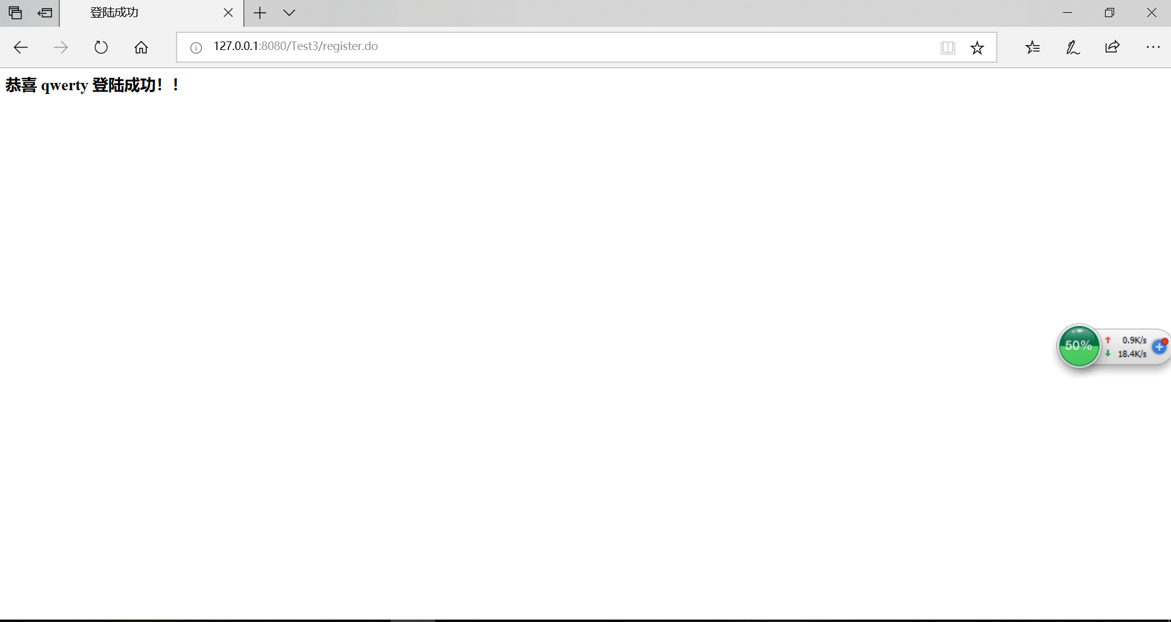

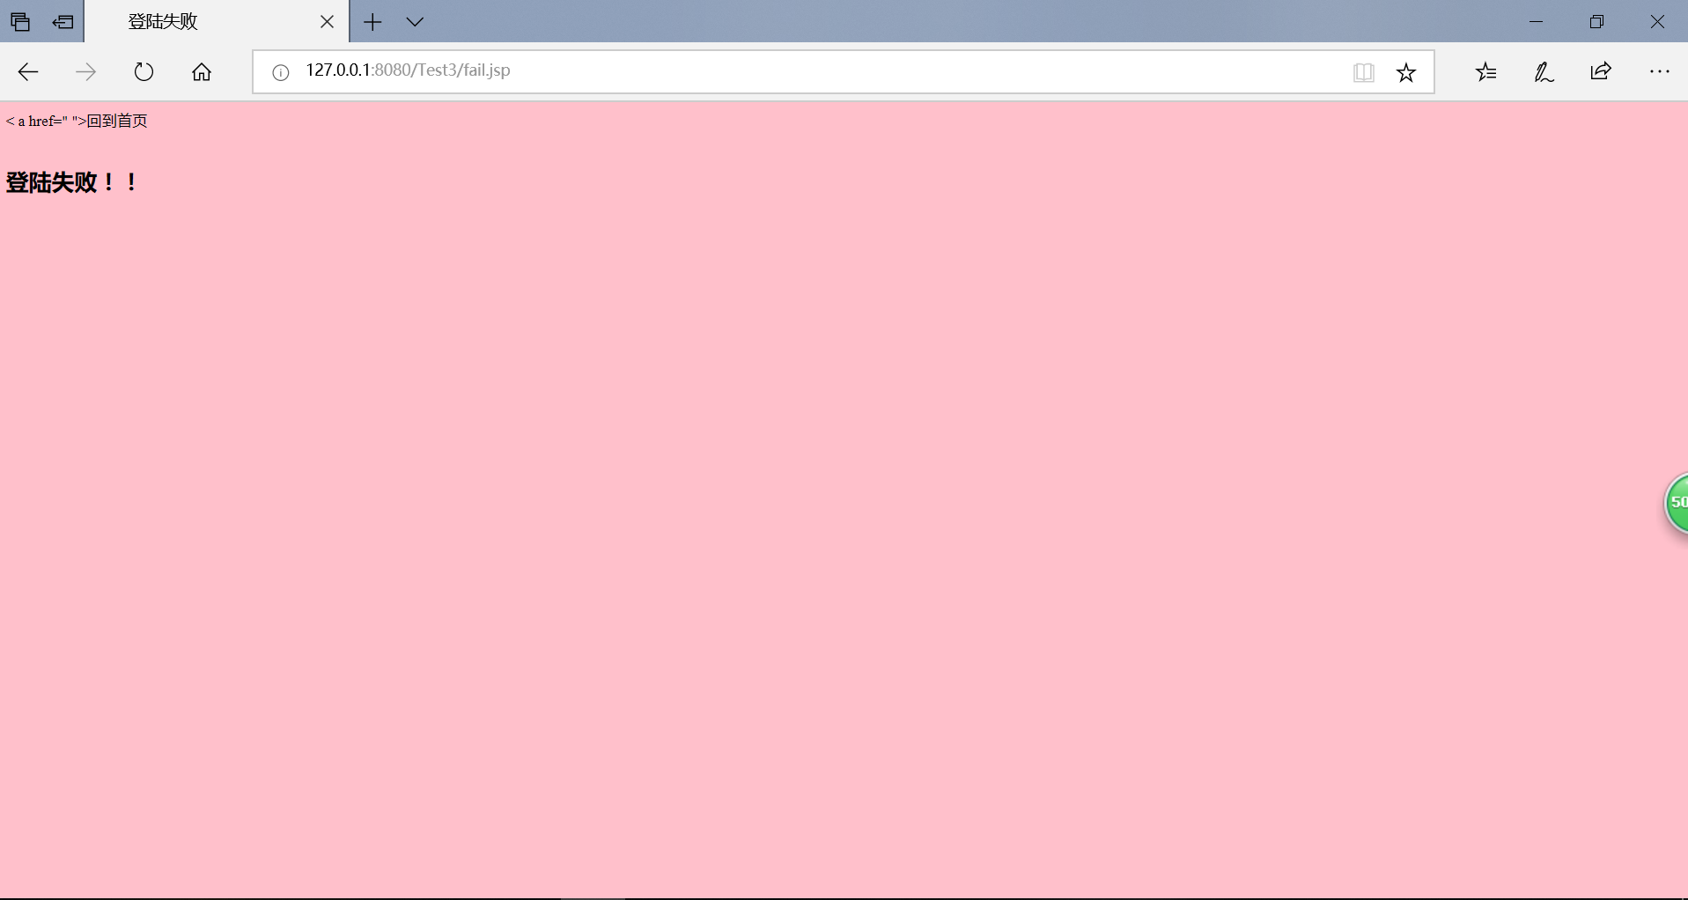

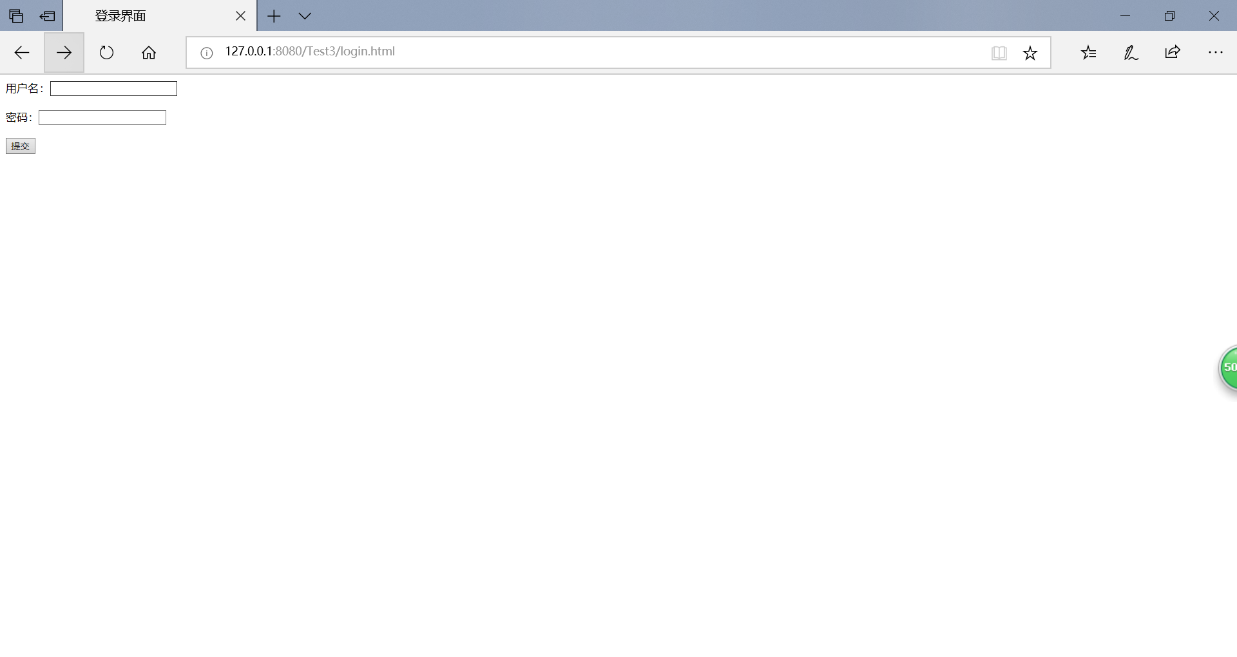

# 收获与问题

。

通过这次实验，让我初步了解了取得请求参数与标头，以及在网页乱码时如何处理。但是还是存在着一些不足，如还是不能熟悉的操作。