**Java Web开发**

**实验二**

**作业报告**

|  |  |
| --- | --- |
| 学 院 | 计算机 |
| 所在系 班 级 | 2017软件工程系13班 |
| 学 号 姓 名 | 武玉婷 |
| 指 导 教 师 | 罗永升 |
| 完 成 时 间 | 2018年3月 |

# 实验题目

将第二章实训题的第二题，登录页面，提交用户名、密码，若用户名不为空字符串且长度在6-8位间，密码不为，空长度为6位，则登录成功，显示“***（用户名）登录成功！”，否则显示“***登录失败”。

课后第三章第一题。动态生成验证码

# 分析与设计

如题要求

# 关键源码（部分）

Servlet:

**public** **void** doPost(HttpServletRequest request, HttpServletResponse response)

**throws** ServletException, IOException {

request.setCharacterEncoding("utf-8");

String id=request.getParameter("id");

String user=request.getParameter("un");

String ps1=request.getParameter("pwd");

String ps2=request.getParameter("qr");

String[] strings = {id,user,ps1,ps2};

**boolean** flag=**true**;

**for**(**int** i=0;i<4;i++){

**if**(strings[i].isEmpty())

flag=**false**;

}

request.setAttribute("key", user);

**if**(flag&&ps1.equals(ps2)&&user.length()<=8&&user.length()>=6&&ps1.length()==6)

request.getRequestDispatcher("/success.jsp").forward(request, response);

**else**

request.getRequestDispatcher("/fail.jsp").forward(request, response);

response.setContentType("text/html");

PrintWriter out = response.getWriter();

out.println("<!DOCTYPE HTML PUBLIC \"-//W3C//DTD HTML 4.01 Transitional//EN\">");

out.println("<HTML>");

out.println(" <HEAD><TITLE>A Servlet</TITLE></HEAD>");

out.println(" <BODY>");

out.print(" This is ");

out.print(**this**.getClass());

out.println(", using the POST method");

out.println(" </BODY>");

out.println("</HTML>");

out.flush();

out.close();

}

验证码：

<canvas width=*"200"* height=*"60"* id=*"check"* style="border:*1px solid #000*;">您的浏览器不支持canvas标签！</canvas>

<script>

**var** ctx = document.getElementById("check").getContext("2d");

**var** ctxW = document.getElementById("check").clientWidth;

**var** ctxH = document.getElementById("check").clientHeight;

**function** ranNum(min, max) {

**return** Math.random() * (max - min) + min;

}

**function** ranColor(min, max) {

**var** r = ranNum(min, max);

**var** g = ranNum(min, max);

**var** b = ranNum(min, max);

**return** `rgb(${r},${g},${b})`;

}

**function** ranStr() {

**var** str = "QWERTYUIOPASDFGHJKLZXCVBNMqwertyuiopasdfghjklzxcvbnm0123456789";

**return** str.split("").sort(**function** () {

**return** Math.random() - 0.5

});

}

**function** drawText(canvasId, canvasW, canvasH, num, fsMin, fsMax, frMin, frMax, min, max) {

**var** str = "";

**for** (**var** i = 0; i < num; i++) {

**var** char = ranStr()[Math.floor(0, ranStr().length)];

**var** fs = ranNum(fsMin, fsMax);

canvasId.font = fs + "px Verdana";

canvasId.fillStyle = ranColor(min, max);

canvasId.save();

canvasId.translate(canvasW / num * i + canvasW / 20, 0);

canvasId.rotate(ranNum(frMin, frMax) * Math.PI / 180);

canvasId.fillText(char, 0, (canvasH + fs) / 2.5, canvasW / num);

ctx.restore();

str += char;

}

**return** str;

}

**function** drawBg(canvasId, canvasW, canvasH, min, max) {

canvasId.fillStyle = ranColor(min, max);

canvasId.fillRect(0, 0, canvasW, canvasH);

}

**function** drawCircle(canvasId, canvasW, canvasH, num, r, min, max) {

**for** (**var** i = 0; i < num; i++) {

canvasId.beginPath();

canvasId.arc(ranNum(0, canvasW), ranNum(0, canvasH), r, 0, 2 * Math.PI);

canvasId.fillStyle = ranColor(min, max);

canvasId.fill();

canvasId.closePath();

}

}

**function** drawLine(canvasId, canvasW, canvasH, num, min, max) {

**for** (**var** i = 0; i < num; i++) {

canvasId.beginPath();

canvasId.moveTo(ranNum(0, canvasW), ranNum(0, canvasH));

canvasId.lineTo(ranNum(0, canvasW), ranNum(0, canvasH));

canvasId.strokeStyle = ranColor(min, max);

canvasId.stroke();

canvasId.closePath();

}

}

**function** drawCanvas() {

ctx.clearRect(0, 0, 200, 60);

drawBg(ctx, ctxW, ctxH, 200, 255);

drawCircle(ctx, ctxW, ctxH, 20, 5, 200, 255);

drawLine(ctx, ctxW, ctxH, 20, 0, 255);

**var** str = drawText(ctx, ctxW, ctxH, 4, 10, 50, -30, 30, 0, 100);**return** str;

}

drawCanvas();

document.getElementById('check').onclick = drawCanvas;

</script>

# 运行效果图

正确登陆：

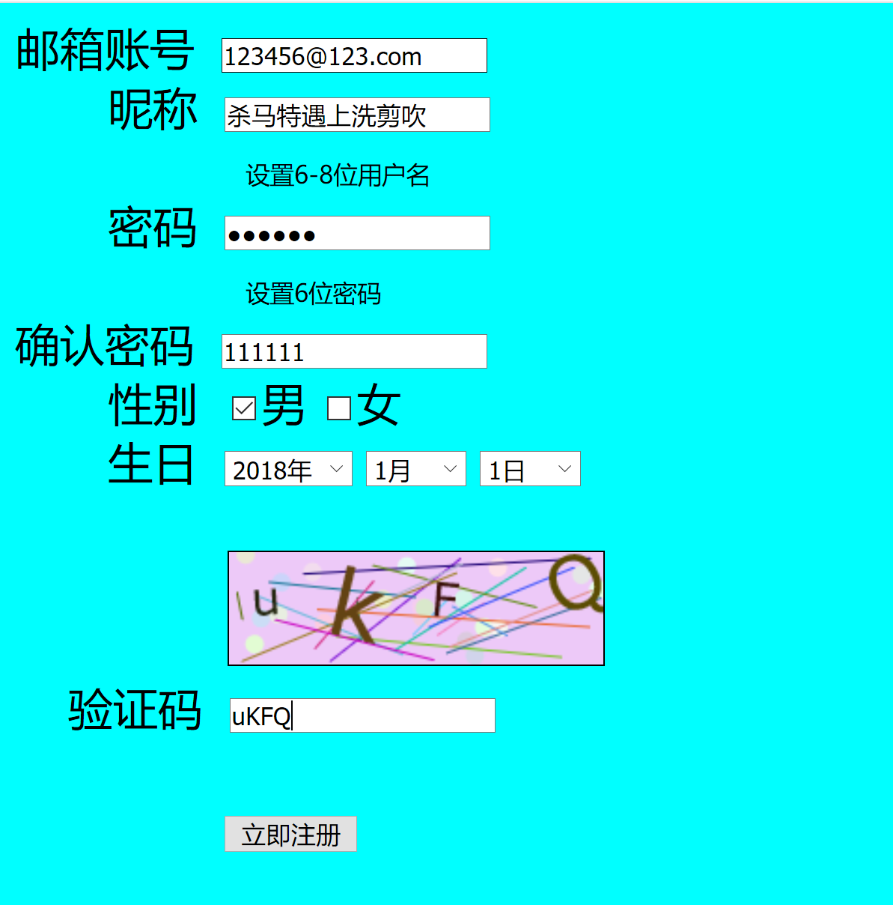

成功页面：

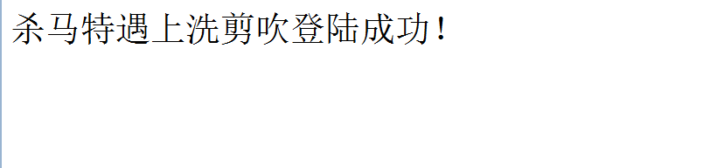

错误登陆：

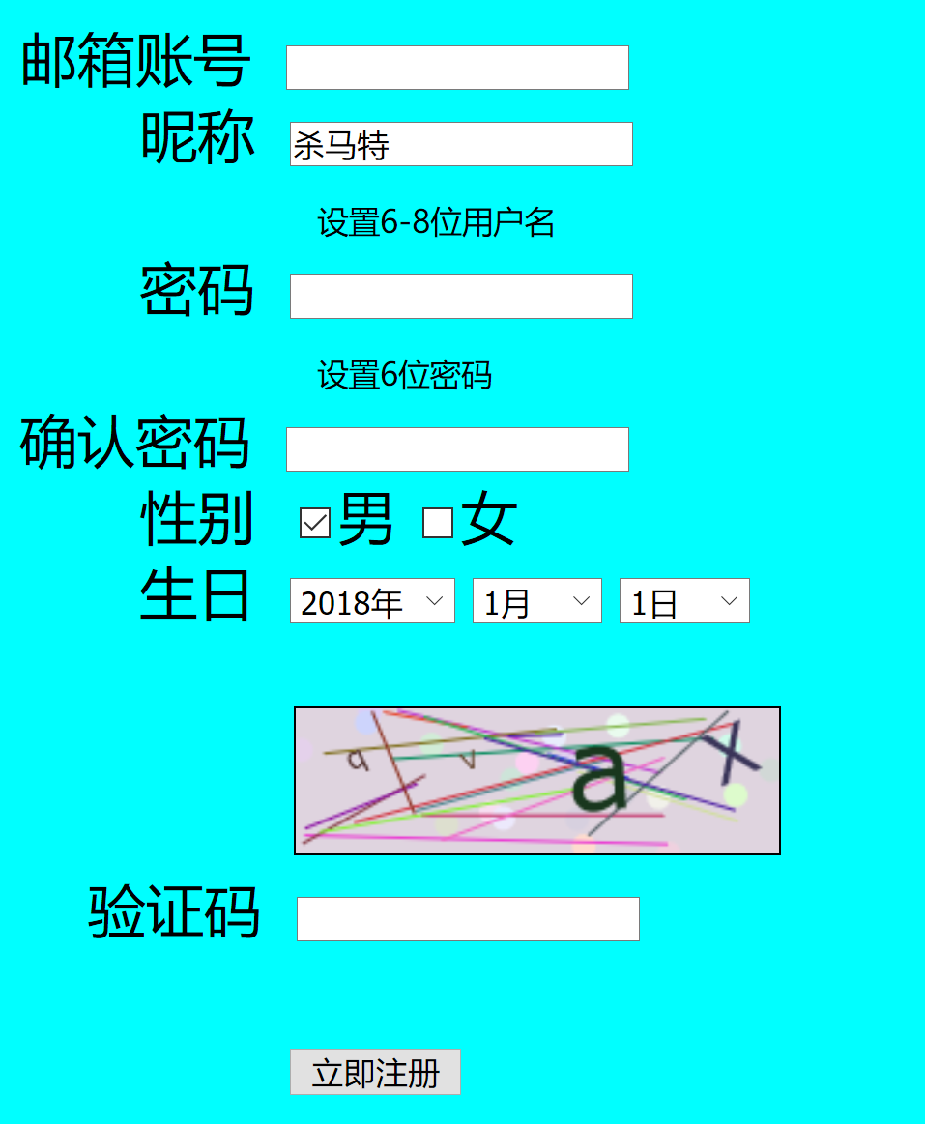

失败页面：

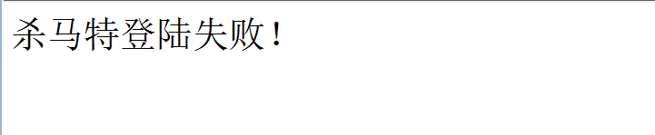

# 收获与问题

要好好学习