Success.java

package com.demo;

import java.io.IOException;

import java.io.PrintWriter;

import javax.servlet.ServletException;

import javax.servlet.http.HttpServlet;

import javax.servlet.http.HttpServletRequest;

import javax.servlet.http.HttpServletResponse;

public class success extends HttpServlet {

public void doPost(HttpServletRequest request, HttpServletResponse response)

throws ServletException, IOException {

response.setContentType("text/html");

PrintWriter out = response.getWriter();

String username = request.getParameter("name");

String email = request.getParameter("E");

out.println("<!DOCTYPE HTML PUBLIC \"-//W3C//DTD HTML 4.01 Transitional//EN\">");

out.println("<HTML>");

out.println(" <HEAD><TITLE>success</TITLE></HEAD>");

out.println(" <BODY>");

out.println("<h1>congratulation ! it is success to create a menber.</h1>");

out.println("<p>your username is :"+username+"</p>");

out.println("<p>your email is :"+email+"</p>");

out.println(" </BODY>");

out.println("</HTML>");

out.flush();

out.close();

}

}

Error.java

package com.demo;

import java.util.List;

import java.io.*;

import javax.servlet.ServletException;

import javax.servlet.http.HttpServlet;

import javax.servlet.http.HttpServletRequest;

import javax.servlet.http.HttpServletResponse;

public class Error extends HttpServlet {

public void doPost(HttpServletRequest request, HttpServletResponse response)

throws ServletException, IOException {

response.setContentType("text/html");

request.setCharacterEncoding("UTF-8");

response.setContentType("text/html");

PrintWriter out = response.getWriter();

// out.println("<!DOCTYPE HTML PUBLIC \"-//W3C//DTD HTML 4.01 Transitional//EN\">");

out.println("<HTML>");

out.println(" <HEAD><TITLE>Sorry!</TITLE></HEAD>");

out.println(" <BODY>");

out.println("<h1>Sorry!fail to create a menber!</h1>");

out.println("<ul>");

List<String> errors = (List<String>) request.getAttribute("errors");

for(String error : errors){

out.println("<li>"+error+"<li>");

}

out.println("</ul>");

out.println(" </BODY>");

out.println("</HTML>");

out.flush();

out.close();

}

}

CheckServlet.java

package com.demo;

import java.io.*;

import java.util.*;

import javax.servlet.ServletException;

import javax.servlet.http.HttpServlet;

import javax.servlet.http.HttpServletRequest;

import javax.servlet.http.HttpServletResponse;

public class CheckServlet extends HttpServlet {

private final String SUCCESS_VIEW = "success.view";

private final String ERROR_VIEW = "error.view";

public void doPost(HttpServletRequest req, HttpServletResponse resp)

throws ServletException, IOException {

resp.setContentType("text/html");

PrintWriter out = resp.getWriter();

// String email = req.getParameter("E");

String username = req.getParameter("name");

String password = req.getParameter("password");

String psw = req.getParameter("psw");

// String yourSex = req.getParameter("R");

// String yourBirth = req.getParameter("birthday");

String country = req.getParameter("country");

String province = req.getParameter("province");

String city = req.getParameter("city");

String place = country + "-" + province + city;

// out.println("<html>"+"<head>"+"</head>"+"<body>"+username + " " + password+ " " + place+"</body>"+"</html>");

List<String> errors = new ArrayList<String>();

// if (isInvalidEmai(email)){

// errors.add("未填写邮件或邮件格式不正确");

// }

if (username.isEmpty()){

errors.add("user exist or user name null");

}

if (!password.equals(psw) || password.isEmpty() || psw.isEmpty()){

errors.add("please check your password");

}

String resultPage = ERROR_VIEW;

if(!errors.isEmpty()){

req.setAttribute("errors",errors);

}else{

resultPage = SUCCESS_VIEW;

// create

}

// private boolean isInvalidEmail(String email){

// return email == null || !email.matches("^[_a-z0-9-]+([.]"+"[_a-z0-9-]+)*@[a-z0-9-]+([.][a-z0-9-]+)*$");

// }

req.getRequestDispatcher(resultPage).forward(req, resp);

out.flush();

out.close();

}

public void init() throws ServletException {

// Put your code here

}

}

成功注册时

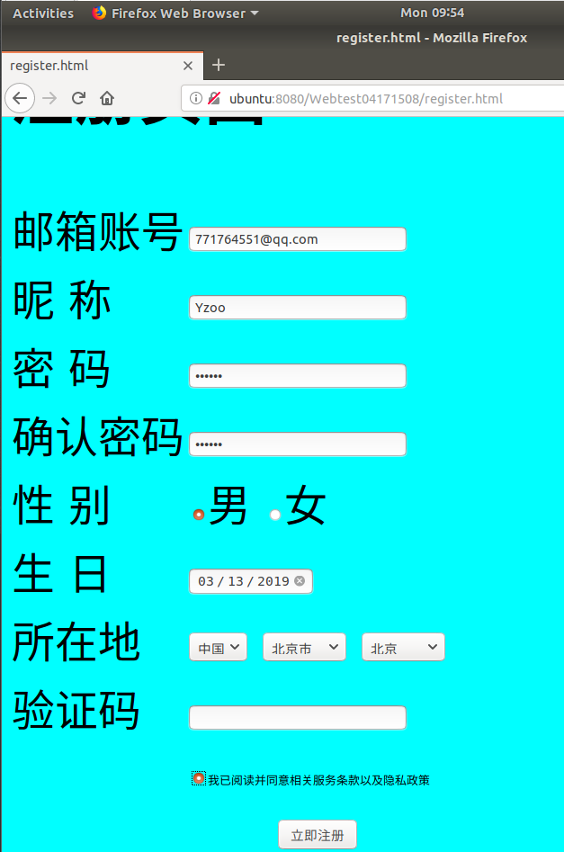

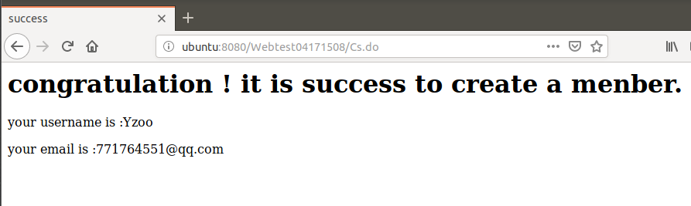

注册失败时：

