**Java Web开发**

**实验三**

**作业报告**

|  |  |
| --- | --- |
| 学 院 | 计算机 |
| 所在系 班 级 | 2017软件工程系8班 |
| 学 号 姓 名 | 钟静波 |
| 指 导 教 师 | 郭晓燕 |
| 完 成 时 间 | 2019年3月20日 |

# 实验题目

# 将第二章实训题的第二题，登录页面，提交用户名、密码，若用户名不为空字符串且长度在6-8位间，密码不为，空长度为6位，则登录成功，显示“***（用户名）登录成功！”，否则显示“***登录失败”。

# 分析与设计

# 关键源码（部分）

index.jsp

<%@ page contentType=*"text/html;charset=utf-8"* %>

<HTML><BODY><Font size=*8*>

<FORM method=*post* name=*form* action=*"mailServlet"*>

<P>请输入下列信息：

<BR>username:<INPUT type=*"text"* name=*"name"* ></BR>

<BR>password:<INPUT type=*"text"* name=*"psd"* ></BR></P>

<BR><INPUT TYPE=*"submit"* value=*"sign in"* name=*"submit"*>

</FORM>

</FONT></BODY></HTML>

mailServlet.java

package servlet;

import java.io.IOException;

import java.io.PrintWriter;

import javax.servlet.ServletException;

import javax.servlet.http.HttpServlet;

import javax.servlet.http.HttpServletRequest;

import javax.servlet.http.HttpServletResponse;

public class mailServlet extends HttpServlet {

public void doPost(HttpServletRequest request, HttpServletResponse response)

throws ServletException, IOException {

String name = request.getParameter("name");

String psd=request.getParameter("psd"); if(name.equals("")||psd.equals("")||name.length()<6||name.length()>8||psd.length()<6){

request.getRequestDispatcher("fail.jsp").forward(request, response);

return;

}

else{

request.getRequestDispatcher("success.jsp").forward(request, response);

}

}

}

success.jsp

<%@ page contentType=*"text/html;charset=utf-8"* %>

<%response.setCharacterEncoding("utf-8");

response.setHeader("iso-8859-1","utf-8");

request.setCharacterEncoding("utf-8");

String name = request.getParameter("name");

String psd = request.getParameter("psd");

String yourName=request.getParameter("name");

out.println("<HTML><BODY><Font size=8><P>开心，恭喜你！你的");

out.println(yourName);

out.println("</P><BR>登陆成功</BR></FONT></BODY></HTML>");

%>

fail.jsp

<%@ page language=*"java"* import=*"java.util.*"* pageEncoding=*"UTF-8"*%>

<%

String path = request.getContextPath();

String basePath = request.getScheme()+"://"+request.getServerName()+":"+request.getServerPort()+path+"/";

%>

<%@ page contentType=*"text/html;charset=utf-8"* %>

<%response.setCharacterEncoding("utf-8");

response.setHeader("iso-8859-1","utf-8");

request.setCharacterEncoding("utf-8");

String name = request.getParameter("name");

out.println("<HTML><BODY><Font size=8>");

String yourName=request.getParameter("name");

out.println(yourName);

out.println("登陆失败</FONT></BODY></HTML>"); %>

# 运行效果图

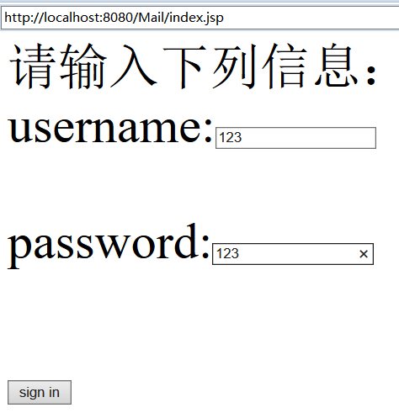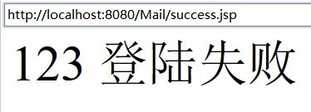

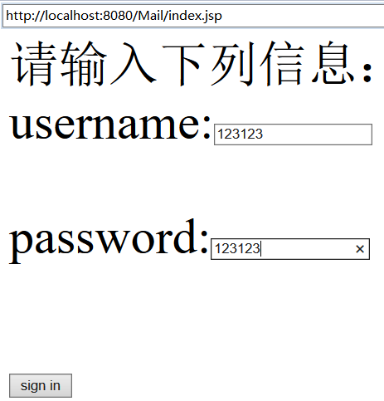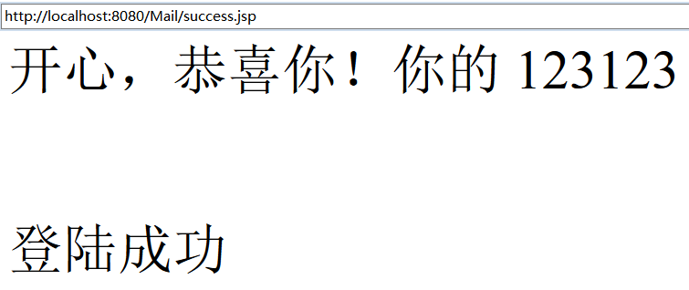

# 收获与问题