**Java Web开发**

**实验三**

**作业报告**

|  |  |
| --- | --- |
| 学 院 | 计算机 |
| 所在系 班 级 | 2017软件工程系8班 |
| 学 号 姓 名 | 04171628李嘉如 |
| 指 导 教 师 | 郭晓燕 |
| 完 成 时 间 | 2019年3月- |

题目：

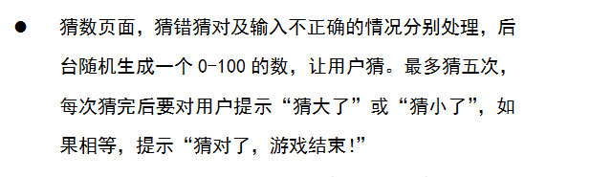

源码：

<%@ page language=*"java"* contentType=*"text/html; charset=UTF-8"*

pageEncoding=*"UTF-8"*%>

<!DOCTYPE html PUBLIC "-//W3C//DTD HTML 4.01 Transitional//EN" "http://www.w3.org/TR/html4/loose.dtd">

<html>

<head>

<meta http-equiv=*"Content-Type"* content=*"text/html; charset=UTF-8"*>

<title>这是一个猜数字的小游戏</title>

</head>

<body>

<h1>猜数小游戏</h1>

游戏说明：随机生成一个0-100的随机整数，然后输入您要猜的数字，点击提交按钮即可，最多有5次猜的机会。

<br />

<%

//保存随机数

**int** num=-1;

//猜测的次数

**int** flg=0;

//生成0-100之间的随机数

num=(**int**)(Math.random()*101);

//次数累加

**if**(request.getParameter("number")!=**null**)

flg++;

System.out.println(flg);

//保存猜测的次数

%>

<form action=*""* method=*"post"*>

请输入所要猜测的数字：

<input type=*"text"* name=*"number"*>

<input type=*"submit"* value=*"提交"*>

</form>

<%

**if**(request.getParameter("number")!=**null**)

{

//获得用户所猜测的数字

**int** num1=-1;

num1=Integer.parseInt(request.getParameter("number"));

**if**(num1>num)

out.println("你猜的数太大了！<br>");

**if**(num1<num)

out.println("你猜的数太小了！<br>");

**if**(num1==num)

out.println("恭喜你猜对了！<br>");

out.println("你已经猜了"+flg+"次");

}

%>

</body>

</html>

运行结果：

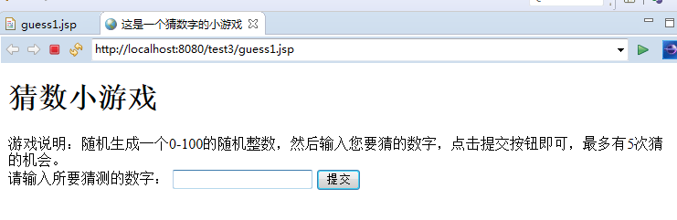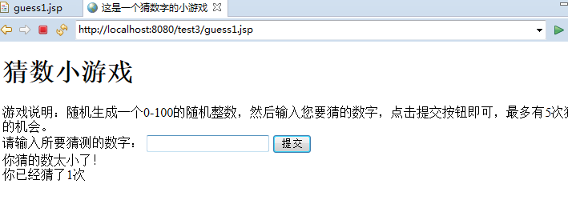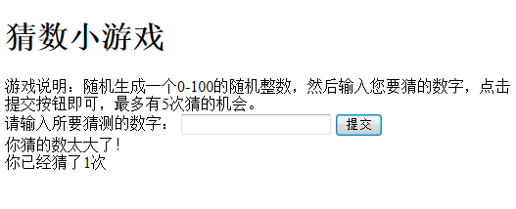

第一题：

源码：<%@ page language=*"java"* contentType=*"text/html; charset=UTF-8"*

pageEncoding=*"UTF-8"*%>

<!DOCTYPE html PUBLIC "-//W3C//DTD HTML 4.01 Transitional//EN" "http://www.w3.org/TR/html4/loose.dtd">

<html>

<head>

<meta http-equiv=*"Content-Type"* content=*"text/html; charset=UTF-8"*>

<title>登录界面</title>

</head>

<body>

<Form action=*"loginS.java"* method=*"post"*>

学号：

<input type=*"text"* name=*"ID"* width=*"100"* /><br/>

姓名：

<input type=*"text"* name=*"name"* width=*"100"* /><br/>

密码：

<input type=*"password"* name=*"ps "* width=*"100"*/><br/>

请选择你的专业：

<select name=*"zy"*>

<option value=*"1"*>计算机</option>

<option value=*"2"*>软件工程</option>

<option value=*"3"* >网络工程</option>

</select>

<input type=*"submit"* value=*"提交"*>

</Form>

</body>

</html>

import java.io.IOException;

import javax.servlet.ServletException;

import javax.servlet.annotation.WebServlet;

import javax.servlet.http.HttpServlet;

import javax.servlet.http.HttpServletRequest;

import javax.servlet.http.HttpServletResponse;

/**

* Servlet implementation class loginS

*/

@WebServlet("/loginS")

public class loginS extends HttpServlet {

private static final long serialVersionUID = 1L;

/**

* @see HttpServlet#HttpServlet()

*/

public loginS() {

super();

// TODO Auto-generated constructor stub

}

/**

* @see HttpServlet#doPost(HttpServletRequest request, HttpServletResponse response)

*/

protected void doPost(HttpServletRequest request,

HttpServletResponse response)

throws ServletException, IOException {

// TODO Auto-generated method stub

request.setCharacterEncoding("UTF-8");

String id=request.getParameter("ID");

String name=request.getParameter("name");

String psw=request.getParameter("psw");

String zy=request.getParameter("zy");

System.out.println(name);

boolean flag=validate(id,psw,name);

Student a=new Student();

a.setName(name);

a.setId(id);

a.setPsw(psw);

a.setZy(zy);

request.setAttribute(id, a);

if(flag)

{

request.getRequestDispatcher("success.jsp").forward(request, response);

}

else

response.sendRedirect("fail.jsp");

}

private boolean validate(String id, String psw,String name) {

// TODO Auto-generated method stub

boolean flag=false;

if((null!=id)&&(psw.length()==6)&&(name!=null))

flag=true;

return flag;

}

}

<%@ page language=*"java"* contentType=*"text/html; charset=UTF-8"*

pageEncoding=*"UTF-8"*%>

<!DOCTYPE html PUBLIC "-//W3C//DTD HTML 4.01 Transitional//EN" "http://www.w3.org/TR/html4/loose.dtd">

<html>

<head>

<meta http-equiv=*"Content-Type"* content=*"text/html; charset=UTF-8"*">

<title>成功登录页面</title>

</head>

<body>

<%

String id=request.getParameter("ID");

String name=request.getParameter("name");

String zy=request.getParameter("zy");

out.println("<P>学号："+id+"</P>");

out.println("<P>姓名："+name+"</P>");

out.println("<P>专业："+zy+"</P>");

%>

</body>

</html>

<%@ page language=*"java"* contentType=*"text/html; charset=UTF-8"*

pageEncoding=*"UTF-8"*%>

<!DOCTYPE html PUBLIC "-//W3C//DTD HTML 4.01 Transitional//EN" "http://www.w3.org/TR/html4/loose.dtd">

<html>

<head>

<meta http-equiv=*"Content-Type"* content=*"text/html; charset=UTF-8"*>

<title>登录失败界面</title>

</head>

<body>

抱歉的通知你，您无法登录！

</body>

</html>

截图：

