1. 第四章课后练习3购物车，实现一个购物车应用程序，可以购物，显示购物数量并查看购物车内容。
2. Main.jsp登录页面；chart.java保存商品信息；shoplogin.java获取登录信息，对商品进行初始化；book.jsp商品选购页面；bookcount.jsp计算商品总数。
3. Main.jsp

<%@ page language=*"java"* import=*"javax.servlet.http.HttpSession"* pageEncoding=*"UTF-8"*%>

<html><body><font size=*7*></font>

<p>请输入用户名进行登录

<form action=*"shoplogin.view"* method=*post* name=*form*>

<input type=*"text"* name=*"name"*>

<input type=*"submit"* value=*"提交"* name=*"submit"*>

</form>

<%

String ID=(String)session.getId();

String name=(String)session.getAttribute("customernName");

**if** ((name!=**null**)&&(name.length()>0))

{

%><p>登录成功的ID号<%=ID%>

<P>session

<a href=*"book.jsp"*>欢迎选购商品</a>

<%

}%>

</body>

</html>

Book.jsp

<%@ page language=*"java"* import=*"java.util.*"* pageEncoding=*"UTF-8"*%>

<html>

<body>

ID号<%= (String)session.getId() %><br>

<%

String name=(String)session.getAttribute("customerName");

chart[] charts=(chart[])session.getAttribute("chart");

%>

欢迎你<%=name %>

<p>请选购商品：

<from action=*"bookcount.do"* method=*post* name=*form*>

<%

**if**(charts!=**null**){

**for**(chart chart:charts){

%><br>

<input type=*"checkbox"* name=*"choice"* value=<%chart.getProductID()%>>

<%=chart.getProductName() %>

<%=chart.getProductPrice() %>

<%}

%>

<input type=*"submit"* value=*"提交"* name=*"submit"*>

<br>

</body>

</html>

Chart.java

**public** **class** Chart {

String productID;

String productName;

**float** productPrice;

**int** shopNum;

**public** Chart(String id,String name,**double** price){

**this**.productID=id;

**this**.productName=name;

**this**.productPrice=(**float**)price;

**this**.shopNum=0;

}

**public** String getProductID(){

**return** productID;

}

**public** **void** setProductID(String productID){

**this**.productID=productID;

}

**public** String getProductName(){

**return** productName;

}

**public** **void** setProductName(String productName){

**this**.productName=productName;

}

**public** **float** getProductPrice(){

**return** productPrice;

}

**public** **void** setProductPrice(**float** productPrice){

**this**.productPrice=productPrice;

}

**public** **int** getshopNum(){

**return** shopNum;

}

**public** **void** setShopNum(**int** shopNum){

**this**.shopNum=shopNum;

}

}

Shoplogin.java

@WebServlet("/shop/shoplogin.view")

**public** **class** ShopLogin **extends** HttpServlet {

**public** **void** doGet(HttpServletRequest request, HttpServletResponse response)

**throws** ServletException, IOException {

doPost(request,response);

}

**public** **void** doPost(HttpServletRequest request, HttpServletResponse response)

**throws** ServletException, IOException {

request.setCharacterEncoding("UTF-8");

HttpSession session=request.getSession();

String name=request.getParameter("name");

**if**(name==**null**){

name="";

response.sendRedirect("main.jsp");

}

**else**{

session.setAttribute("customerName", name);

Chart[] chart=initChart();

session.setAttribute("chart", chart);

response.sendRedirect("book.jsp");

}

**public** Chart[] initChart(){

Chart[] charts=**new** Chart[3];

Chart[0]=**new** Chart("01","servletjsp",25);

Chart[1]=**new** Chart("02","技术手册",25);

Chart[2]=**new** Chart("03","Jqua",25);

**return** charts;

}

}

}

Bookcount.java

**public** **class** BookCount **extends** HttpServlet {

**public** **void** doGet(HttpServletRequest request, HttpServletResponse response)

**throws** ServletException, IOException {

doPost(request,response);

}

*/

**public** **void** doPost(HttpServletRequest request, HttpServletResponse response)

**throws** ServletException, IOException {

response.setContentType("text/html,charset=utf-8");

HttpSession session=request.getSession();

request.setCharacterEncoding("utf-8");

Chart[] chartS=(chart[])session.getAttribute("chart");

String proS[]=request.getParameterValues("choice");

**if**(proS!=NULL)

{

**for**(**int** k=0;k<proS;lenth;k++){

id=proS[k];

**for**(**int** i=0;i<chartS.length;i++){

**if**(id.equals(chartS[i].getProductID())){

chartS[i].setShopNum(chartS[i].getshopNum()+1);

**break**;

}

}

}

}

}

}

4运行截图

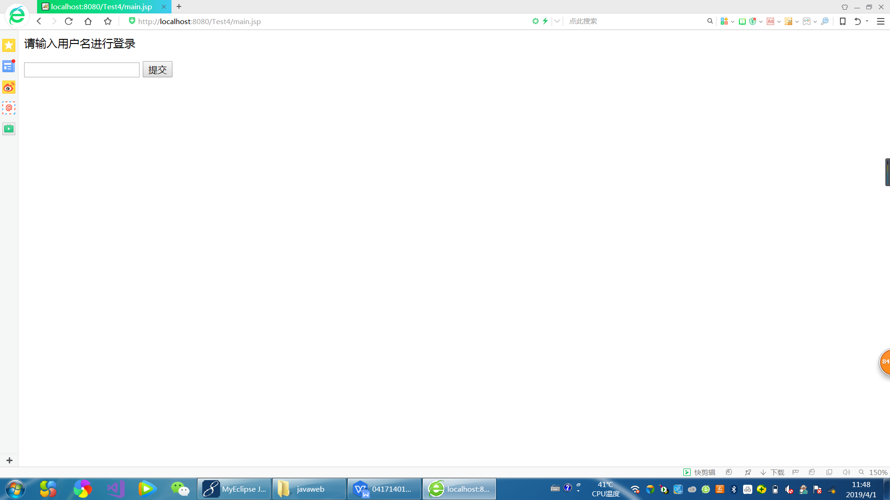

5除了第一个登录页面的jsp可以实现，其他页面代码功能还没能实现，还是不怎么会对页面的跳转。