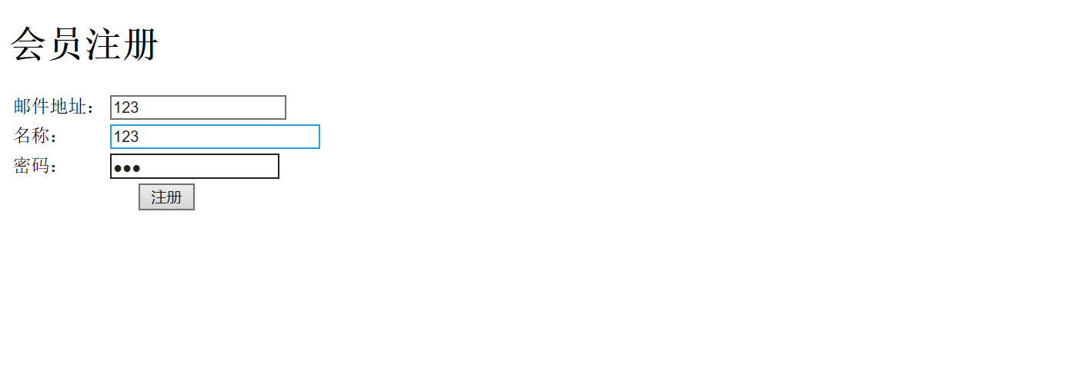第一题

package main;

import java.io.IOException;

import java.io.PrintWriter;

import javax.servlet.ServletException;

import javax.servlet.annotation.WebServlet;

import javax.servlet.http.HttpServlet;

import javax.servlet.http.HttpServletRequest;

import javax.servlet.http.HttpServletResponse;

/**

* Servlet implementation class HelloServlet

*/

@WebServlet("/Hello1.view")

public class HelloServlet extends HttpServlet {

private static final long serialVersionUID = 1L;

/**

* @see HttpServlet#HttpServlet()

*/

public HelloServlet() {

super();

// TODO Auto-generated constructor stub

}

/**

* @see HttpServlet#doGet(HttpServletRequest request, HttpServletResponse response)

*/

protected void doGet(HttpServletRequest request, HttpServletResponse response) throws ServletException, IOException {

// TODO Auto-generated method stub

response.setContentType("text/html;charset=utf-8");

response.setCharacterEncoding("utf-8");

response.getWriter().append("Served at: ").append(request.getContextPath());

PrintWriter out = response.getWriter();

String name = request.getParameter("name");

out.println("<html>");

out.println("<head>");

out.println("<title>Hello Servlet</title>");

out.println("</head>");

out.println("<body>");

out.println("<h1>您好！欢迎个位软件工程专业的同学</h1>");

out.println("</body>");

out.println("</html>");

out.close();

}

/**

* @see HttpServlet#doPost(HttpServletRequest request, HttpServletResponse response)

*/

protected void doPost(HttpServletRequest request, HttpServletResponse response) throws ServletException, IOException {

// TODO Auto-generated method stub

doGet(request, response);

}

}

配置法

<?**xml** version=*"1.0"* encoding=*"UTF-8"*?>

<**web-app** xmlns:xsi=*"http://www.w3.org/2001/XMLSchema-instance"* xmlns=*"http://xmlns.jcp.org/xml/ns/javaee"* xsi:schemaLocation=*"http://xmlns.jcp.org/xml/ns/javaee http://xmlns.jcp.org/xml/ns/javaee/web-app_4_0.xsd"* version=*"4.0"*>

<**display-name**>java_web</**display-name**>

<**welcome-file-list**>

<**welcome-file**>index.html</**welcome-file**>

</**welcome-file-list**>

<**servlet**>

<**servlet-name**>hello</**servlet-name**>

<**servlet-class**>main.HelloServlet</**servlet-class**>

</**servlet**>

<**servlet-mapping**>

<**servlet-name**>hello</**servlet-name**>

<**url-pattern**>/hello.view</**url-pattern**>

</**servlet-mapping**>

</**web-app**>

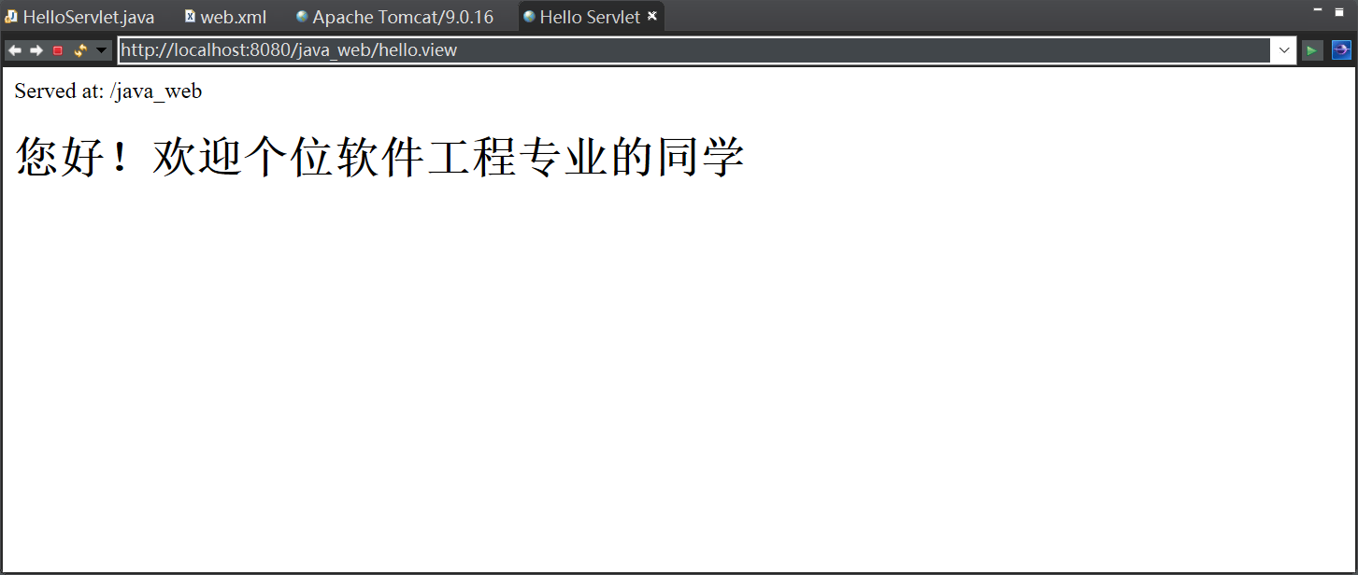

第二题

1. 得到名字为user的参数

package main;

import java.io.IOException;

import java.io.PrintWriter;

import javax.servlet.ServletException;

import javax.servlet.annotation.WebServlet;

import javax.servlet.http.HttpServlet;

import javax.servlet.http.HttpServletRequest;

import javax.servlet.http.HttpServletResponse;

/**

* Servlet implementation class HelloServlet

*/

@WebServlet("/Hello1.view")

public class HelloServlet extends HttpServlet {

private static final long serialVersionUID = 1L;

/**

* @see HttpServlet#HttpServlet()

*/

public HelloServlet() {

super();

// TODO Auto-generated constructor stub

}

/**

* @see HttpServlet#doGet(HttpServletRequest request, HttpServletResponse response)

*/

protected void doGet(HttpServletRequest request, HttpServletResponse response) throws ServletException, IOException {

// TODO Auto-generated method stub

response.setContentType("text/html;charset=utf-8");

response.setCharacterEncoding("utf-8");

request.setCharacterEncoding("utf-8");

response.encodeUrl("utf-8");

PrintWriter out = response.getWriter();

String user = request.getParameter("user");

String welcomeInfo = "Welcome You"+user+"同学";

out.println("<html>");

out.println("<head>");

out.println("<title>欢迎页面</title>");

out.println("</head>");

out.println("<body>");

out.println(welcomeInfo);

out.println("</body>");

out.println("</html>");

out.close();

}

/**

* @see HttpServlet#doPost(HttpServletRequest request, HttpServletResponse response)

*/

protected void doPost(HttpServletRequest request, HttpServletResponse response) throws ServletException, IOException {

doGet(request, response);

}

}

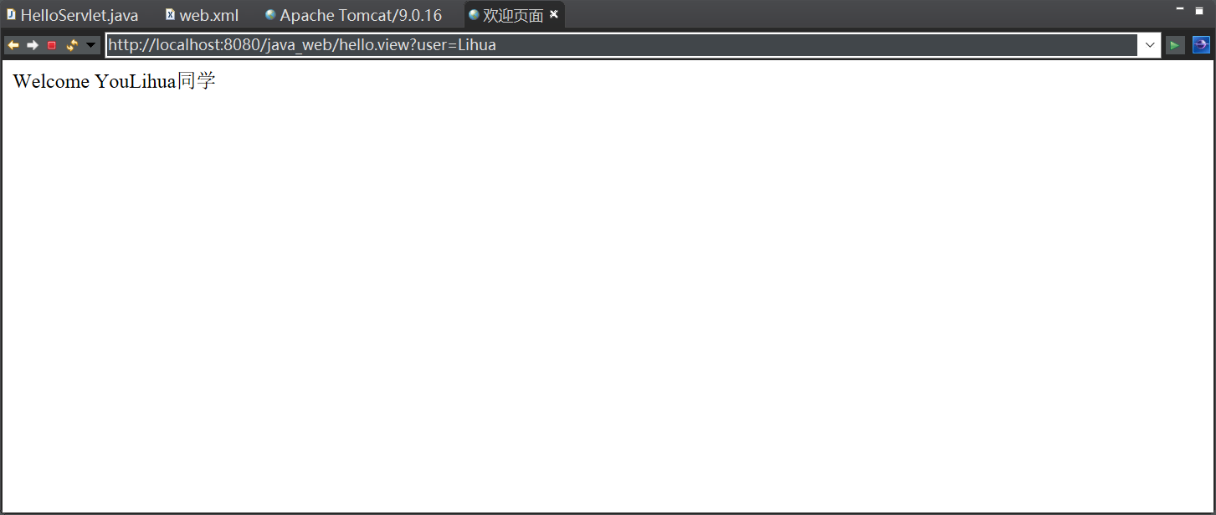



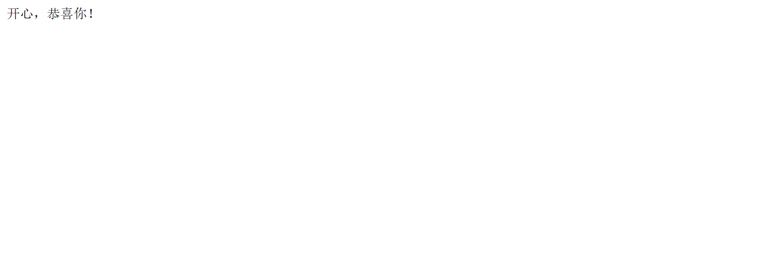

<!**DOCTYPE** html PUBLIC "-//W3C//DTD HTML 4.01 Transitional//EN" "http://www.w3.org/TR/html4/loose.dtd">

<**html**>

<**head**>

<**meta** http-equiv=*"Content-Type"* content=*"text/html; charset=UTF-8"*>

<**title**></**title**>

</**head**>

<**body**>

<**h1**>会员注册</**h1**>

<**form** method=*'post'* action=*'h'*>

<**table**>

<**tr**>

<**td**>邮件地址：</**td**>

<**td**><**input** type=*'text'* name=*'email'*>

</**td**>

</**tr**>

<**tr**>

<**td**>名称：</**td**>

<**td**><**input** type=*'text'* name=*'username'* size=*'25'*>

</**td**>

</**tr**>

<**tr**>

<**td**>密码：</**td**>

<**td**><**input** type=*'password'* name=*'password'*>

</**td**>

</**tr**>

<**tr**>

<**td** colspan=*'2'* align=*'center'*><**input** type=*'submit'* value=*'注册'*>

</**td**>

</**tr**>

</**table**>

</**form**>

</**body**>

</**html**>

<%@ **page** language=*"java"*

pageEncoding=*"utf-8"*%>

<!**DOCTYPE** html>

<**html**>

<**head**>

<**meta** charset=*"utf-8"*>

<**title**>Insert title here</**title**>

</**head**>

<**body**>

开心，恭喜你！

</**body**>

</**html**>

<%@ **page** language=*"java"* contentType=*"text/html; charset=ISO-8859-1"*

pageEncoding=*"ISO-8859-1"*%>

<!**DOCTYPE** html>

<**html**>

<**head**>

<**meta** charset=*"ISO-8859-1"*>

<**title**>Insert title here</**title**>

</**head**>

<**body**>

登录失败

</**body**>

</**html**>