**Java Web开发**

**实验四**

**作业报告**

|  |  |
| --- | --- |
| 学 院 | 计算机 |
| 所在系 班 级 | 2017软件工程系6班 |
| 学 号 姓 名 | 04171424柯海扬 |
| 指 导 教 师 | 罗永升 |
| 完 成 时 间 | 2019年3月18日 |

# 实验题目

1.改造实验三的第一题

# 分析与设计

<%@ page contentType=*"text/html;charset=utf-8"* %>

<html>

<head>

<meta charset=*"UTF-8"*>

<title>提交表单时加入验证码</title>

</head>

<body>

<form action=*"./register1.do"* method=*post* name=*form*>

<pre>用户名：<input name=*"user"* type=*"text"*>

学号： <input name=*"studentnum"* type=*"text"*>

邮 箱：<input name=*"mailbox"* type=*"text"*>

密 码：<input name=*"PWD"* type=*"password"* width=*"500"*>

验证码：<input name=*"yanzheng"* type=*"text"*></pre>

<%

**int** intmethod1=(**int**)((Math.random()*10)-1);

**int** intmethod2=(**int**)((Math.random()*10)-1);

**int** intmethod3=(**int**)((Math.random()*10)-1);

**int** intmethod4=(**int**)((Math.random()*10)-1);

String intsum=intmethod1+""+intmethod2+intmethod3+intmethod4;

%>

<input type=*"hidden"* name=*"yanzhengma"* value=*"*<%=intsum%>*"*/>

<img src=*"num/*<%=intmethod1%>*.PNG"* align=*"bottom"*>

<img src=*"num/*<%=intmethod2%>*.PNG"* align=*"bottom"*>

<img src=*"num/*<%=intmethod3%>*.PNG"* align=*"bottom"*>

<img src=*"num/*<%=intmethod4%>*.PNG"* align=*"bottom"*>

<select name=*"type"*>

<option value=*"计算机"*>计算机</option>

<option value=*"软件工程"*>软件工程</option>

<option value=*"网络工程"*>网络工程</option>

</select>

<br>

<INPUT TYPE=*"submit"* value=*"提交"* name=*"submit"*>

<INPUT TYPE=*"reset"* value=*"取消"* name=*"reset"*>

</form>

</body>

</html>

<%@ page language=*"java"* contentType=*"text/html; charset=UTF-8"*

pageEncoding=*"UTF-8"*%>

<!DOCTYPE HTML PUBLIC "-//W3C//DTD HTML 4.01 Transitional//EN">

<html>

<head>

</head>

<body>

<a href=*"./register.jsp"*>验证失败</a>

</body>

</html>

**package** cc;

**import** java.io.IOException;

**import** java.io.PrintWriter;

**import** javax.servlet.ServletException;

**import** javax.servlet.annotation.WebServlet;

**import** javax.servlet.http.HttpServlet;

**import** javax.servlet.http.HttpServletRequest;

**import** javax.servlet.http.HttpServletResponse;

@WebServlet(name = "register1", urlPatterns = { "/register1.do" })

**public** **class** register1 **extends** HttpServlet {

**protected** **void** doGet(HttpServletRequest request, HttpServletResponse response) **throws** ServletException, IOException {

response.setContentType("text/html;charset=UTF-8");

request.setCharacterEncoding("UTF-8");

String success="./welcome.jsp";

String fail="./success.do";

String user=request.getParameter("user");

String password_=request.getParameter("password");

String mailbox=request.getParameter("mailbox");

String yanzheng=request.getParameter("yanzheng");

String yanzhengma=request.getParameter("yanzhengma");

String studentnum=request.getParameter("studentnum");

String type=request.getParameter("type");

**if**(user.equals("")&&user==**null**&&!(yanzheng.equals(yanzhengma))&&mailbox.equals("")&&mailbox==**null**&&studentnum.equals("")&&studentnum==**null**&&type.equals("")&&type==**null**)

{ response.sendRedirect(fail);}

**else**

{

request.getRequestDispatcher(success).forward(request, response);

}

}

**protected** **void** doPost(HttpServletRequest request, HttpServletResponse response) **throws** ServletException, IOException {

response.setContentType("text/html;charset=UTF-8");

request.setCharacterEncoding("UTF-8");

String success="./success.do";

String fail="./fail.jsp";

String user=request.getParameter("user");

String password_=request.getParameter("password");

String mailbox=request.getParameter("mailbox");

String yanzheng=request.getParameter("yanzheng");

String yanzhengma=request.getParameter("yanzhengma");

**if**(user.equals("")&&user==**null**||!(yanzheng.equals(yanzhengma))||yanzheng==**null**||mailbox.equals("")||mailbox==**null**)

{ response.sendRedirect(fail);}

**else**

{

request.getRequestDispatcher(success).forward(request, response);

}

}

}

package cc;

import java.io.IOException;

import java.io.PrintWriter;

import javax.servlet.ServletException;

import javax.servlet.annotation.WebServlet;

import javax.servlet.http.HttpServlet;

import javax.servlet.http.HttpServletRequest;

import javax.servlet.http.HttpServletResponse;

@WebServlet(name = "success", urlPatterns = { "/success.do" })

public class success extends HttpServlet {

private static final long serialVersionUID = 1L;

public success() {

super();

}

protected void doGet(HttpServletRequest request, HttpServletResponse response) throws ServletException, IOException {

// TODO Auto-generated method stub

response.getWriter().append("Served at: ").append(request.getContextPath());

}

protected void doPost(HttpServletRequest request, HttpServletResponse response) throws ServletException, IOException {

response.setContentType("text/html;charset=UTF-8");

request.setCharacterEncoding("UTF-8");

String user=request.getParameter("user");

String studentnum=request.getParameter("studentnum");

String type=request.getParameter("type");

String mailbox=request.getParameter("mailbox");

PrintWriter out = response.getWriter();

out.println("<html>");

out.println("<head>");

out.println("<title>Hello Servlet</title>");

out.println("</head>");

out.println("<body>");

out.println("<h12>"+"恭喜"+type+"学号为"+studentnum+"同学"+user+"登陆成功"+"</h2>");

out.println("</body>");

out.println("</html>");

out.close();

}

}

# 关键源码（部分）

# 运行效果图

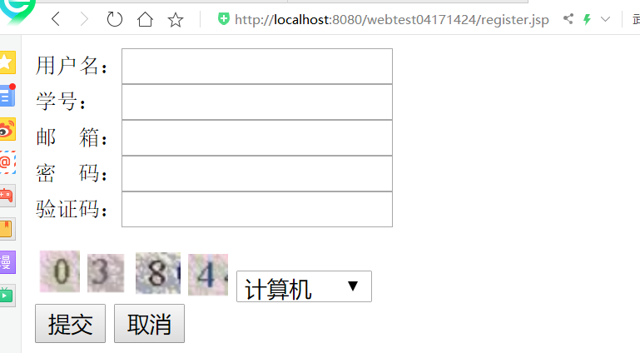

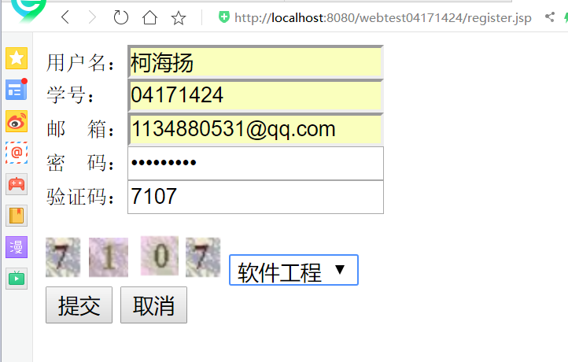

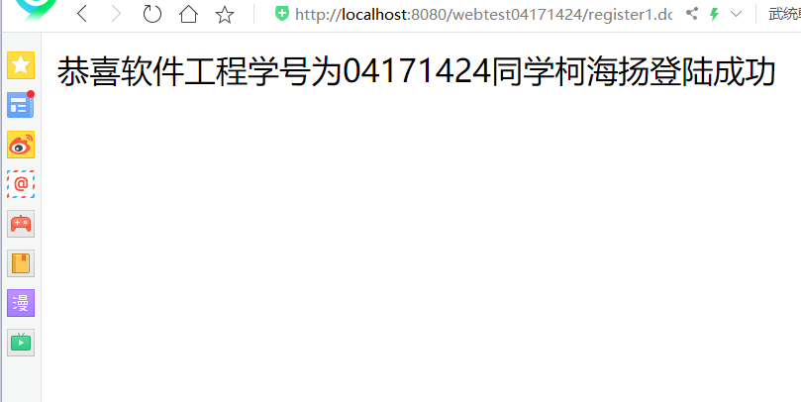

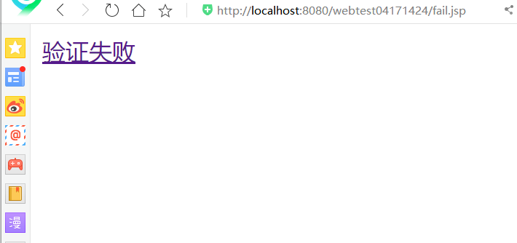

# 收获与问题