## 实验环境

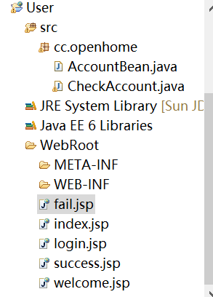

## 二．关键部分（源码）

【AccountBean.java】

**import** java.io.IOException;

**import** javax.servlet.ServletException;

**import** javax.servlet.http.HttpServlet;

**import** javax.servlet.http.HttpServletRequest;

**import** javax.servlet.http.HttpServletResponse;

**import** javax.servlet.http.HttpSession;

**public** **class** CheckAccount **extends** HttpServlet {

**protected** **void** doPost(HttpServletRequest req, HttpServletResponse resp)

**throws** ServletException, IOException {

doGet(req,resp);

}

**public** **void** doGet(HttpServletRequest req, HttpServletResponse resp)

**throws** ServletException, IOException {

HttpSession session = req.getSession();

AccountBean account = **new** AccountBean();

String username = req.getParameter("username");

String pwd = req.getParameter("pwd");

account.setPassword(pwd);

account.setUsername(username);

**if**((username != **null**)&&(username.trim().equals("jsp"))) {

**if**((pwd != **null**)&&(pwd.trim().equals("1"))) {

System.*out*.println("success");

session.setAttribute("account", account);

String login_suc = "success.jsp";

resp.sendRedirect(login_suc);

**return**;

}

}

String login_fail = "fail.jsp";

resp.sendRedirect(login_fail);

**return**;

}

}

【CheckAccount.java】

**import** java.io.IOException;

**import** javax.servlet.ServletException;

**import** javax.servlet.http.HttpServlet;

**import** javax.servlet.http.HttpServletRequest;

**import** javax.servlet.http.HttpServletResponse;

**import** javax.servlet.http.HttpSession;

**public** **class** CheckAccount **extends** HttpServlet {

**protected** **void** doPost(HttpServletRequest req, HttpServletResponse resp)

**throws** ServletException, IOException {

doGet(req,resp);

}

**public** **void** doGet(HttpServletRequest req, HttpServletResponse resp)

**throws** ServletException, IOException {

HttpSession session = req.getSession();

AccountBean account = **new** AccountBean();

String username = req.getParameter("username");

String pwd = req.getParameter("pwd");

account.setPassword(pwd);

account.setUsername(username);

**if**((username != **null**)&&(username.trim().equals("jsp"))) {

**if**((pwd != **null**)&&(pwd.trim().equals("1"))) {

System.*out*.println("success");

session.setAttribute("account", account);

String login_suc = "success.jsp";

resp.sendRedirect(login_suc);

**return**;

}

}

String login_fail = "fail.jsp";

resp.sendRedirect(login_fail);

**return**;

}

}

【login.jsp】

<%@ page language=*"java"* import=*"java.util.*"* pageEncoding=*"ISO-8859-1"*%>

<%

String path = request.getContextPath();

String basePath = request.getScheme()+"://"+request.getServerName()+":"+request.getServerPort()+path+"/";

%>

<!DOCTYPE HTML PUBLIC "-//W3C//DTD HTML 4.01 Transitional//EN">

<html>

<head>

<base href=*"*<%=basePath%>*"*>

<title>My JSP 'login.jsp' starting page</title>

<meta http-equiv=*"pragma"* content=*"no-cache"*>

<meta http-equiv=*"cache-control"* content=*"no-cache"*>

<meta http-equiv=*"expires"* content=*"0"*>

<meta http-equiv=*"keywords"* content=*"keyword1,keyword2,keyword3"*>

<meta http-equiv=*"description"* content=*"This is my page"*>

<!--

<link rel="stylesheet" type="text/css" href="styles.css">

-->

</head>

<body>

<form action=*"login"*>

username:<input type=*"text"* name=*"username"*><br>

password:<input type=*"password"* name=*"pwd"*><br>

<input type=*"submit"*>

</form>

</body>

</html>

【success.jsp】

<%@ page language=*"java"* import=*"java.util.*"* pageEncoding=*"ISO-8859-1"*%>

<%

String path = request.getContextPath();

String basePath = request.getScheme()+"://"+request.getServerName()+":"+request.getServerPort()+path+"/";

%>

<!DOCTYPE HTML PUBLIC "-//W3C//DTD HTML 4.01 Transitional//EN">

<html>

<head>

<base href=*"*<%=basePath%>*"*>

<title>My JSP 'success.jsp' starting page</title>

<meta http-equiv=*"pragma"* content=*"no-cache"*>

<meta http-equiv=*"cache-control"* content=*"no-cache"*>

<meta http-equiv=*"expires"* content=*"0"*>

<meta http-equiv=*"keywords"* content=*"keyword1,keyword2,keyword3"*>

<meta http-equiv=*"description"* content=*"This is my page"*>

<!--

<link rel="stylesheet" type="text/css" href="styles.css">

-->

</head>

<body>

Welcome you!<br/>

</body>

</html>

【fail.jsp】

<%@ page language=*"java"* import=*"java.util.*"* pageEncoding=*"ISO-8859-1"*%>

<%

String path = request.getContextPath();

String basePath = request.getScheme()+"://"+request.getServerName()+":"+request.getServerPort()+path+"/";

%>

<!DOCTYPE HTML PUBLIC "-//W3C//DTD HTML 4.01 Transitional//EN">

<html>

<head>

<base href=*"*<%=basePath%>*"*>

<title>My JSP 'fail.jsp' starting page</title>

<meta http-equiv=*"pragma"* content=*"no-cache"*>

<meta http-equiv=*"cache-control"* content=*"no-cache"*>

<meta http-equiv=*"expires"* content=*"0"*>

<meta http-equiv=*"keywords"* content=*"keyword1,keyword2,keyword3"*>

<meta http-equiv=*"description"* content=*"This is my page"*>

<!--

<link rel="stylesheet" type="text/css" href="styles.css">

-->

</head>

<body>

Login Failed! <br>

</body>

</html>

【welcome.jsp】

<%@ page language=*"java"* contentType=*"text/html; charset=UTF-8"*

pageEncoding=*"UTF-8"*%>

<!DOCTYPE html>

<FORM action=*"Number.jsp"* method=*post* name=*form*>

<html>

<head>

<meta charset=*"UTF-8"*>

<title>猜数游戏</title>

</head>

<body>

<%

**int** n=5;

%>

<P> 请猜一个1到10之间的数：<BR>

<!-- <form method='post' action='RegisterServlet'> -->

<table>

<tr> <td>请输入数字</td>

<td><input type=*'number'* name=*'GuessNum'* > <input type=*"submit"* name=*"submit"* value=*"提交"* />

</td>

</tr>

</table>

<!-- </form> -->

</body>

</html>

【配置web-xml】

<?xml version=*"1.0"* encoding=*"UTF-8"*?>

<web-app version=*"2.5"*

xmlns=*"http://java.sun.com/xml/ns/javaee"*

xmlns:xsi=*"http://www.w3.org/2001/XMLSchema-instance"*

xsi:schemaLocation=*"http://java.sun.com/xml/ns/javaee*

*http://java.sun.com/xml/ns/javaee/web-app_2_5.xsd"*>

<welcome-file-list>

<welcome-file>login.jsp</welcome-file>

</welcome-file-list>

<servlet>

<description>This is the description of my J2EE component</description>

<display-name>This is the display name of my J2EE component</display-name>

<servlet-name>CheckAccount</servlet-name>

<servlet-class>com.ht.servlet.CheckAccount</servlet-class>

</servlet>

<servlet-mapping>

<servlet-name>CheckAccount</servlet-name>

<url-pattern>/login</url-pattern>

</servlet-mapping>

</web-app>

## 三．运行结果

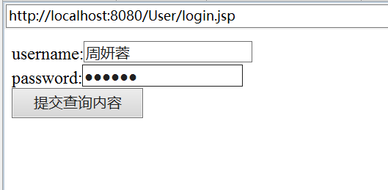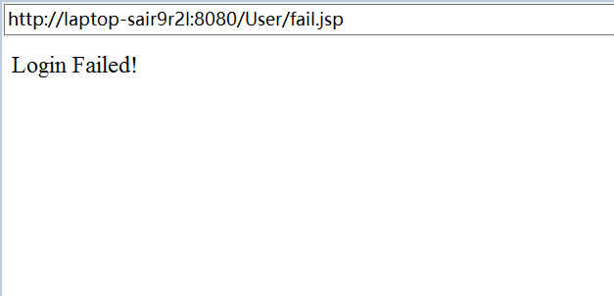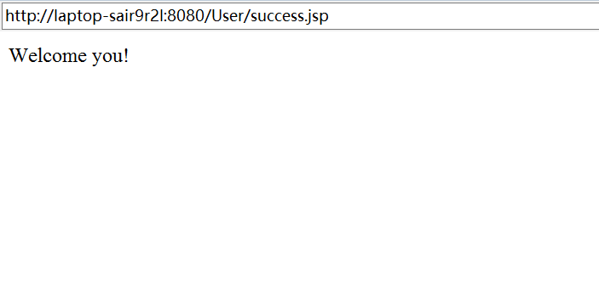

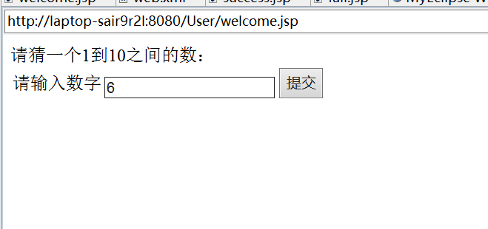

## 四．遇到的问题

1.页面与页面之间跳转不成功

2.猜数字功能和登录功能无法关联