**Login.html代码：**

<!DOCTYPE html>

<html>

<head>

<title>login</title>

<meta charset=*"UTF-8"*>

<meta http-equiv=*"content-type"* contentType=*"text/html; charset=UTF-8"*>

</head>

<body>

<div>

<form action=*"CheckLogin.do"* method=*'post'* name=*form*>

<table border=*"0"* cellspacing=*"5"* cellpadding=*"5"*>

<tr>

<td>UserName:</td>

<td><input type=*"text"* name=*"user"* style="width: *130px*; "> </td>

</tr>

<tr>

<td>Password:</td>

<td><input type=*"password"* name=*"pswd"* style="width: *130px*; "> </td>

</tr>

<tr>

<td>Profession:</td>

<td>

<select name=*"profession"* style="width: *130px*; ">

<option value=*"计算机"*>计算机</option>

<option value=*"软件工程"*>软件工程</option>

<option value=*"网络工程"*>网络工程</option>

</select>

</td>

</tr>

<tr>

<td>AutoLogin:</td>

<td><input type=*"radio"* value=*"1"* id=*"autologin"* name=*"autologin"*></td>

</tr>

<tr>

<td></td>

<td><input type=*"submit"* value=*"login"*></td>

</tr>

</table>

</form>

</div>

</body>

</html>

**页面效果图：**

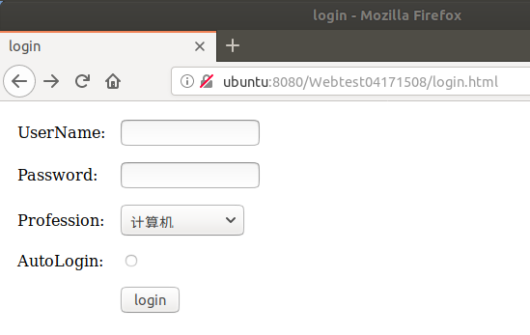

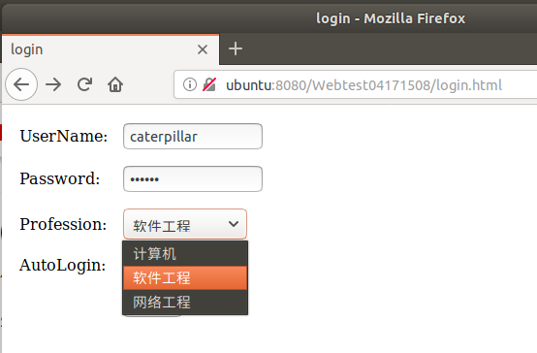

**Login.html点击submit按键时以post方式去请求CheckLogin.java这个Servlet**

**以下为CheckLogin.java的代码：**

package com.exp4;

import java.io.IOException;

import javax.servlet.ServletException;

import javax.servlet.http.Cookie;

import javax.servlet.http.HttpServlet;

import javax.servlet.http.HttpServletRequest;

import javax.servlet.http.HttpServletResponse;

public class CheckLogin extends HttpServlet {

public CheckLogin() {

super();

}

public void destroy() {

super.destroy(); // Just puts "destroy" string in log

// Put your code here

}

public void doPost(HttpServletRequest request, HttpServletResponse response)

throws ServletException, IOException {

request.setCharacterEncoding("utf-8");

String user = request.getParameter("user");

String passwd = request.getParameter("pswd");

if("caterpillar".equals(user)&&"123456".equals(passwd)){

String login = request.getParameter("autologin");

if("1".equals(login)){

Cookie cookie = new Cookie("user", "caterpillar");

cookie.setMaxAge(7 * 24 * 60 * 60);

response.addCookie(cookie);

}

request.setAttribute("user", user);

request.getRequestDispatcher("user.view").forward(request, response);

}

else{

response.sendRedirect("login.html");

}

}

public void init() throws ServletException {

}

}

**以上代码实现对用户以及密码的判断，若都正确可以访问user.java Servlet。**

**访问user.java用的是request.getRequestDispatcher(URL).forward(request, response);方法**

**User.java代码：**

package com.exp4;

import java.io.IOException;

import java.io.PrintWriter;

import javax.servlet.ServletException;

import javax.servlet.http.HttpServlet;

import javax.servlet.http.HttpServletRequest;

import javax.servlet.http.HttpServletResponse;

public class User extends HttpServlet {

protected void processRequest(HttpServletRequest request, HttpServletResponse response)

throws ServletException, IOException{

response.setContentType("text/html;charset=UTF-8");

if(request.getAttribute("user") == null){

response.sendRedirect("login.html");

}

PrintWriter out = response.getWriter();

out.println("<html>");

out.println("<head>");

out.println("<title>Servlet User</title>");

out.println("</head>");

out.println("<body>");

out.println("<h1>Congratulation!</h1>");

out.println("<h1> "+ request.getParameter("profession") +" " +request.getAttribute("user")+" success to login</h1>");

out.println("</body>");

out.println("</html>");

out.close();

}

protected void doGet(HttpServletRequest request, HttpServletResponse response)

throws ServletException, IOException{

processRequest(request, response);

}

protected void doPost(HttpServletRequest request, HttpServletResponse response)

throws ServletException, IOException{

processRequest(request, response);

}

}

**登录成功效果图：**

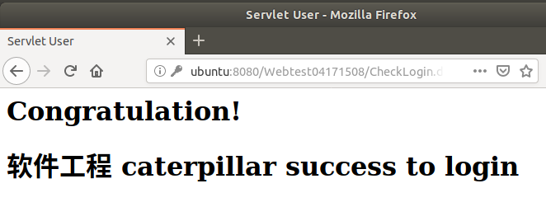

**登陆失败时当输入错误用户名或者错误密码时使用重定向回到login.html。**

**自动登录功能尚未实现**

**验证码功能在另一个界面实现了但未加到本实验中**

**CheckCodeDemo.html代码：**

<html>

<meta charset=*"UTF-8"*>

<head>

<title>js验证码</title>

<style type=*"text/css"*>

*.code*

{

background:*url(code_bg.jpg)*;

font-family:*Arial*;

font-style:*italic*;

color:*blue*;

font-size:*30px*;

border:*0*;

padding:*2px 3px*;

letter-spacing:*3px*;

font-weight:*bolder*;

float:*left*;

cursor:*pointer*;

width:*150px*;

height:*60px*;

line-height:*60px*;

text-align:*center*;

vertical-align:*middle*;

}

**a**

{

text-decoration:*none*;

font-size:*12px*;

color:*#288bc4*;

}

**a***:hover*

{

text-decoration:*underline*;

}

</style>

<script type=*"text/javascript"*>

**var** code;

**function** createCode() //create the check code

{

code = "";

**var** codeLength = 6; //验证码的长度

**var** checkCode = document.getElementById("checkCode");

**var** codeChars = **new** Array(0, 1, 2, 3, 4, 5, 6, 7, 8, 9,

'a','b','c','d','e','f','g','h','i','j','k','l','m','n','o','p','q','r','s','t','u','v','w','x','y','z',

'A', 'B', 'C', 'D', 'E', 'F', 'G', 'H', 'I', 'J', 'K', 'L', 'M', 'N', 'O', 'P', 'Q', 'R', 'S', 'T', 'U', 'V', 'W', 'X', 'Y', 'Z'); //所有候选组成验证码的字符，当然也可以用中文的

**for**(**var** i = 0; i < codeLength; i++)

{

**var** charNum = Math.floor(Math.random() * 52); //Math.floor() 返回小于或等于一个给定数字的最大整数。

code += codeChars[charNum];

}

**if**(checkCode)

{

checkCode.className = "code";

checkCode.innerHTML = code;

}

}

**function** validateCode() //check the code is correct or not

{

**var** inputCode=document.getElementById("inputCode").value;

**if**(inputCode.length <= 0)

{

alert("请输入验证码！");

}

**else if**(inputCode.toUpperCase() != code.toUpperCase())

{

alert("验证码输入有误！");

createCode();

}

**else**

{

alert("验证码正确！");

}

}

</script>

</head>

<body onload="createCode()">

<form id=*"form1"* runat=*"server"* onsubmit="validateCode()">

<div>

<table border=*"0"* cellspacing=*"5"* cellpadding=*"5"* >

<tr>

<td></td>

<td><div class=*"code"* id=*"checkCode"* onclick="createCode()" ></div></td>

<td><a href=*"#"* onclick="createCode()">看不清换一张</a></td> <!-- 如果希望点了以后不跳转留在当前页面 就是点了没反应 写成 href="#", 不要写成 href=""，这样点击后会打开本地文件夹 -->

</tr>

<tr>

<td>验证码：</td>

<td><input style="float:*left*;" type=*"text"* id=*"inputCode"* /></td>

<td>请输入验证码</td>

</tr>

<tr>

<td></td>

<td><input id=*"Button1"* onclick="validateCode();" type=*"button"* value=*"确定"* /></td>

<td></td>

</tr>

</table>

</div>

</form>

</body>

</html>

**页面效果图：**

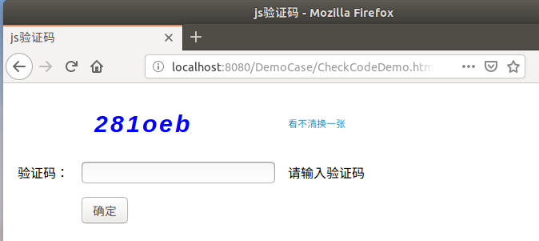

**未输入效果图：**

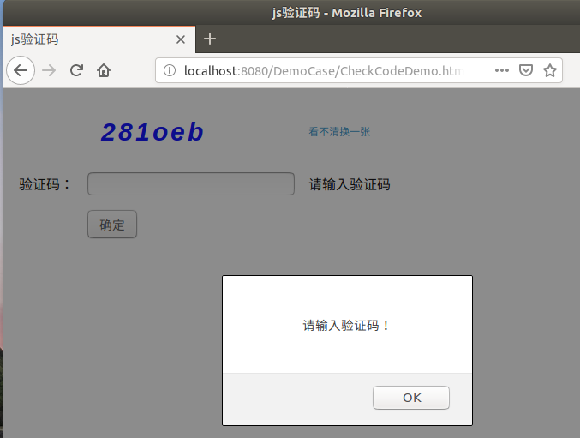

**输入错误效果图：**



**输入正确效果图：**

