**Java Web开发**

**实验四**

**作业报告**

|  |  |
| --- | --- |
| 学 院 | 计算机 |
| 所在系 班 级 | 2017软件工程系08班 |
| 学 号 姓 名 | 04171601刘嘉威 |
| 指 导 教 师 | 郭晓燕 |
| 完 成 时 间 | 2018年4月7日 |

# 实验题目

、将第二章实训题的第二题，登录页面，提交用户名、密码，若用户名不为空字符串且长度在6-8位间，密码不为，空长度为6位，则登录成功，显示“***（用户名）登录成功！”，否则显示“***登录失败”。

# 分析与设计

# 关键源码（部分）

**-----------------login--------------------------**

**public** **void** doPost(HttpServletRequest request, HttpServletResponse response)

**throws** ServletException, IOException {

response . setContentType ("text/html; charset=UTF-8");

PrintWriter out = response.getWriter();

request.setCharacterEncoding("UTF-8");

out.println("<FORM method=post>"

+ "<style> p{line-height:8px} </style>"

+ "<html><head>"

+ "<title>窗体网页-登陆</title></head>"

+ "<body bgcolor=cyan><font size=8>"

+ "<h1>请输入以下信息：</h1>"

+ "<p><font size=4>请输入您的用户名：<input type = \"text\" name =\"name\" value=\"\"></br>"

+ "<p>请输入您的密码：</font><input type = \"password\" name =\"key\" value=\"\"></br>"

+ "<input type=\"submit\" value=\"提交\" name=\"submit\">"

+ "</form></font></body></html>"

);

**if**(request.getParameter("name").length()<6||request.getParameter("name").length()>8

||request.getParameter("name")==**null**

||request.getParameter("key").length()!=6)//此处判断输入用户名的长度和是否为空，和密码的长度是否为6位

request.getRequestDispatcher("failed_page").forward(request, response);

**else**

{

request.getRequestDispatcher("success_page").forward(request, response);

System.*out*.println(request.getParameter("name")+request.getParameter("key"));

}

out.flush();

out.close();

}

**-----------------success_page------**

**public** **void** doPost(HttpServletRequest request, HttpServletResponse response)

**throws** ServletException, IOException {

response . setContentType ("text/html; charset=UTF-8");

PrintWriter out = response.getWriter();

out.println("<FORM method=post> <HTML>");

out.println(" <HEAD><TITLE>success</TITLE></HEAD>");

out.println(" <BODY>");

out.println("<html>"

+ "<body bgcolor=cyan><font size=8>"

+ "<td style=\"text-align:center\">登陆成功</td></font>");

out.println("<h1> "+request.getParameter("name")+"你好! !</h1>"); //读取用户名

out.println(" </BODY>");

out.println("</form></HTML>");

out.flush();

out.close();

}

**-----------------failed_page------**

**public** **void** doPost(HttpServletRequest request, HttpServletResponse response)

**throws** ServletException, IOException {

response . setContentType ("text/html; charset=UTF-8");

PrintWriter out = response.getWriter();

out.println("<HTML>");

out.println(" <HEAD><TITLE>failed</TITLE></HEAD>");

out.println(" <BODY bgcolor=cyan>"

+ "<font size=7> <td style=\"text-align:center\">登陆失败</td></font>"

+ "<a href=\"login\">回到首页</a>");

out.println(" </BODY>");

out.println("</HTML>");

out.flush();

out.close();

}

# 运行效果图

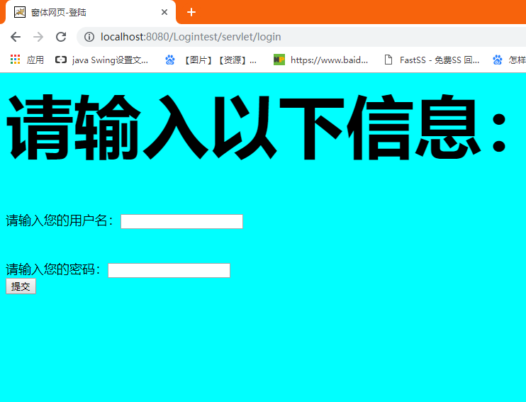

**登录界面**

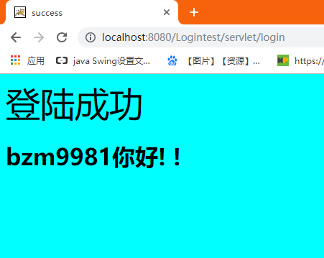

**登录成功的提示**

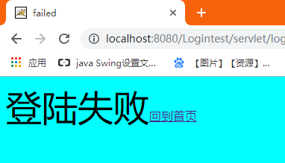

**登录失败的提示**

# 收获与问题