**Java Web开发**

**实验一**

**作业报告**

|  |  |
| --- | --- |
| 学 院 | 计算机 |
| 所在系 班 级 | 2017软件工程系8班 |
| 学 号 姓 名 |  |
| 指 导 教 师 | 郭晓燕 |
| 完 成 时 间 |  |

# 实验题目

# 分析与设计

分析：加个重定向方法

# 关键源码（部分）

loginServlet.java

package LoginServlet;

import java.io.IOException;

import java.io.PrintWriter;

import javax.servlet.ServletException;

import javax.servlet.annotation.WebServlet;

import javax.servlet.http.HttpServlet;

import javax.servlet.http.HttpServletRequest;

import javax.servlet.http.HttpServletResponse;

@WebServlet("login.do")

public class loginServlet extends HttpServlet {

private final String SUCCESS_VIEW="success.jsp";

private final String FAIL_VIEW="fail.jsp";

public void doPost(HttpServletRequest request, HttpServletResponse response) throws ServletException, IOException {

request.setCharacterEncoding("utf-8");

String number=request.getParameter("number");

String name=request.getParameter("name");

String password=request.getParameter("pwd");

String major=request.getParameter("major");

String error = null;

if(isInvalidName(name)&&isInvalidNumber(number)&&isInvalidPassword(password))

request.getRequestDispatcher(SUCCESS_VIEW).forward(request, response);

else{

response.sendRedirect(FAIL_VIEW);

}

}

private boolean isInvalidName(String name){

return name!=null&&name.equals("xiaoming");

}

private boolean isInvalidNumber(String number){

return number!=null&&number.equals("04170101");

}

private boolean isInvalidPassword(String pwd){

return pwd!=null&&pwd.equals("123456");

}

}

login.jsp

<%@ page language=*"java"* import=*"java.util.*"* pageEncoding=*"UTF-8"*%>

<!DOCTYPE HTML PUBLIC "-//W3C//DTD HTML 4.01 Transitional//EN">

<html>

<head>

<h1>登录页面</h1>

</head>

<body bgcolor=*"#00FFFF"*>

<form action=*"login.do"* method=*"post"*>

用户名:

<input type=*"text"* name=*"number"*>(备注:学号)<br><br>

姓&nbsp;&nbsp;&nbsp;&nbsp;名:

<input type=*"text"* name=*"name"*><br><br>

密&nbsp;&nbsp;&nbsp;&nbsp;码:

<input type=*"password"* name=*"pwd"*><br><br>

专&nbsp;&nbsp;&nbsp;&nbsp;业:

<select name=*"major"*>

<option value=*"计算机"*>计算机</option>

<option value=*"软件工程"*>软件工程</option>

<option value=*"网络工程"*>网络工程</option>

</select>

<br><br>

<input type=*"submit"* value=*"登录"*><br><br>

</form>

</body>

</html>

success.jsp

<%@ page language=*"java"* import=*"java.util.*"* pageEncoding=*"UTF-8"*%>

<!DOCTYPE HTML PUBLIC "-//W3C//DTD HTML 4.01 Transitional//EN">

<html>

<body>

<Font size=*8*> <a href=*"login.jsp"*>回到登录页面</a>

<% request.setCharacterEncoding("utf-8");

String yourMajor=request.getParameter("major");

String yourName=request.getParameter("name");

String yourNumber=request.getParameter("number");

out.println("<br>");

out.println(yourMajor+"专业"+" "+yourNumber+" "+yourName);

out.println("恭喜你登录成功");

%>

</body>

</html>

fail.jsp

<%@ page language=*"java"* import=*"java.util.*"* pageEncoding=*"UTF-8"*%>

<!DOCTYPE HTML PUBLIC "-//W3C//DTD HTML 4.01 Transitional//EN">

<html>

<body>

<Font size=*8*> <a href=*"login.jsp"*>返回登录页面</a>

<% request.setCharacterEncoding("utf-8");

out.println("<br>");

out.println("登录失败!");

%>

</body>

</html>

# 运行效果图

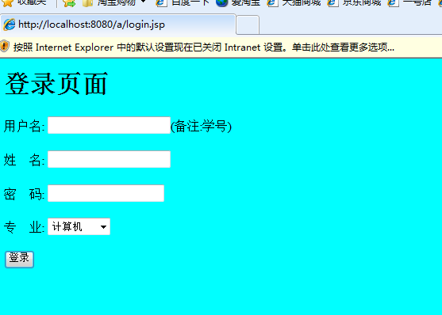

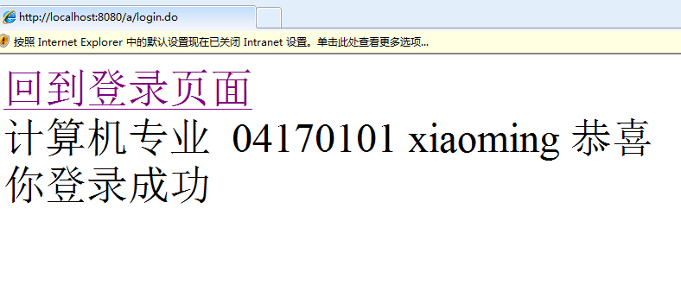

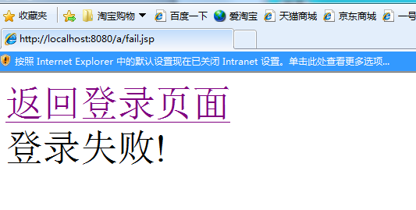

# 收获与问题

response.sendRedirect();

这个是重定向方法