**Java Web开发**

**实验四**

**作业报告**

|  |  |
| --- | --- |
| 学院 | 计算机 |
| 所在系班级 | 2017软件工程系8班 |
| 学号姓名 | 04171627柯晓君 |
| 指导教师 | 郭晓燕 |
| 完成时间 | 2019年3月20日 |

# 实验题目

生成动态验证码图片进行注册

# 分析与设计

# 关键源码

package cc;

import java.io.IOException;

import javax.servlet.ServletException;

import javax.servlet.annotation.WebServlet;

import javax.servlet.http.HttpServlet;

import javax.servlet.http.HttpServletRequest;

import javax.servlet.http.HttpServletResponse;

import javax.servlet.http.HttpSession;

/**

* Servlet implementation class registerEX

*/

@WebServlet("/registerEX")

public class registerEX extends HttpServlet {

protected void doGet(HttpServletRequest request, HttpServletResponse response) throws ServletException, IOException {

}

protected void doPost(HttpServletRequest request, HttpServletResponse response) throws ServletException, IOException {

request.setCharacterEncoding("utf-8");

String yourEmail=request.getParameter("EmailName");

String yourName=request.getParameter("name");

String yourClass=request.getParameter("class");

HttpSession session=request.getSession();

if("".equals(yourName)||"".equals(yourEmail))

{

request.getRequestDispatcher("fail.jsp").forward(request, response);

}

else {

session.setAttribute("StudentEmailNumber", yourEmail);

session.setAttribute("StudentName", yourName);

session.setAttribute("StudentClass", yourClass);

response.sendRedirect("success.jsp");

}

}

}

# 运行效果图

注册登录页面;

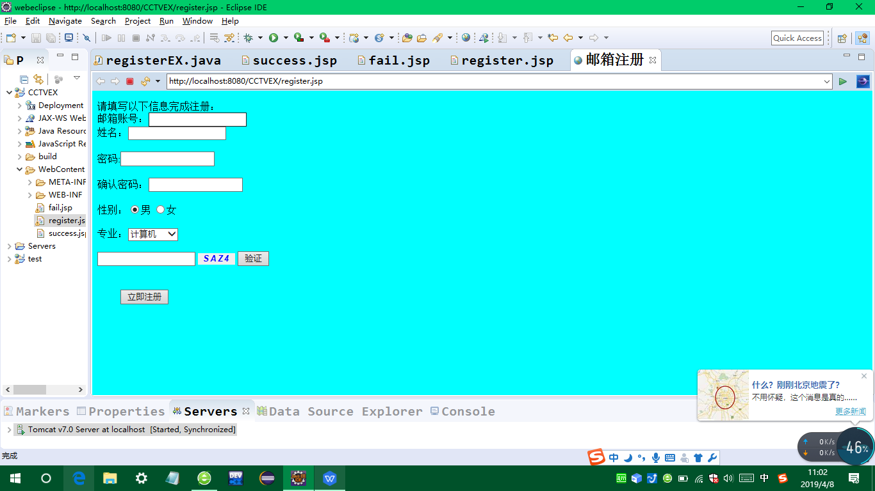

失败页面

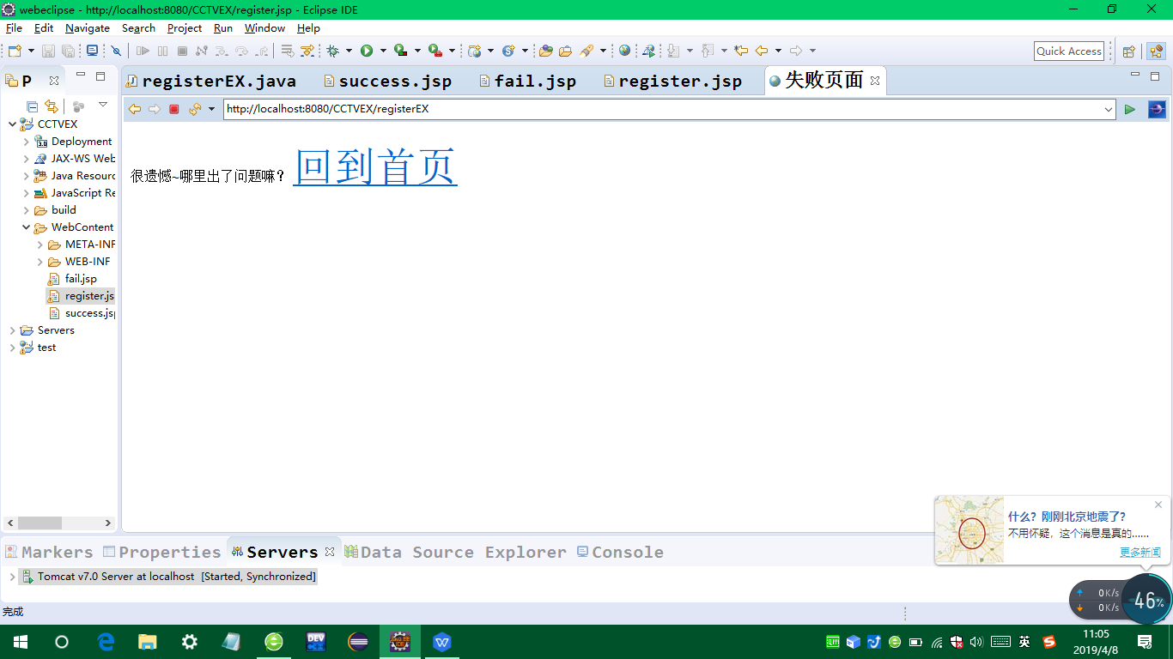

成功页面：

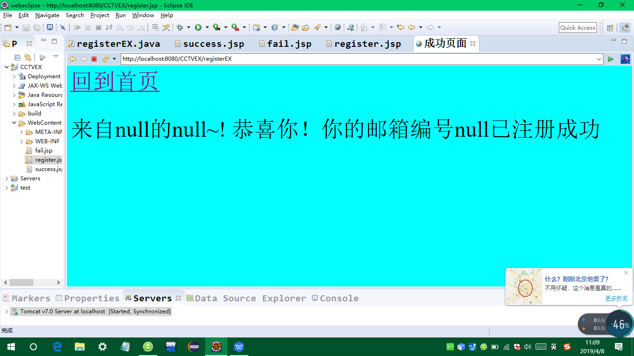

# 收获与问题