**Java Web开发**

**实验五**

**作业报告**

|  |  |
| --- | --- |
| 学 院 | 计算机 |
| 所在系 班 级 | 2017软件工程系5班 |
| 学 号 姓 名 | 04171306叶铭浩 |
| 指 导 教 师 | 郭晓燕 |
| 完 成 时 间 | 2019年4月6日- |

# 实验题目

第四章课后练习3购物车，实现一个购物车应用程序，可以购物，显示购物数量并查看购物车内容。（此题模版test4E，提供给大家参考。）

提示：采购此书做成超链接，并用URL重写带关键信息

* 1. Shopping.view?bookID=‘0001’，其中0001是你选中图书对应的ID号，每点击一次就在相应的购书数量上加一，并返回当前的选购页面。
  2. 除了要保存图书的ID号、书名，还要保存购书数量，所以session对象保存的信息需要考虑清楚，最好是一个对象数组或列表。

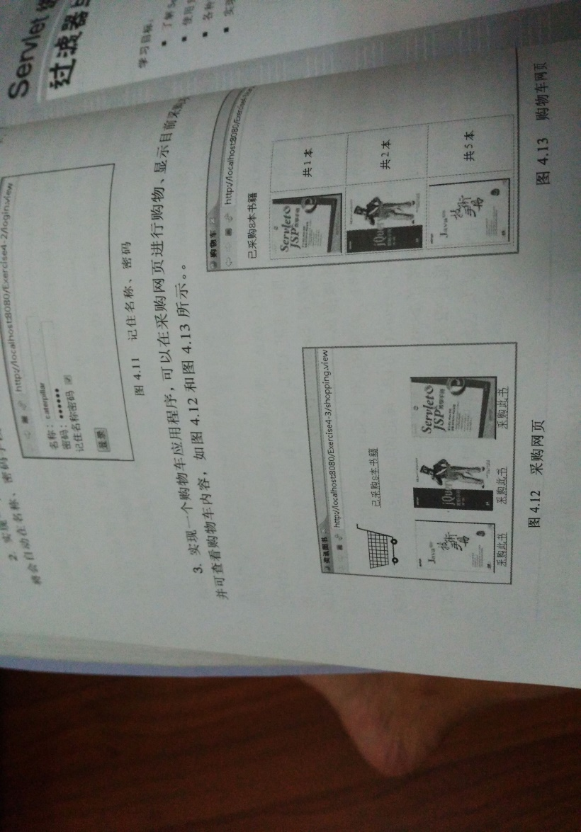

购物车的效果图

# 分析与设计

Jsp发送数据时，通过session的URL重定向交给Servlet处理，再将处理的数据发送给jsp，页面产生变化。

# 关键源码（部分）

1. Book.java

**package** com.exl_4;  
  
*/**  
 \** ***@author*** *U12  
 \** ***@data*** *2019/4/8 - 11:28  
 */***public class** Book {  
 **private** String **BookID**;  
  
 **private** String **BookName**;  
  
 **private** String **BookImg**;  
  
 **private int BookSum**;  
  
 **public** Book(String bookID,String bookName,String bookImg,**int** bookSum){  
 setBookID(bookID);  
 setBookName(bookName);  
 setBookImg(bookImg);  
 setBookSum(bookSum);  
 }  
  
 **public** String getBookID() {  
 **return BookID**;  
 }  
  
 **public void** setBookID(String bookID) {  
 **BookID** = bookID;  
 }  
  
 **public** String getBookName() {  
 **return BookName**;  
 }  
  
 **public void** setBookName(String bookName) {  
 **BookName** = bookName;  
 }  
  
 **public** String getBookImg() {  
 **return BookImg**;  
 }  
  
 **public void** setBookImg(String bookImg) {  
 **BookImg** = bookImg;  
 }  
  
 **public int** getBookSum() {  
 **return BookSum**;  
 }  
  
 **public void** setBookSum(**int** bookSum) {  
 **BookSum** = bookSum;  
 }  
}

1. Shopping.jsp

<%@ **page contentType**="**text/html;charset=UTF-8**" **language**="**java**" %>  
<%@ **page import**="**com.exl_4.Book**" %>  
<**html**>  
<**head**>  
 <**title**>二狗子的书店</**title**>  
</**head**>  
  
<**body**>  
 **<%  
 if**(session.getAttribute(**"bookList"**)==**null**){  
 Book[] BookList = **new** Book[3];  
 BookList[0] = **new** Book(**"0001"**,**"演员的自我修养"**,**"img\\book1.jpg"**,0);  
 BookList[1] = **new** Book(**"0002"**,**"大头儿子和小头爸爸"**,**"img\\book2.jpg"**,0);  
 BookList[2] = **new** Book(**"0003"**,**"javaweb技术"**,**"img\\book3.jpg"**,0);  
  
 session.setAttribute(**"bookList"**,BookList);  
 session.setAttribute(**"sum"**,0);  
 }  
 **%>** <**div id="Container"**>  
 <**div id="header"**>  
 *<%--<div id="left">--%>  
 <%--<img src="img\ShopCar.jpg" height="60px" width="60px">--%>  
 <%--</div>--%>* <**div id="right"**>  
 <**img src="img\ShopCar.jpg" height="120px" width="120px"**>  
 <**a href="card.jsp"**>已采购**<%=**session.getAttribute(**"sum"**) **%>**本书籍</**a**>  
 </**div**>  
 </**div**>  
 <**div id="main"**>  
 <**table border="1"**><**img width=""  
 <%** Book[] booklist=(Book[])session.getAttribute(**"bookList"**);  
 **for** (Book book : booklist) {  
 out.println(**"<tr>"**);  
 out.println(**"<td> <img width='240px' height='240px' src='"**+book.getBookImg()+**"'></td>"**);  
*// out.println("<td> <a href='shopping.view?id=\"0001\"'>采购此书</a></td>");* out.println(**"<td> <a href='shopping.view?id="**+book.getBookID()+**"'>采购此书</a></td>"**);  
 out.println(**"</tr>"**);  
 }  
 **%>** </**table**>  
 </**div**>  
 </**div**>  
  
</**body**>  
</**html**>

1. Shoppingservlet.java (shopping.view)

**package** com.exl_4;  
  
**import** javax.servlet.ServletException;  
**import** javax.servlet.annotation.WebServlet;  
**import** javax.servlet.http.HttpServlet;  
**import** javax.servlet.http.HttpServletRequest;  
**import** javax.servlet.http.HttpServletResponse;  
**import** javax.servlet.http.HttpSession;  
**import** java.io.IOException;  
**import** java.io.PrintWriter;  
  
*/**  
 \** ***@author*** *U12  
 \** ***@data*** *2019/4/8 - 11:30  
 */*@WebServlet(name = **"ShoppingServlet"**)  
**public class** ShoppingServlet **extends** HttpServlet {  
 **protected void** doPost(HttpServletRequest request, HttpServletResponse response) **throws** ServletException, IOException {  
  
 }  
  
 **protected void** doGet(HttpServletRequest request, HttpServletResponse response) **throws** ServletException, IOException {  
 response.setContentType(**"text/html;charset=UTF-8"**);  
 String id=(String) request.getParameter(**"id"**);  
 HttpSession session=request.getSession();  
  
 PrintWriter out = response.getWriter();  
  
 Book[] bookList=(Book[]) session.getAttribute(**"bookList"**);  
 **int** sum=(**int**)session.getAttribute(**"sum"**);  
 **for** (Book book : bookList) {  
 **if**(book.getBookID().equals(id)){  
 **int** bookSum=book.getBookSum()+1;  
 book.setBookSum(bookSum);  
 sum++;  
 }  
 }  
  
 session.setAttribute(**"bookList"**,bookList);  
 session.setAttribute(**"sum"**,sum);  
*// request.getRequestDispatcher("shopping.jsp").forward(request,response);* response.sendRedirect(**"shopping.jsp"**);  
 }  
}

*4.Card.jsp*<%@ **page import**="**com.exl_4.Book**" %>*<%--  
 Created by IntelliJ IDEA.  
 User: asus  
 Date: 2019/4/8  
 Time: 10:26  
 To change this template use File | Settings | File Templates.  
--%>*<%@ **page contentType**="**text/html;charset=UTF-8**" **language**="**java**" %>  
<**html**>  
<**head**>  
 <**title**>购物车</**title**>  
</**head**>  
<**body**>  
  
<**div id="Container"**>  
 <**div id="header"**>  
 <**div id="right"**>  
 <**a href="shopping.jsp"**>已采购**<%=**session.getAttribute(**"sum"**) **%>**本书籍</**a**>  
 </**div**>  
 </**div**>  
 <**div id="main"**>  
 <**table border="1"**>  
 **<%** Book[] booklist=(Book[])session.getAttribute(**"bookList"**);  
 **for** (Book book : booklist) {  
 **if**(book.getBookSum()!=0){  
 out.println(**"<tr>"**);  
 out.println(**"<td> <img width='240px' height='240px' src='"**+book.getBookImg()+**"'></td>"**);  
*// out.println("<td> <a href='shopping.view?id=\"0001\"'>采购此书</a></td>");* out.println(**"<td> <p>共"**+ book.getBookSum() +**"本</td>"**);  
 out.println(**"<td> <a href='card.view?id="**+book.getBookID()+**"'>减少一本</a></td>"**);  
 out.println(**"</tr>"**);  
 }  
  
 }  
 **%>** </**table**>  
 </**div**>  
</**body**>  
</**html**>

5.cardServlet.java(card.view)

**package** com.exl_4;  
  
**import** javax.servlet.ServletException;  
**import** javax.servlet.annotation.WebServlet;  
**import** javax.servlet.http.HttpServlet;  
**import** javax.servlet.http.HttpServletRequest;  
**import** javax.servlet.http.HttpServletResponse;  
**import** javax.servlet.http.HttpSession;  
**import** java.io.IOException;  
**import** java.io.PrintWriter;  
  
*/**  
 \** ***@author*** *U12  
 \** ***@data*** *2019/4/8 - 11:31  
 */*@WebServlet(name = **"CardServlet"**)  
**public class** CardServlet **extends** HttpServlet {  
 **protected void** doPost(HttpServletRequest request, HttpServletResponse response) **throws** ServletException, IOException {  
  
 }  
  
 **protected void** doGet(HttpServletRequest request, HttpServletResponse response) **throws** ServletException, IOException {  
 response.setContentType(**"text/html;charset=UTF-8"**);  
 String id=(String) request.getParameter(**"id"**);  
 HttpSession session=request.getSession();  
  
 PrintWriter out = response.getWriter();  
  
 Book[] bookList=(Book[]) session.getAttribute(**"bookList"**);  
 **int** sum=(**int**)session.getAttribute(**"sum"**);  
 **for** (Book book : bookList) {  
 **if**(book.getBookID().equals(id)){  
 **int** bookSum=book.getBookSum()-1;  
 book.setBookSum(bookSum);  
 sum--;  
 }  
 }  
  
 session.setAttribute(**"bookList"**,bookList);  
 session.setAttribute(**"sum"**,sum);  
*// request.getRequestDispatcher("shopping.jsp").forward(request,response);* response.sendRedirect(**"card.jsp"**);  
 }  
}

6.web.xml

*<?***xml version="1.0" encoding="UTF-8"***?>*<**web-app xmlns="http://xmlns.jcp.org/xml/ns/javaee"  
 xmlns:xsi="http://www.w3.org/2001/XMLSchema-instance"  
 xsi:schemaLocation="http://xmlns.jcp.org/xml/ns/javaee http://xmlns.jcp.org/xml/ns/javaee/web-app_4_0.xsd"  
 version="4.0"**>  
 <**servlet**>  
 <**servlet-name**>shop</**servlet-name**>  
 <**servlet-class**>com.exl_4.ShoppingServlet</**servlet-class**>  
 <**load-on-startup**>1</**load-on-startup**>  
 </**servlet**>  
 <**servlet-mapping**>  
 <**servlet-name**>shop</**servlet-name**>  
 <**url-pattern**>/shopping.view</**url-pattern**>  
 </**servlet-mapping**>  
  
  
  
 <**servlet**>  
 <**servlet-name**>card</**servlet-name**>  
 <**servlet-class**>com.exl_4.CardServlet</**servlet-class**>  
 <**load-on-startup**>1</**load-on-startup**>  
 </**servlet**>  
 <**servlet-mapping**>  
 <**servlet-name**>card</**servlet-name**>  
 <**url-pattern**>/card.view</**url-pattern**>  
 </**servlet-mapping**>  
</**web-app**>

# 运行效果图

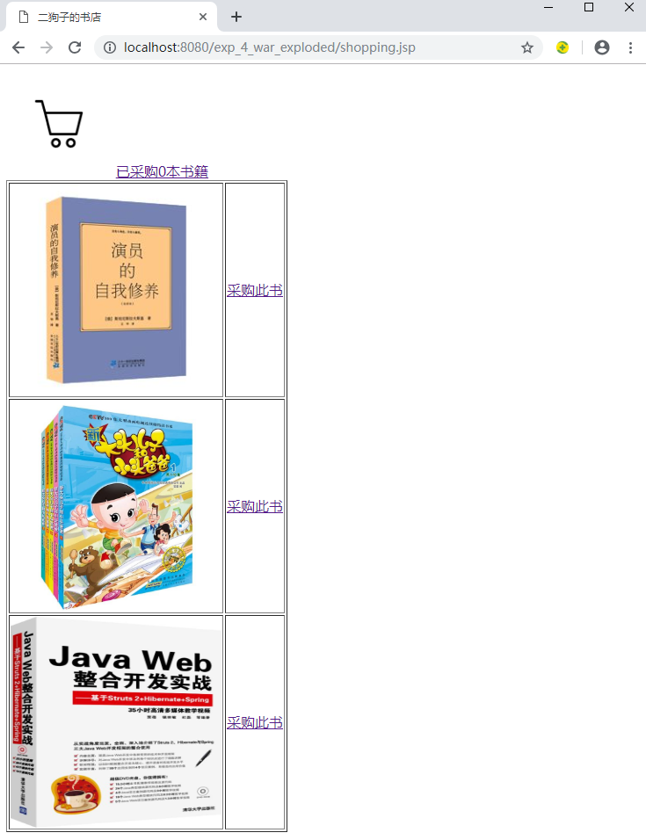

点击采购此书，session中存储的booklist数组中对应的book的booksum--，并且session存储的全部书数量的sum也--

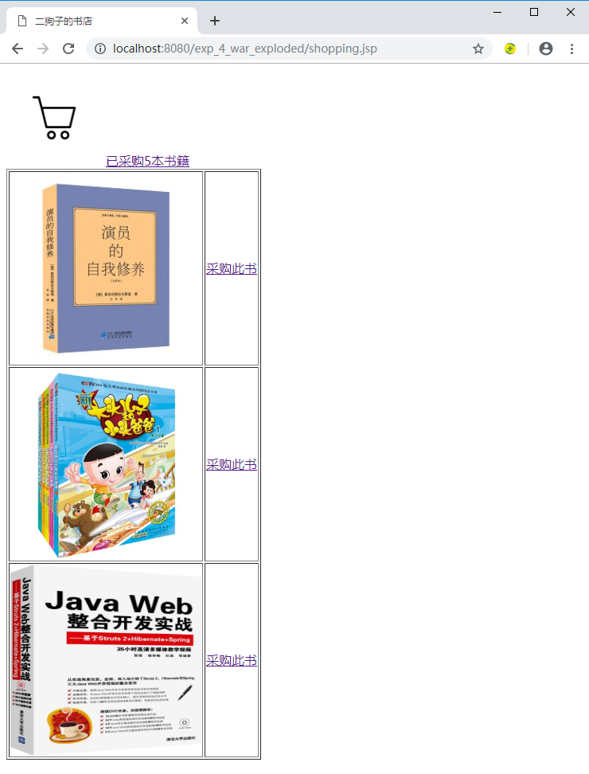

点击购物车，显示购买的书的数量以及购买的总数

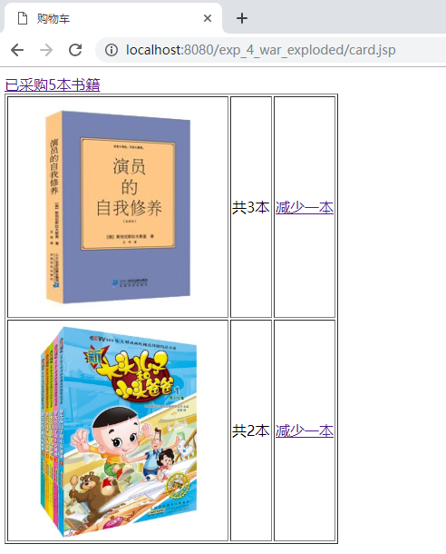

点击减少一本，session中存储的booklist数组中对应的book的booksum--，并且session存储的全部书数量的sum也--

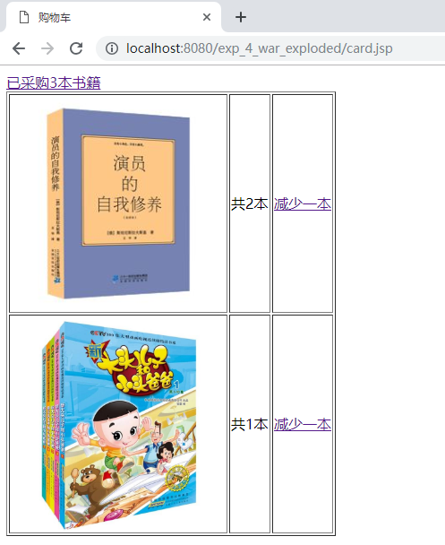

最后可以点击最上面的超链接回到原来的页面

# 收获与问题

学会了session中存储数据，延长了数据的生命周期。实现了页面的互动。