**Java Web开发**

**实验五 作业报告**

|  |  |
| --- | --- |
| 学 院 | 计算机 |
| 所在系 班 级 | 2017软件工程系5班 |
| 学 号 姓 名 | 04171312谭兆 |
| 指 导 教 师 | 郭晓燕 |
| 完 成 时 间 | 2019年4月-14 |

# 实验题目

# 分析与设计

# 关键源码（部分）

<%@ page language=*"java"* import=*"java.util.*"* pageEncoding=*"UTF-8"*%>

<%

String path = request.getContextPath();

String basePath = request.getScheme() + "://"

+ request.getServerName() + ":" + request.getServerPort()

+ path + "/";

%>

<!DOCTYPE html>

<html lang=*"zh-CN"*>

<head>

<link rel=*"stylesheet"* href=*"//cdn.bootcss.com/bootstrap/3.3.5/css/bootstrap.min.css"*>

<link rel=*"stylesheet"* href=*"//cdn.bootcss.com/bootstrap/3.3.5/css/bootstrap-theme.min.css"*>

<script src=*"//cdn.bootcss.com/jquery/1.11.3/jquery.min.js"*></script>

<script src=*"//cdn.bootcss.com/bootstrap/3.3.5/js/bootstrap.min.js"*></script>

<meta charset=*"UTF-8"*>

<meta http-equiv=*"X-UA-Compatible"* content=*"IE=Edge"*>

<meta name=*"viewport"* content=*"width=device-width, initial-scale=1"*>

<title>login</title>

<link rel=*"stylesheet"* href=*"*<%=basePath %>*/css/bootstrap.css"*>

<link rel=*"stylesheet"* href=*"*<%=basePath %>*/css/login.css"*>

</head>

<body>

<div class=*"modal show"* id=*"loginModal"*>

<div class=*"modal-dialog"*>

<div class=*"modal-content"*>

<div class=*"modal-header"*>

<button type=*"button"* class=*"close"*>&times;</button>

<h1 class=*"text-center text-primary"*>用户登录</h1>

</div>

<div class=*"modal-body"*>

<form class=*"form col-md-12 center-block"* id=*"loginForm"* action=*"logincontroll.do"* method=*"post"*>

<div class=*"form-group-lg"* id=*"accountDiv"*>

<label class=*"sr-only"* for=*"inputAccount"*>账号</label>

<div class=*"input-group"*>

<div class=*"input-group-addon"*><span class=*"glyphicon glyphicon-user"* aria-hidden=*"true"*></span></div>

<input class=*"form-control"* id=*"inputAccount"* name=*"accountNo"* type=*"text"* placeholder=*"账号"* required autofocus>

</div>

<div class=*"hidden text-center"* id=*"accountMsg"*><span class=*"glyphicon glyphicon-exclamation-sign"*></span>用户名不存在</div>

</div>

<br>

<div class=*"form-group-lg"* id=*"pwdDiv"*>

<label class=*"sr-only"* for=*"inputPassword"*>密码</label>

<div class=*"input-group"*>

<div class=*"input-group-addon"*><span class=*"glyphicon glyphicon-lock"*></span></div>

<input class=*"form-control"* id=*"inputPassword"* name=*"pwd"* type=*"password"* placeholder=*"密码"* required>

<div class=*"input-group-addon"*><span class=*"glyphicon glyphicon-eye-open"*></span></div>

</div>

<div class=*"hidden text-center"* id=*"pwdMsg"*><span class=*"glyphicon glyphicon-exclamation-sign"*></span>用户名密码错误</div>

</div>

<div class=*"checkbox"*>

<label> <input type=*"checkbox"* value=*"remember-me"*>记住我</label>

</div>

<div class=*"form-group"*>

>

<button class=*"btn btn-default btn-lg col-md-6"* id=*"btn_register"* type=*"submit"*>登录</button>

</div>

</form>

</div>

<div class=*"modal-footer"*>

</div>

</div>

</div>

</div>

<!-- /container -->

</body>

</html>

import java.io.IOException;

import javax.servlet.ServletException;

import javax.servlet.http.HttpServlet;

import javax.servlet.http.HttpServletRequest;

import javax.servlet.http.HttpServletResponse;

import com.domain.Book;

import com.domain.Cart;

import com.service.BusinessService;

//完成书籍购买

//完成书籍购买

public class BuyServlet extends HttpServlet {

 public void doGet(HttpServletRequest request, HttpServletResponse response)

  throws ServletException, IOException {

 String id = request.getParameter("id");

 BusinessService service = new BusinessService();

 Book book = service.findBook(id);

 //得到用户的购物车

 Cart cart = (Cart) request.getSession().getAttribute("cart");

 if(cart==null){

  cart = new Cart();

  request.getSession().setAttribute("cart", cart);

 }

 //把书加到用户购物车中,完成购买

 cart.add(book);

 //response.sendRedirect("/WEB-INF/jsp/listcart.jsp");

 request.getRequestDispatcher("/WEB-INF/jsp/listcart.jsp").forward(request, response);

 }

 public void doPost(HttpServletRequest request, HttpServletResponse response)

  throws ServletException, IOException {

 doGet(request, response);

 }

}

# 运行效果图

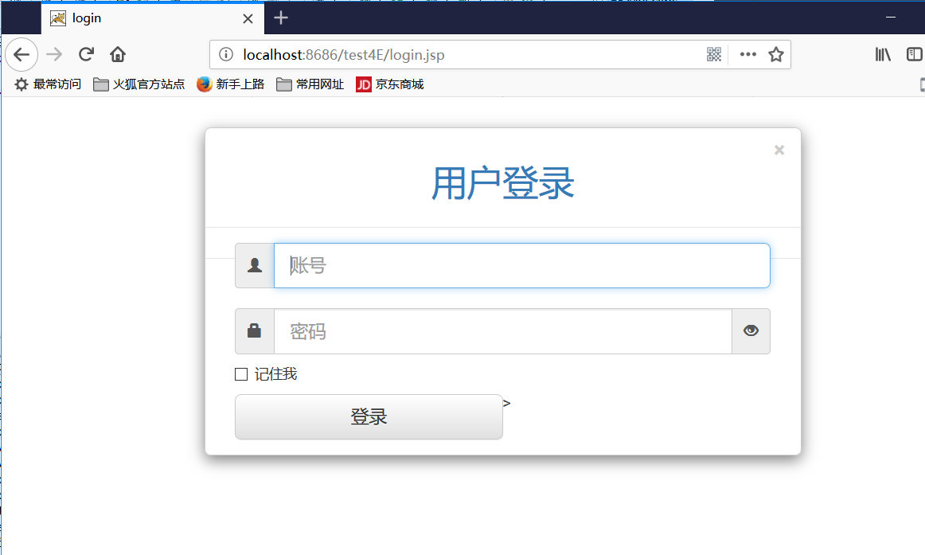

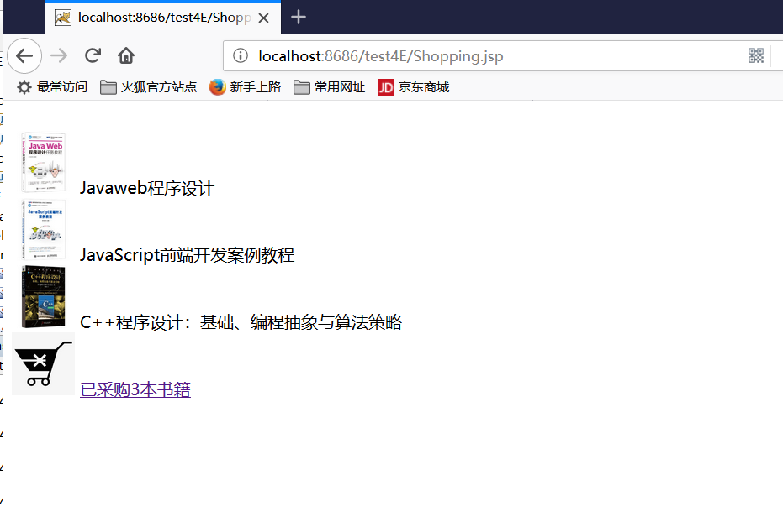

# 收获与问题

谈一谈你在本实验中所收获的内容及问题。