**Java Web开发**

**实验五**

**作业报告**

|  |  |
| --- | --- |
| 学 院 | 计算机 |
| 所在系 班 级 | 2017软件工程系14班 |
| 学 号 姓 名 | 04171327 |
| 指 导 教 师 | 罗永生 |
| 完 成 时 间 | 2019年4月- |

# 实验题目

一）必做。

* 第四章课后练习3购物车，实现一个购物车应用程序，可以购物，显示购物数量并查看购物车内容。（此题模版test4E，提供给大家参考。）。

；

# 关键源码（部分）

Shopping.Java

<%@page import=*"b.Book"*%>

<%@page import=*"b.ShopingServlet"*%>

<%@ page language=*"java"* import=*"java.util.*"* pageEncoding=*"UTF-8"*%>

<%@page import=*"b.*"* %>

<!DOCTYPE HTML PUBLIC "-//W3C//DTD HTML 4.01 Transitional//EN">

<html>

<%

//当第一次访问采购网页，session对象中还没有book购物车信息时，进行初始化。

**if** (session.getAttribute("book")==**null**){

//在session对象中存储图书采购信息

Book[] BookList = **new** Book[4];

BookList[0] = **new** Book("10101", "小王子", "img\10101.jpg", 0);

BookList[1] = **new** Book("10102", "月亮和六便士", "img\10102.jpg", 0);

BookList[2] = **new** Book("10103", "社会心理学", "img\10103.jpg", 0);

BookList[3] = **new** Book("10104", "十宗罪", "img\10104.jpg",0);

//存入session对象中

session.setAttribute("book", BookList);

}

%>

<body bgcolor = *pink*>

<br>

<img src=*"img/cart.jpg"* height=*"60px"* width=*"60px"*>

<%

Book[] BookList=(Book[])session.getAttribute("book");

%>

<a href=*"cart.view"*>已采购<%=BookList[0].getBookNum()+BookList[1].getBookNum()+BookList[2].getBookNum()+BookList[3].getBookNum() %> 本书籍</a><br>

<br>

<table border=*"1"*>

<tr>

<td><img src=*"img/10101.jpg"*></td>

<td><img src=*"img/10102.jpg"*></td>

<td><img src=*"img/10103.jpg"*></td>

<td><img src=*"img/10104.jpg"*></td>

</tr>

<tr>

<td><img height=*"100"* src=*"img/10101.jpg"*></td>

<td><img height=*"100"* src=*"img/10102.jpg"*></td>

<td><img height=*"100"* src=*"img/10103.jpg"*></td>

<td><img height=*"100"* src=*"img/10104.jpg"*></td>

</tr></table>

</body>

</html>

Book.java

**package** b;

**public** **class** Book {

**private** String bookId; //书号

**private** String bookName;//书名

String bookImg; //书封面所在地址

**private** **int** bookNum; //购书本数

**public** Book(String bookId, String bookName, String bookImg, **int** bookNum) {

**this**.bookId = bookId;

**this**.bookName = bookName;

**this**.bookImg = bookImg;

**this**.bookNum = 0;

}

**public** String getBookId() {

**return** bookId;

}

**public** String getBookName() {

**return** bookName;

}

**public** String getBookImg() {

**return** bookImg;

}

**public** **int** getBookNum() {

**return** bookNum;

}

**public** **void** setBookNum(**int** bookNum){

**this**.bookNum=bookNum;

}

}

CarServlet.java

package b;

import java.io.IOException;

import java.io.PrintWriter;

import javax.servlet.ServletException;

import javax.servlet.annotation.WebServlet;

import javax.servlet.http.HttpServlet;

import javax.servlet.http.HttpServletRequest;

import javax.servlet.http.HttpServletResponse;

import javax.servlet.http.HttpSession;

@WebServlet(name="Hello1",urlPatterns={"/cart.view"})

public class CarServlet extends HttpServlet {

public void doGet(HttpServletRequest request, HttpServletResponse response)

throws ServletException, IOException {

/*判断得到session对象中存储的book信息是否为空

不为空的前提下，读出Book数组中的内容，并将数目不为1的图书信息显示在网页上。

*/

PrintWriter out=response.getWriter();

HttpSession session=request.getSession();

Book[] BookList=(Book[])session.getAttribute("book");

for(int b=0;b<BookList.length;b++){

if(BookList[b].getBookNum()!=0){

out.println(BookList[b].getBookId()+"+"+BookList[b].getBookNum());

}

}

}

public void doPost(HttpServletRequest request, HttpServletResponse response)

throws ServletException, IOException {

doGet(request,response);

}

}

Shoping.java

package b;

import java.io.IOException;

import java.io.PrintWriter;

import javax.servlet.ServletException;

import javax.servlet.annotation.WebServlet;

import javax.servlet.http.HttpServlet;

import javax.servlet.http.HttpServletRequest;

import javax.servlet.http.HttpServletResponse;

import javax.servlet.http.HttpSession;

@WebServlet(name="Hello",urlPatterns={"/shopping.view"})

public class ShopingServlet extends HttpServlet {

public void doGet(HttpServletRequest request, HttpServletResponse response)

throws ServletException, IOException {

//获取从Shopping.jsp传来的request对象中的ID号

//在ID号不为空的情况下，获取Session对象中的购物车信息，Book数组。

//找到数组中与ID对应的Book对象，将其属性bookNum数字加1

//将数组写回session对象中去。

//跳转回Shopping.jsp

HttpSession session=request.getSession();

Book[] BookList=(Book[])session.getAttribute("book");

String id=request.getParameter("id");

for(int i=0;i<BookList.length;i++){

if(id.equals(BookList[i].getBookId())){

BookList[i].setBookNum(BookList[i].getBookNum()+1);

response.sendRedirect("Shopping.jsp");

}

}

}

public void doPost(HttpServletRequest request, HttpServletResponse response)

throws ServletException, IOException {

doGet(request,response);

}

}

# 运行效果图

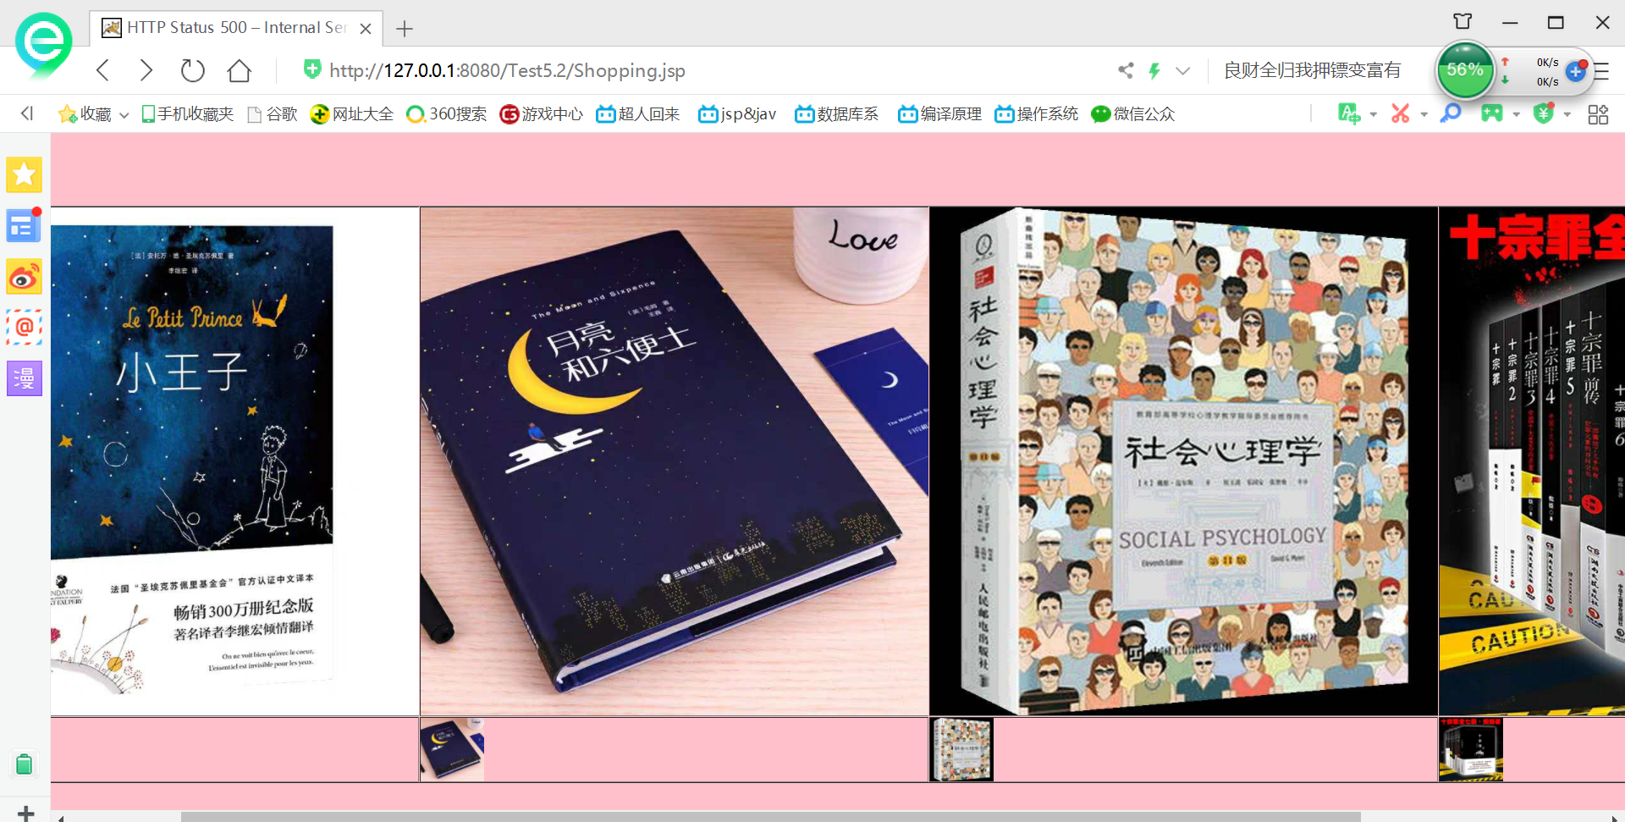

# 收获与问题

。

这次实验对于我来讲还是有点困难，页面不好看，我在课后再去修改。