**Java Web开发**

**实验五**

**作业报告**

|  |  |
| --- | --- |
| 学 院 | 计算机 |
| 所在系 班 级 | 2017软件工程系6班 |
| 学 号 姓 名 | 04171417刘泽峰 |
| 指 导 教 师 | 郭晓燕 |
| 完 成 时 间 | 2018年5月- |

# 实验题目

第四章课后练习3购物车，实现一个购物车应用程序，可以购物，显示购物数量并查看购物车内容。

对第三章动态验证码程序实现动态验证。

# 分析与设计

**Book.java**:数据类，用来保存图书的基本信息（ID、书名、价格、图片地址）和购书信息（购书数量）。

**Shopping.jsp**:购书页面，通过此页面用户选购图书

**ShoppingServlet.java**：获取到用户所点击的ID号（即书号），同时从Session对象中将图书数组取出来。。

**CarServlet.java**：从Session对象中取出图书数组，对其进行遍历，计算数量及价格并写入session。

**Car.jsp**:我的购物车页面

**Code.jsp**:验证码页面

**Checkcode.Java**:检查验证码是否正确

**ServletImage.java**：生成验证码图片

# 关键源码（部分）

**Book.java**

**package** cc.test.vo;

**public** **class** Book {

**private** String bookId; //书号

**private** String bookName;//书名

String bookImg; //书封面所在地址

**private** **int** bookNum; //购书本数

**private** **double** bookPrice;//价格

**public** Book(String bookId, String bookName, String bookImg, **int** bookNum, **double** bookPrice) {

**this**.bookId = bookId;

**this**.bookName = bookName;

**this**.bookImg = bookImg;

**this**.bookNum = 0;

**this**.bookPrice = bookPrice;

}

**public** String getBookId() {

**return** bookId;

}

**public** **void** setBookId(String bookId){

**this**.bookId = bookId;

}

**public** String getBookName() {

**return** bookName;

}

**public** **void** setBookName(String bookName){

**this**.bookName = bookName;

}

**public** String getBookImg() {

**return** bookImg;

}

**public** **void** setBookImg(String bookImg){

**this**.bookImg = bookImg;

}

**public** **int** getBookNum() {

**return** bookNum;

}

**public** **void** setBookNum(**int** bookNum){

**this**.bookNum=bookNum;

}

**public** **double** getBookPrice() {

**return** bookPrice;

}

**public** **void** setBookPrice(**double** bookPrice){

**this**.bookPrice=bookPrice;

}

}

**Shopping.jsp**

<%@ page language=*"java"* import=*"java.util.*"* pageEncoding=*"UTF-8"*%>

<%@page import=*"cc.test.vo.*"* %>

<!DOCTYPE HTML PUBLIC "-//W3C//DTD HTML 4.01 Transitional//EN">

<html>

<%

//当第一次访问采购网页，session对象中还没有book购物车信息时，进行初始化。

**if** (session.getAttribute("bookList")==**null**){

//在session对象中存储图书采购信息

Book[] BookList = **new** Book[4];

BookList[0] = **new** Book("10101", "Java核心技术", "img\\10101.jpg", 0, 95.20);

BookList[1] = **new** Book("10102", "Java经典实例", "img\\10102.jpg", 0, 74.00);

BookList[2] = **new** Book("10103", "Java7", "img\\10103.jpg", 0, 78.20);

BookList[3] = **new** Book("10104", "JSP&Servlet", "img\\10104.jpg", 0, 73.90);

//存入session对象中

session.setAttribute("bookList", BookList);

session.setAttribute("sum",0);

}

%>

<body>

<br>

<img src=*"img/cart.jpg"* height=*"60px"* width=*"60px"*>

<a href=*"cart.view"*>已采购<%=session.getAttribute("sum") %>本书籍，查看购物车</a><br>

<br>

<table border=*"1"*>

<%

Book[] bookList=(Book[])session.getAttribute("bookList");

out.println("<tr>");

**for**(Book book:bookList){

out.println("<td><img src='"+book.getBookImg()+"'></td>");

}

out.println("</tr>");

out.println("<tr>");

**for**(Book book:bookList){

out.println("<td><p>"+book.getBookName()+"</td>");

}

out.println("</tr>");

out.println("<tr>");

**for**(Book book:bookList){

out.println("<td><p>"+book.getBookPrice()+"</td>");

}

out.println("</tr>");

out.println("<tr>");

**for**(Book book:bookList){

out.println("<td><a href=\"shopping.view?id="+book.getBookId()+"\">采购此书</a></td>");

}

out.println("</tr>");

%>

</body>

</html>

**car.jsp**

<%@ page language=*"java"* import=*"java.util.*"* pageEncoding=*"UTF-8"* %>

<%@page import=*"cc.test.vo.*"* import=*"java.text.DecimalFormat"*%>

<%

String path = request.getContextPath();

String basePath = request.getScheme()+"://"+request.getServerName()+":"+request.getServerPort()+path+"/";

%>

<!DOCTYPE HTML PUBLIC "-//W3C//DTD HTML 4.01 Transitional//EN">

<html>

<% Book[] bookList=(Book[])session.getAttribute("bookList");

**double** price=(Double)session.getAttribute("totalprice");

DecimalFormat df = **new** DecimalFormat("#.00");

%>

<body>

<img src=*"img/cart.jpg"* height=*"60px"* width=*"60px"*>

<a>已采购<%=session.getAttribute("sum")%>本书籍</a><br>

<table border=*"1"*>

<tr>

<%

**for**(Book book:bookList){

out.println("<tr>");

**if**(book.getBookNum()!=0){

out.println("<td><img src='"+book.getBookImg()+"'></td>");

out.println("<td><p>"+book.getBookName()+"</td>");

out.println("<td><p>"+df.format(book.getBookPrice()*book.getBookNum())+"（元）</td>");

out.println("<td><a>已购"+book.getBookNum()+"本</a></td>");

}

out.println("</tr>");

}

%>

</tr>

</table>

<%

out.println("<p>共"+df.format(price)+"元");

out.println("<a href='code.jsp'>结算</a>");

%>

</body>

</html>

**ShoppingServlet.java**

package cc.test.Controller;

import java.io.IOException;

import java.io.PrintWriter;

import javax.servlet.ServletException;

import javax.servlet.annotation.WebServlet;

import javax.servlet.http.HttpServlet;

import javax.servlet.http.HttpServletRequest;

import javax.servlet.http.HttpServletResponse;

import javax.servlet.http.HttpSession;

import cc.test.vo.Book;

@WebServlet(urlPatterns={"/shopping.view"})

public class ShopingServlet extends HttpServlet {

public void doGet(HttpServletRequest request, HttpServletResponse response)

throws ServletException, IOException {

String bookid = null;

String bookname;

String bookimg;

int booknum = 0;

//获取从Shopping.jsp传来的request对象中的ID号

HttpSession session=request.getSession();

String id=request.getParameter("id");

//在ID号不为空的情况下，获取Session对象中的购物车信息，Book数组。

Book[] bookList=(Book[])session.getAttribute("bookList");

if(id!=null){

for(Book book:bookList){

if(id.equals(book.getBookId())){

booknum=book.getBookNum();

booknum++;

book.setBookNum(booknum);

}

}

}

int sum=0;

for(Book book:bookList){

int num=book.getBookNum();

sum+=num;

}

session.setAttribute("sum", sum);

//将数组写回session对象中去。

session.setAttribute("bookList", bookList);

//跳转回Shopping.jsp

response.sendRedirect("Shopping.jsp");

}

public void doPost(HttpServletRequest request, HttpServletResponse response)

throws ServletException, IOException {

doGet(request,response);

}

}

**CarServlet.java**

**package** cc.test.Controller;

**import** java.io.IOException;

**import** java.io.PrintWriter;

**import** java.text.DecimalFormat;

**import** javax.servlet.ServletException;

**import** javax.servlet.annotation.WebServlet;

**import** javax.servlet.http.HttpServlet;

**import** javax.servlet.http.HttpServletRequest;

**import** javax.servlet.http.HttpServletResponse;

**import** javax.servlet.http.HttpSession;

**import** cc.test.vo.Book;

@WebServlet("/cart.view")

**public** **class** CarServlet **extends** HttpServlet {

**public** **void** doGet(HttpServletRequest request, HttpServletResponse response)

**throws** ServletException, IOException {

/*判断得到session对象中存储的book信息是否为空

不为空的前提下，读出Book数组中的内容，并将数目大于0的图书信息显示在网页上。

*/

HttpSession session=request.getSession();

Book[] bookList=(Book[])session.getAttribute("bookList");

**int** sum=0;

**double** totalprice=0;

DecimalFormat df = **new** DecimalFormat("#.00");

**for**(Book book:bookList){

**int** num=book.getBookNum();

**double** price=book.getBookPrice();

totalprice+=price*num;

sum+=num;

}

session.setAttribute("sum", sum);

session.setAttribute("totalprice", totalprice);

request.getRequestDispatcher("car.jsp").forward(request, response);

}

**public** **void** doPost(HttpServletRequest request, HttpServletResponse response)

**throws** ServletException, IOException {

doGet(request,response);

}

}

**Code.jsp**

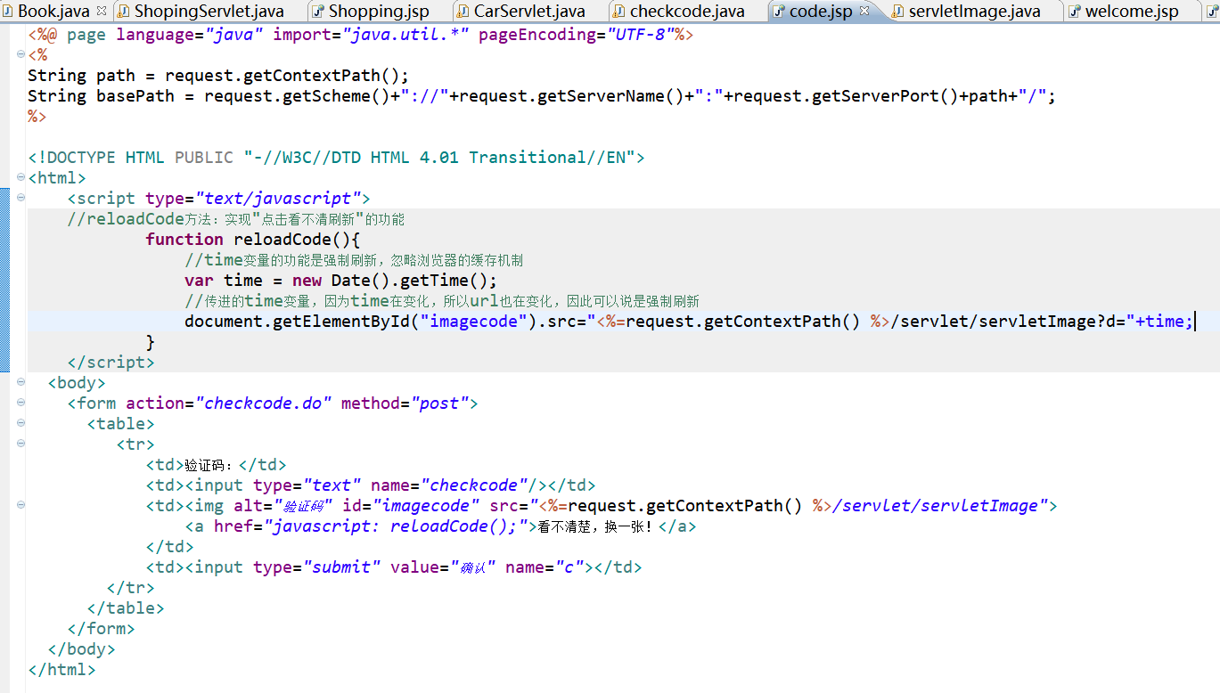

**servletImage.java**

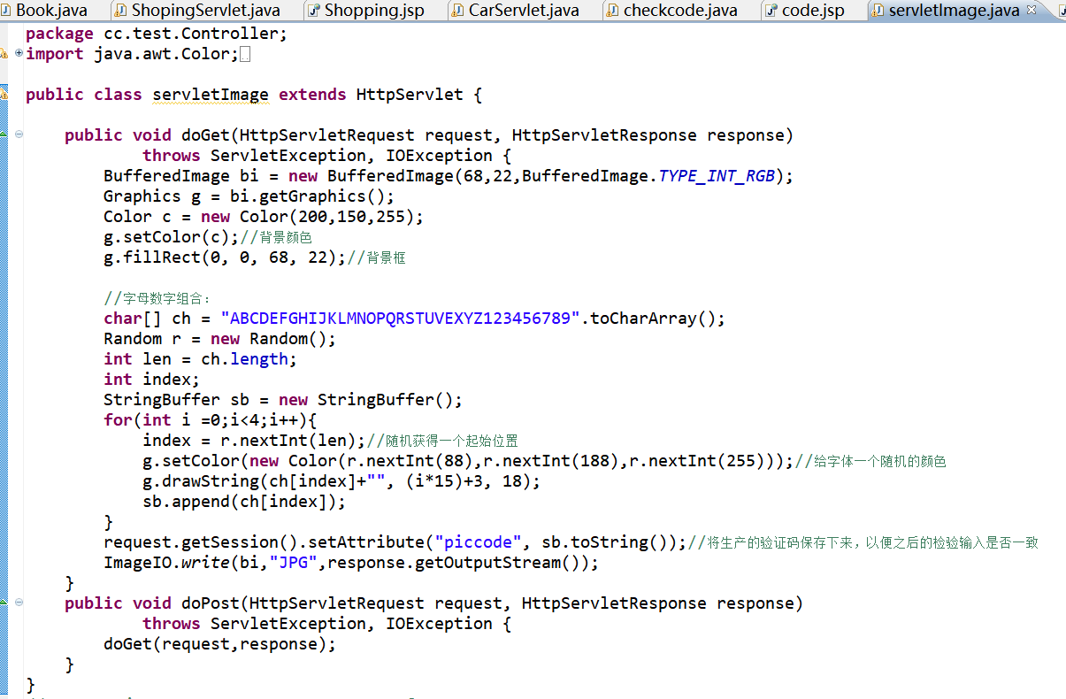

**checkcode.java**

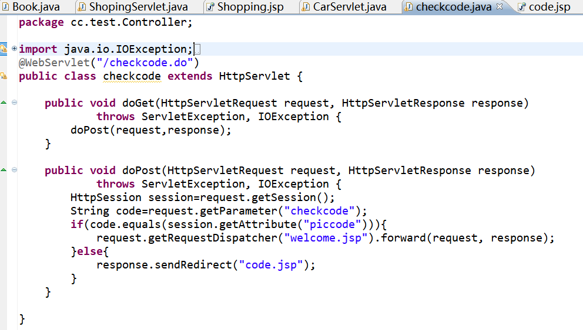

**welcome.jsp**

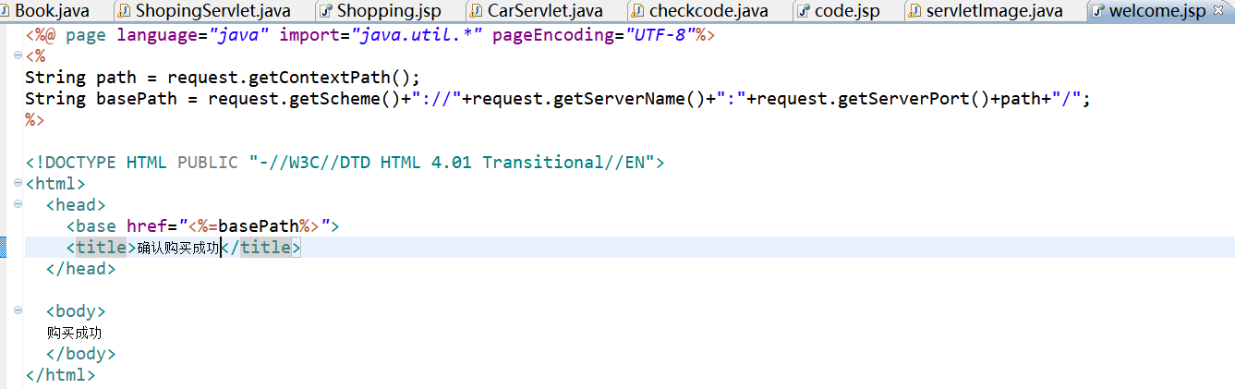

# 运行效果图

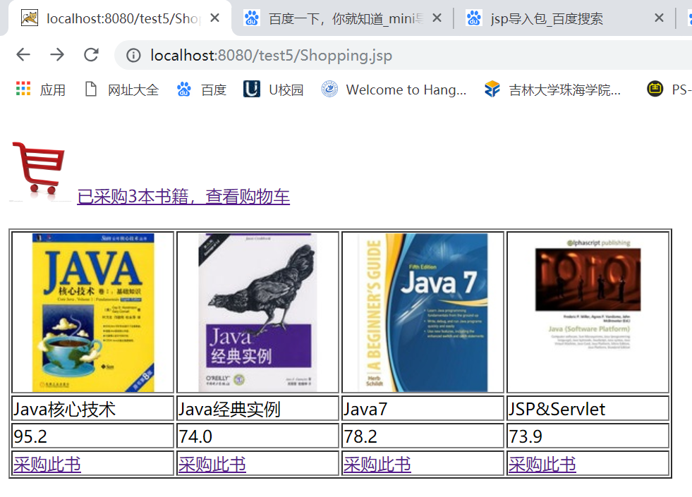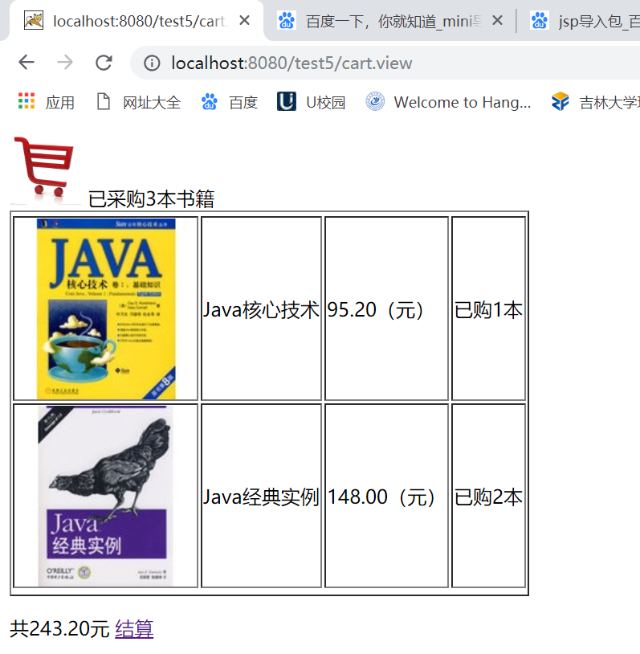

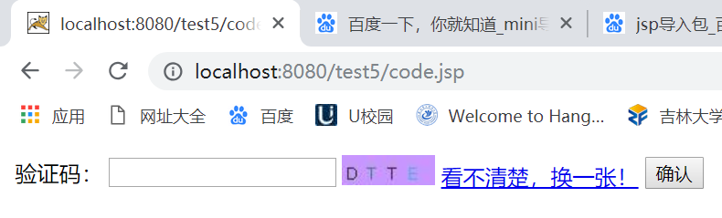

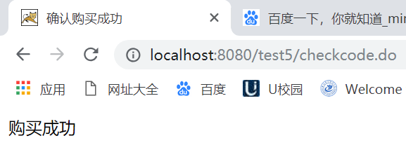

# 收获与问题

1、理解会话的原理和HttpSession会话期；

2、掌握如何使用URL重写；

3、掌握如何使用HttpSession会话管理

。