**Java Web开发**

**实验五**

**作业报告**

|  |  |
| --- | --- |
| 学 院 | 计算机 |
| 所在系 班 级 | 2017软件工程系06班 |
| 学 号 姓 名 | 刘银升 |
| 指 导 教 师 | 郭晓燕 |
| 完 成 时 间 | 2019年4月- |

# 实验题目

练习老师在理论课上演示的购物车实例，理解购物功能如何实现，理解如何利用session对象保存购物信息，如何设计封装数据类。（请参考“第四章会话管理课上的购物车实例代码.docx”文档）；

如果上课听懂了购物车的原理或者部分理解，可以参考我的实例完成第2题，此题可忽略不写。

# 分析与设计

根据题目要求，计划设计几个文件来完成实验，每个文件的名字、作用。如果是类，要求写出类的变量和方法

# 关键源码（部分）

package com.session;

import java.io.IOException;

import javax.servlet.ServletException;

import javax.servlet.annotation.WebServlet;

import javax.servlet.http.HttpServlet;

import javax.servlet.http.HttpServletRequest;

import javax.servlet.http.HttpServletResponse;

import javax.servlet.http.HttpSession;

/**

* Servlet implementation class ShoppingServlet

*/

@WebServlet(urlPatterns= {"/Shopping.view"})

public class ShoppingServlet extends HttpServlet {

private static final long serialVersionUID = 1L;

protected void doGet(HttpServletRequest request, HttpServletResponse response) throws ServletException, IOException {

doPost(request, response);

}

protected void doPost(HttpServletRequest request, HttpServletResponse response) throws ServletException, IOException {

response.setContentType("text/html;charset=UTF-8");

int booknum=0;

HttpSession session=request.getSession();

String id=(String) request.getParameter("id");

System.out.println(id);

Book[] booklist=(Book[]) session.getAttribute("booklist");

if(id!=null) {

for (Book book:booklist) {

if(id.equals(book.getBookId())) {

booknum=book.getBookNum();

booknum++;

book.setBookNum(booknum);

}

}

}

int booksum=0;

for(Book book:booklist) {

booksum+=book.getBookNum();

}

session.setAttribute("booksum", booksum);

session.setAttribute("booklist", booklist);

response.sendRedirect("Shopping.jsp");

}

}

<%@ page language=*"java"* import=*"java.util.*"* pageEncoding=*"UTF-8"*%>

<%@page import=*"com.session.*"* %>

<!DOCTYPE HTML PUBLIC "-//W3C//DTD HTML 4.01 Transitional//EN">

<html>

<%

//当第一次访问采购网页，session对象中还没有book购物车信息时，进行初始化。

**if** (session.getAttribute("booklist")==**null**){

//在session对象中存储图书采购信息

Book[] BookList = **new** Book[4];

BookList[0] = **new** Book("10101", "Java核心技术", "img\\10101.jpg", 0,11.1);

BookList[1] = **new** Book("10102", "Java经典实例", "img\\10102.jpg", 0,22.2);

BookList[2] = **new** Book("10103", "Java7", "img\\10103.jpg", 0,33.3);

BookList[3] = **new** Book("10104", "JSP&Servlet", "img\\10104.jpg",0,44.4);

//存入session对象中

session.setAttribute("booklist", BookList);

session.setAttribute("booksum", 0);

}

%>

<body>

<br>

<img src=*"img/cart.jpg"* height=*"60px"* width=*"60px"*>

<a href=*"ShoppingCar.jsp"*>已采购<%=session.getAttribute("booksum") %> 本书籍</a><br>

<br>

<table border=*"1"*>

<%

Book[] booklist=(Book[])session.getAttribute("booklist");

out.println("<tr>");

**if**(booklist!=**null**)

**for**(Book book:booklist){

out.println("<td><img src='"+book.getBookImg()+"'></td>");

}

out.println("</tr>");

out.println("<tr>");

**for**(Book book:booklist){

out.println("<td><p>"+book.getBookName()+"</td>");

}

out.println("</tr>");

out.println("<tr>");

**for**(Book book:booklist){

out.println("<td><p>"+book.getBookPrice()+"</td>");

}

out.println("</tr>");

out.println("<tr>");

**for**(Book book:booklist){

out.println("<td><a href=\"Shopping.view?id="+book.getBookId()+"\">加入购物车</a></td>");

}

out.println("</tr>");

%>

</body>

</html>

package com.session;

import java.io.IOException;

import javax.servlet.ServletException;

import javax.servlet.annotation.WebServlet;

import javax.servlet.http.HttpServlet;

import javax.servlet.http.HttpServletRequest;

import javax.servlet.http.HttpServletResponse;

import javax.servlet.http.HttpSession;

import javax.websocket.Session;

@WebServlet("/ShoppingCar.view")

public class CarServlet extends HttpServlet {

private static final long serialVersionUID = 1L;

protected void doGet(HttpServletRequest request, HttpServletResponse response) throws ServletException, IOException {

doPost(request, response);

}

protected void doPost(HttpServletRequest request, HttpServletResponse response) throws ServletException, IOException {

response.setContentType("text/html;charset=UTF-8");

HttpSession session=request.getSession();

int booksum=0;

double totalPrice=0;

Book[] booklist=(Book[]) session.getAttribute("booklist");

if(booklist!=null)

for(Book book:booklist) {

int num=book.getBookNum();

double price=book.getBookPrice();

booksum+=num;

totalPrice+=price*num;

System.out.println(totalPrice);

session.setAttribute("booksum",booksum );

session.setAttribute("totalPrice", totalPrice);

request.getRequestDispatcher("ShoppingCar.jsp").forward(request, response);

}

}

}

<%@ page language=*"java"* contentType=*"text/html; charset=UTF-8"*

pageEncoding=*"UTF-8"*%>

<%@page import=*"com.session.*"* %>

<%

String path = request.getContextPath();

String basePath = request.getScheme()+"://"+request.getServerName()+":"+request.getServerPort()+path+"/";

%>

<!DOCTYPE html>

<html>

<head>

<meta charset=*"UTF-8"*>

<title>购物车</title>

</head>

<%

Book[] booklist=(Book[])session.getAttribute("booklist");

**double** totalprice=(Double)session.getAttribute("totalPrice");

%>

<body>

<img src=*"img/cart.jpg"* height=*"60px"* width=*"60px"*>

<a>已采购<%=session.getAttribute("booksum")%>本书籍</a><br>

<table border=*"1"*>

<tr>

<%

**double** sum=0;

**if**(session.getAttribute("booklist")!=**null**){

**for**(Book book:booklist){

out.println("<tr>");

**if**(book.getBookNum()!=0){

out.println("<td><img src='"+book.getBookImg()+"'></td>");

out.println("<td><p>"+book.getBookName()+"</td>");

out.println("<td><p>"+book.getBookPrice()*book.getBookNum()+"（元）</td>");

out.println("<td><a>已购"+book.getBookNum()+"本</a></td>");

sum+=book.getBookNum()*book.getBookPrice();

}

out.println("</tr>");

}

out.println("<td><a>合计"+sum+"元</a></td>");

}

%>

</tr>

</table>

</body>

</html>

# 运行效果图

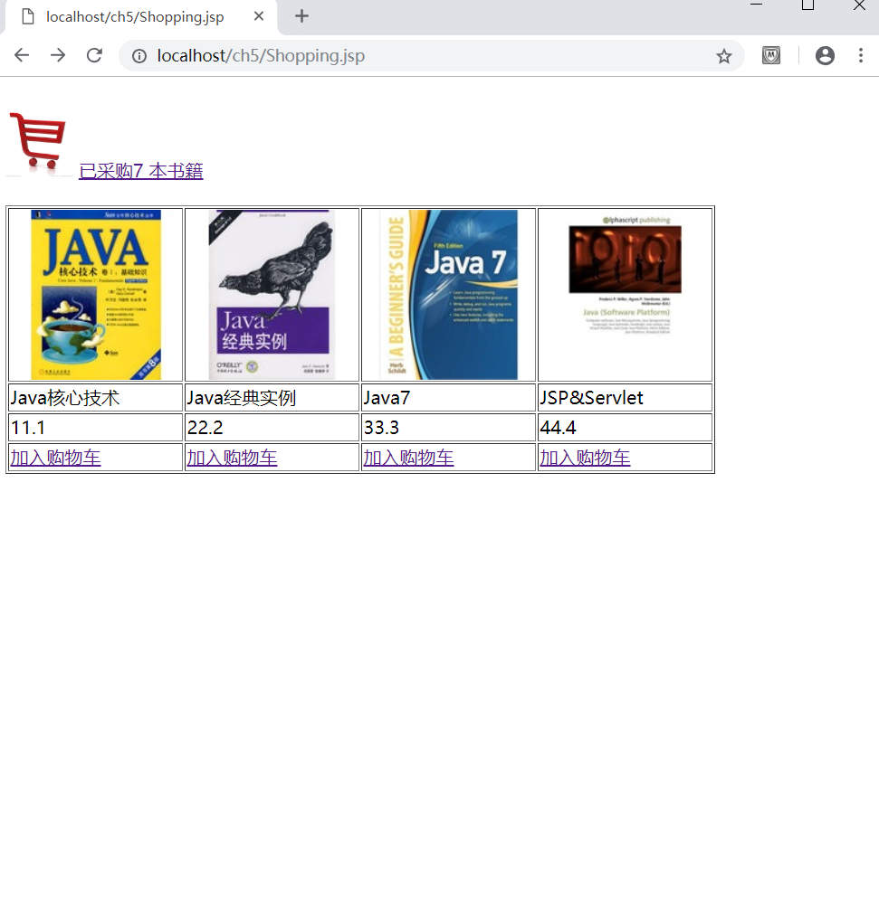 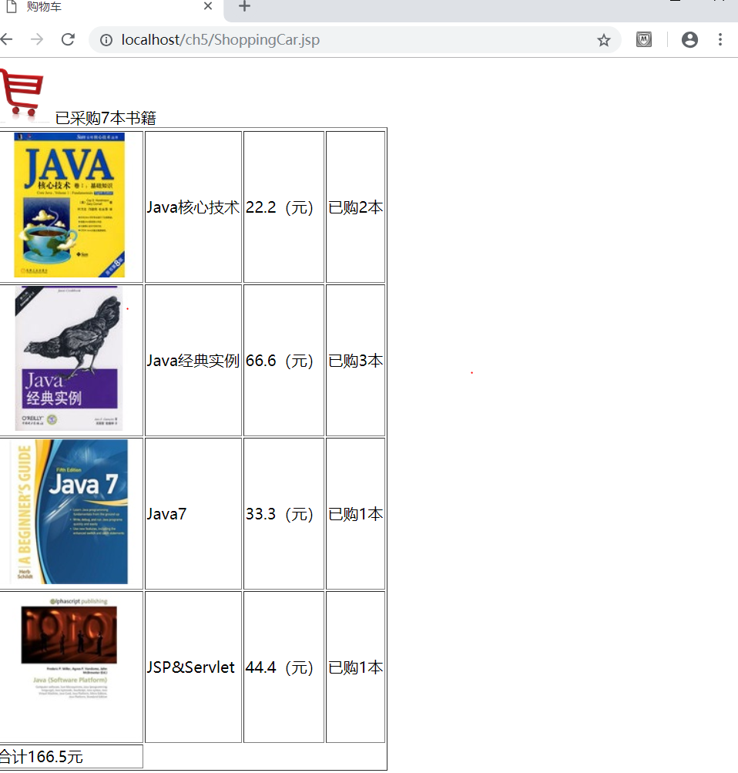

实验在浏览器下运行的结果截图，并进行解释。

# 收获与问题

谈一谈你在本实验中所收获的内容及问题。