**Java Web开发**

**实验五**

**作业报告**

|  |  |
| --- | --- |
| 学 院 | 计算机 |
| 所在系 班 级 | 2017软件工程系6班 |
| 学 号 姓 名 | 04171424柯海扬 |
| 指 导 教 师 | 罗永升 |
| 完 成 时 间 | 2019年4月8日 |

# 实验题目

1. 第四章课后练习3购物车，实现一个购物车应用程序，可以购物，显示购物数量并查看购物车内容。（此题模版test4E，提供给大家参考。）

提示：采购此书做成超链接，并用URL重写带关键信息

* 1. Shopping.view?bookID=‘0001’，其中0001是你选中图书对应的ID号，每点击一次就在相应的购书数量上加一，并返回当前的选购页面。

b）除了要保存图书的ID号、书名，还要保存购书数量，所以session对象保存的信息需要考虑清楚，最好是一个对象数组或列表。

# 分析与设计

# 关键源码（部分）

#Shopping.jsp

<%@ page language=*"java"* import=*"java.util.*"* pageEncoding=*"UTF-8"*%>

<%@page import=*"cc.*"* %>

<!DOCTYPE HTML PUBLIC "-//W3C//DTD HTML 4.01 Transitional//EN">

<html>

<%

//当第一次访问采购网页，session对象中还没有book购物车信息时，进行初始化。

**int** num;

**if** (session.getAttribute("num") == **null**) {

num = 0;

session.setAttribute("num", num);

}

**else**

{

num= (Integer) session.getAttribute("num");

}

**if** (session.getAttribute("book") == **null**) {

//在session对象中存储图书采购信息

Buy_Book[] BookList = **new** Buy_Book[4];

BookList[0] = **new** Buy_Book("10101", "Java核心技术", "./img/10101.jpg", 0);

BookList[1] = **new** Buy_Book("10102", "Java经典实例", "./img/10102.jpg", 0);

BookList[2] = **new** Buy_Book("10103", "Java7", "./img/10103.jpg", 0);

BookList[3] = **new** Buy_Book("10104", "JSP&Servlet", "./img/10104.jpg", 0);

//存入session对象中

session.setAttribute("book", BookList);

}

%>

<body>

<br>

<img src=*"img/cart.PNG"* height=*"250px"* width=*"250px"*>

<a href=*"cart.view"*>已采购<%=num %>本书籍</a><br>

<br>

<table border=*"1"*>

<tr>

<td><img src=*"./img/10101.jpg"*></td>

<td><img src=*"./img/10102.jpg"*></td>

<td><img src=*"./img/10103.jpg"*></td>

<td><img src=*"./img/10104.jpg"*></td>

</tr>

<tr>

<td><a href=*"shopping.view?id=10101"*>采购此书</a></td>

<td><a href=*"shopping.view?id=10102"*>采购此书</a></td>

<td><a href=*"shopping.view?id=10103"*>采购此书</a></td>

<td><a href=*"shopping.view?id=10104"*>采购此书</a></td>

</tr>

</body>

</html>

#cart.java

**import** java.io.IOException;

**import** java.io.PrintWriter;

**import** javax.servlet.ServletException;

**import** javax.servlet.annotation.WebServlet;

**import** javax.servlet.http.HttpServlet;

**import** javax.servlet.http.HttpServletRequest;

**import** javax.servlet.http.HttpServletResponse;

**import** javax.servlet.http.HttpSession;

@WebServlet(name = "cart", urlPatterns = { "/cart.view" })

**public** **class** cart **extends** HttpServlet {

**protected** **void** doGet(HttpServletRequest request, HttpServletResponse response)

**throws** ServletException, IOException {

// **TODO** Auto-generated method stub

request.setCharacterEncoding("UTF-8");

HttpSession session = request.getSession();

session.getAttribute("book");

Buy_Book[] BookList=(Buy_Book[])session.getAttribute("book");

session.setAttribute("book", BookList);

response.setContentType("text/html;charset=UTF-8");

PrintWriter out = response.getWriter();

**int** num=(Integer) session.getAttribute("num");

out.println("<html>");

out.println("<head>");

out.println("<title>购物车</title>");

out.println("</head>");

out.println("<body>");

out.println("<a href='Shopping.jsp'>返回主页</a><br>");

out.println("已购书"+num+"本<br>");

out.println("<br> ");

out.println("<table border='1'>");

out.println("<tr>");

out.println("<td><img src='./img/10101.jpg'></td>");

out.println("<td><img src='./img/10102.jpg'></td>");

out.println("<td><img src='./img/10103.jpg'></td>");

out.println("<td><img src='./img/10104.jpg'></td>");

out.println("</tr>");

out.println("<tr>");

out.println("<td>共"+BookList[0].getNumber()+"本</td>");

out.println("<td>共"+BookList[1].getNumber()+"本</td>");

out.println("<td>共"+BookList[2].getNumber()+"本</td>");

out.println("<td>共"+BookList[3].getNumber()+"本</td>");

out.println("</tr>");

out.println("</body>");

out.println("</html>");

out.close();

session.setAttribute("num",0);

}

/**

* **@see** HttpServlet#doPost(HttpServletRequest request, HttpServletResponse

* response)

*/

**protected** **void** doPost(HttpServletRequest request, HttpServletResponse response)

**throws** ServletException, IOException {

// **TODO** Auto-generated method stub

doGet(request, response);

}

}

#Buy_Book.java

**public** **class** Buy_Book {

String id,name,img;

**int** number;

**public** Buy_Book(String id,String name,String img,**int** num) {

**this**.id=id;

**this**.name=name;

**this**.img=img;

**this**.number=num;

}

**public** String getId() {

**return** id;

}

**public** **void** setId(String id) {

**this**.id = id;

}

**public** String getName() {

**return** name;

}

**public** **void** setName(String name) {

**this**.name = name;

}

**public** String getImg() {

**return** img;

}

**public** **void** setImg(String img) {

**this**.img = img;

}

**public** **int** getNumber() {

**return** number;

}

**public** **void** setNumber(**int** number) {

**this**.number = number;

}

}

#shopping.java

import java.io.IOException;

import javax.servlet.ServletException;

import javax.servlet.annotation.WebServlet;

import javax.servlet.http.HttpServlet;

import javax.servlet.http.HttpServletRequest;

import javax.servlet.http.HttpServletResponse;

import javax.servlet.http.HttpSession;

@WebServlet(name = "shopping", urlPatterns = { "/shopping.view" })

public class shopping extends HttpServlet {

protected void doGet(HttpServletRequest request, HttpServletResponse response) throws ServletException, IOException {

// TODO Auto-generated method stub

request.setCharacterEncoding("UTF-8");

HttpSession session = request.getSession();

Buy_Book[] BookList=(Buy_Book[])session.getAttribute("book");

String id=request.getParameter("id");

int num=(Integer) session.getAttribute("num");

num=num+1;

session.setAttribute("num", num);

if(id.equals("10101"))

{

BookList[0].setNumber(BookList[0].getNumber()+1);

}

else if(id.equals("10102"))

{

BookList[1].setNumber(BookList[1].getNumber()+1);

}

else if(id.equals("10103"))

{

BookList[2].setNumber(BookList[2].getNumber()+1);

}

else if(id.equals("10104"))

{

BookList[3].setNumber(BookList[3].getNumber()+1);

}

session.setAttribute("book", BookList);

response.sendRedirect("Shopping.jsp");

}

protected void doPost(HttpServletRequest request, HttpServletResponse response) throws ServletException, IOException {

// TODO Auto-generated method stub

doGet(request, response);

}

}

# 运行效果图

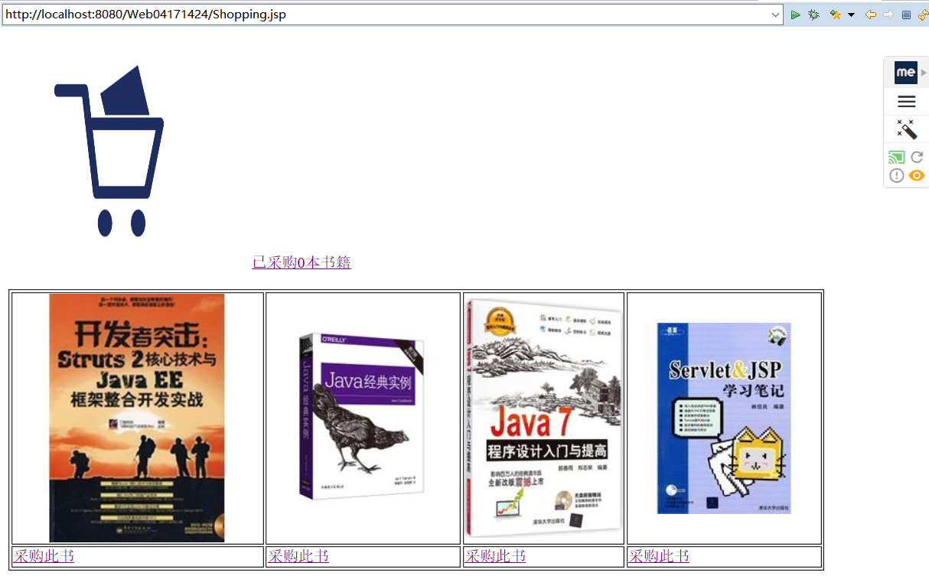

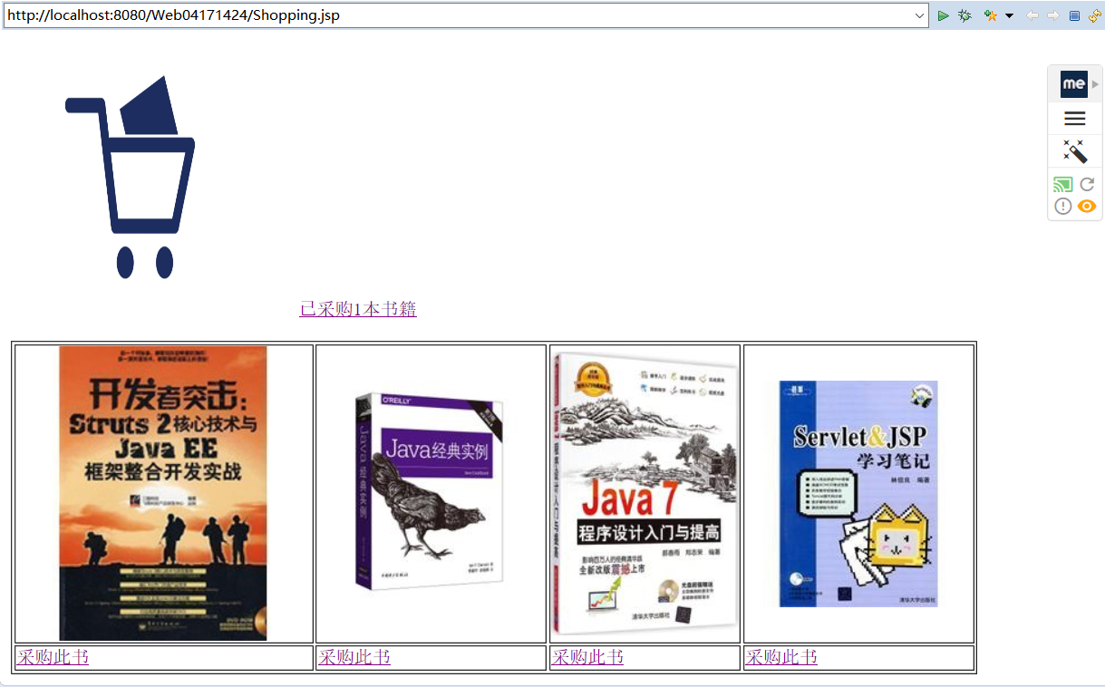

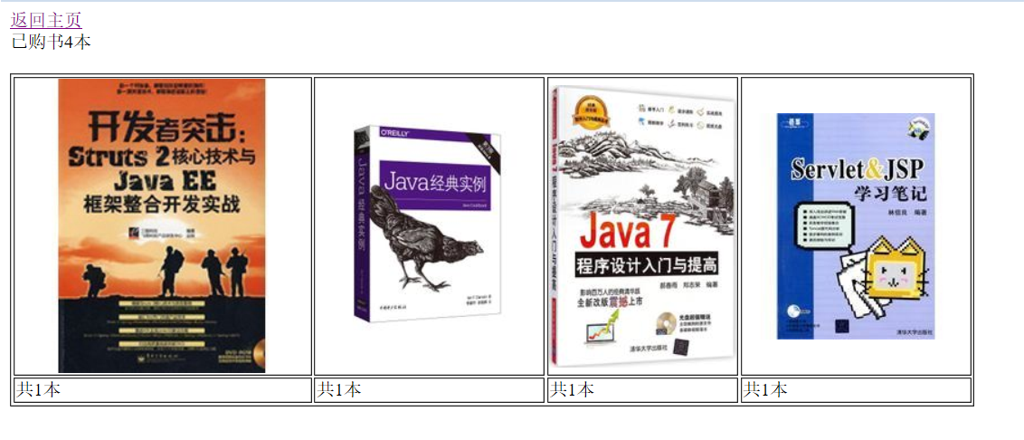

# 收获与问题