**Java Web开发**

**实验五**

**作业报告**

|  |  |
| --- | --- |
| 学 院 | 计算机学院 |
| 所在系 班 级 | 2017软件工程系15班 |
| 学 号 姓 名 | 04171427詹明 |
| 指 导 教 师 | 罗永升 |
| 完 成 时 间 | 2019年4月- |

# 实验题目

第四章课后练习3购物车，实现一个购物车应用程序，可以购物，显示购物数量并查看购物车内容。

# 分析与设计

采购此书做成超链接，并用URL重写带关键信息

a) Shopping.view?bookID=‘0001’，其中0001是你选中图书对应的ID号，每点击一次就在相应的购书数量上加一，并返回当前的选购页面。

b) 除了要保存图书的ID号、书名，还要保存购书数量，所以session对象保存的信息需要考虑清楚，最好是一个对象数组或列表。

# 关键源码（部分）

1. **StoreInCart.java:**

package cc.openhome;

import java.io.IOException;

import java.util.HashMap;

import java.util.Map;

import javax.servlet.ServletException;

import javax.servlet.annotation.WebServlet;

import javax.servlet.http.HttpServlet;

import javax.servlet.http.HttpServletRequest;

import javax.servlet.http.HttpServletResponse;

/**

* Servlet implementation class StoreInCart

*/

@WebServlet("/shop.view")

public class StoreInCart extends HttpServlet {

protected void doGet(HttpServletRequest request, HttpServletResponse response) throws ServletException, IOException {

doPost(request, response);

}

/**

* @see HttpServlet#doPost(HttpServletRequest request, HttpServletResponse response)

*/

protected void doPost(HttpServletRequest request, HttpServletResponse response) throws ServletException, IOException {

response.setContentType("text/html;charset=utf-8");

String id = request.getParameter("id");

String[] names={"c++","javaweb","matlab"};

String productName=names[Integer.parseInt(id)-1];

//将产品名和数量放到一个map集合里,再放入购物车

Map<String,Integer> cart = (Map<String, Integer>) request.getSession().getAttribute("cart");

//判断购物车是否为空

if (cart==null) {

cart=new HashMap<String, Integer>();

cart.put(productName, 1);

}else {

//不重复的产品存入购物

if (cart.containsKey(productName)) {

int num=cart.get(productName);

cart.put(productName, num+1);

}else {

cart.put(productName, 1);

}

}

//将map集合设置到购物车cart里面

request.getSession().setAttribute("cart", cart);

response.sendRedirect("continue.jsp");

//request.getRequestDispatcher("continue.jsp").forward(request, response);

//response.getWriter().write("<a href='product.jsp'>继续购物</a><br/>"+"<a href='cart.jsp'>去结算</a>");

}

}

1. ClearCart:

package cc.openhome;

import java.io.IOException;

import javax.servlet.ServletException;

import javax.servlet.annotation.WebServlet;

import javax.servlet.http.HttpServlet;

import javax.servlet.http.HttpServletRequest;

import javax.servlet.http.HttpServletResponse;

import javax.servlet.http.HttpSession;

/**

* Servlet implementation class ClearCart

*/

@WebServlet("/clear.do")

public class ClearCart extends HttpServlet {

protected void doGet(HttpServletRequest request, HttpServletResponse response) throws ServletException, IOException {

doPost(request, response);

}

/**

* @see HttpServlet#doPost(HttpServletRequest request, HttpServletResponse response)

*/

protected void doPost(HttpServletRequest request, HttpServletResponse response) throws ServletException, IOException {

// TODO Auto-generated method stub

HttpSession session = request.getSession();

//利用session自己的方法结果掉session

session.invalidate();

response.sendRedirect("cart.jsp");

}

}

3.**Product.jsp:**

<%@ page language=*"java"* import=*"java.util.*"* pageEncoding=*"utf-8"*%>

<%

String path = request.getContextPath();

String basePath = request.getScheme()+"://"+request.getServerName()+":"+request.getServerPort()+path+"/";

%>

<!DOCTYPE HTML PUBLIC "-//W3C//DTD HTML 4.01 Transitional//EN">

<html>

<head>

<base href=*"*<%=basePath%>*"*>

<title>My JSP 'product.jsp' starting page</title>

</head>

<body>

<img src=*"img/c++.png"* height=*"200px"* width=*"200px"*><a href=*"shop.view?id=1"*>c++</a>

<img src=*"img/javaweb.png"* height=*"200px"* width=*"200px"*><a href=*"shop.view?id=2"*>javaweb</a>

<img src=*"img/matlab.png"* height=*"200px"* width=*"200px"*><a href=*"shop.view?id=3"*>matlab</a>

</body>

</html>

4.continue.jsp:  
<%@ page language=*"java"* import=*"java.util.*"* pageEncoding=*"utf-8"*%>

<%

String path = request.getContextPath();

String basePath = request.getScheme()+"://"+request.getServerName()+":"+request.getServerPort()+path+"/";

%>

<!DOCTYPE HTML PUBLIC "-//W3C//DTD HTML 4.01 Transitional//EN">

<html>

<head>

<base href=*"*<%=basePath%>*"*>

<title>My JSP 'continue.jsp' starting page</title>

</head>

<body>

<h3><a href=*"product.jsp"*>继续购物</a><br/>

<a href=*"cart.jsp"*>去结算</a></h3>

</body>

</html>

5.cart.jsp:

<%@ page language=*"java"* import=*"java.util.*"* pageEncoding=*"utf-8"*%>

<%

String path = request.getContextPath();

String basePath = request.getScheme()+"://"+request.getServerName()+":"+request.getServerPort()+path+"/";

%>

<!DOCTYPE HTML PUBLIC "-//W3C//DTD HTML 4.01 Transitional//EN">

<html>

<head>

<base href=*"*<%=basePath%>*"*>

<title>My JSP 'cart.jsp' starting page</title>

</head>

<body>

<h1>结算页面</h1>

<h3><a href=*"clear.do"*>清空购物车</a></h3>

<h5>购物车清单:</h5>

<br/>

<%

//获取购物车cart,遍历购物车,打印出商品详情

Map<String,Integer> cart=(Map<String,Integer>) request.getSession().getAttribute("cart");

**if**(cart==**null**){

%>

<h2>没有任何购物记录</h2>

<%

}**else**{

**for**(String name:cart.keySet()){

**int** num=cart.get(name);

%>

商品:<%=name %>, 数量:<%=num %>

<br/>

<%

}

}

%>

</body>

</html>

# 运行效果图

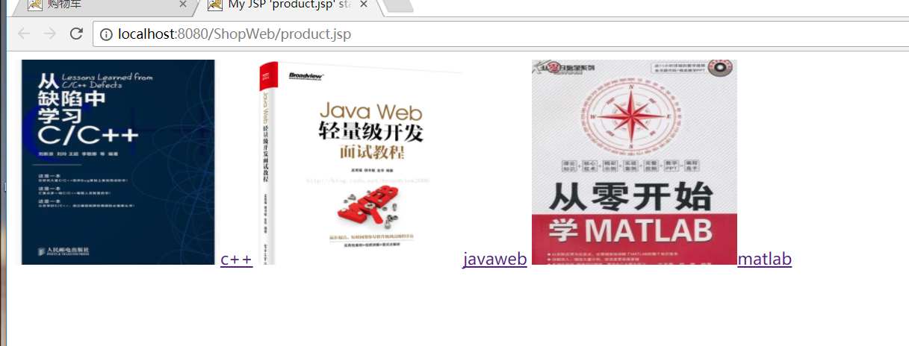

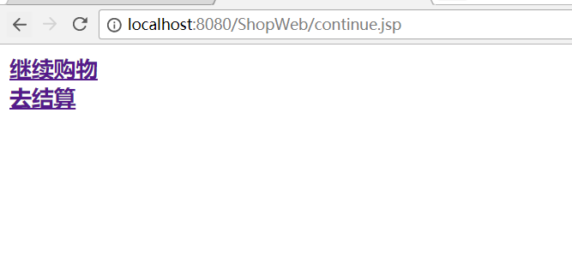

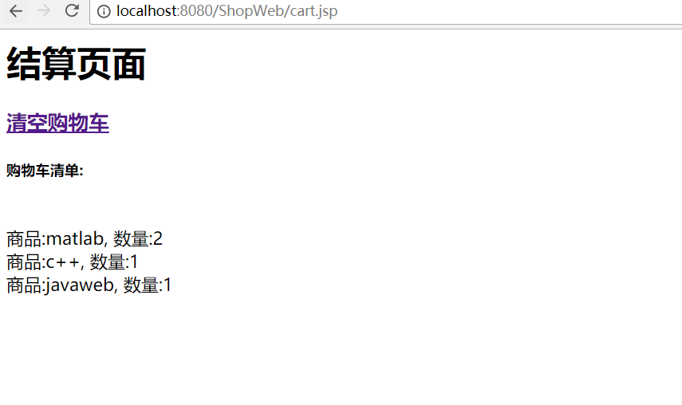

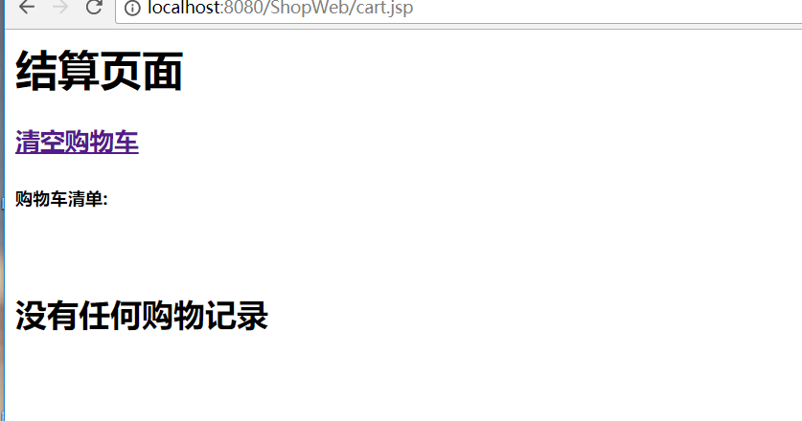

# 收获与问题

起初session和cookie什么都不懂，询问大佬，加看B站的网课，各种百度csdn博客，才慢慢入门，越发感觉javaweb真心不容易，不过只要肯学，我相信404，500这些慢慢都不会是问题。