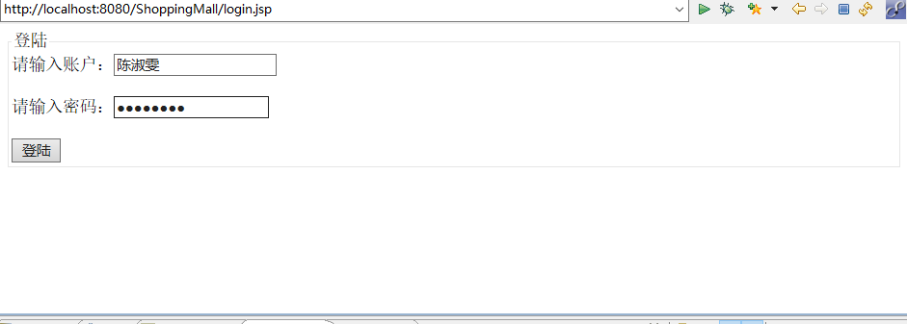

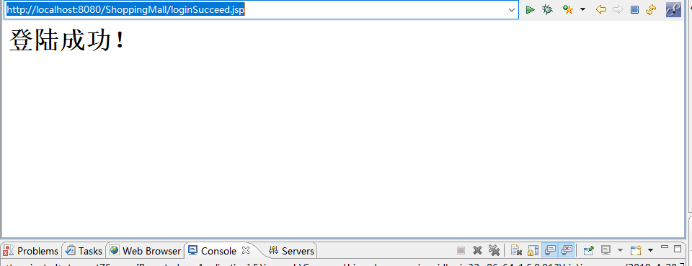

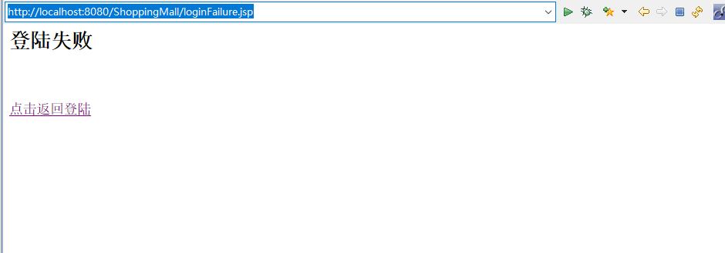

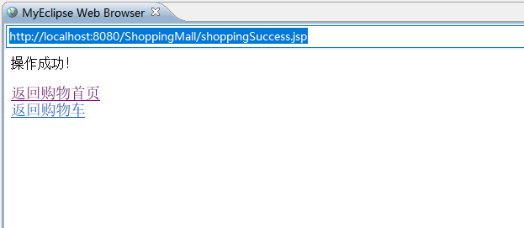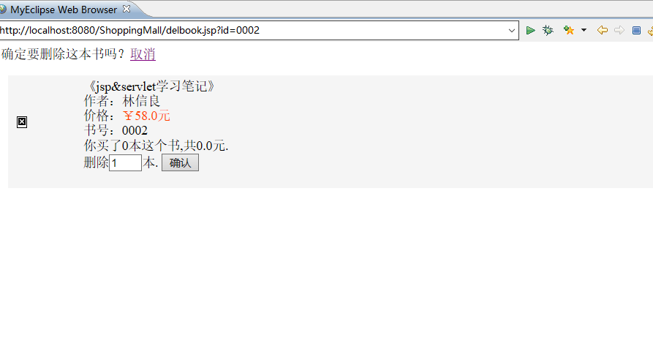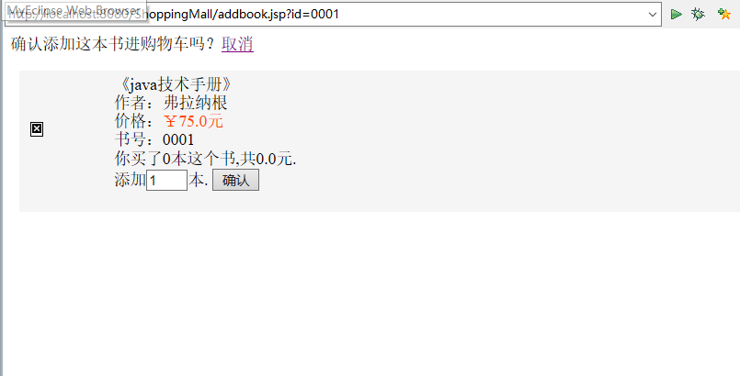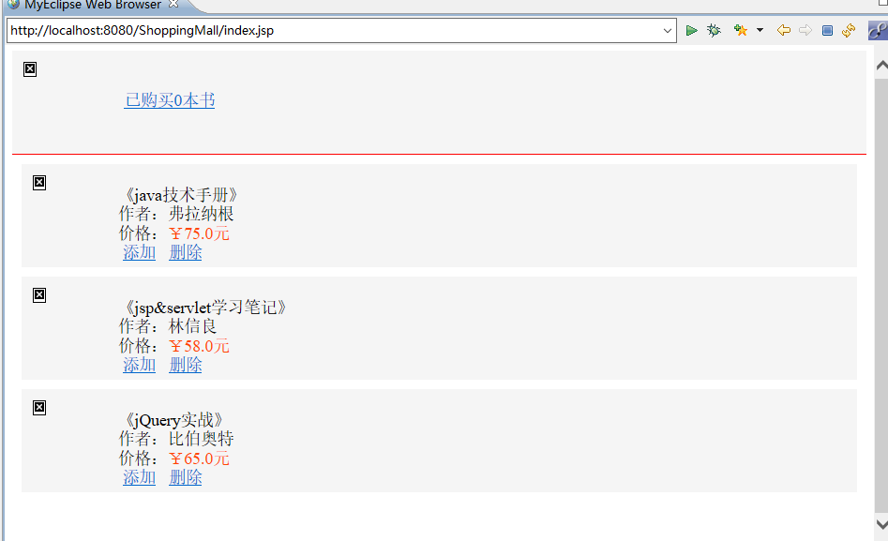

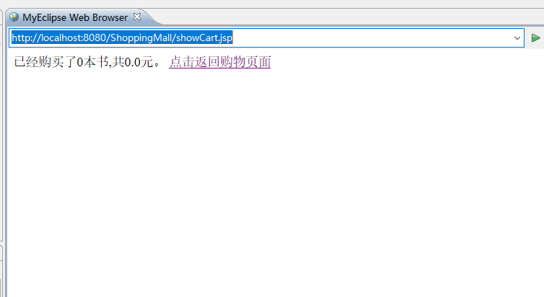

package chansukman.one;

import java.io.IOException;

import java.io.PrintWriter;

import javax.servlet.ServletException;

import javax.servlet.annotation.WebInitParam;

import javax.servlet.annotation.WebServlet;

import javax.servlet.http.HttpServlet;

import javax.servlet.http.HttpServletRequest;

import javax.servlet.http.HttpServletResponse;

import javax.servlet.http.HttpSession;

@WebServlet("/loginC.do")

public class LoginC extends HttpServlet {

private void processRequest(HttpServletRequest request, HttpServletResponse response)

throws ServletException, IOException {

request.setCharacterEncoding("utf-8");

response.setContentType("text/html;charset=utf-8");

if(request.getParameter("username")!=null

&&request.getParameter("password")!=null){

request.getRequestDispatcher("LoginM.server")

.forward(request, response);

}else{

response.sendRedirect("loginFailure.jsp");

}

}

public void doGet(HttpServletRequest request, HttpServletResponse response)

throws ServletException, IOException {

processRequest(request,response);

}

public void doPost(HttpServletRequest request, HttpServletResponse response)

throws ServletException, IOException {

processRequest(request,response);

}

}

package chansukman.one;

import java.io.IOException;

import java.io.PrintWriter;

import javax.servlet.ServletException;

import javax.servlet.annotation.WebServlet;

import javax.servlet.http.HttpServlet;

import javax.servlet.http.HttpServletRequest;

import javax.servlet.http.HttpServletResponse;

import javax.servlet.http.HttpSession;

@WebServlet("/loginM.do")

public class LoginM extends HttpServlet {

private void processRequest(HttpServletRequest request, HttpServletResponse response)

throws ServletException, IOException {

request.setCharacterEncoding("utf-8");

response.setContentType("text/html;charset=utf-8");

if(!request.getParameter("username").equals("")

&&!request.getParameter("password").equals("")){

if(request.getParameter("username").equals("陈淑雯")

&&request.getParameter("password").equals("04171428")){

request.getRequestDispatcher("loginSucceed.jsp")

.forward(request, response);

}else

response.sendRedirect("loginFailure.jsp");

}else

response.sendRedirect("loginFailure.jsp");

}

public void doGet(HttpServletRequest request, HttpServletResponse response)

throws ServletException, IOException {

processRequest(request,response);

}

public void doPost(HttpServletRequest request, HttpServletResponse response)

throws ServletException, IOException {

processRequest(request,response);

}

}

package chansukman.one;

import java.io.IOException;

import java.io.PrintWriter;

import javax.servlet.ServletException;

import javax.servlet.annotation.WebServlet;

import javax.servlet.http.HttpServlet;

import javax.servlet.http.HttpServletRequest;

import javax.servlet.http.HttpServletResponse;

import javax.servlet.http.HttpSession;

@WebServlet("/loginM.do")

public class LoginM extends HttpServlet {

private void processRequest(HttpServletRequest request, HttpServletResponse response)

throws ServletException, IOException {

request.setCharacterEncoding("utf-8");

response.setContentType("text/html;charset=utf-8");

if(!request.getParameter("username").equals("")

&&!request.getParameter("password").equals("")){

if(request.getParameter("username").equals("陈淑雯")

&&request.getParameter("password").equals("04171428")){

request.getRequestDispatcher("loginSucceed.jsp")

.forward(request, response);

}else

response.sendRedirect("loginFailure.jsp");

}else

response.sendRedirect("loginFailure.jsp");

}

public void doGet(HttpServletRequest request, HttpServletResponse response)

throws ServletException, IOException {

processRequest(request,response);

}

public void doPost(HttpServletRequest request, HttpServletResponse response)

throws ServletException, IOException {

processRequest(request,response);

}

}

**package** chansukman.two;

**import** java.io.Serializable;

**public** **class** Book **implements** Serializable {

**private** String id;//图书编号

**private** String name;//书名

**private** String author;//作者

**private** String imgsrc;//图书图片来源

**private** **double** price;//价格

**public** **void** setId(String id){

**this**.id=id;

}

**public** **void** setName(String name){

**this**.name=name;

}

**public** **void** setAuthor(String author){

**this**.author=author;

}

**public** **void** setImgsrc(String imgsrc){

**this**.imgsrc=imgsrc;

}

**public** **void** setPrice(**double** price){

**this**.price=price;

}

**public** String getId(){

**return** **this**.id;

}

**public** String getName(){

**return** **this**.name;

}

**public** String getAuthor(){

**return** **this**.author;

}

**public** String getImgsrc(){

**return** **this**.imgsrc;

}

**public** **double** getPrice(){

**return** **this**.price;

}

}

**package** chansukman.two;

**import** java.io.Serializable;

**public** **class** BookList **implements** Serializable {

**private** Book book=**new** Book();//书

**private** **int** count;//购买这本书的数量

**private** **double** amount;//购买这么多本书的总价

**public** **void** setBook(Book book){

**this**.book=book;

}

**public** **void** setCount(**int** count){

**this**.count=count;

}

**public** **void** setAmount(**double** amount){

**this**.amount=amount;

}

**public** Book getBook(){

**return** **this**.book;

}

**public** **int** getCount(){

**return** **this**.count;

}

**public** **double** getAmount(){

**return** **this**.amount;

}

//调用setAmount()时可以用到

**public** **double** calcAmount(){

**double** am;

am=count*book.getPrice();

**return** am;

}

}

package chansukman.two;

import java.io.Serializable;

import java.util.ArrayList;

import java.util.List;

public class CartBook implements Serializable {

private ArrayList<BookList> bookLists=new ArrayList<BookList>();//购书数组

private int sumCount;//一共买了几本书

private double sumAmount;//这些书一共多少钱

public void setBookLists(ArrayList<BookList> bookLists){

this.bookLists=bookLists;

}

public void setSumCount(int sumCount){

this.sumCount=sumCount;

}

public void setSumAmount(double sumAmount){

this.sumAmount=sumAmount;

}

public ArrayList<BookList> getBookLists(){

return this.bookLists;

}

public int getSumCount(){

return this.sumCount;

}

public double getSumAmount(){

return this.sumAmount;

}

//调用setSumCount()时可以用到

public int calcSumCount(){

int sc=0;

for(BookList bookList:bookLists){

sc+=bookList.getCount();

}

return sc;

}

//调用getSumAmount()时可以用到

public double calcSumAmount(){

double sa=0;

for(BookList bookList:bookLists){

sa+=bookList.getAmount();

}

return sa;

}

}

package chansukman.two;

import java.io.IOException;

import java.io.PrintWriter;

import java.util.ArrayList;

import javax.servlet.ServletException;

import javax.servlet.http.HttpServlet;

import javax.servlet.http.HttpServletRequest;

import javax.servlet.http.HttpServletResponse;

import javax.servlet.http.HttpSession;

public class Del extends HttpServlet {

private void processRequest(HttpServletRequest request, HttpServletResponse response)

throws ServletException, IOException {

request.setCharacterEncoding("utf-8");

response.setContentType("text/html;charset=utf-8");

HttpSession session=request.getSession();

CartBook cartBook=(CartBook)session.getAttribute("cartbook");

String delid=(String)session.getAttribute("delid");

int delnum=Integer.parseInt((String) session.getAttribute("del"));

Book book;

BookList bl=new BookList();

BookList temp=new BookList();

ArrayList<BookList> bookLists=cartBook.getBookLists();

for(BookList bookList:bookLists){

book=bookList.getBook();

if(book.getId().equals(delid)){

temp=bookList;

bl.setBook(book);

if(delnum>=bookList.getCount()){

bl.setCount(0);

}else{

bl.setCount(bookList.getCount()-delnum);

}

bl.setAmount(bl.calcAmount());

}

}

bookLists.remove(temp);

bookLists.add(bl);

cartBook.setBookLists(bookLists);

cartBook.setSumCount(cartBook.calcSumCount());

cartBook.setSumAmount(cartBook.calcSumAmount());

session.setAttribute("cartbook",cartBook);

response.sendRedirect("shoppingSuccess.jsp");

}

public void doGet(HttpServletRequest request, HttpServletResponse response)

throws ServletException, IOException {

processRequest(request,response);

}

public void doPost(HttpServletRequest request, HttpServletResponse response)

throws ServletException, IOException {

processRequest(request,response);

}

}

package chansukman.two;

import java.io.IOException;

import java.io.PrintWriter;

import java.util.ArrayList;

import javax.servlet.ServletException;

import javax.servlet.http.HttpServlet;

import javax.servlet.http.HttpServletRequest;

import javax.servlet.http.HttpServletResponse;

import javax.servlet.http.HttpSession;

public class Del extends HttpServlet {

private void processRequest(HttpServletRequest request, HttpServletResponse response)

throws ServletException, IOException {

request.setCharacterEncoding("utf-8");

response.setContentType("text/html;charset=utf-8");

HttpSession session=request.getSession();

CartBook cartBook=(CartBook)session.getAttribute("cartbook");

String delid=(String)session.getAttribute("delid");

int delnum=Integer.parseInt((String) session.getAttribute("del"));

Book book;

BookList bl=new BookList();

BookList temp=new BookList();

ArrayList<BookList> bookLists=cartBook.getBookLists();

for(BookList bookList:bookLists){

book=bookList.getBook();

if(book.getId().equals(delid)){

temp=bookList;

bl.setBook(book);

if(delnum>=bookList.getCount()){

bl.setCount(0);

}else{

bl.setCount(bookList.getCount()-delnum);

}

bl.setAmount(bl.calcAmount());

}

}

bookLists.remove(temp);

bookLists.add(bl);

cartBook.setBookLists(bookLists);

cartBook.setSumCount(cartBook.calcSumCount());

cartBook.setSumAmount(cartBook.calcSumAmount());

session.setAttribute("cartbook",cartBook);

response.sendRedirect("shoppingSuccess.jsp");

}

public void doGet(HttpServletRequest request, HttpServletResponse response)

throws ServletException, IOException {

processRequest(request,response);

}

public void doPost(HttpServletRequest request, HttpServletResponse response)

throws ServletException, IOException {

processRequest(request,response);

}

}

package chansukman.two;

import java.io.IOException;

import java.io.PrintWriter;

import javax.servlet.ServletException;

import javax.servlet.annotation.WebServlet;

import javax.servlet.http.HttpServlet;

import javax.servlet.http.HttpServletRequest;

import javax.servlet.http.HttpServletResponse;

import javax.servlet.http.HttpSession;

public class Shopping extends HttpServlet {

private void processRequest(HttpServletRequest request, HttpServletResponse response)

throws ServletException, IOException {

request.setCharacterEncoding("utf-8");

response.setContentType("text/html;charset=utf-8");

HttpSession session=request.getSession();

String add=request.getParameter("add");

String del=request.getParameter("del");

if(add!=null){

session.setAttribute("add", add);

response.sendRedirect("add.do");

}

if(del!=null){

session.setAttribute("del", del);

response.sendRedirect("del.do");

}

}

public void doGet(HttpServletRequest request, HttpServletResponse response)

throws ServletException, IOException {

processRequest(request,response);

}

public void doPost(HttpServletRequest request, HttpServletResponse response)

throws ServletException, IOException {

processRequest(request,response);

}

}

<%@ page language=*"java"* import=*"java.util.*"* pageEncoding=*"utf-8"* %>

<%@ page import=*"chansukman.two.*"* %>

<!DOCTYPE HTML PUBLIC "-//W3C//DTD HTML 4.01 Transitional//EN">

<html>

<head>

<title>添加购物车</title>

</head>

<body>

<p>确认添加这本书进购物车吗？<a href=*"index.jsp"*>取消</a></p>

<%

CartBook cartBook;

**if**(session.getAttribute("cartbook")==**null**){

cartBook=InitCartBook.init();

session.setAttribute("cartbook", cartBook);

}**else**{

cartBook=(CartBook)session.getAttribute("cartbook");

}

Book book;

**for**(BookList bookList:cartBook.getBookLists()){

book=bookList.getBook();

**if**((book.getId()).equals(request.getParameter("id"))){

session.setAttribute("addid",book.getId());

%>

<div style="background-color:*#F5F5F5*;padding:*5px*;margin:*10px*;">

<img src=<%= book.getImgsrc() %> height=*"100px"* style="vertical-align:*bottom*;"/>

<div style="display:*inline-block*;">

《<%= book.getName() %>》<br>

作者：<%= book.getAuthor() %><br>

价格：<span style="color:*#FF4500*;">￥<%= book.getPrice() %>元</span><br>

书号：<%= book.getId() %><br>

你买了<%= bookList.getCount() %>本这个书,共<%= bookList.getAmount() %>元.<br>

<form method=*"post"* action=*"shopping.do"*>

添加<input type=*"text"* name=*"add"* value=*"1"* size=*"1"*>本.

<input type=*"submit"* value=*"确认"*>

</form>

</div>

</div>

<%

}

}

%>

</body>

</html>

<%@ page language=*"java"* import=*"java.util.*"* pageEncoding=*"utf-8"*%>

<%@ page import=*"chansukman.two.*"* %>

<!DOCTYPE HTML PUBLIC "-//W3C//DTD HTML 4.01 Transitional//EN">

<html>

<head>

<title>删除购物车</title>

</head>

<body>

<p>确定要删除这本书吗？<a href=*"index.jsp"*>取消</a></p>

<%

CartBook cartBook;

**if**(session.getAttribute("cartbook")==**null**){

cartBook=InitCartBook.init();

session.setAttribute("cartbook", cartBook);

}**else**{

cartBook=(CartBook)session.getAttribute("cartbook");

}

Book book;

**for**(BookList bookList:cartBook.getBookLists()){

book=bookList.getBook();

**if**((book.getId()).equals(request.getParameter("id"))){

session.setAttribute("delid",book.getId());

%>

<div style="background-color:*#F5F5F5*;padding:*5px*;margin:*10px*;">

<img src=<%= book.getImgsrc() %> height=*"100px"* style="vertical-align:*bottom*;"/>

<div style="display:*inline-block*;">

《<%= book.getName() %>》<br>

作者：<%= book.getAuthor() %><br>

价格：<span style="color:*#FF4500*;">￥<%= book.getPrice() %>元</span><br>

书号：<%= book.getId() %><br>

你买了<%= bookList.getCount() %>本这个书,共<%= bookList.getAmount() %>元.<br>

<form method=*"post"* action=*"shopping.do"*>

删除<input type=*"text"* name=*"del"* value=*"1"* size=*"1"*>本.

<input type=*"submit"* value=*"确认"*>

</form>

</div>

</div>

<%

}

}

%>

</body>

</html>

<%@ page language=*"java"* import=*"java.util.*"* pageEncoding=*"utf-8"*%>

<%@ page import=*"chansukman.two.*"* %>

<!DOCTYPE HTML PUBLIC "-//W3C//DTD HTML 4.01 Transitional//EN">

<html>

<head>

<title>购书首页</title>

</head>

<body>

<%

CartBook cartBook;

**if**(session.getAttribute("cartbook")==**null**){

cartBook=InitCartBook.init();

session.setAttribute("cartbook", cartBook);

}**else**{

cartBook=(CartBook)session.getAttribute("cartbook");

}

%>

<div style="background-color:*#F5F5F5*;padding:*5px*;border-bottom:*1px solid #ff0000*;">

<img src=*"image/shopCart.jpg"* width=*"100px"* height=*"100px"* style="vertical-align:*middle*;"/>

<a href=*"showCart.jsp"* style="margin:*10px*">已购买<%= cartBook.getSumCount() %>本书</a>

</div>

<%

Book book;

**for**(BookList bookList:cartBook.getBookLists()){

book=bookList.getBook();

%>

<div style="background-color:*#F5F5F5*;padding:*5px*;margin:*10px*;">

<img src=<%= book.getImgsrc() %> height=*"100px"* style="vertical-align:*bottom*;"/>

<div style="display:*inline-block*;">

《<%= book.getName() %>》<br>

作者：<%= book.getAuthor() %><br>

价格：<span style="color:*#FF4500*;">￥<%= book.getPrice() %>元</span><br>

<a href=*"addbook.jsp?id=*<%= book.getId() %>*"* style="margin:*5px*">添加</a>

<a href=*"delbook.jsp?id=*<%= book.getId() %>*"* style="margin:*5px*">删除</a>

</div>

</div>

<%

}

%>

</body>

</html>

<%@ page language=*"java"* import=*"java.util.*"* pageEncoding=*"utf-8"*%>

<!DOCTYPE HTML PUBLIC "-//W3C//DTD HTML 4.01 Transitional//EN">

<html>

<head>

<title>登陆(MVC模式)</title>

</head>

<body>

<form method=*"post"* action=*"loginC.do"*>

<fieldset>

<legend>登陆</legend>

请输入账户：<input type=*"text"* name=*"username"* ><br><br>

请输入密码：<input type=*"password"* name=*"password"*><br><br>

<input type=*"submit"* value=*"登陆"* name=*"submit"*>

</fieldset>

</form>

</body>

</html>

<%@ page language=*"java"* import=*"java.util.*"* pageEncoding=*"utf-8"*%>

<!DOCTYPE HTML PUBLIC "-//W3C//DTD HTML 4.01 Transitional//EN">

<html>

<head>

<title> 登陆失败</title>

</head>

<body>

<h2>登陆失败</h2><br><br>

<a href=*"login.jsp"*>点击返回登陆</a>

</body>

</html>

<%@ page language=*"java"* import=*"java.util.*"* pageEncoding=*"utf-8"*%>

<!DOCTYPE HTML PUBLIC "-//W3C//DTD HTML 4.01 Transitional//EN">

<html>

<head>

<title>登陆成功</title>

</head>

<body>

<h1>${param.username}登陆成功！</h1>

</body>

</html>

<%@ page language=*"java"* import=*"java.util.*"* pageEncoding=*"utf-8"*%>

<!DOCTYPE HTML PUBLIC "-//W3C//DTD HTML 4.01 Transitional//EN">

<html>

<head>

<title>操作成功</title>

</head>

<body>

<p style="font-size:*16px*;">操作成功！</p>

<a href=*"index.jsp"*>返回购物首页</a><br>

<a href=*"showCart.jsp"*>返回购物车</a>

</body>

</html>

<%@ page language=*"java"* import=*"java.util.*"* pageEncoding=*"utf-8"*%>

<%@ page import=*"chansukman.two.*"* %>

<!DOCTYPE HTML PUBLIC "-//W3C//DTD HTML 4.01 Transitional//EN">

<html>

<head>

<title>购物车</title>

</head>

<body>

<%

CartBook cartBook;

**if**(session.getAttribute("cartbook")==**null**){

cartBook=InitCartBook.init();

session.setAttribute("cartbook", cartBook);

}**else**{

cartBook=(CartBook)session.getAttribute("cartbook");

}

%>

<p>已经购买了<%= cartBook.getSumCount() %>本书,共<%= cartBook.getSumAmount() %>元。

<a href=*"index.jsp"*>点击返回购物页面</a>

</p>

<%

Book book;

**for**(BookList bookList:cartBook.getBookLists()){

book=bookList.getBook();

**if**(bookList.getCount()!=0){

%>

<div style="background-color:*#F5F5F5*;padding:*5px*;margin:*10px*;">

<img src=<%= book.getImgsrc() %> height=*"100px"* style="vertical-align:*bottom*;"/>

<div style="display:*inline-block*;">

《<%= book.getName() %>》<br>

作者：<%= book.getAuthor() %><br>

价格：<span style="color:*#FF4500*;">￥<%= book.getPrice() %>元</span><br>

书号：<%= book.getId() %><br>

你买了<%= bookList.getCount() %>本这个书,共<%= bookList.getAmount() %>元.<br>

<a href=*"addbook.jsp?id=*<%= book.getId() %>*"* style="margin:*5px*">添加</a>

<a href=*"delbook.jsp?id=*<%= book.getId() %>*"* style="margin:*5px*">删除</a>

</div>

</div>

<%

}

}

%>

</body>

</html>