**Java Web**开发

实验五

作业报告

|  |  |
| --- | --- |
| 学院 | 计算机 |
| 所在系班级 | 2017软件工程系07班 |
| 学号姓名 | 04171507邓家荣 |
| 指导教师 | 罗永升 |
| 完成时间 | 2019年 4月22 日 |

1. **实验题目**
2. 第四章课后练习3购物车，实现一个购物车应用程序，可以购物，显示购物数量并查看购物车内容。

提示：采购此书做成超链接，并用URL重写带关键信息

* 1. Shopping.view?bookID=”Java 技术手册”，每点击一次增加一本书，并返回当前的选购页面。
  2. 除了要保持商品名字，还要保存对应商品的数量，所以session对象保存的信息需要考虑清楚

**二、 分析与设计**

**三、 关键源码（部分）**

**Book.jsp**

<html>

<%

**if**(session.getAttribute("bookList")==**null**)

{

Book[] Booklist = **new** Book[3];

Booklist[0] = **new** Book("001","Java技术手册","img/001.jpg",48.0,0);

Booklist[1] = **new** Book("002","Java入门经典","img/002.jpg",77.2,0);

Booklist[2] = **new** Book("003","Java核心技术","img/003.jpg",99.5,0);

session.setAttribute("bookList",Booklist);

session.setAttribute("sum",0);

}

%>

<head>

<base href=*"*<%=basePath%>*"*>

<title>书籍选购</title>

<meta http-equiv=*"pragma"* content=*"no-cache"*>

<meta http-equiv=*"cache-control"* content=*"no-cache"*>

<meta http-equiv=*"expires"* content=*"0"*>

<meta http-equiv=*"keywords"* content=*"keyword1,keyword2,keyword3"*>

<meta http-equiv=*"description"* content=*"This is my page"*>

<!--

<link rel="stylesheet" type="text/css" href="styles.css">

-->

</head>

<body style="background:*url(img/004.jpg)*"><font size=*5*>

<p>欢迎来到购书页面，请购买书籍。</p>

<a href=*"cart.jsp"*>已采购<%=session.getAttribute("sum") %>本书籍</a><br>

<table>

<%

Book[] bookList=(Book[])session.getAttribute("bookList");

out.println("<tr align='center'>");

**for**(Book book:bookList)

{

out.println("<td><img src='"+book.getimg()+"' height=500 width=400></td>");

}

out.println("</tr>");

out.println("<tr align='center'>") ;

**for**(Book book:bookList)

{

out.println("<td>"+book.getBookPrice()+"元</td>");

}

out.println("</tr>");

out.println("<tr align='center'>");

**for**(Book book:bookList){

out.println("<td><a href ='shopBuy.view?id=" + book.getBookID() + "'>采购此书</a></td>");

}

out.println("</tr>");

%>

</table>

</form>

</font>

</body>

</html>

cart.jsp

<html>

<head>

<base href=*"*<%=basePath%>*"*>

<title>>购物车</title>

<meta http-equiv=*"pragma"* content=*"no-cache"*>

<meta http-equiv=*"cache-control"* content=*"no-cache"*>

<meta http-equiv=*"expires"* content=*"0"*>

<meta http-equiv=*"keywords"* content=*"keyword1,keyword2,keyword3"*>

<meta http-equiv=*"description"* content=*"This is my page"*>

<!--

<link rel="stylesheet" type="text/css" href="styles.css">

-->

</head>

<body style="background:*url(img/004.jpg)*"><font size=*5*>

<h1> 已采购<%=session.getAttribute("sum")%>本书籍</h1>

<table>

<%

Book[] bookList=(Book[])session.getAttribute("bookList");

%>

<tr align=*'center'*>

<%

**double** aa;

**for**(Book book:bookList)

{

out.println("<td><img src='"+book.getimg()+"' height=500 width=400></td>");

}

%>

</tr>

<tr align=*'center'*>

<%

**for**(Book book:bookList)

{

out.println("<td>共"+book.getshopNum()+"本书籍</td>");

}

%>

<tr><td><a href=*'Book.jsp'*><font size=*5*>返回主页</font></a></td></tr>

</table>

</body>

</html>

Cart.java

**public** **class** cart **extends** HttpServlet {

**protected** **void** doGet(HttpServletRequest request, HttpServletResponse response)

**throws** ServletException, IOException {

request.setCharacterEncoding("utf-8");

response.setCharacterEncoding("utf-8");

response.setContentType("text/html;charset=utf-8");

PrintWriter out=response.getWriter();

HttpSession session=request.getSession();

out.println("<html>");

out.println("<head><title>购物车</title></head>");

out.println("<body style='background:url(img/004.jpg)''>");

out.println("<h1> 已采购"+session.getAttribute("sum")+"本书籍</h1>");

out.println("<table>");

Book[] bookList=(Book[])session.getAttribute("bookList");

out.println("<tr align='center'>");

**for**(Book book:bookList)

{

out.println("<td><img src='"+book.getimg()+"'></td>");

}

out.println("</tr>");

out.println("<tr align='center'>");

**for**(Book book:bookList)

{

out.println("<td>共"+book.getshopNum()+"本书籍</td>");

}

out.println("</tr>");

out.println("<tr><td><a href='Book.jsp'>返回主页</a></td></tr>");

out.println("</table>");

out.println("</body>");

out.println("</html>");

}

}

ShopBuy.java

@WebServlet("/shopBuy.view")

**public** **class** shopBuy **extends** HttpServlet {

**protected** **void** doGet(HttpServletRequest request, HttpServletResponse response)

**throws** ServletException, IOException {

response.setContentType("text/html;charset=utf-8");

request.setCharacterEncoding("utf-8");

response.setCharacterEncoding("utf-8");

HttpSession session=request.getSession();

Object sum=session.getAttribute("sum");

Book[] bookList=(Book[])session.getAttribute("bookList");

String id =request.getParameter("id");

**for**(**int** i=0;i<bookList.length;i++)

{

**if**(bookList[i].getBookID().equals(id))

{

bookList[i].addshopNum();

session.setAttribute("sum", Integer.*parseInt*(sum.toString())+1);

request.getRequestDispatcher("Book.jsp").forward(request, response);

}

}

}

}

Book.java

**public** **class** Book

{

String BookID;//商品ID�?

String BookName;//商品名字

String img;//商品图片

**double** BookPrice;//商品价格

**int** shopNum;//购买商品数量

**public** Book(String id,String name,String img,**double** price,**int** shopNum)

{

BookID=id;

BookName=name;

**this**.img=img;

BookPrice=price;

**this**.shopNum=shopNum;

}

**public** String getBookID()

{

**return** BookID;

}

**public** **void** setBookID(String BookID)

{

**this**.BookID = BookID;

}

**public** String getBookName()

{

**return** BookName;

}

**public** **void** setBookName(String BookName)

{

**this**.BookName = BookName;

}

**public** String getimg()

{

**return** img;

}

**public** **void** setBookImg(String img)

{

**this**.img = img;

}

**public** **double** getBookPrice()

{

**return** BookPrice;

}

**public** **void** setBookPrice(**double** BookPrice)

{

**this**.BookPrice = BookPrice;

}

**public** **int** getshopNum()

{

**return** shopNum;

}

**public** **void** setshopNum(**int** shopNum)

{

**this**.shopNum = shopNum;

}

**public** **void** addshopNum()

{

shopNum++;

}

}

**四、运行效果图**

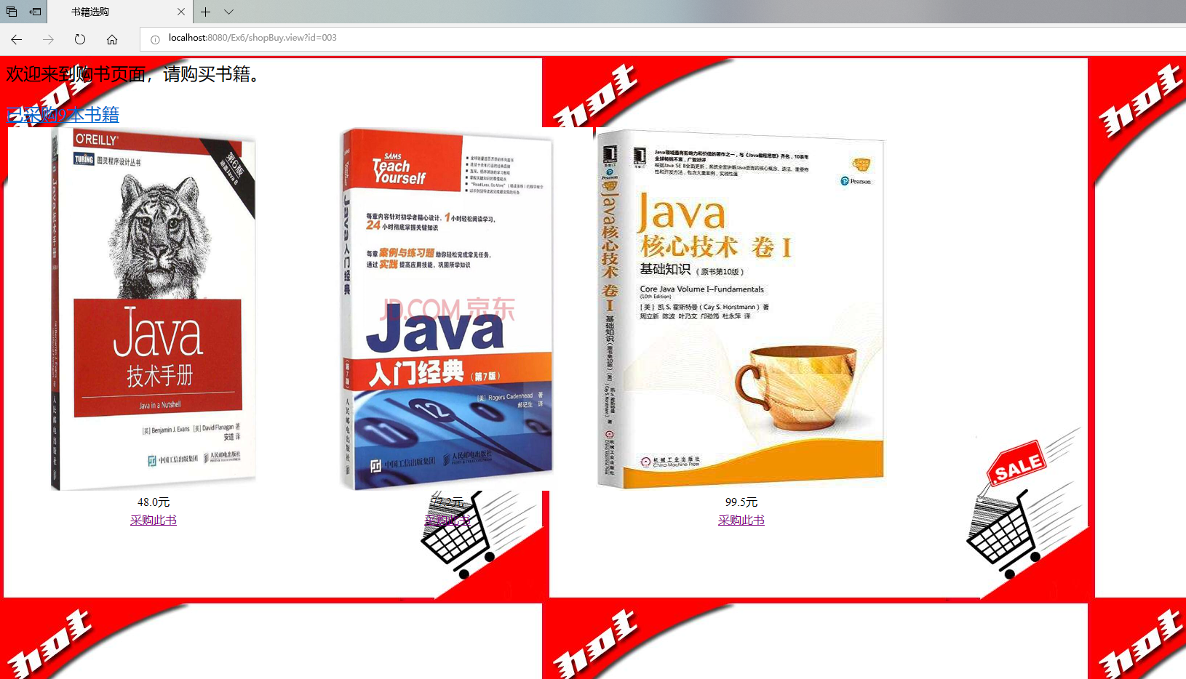

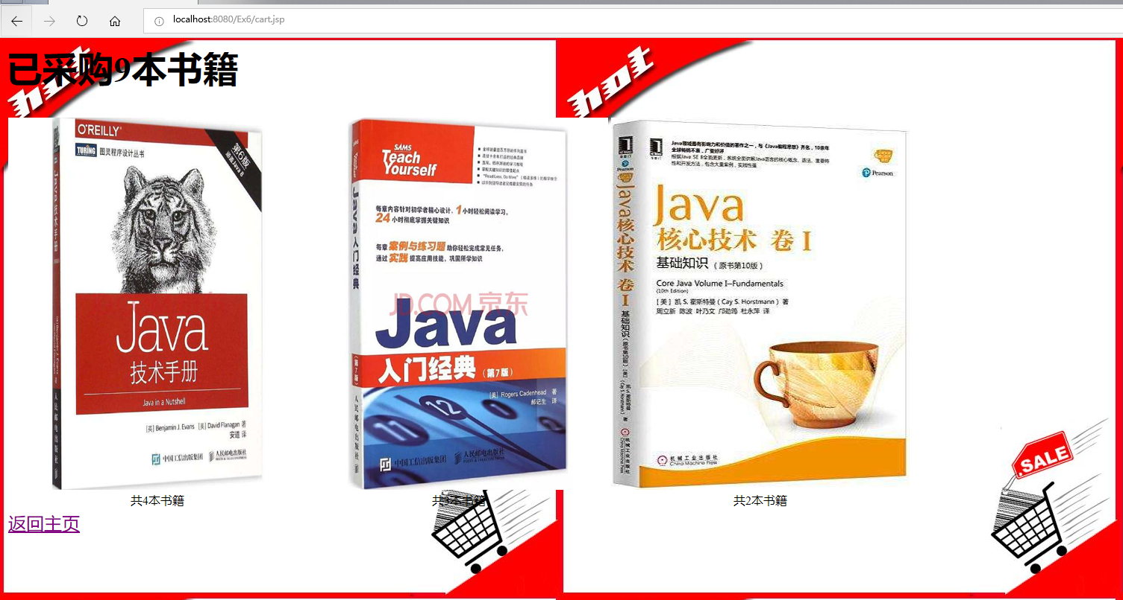

**五、收获与问题**

1、了解HttpSession原理

2、掌握如何使用HttpSession会话管理