**Java Web开发**

**实验五**

**作业报告**

|  |  |
| --- | --- |
| 学 院 | 计算机 |
| 所在系 班 级 | 2017软件工程系7班 |
| 学 号 姓 名 | 04171516周卓逸 |
| 指 导 教 师 | 郭晓燕 |
| 完 成 时 间 | 2019年4月20日 |

# 实验题目

1. 第四章课后练习3购物车，实现一个购物车应用程序，可以购物，显示购物数量并查看购物车内容。（此题模版test4E，提供给大家参考。）

# 关键源码

newcartServlet.java

**package** cc.home;

**import** cc.home.Book;

**import** java.io.IOException;

**import** java.io.PrintWriter;

**import** javax.servlet.ServletException;

**import** javax.servlet.annotation.WebServlet;

**import** javax.servlet.http.HttpServlet;

**import** javax.servlet.http.HttpServletRequest;

**import** javax.servlet.http.HttpServletResponse;

**import** javax.servlet.http.HttpSession;

@WebServlet("/cart.view")

**public** **class** newcartServlet **extends** HttpServlet {

**public** **void** doGet(HttpServletRequest request, HttpServletResponse response)

**throws** ServletException, IOException {

/*判断得到session对象中存储的book信息是否为空

不为空的前提下，读出Book数组中的内容，并将数目不为1的图书信息显示在网页上。

*/

response.setContentType("text/html; charset=UTF-8");

HttpSession session=request.getSession();

PrintWriter out =response.getWriter();

Book[] Books=(Book[])session.getAttribute("bookList");

**if**(Books!=**null**)

{

**for**(**int** i=0;i<Books.length;i++)

{

**if**(Books[i].getBookNum()>0)

{

out.println("<table border=1><tr><td><img src="+Books[i].getBookImg()+"></td><td>"+Books[i].getBookNum()+"本</td>");

}

}

}

session.setAttribute("bookList", Books);

}

**public** **void** doPost(HttpServletRequest request, HttpServletResponse response)

**throws** ServletException, IOException {

doGet(request,response);

}

}

shoppingServlet.java

**package** cc.home;

**import** cc.home.Book;

**import** java.io.IOException;

**import** java.io.PrintWriter;

**import** javax.servlet.ServletException;

**import** javax.servlet.annotation.WebServlet;

**import** javax.servlet.http.HttpServlet;

**import** javax.servlet.http.HttpServletRequest;

**import** javax.servlet.http.HttpServletResponse;

**import** javax.servlet.http.HttpSession;

@WebServlet("/shopping.view")

**public** **class** ShoppingServlet **extends** HttpServlet {

**public** **void** doGet(HttpServletRequest request, HttpServletResponse response)

**throws** ServletException, IOException {

//获取从Shopping.jsp传来的request对象中的ID号

HttpSession session=request.getSession();

String id=request.getParameter("id");

**int** sum=(Integer)session.getAttribute("sum");

//在ID号不为空的情况下，获取Session对象中的购物车信息，Book数组。

**if**(id!=**null**)

{

Book[] books=(Book [])session.getAttribute("bookList");

//找到数组中与ID对应的Book对象，将其属性bookNum数字加1

**for**(**int** i=0;i<books.length;i++)

{

**if**(id.equals(books[i].getBookId()))

{

sum++;

books[i].setBookNum(books[i].getBookNum()+1);

}

}

//将数组写回session对象中去。

session.setAttribute("bookList", books);

session.setAttribute("sum", sum);

}

//跳转回Shopping.jsp

response.sendRedirect("Shopping.jsp");

}

**public** **void** doPost(HttpServletRequest request, HttpServletResponse response)

**throws** ServletException, IOException {

doGet(request,response);

}

}

Book.java

**package** cc.home;

**public** **class** Book {

**private** String bookId;

**private** String bookName;

String bookImg;

**private** **int** bookNum;

**public** Book(String bookId, String bookName, String bookImg, **int** bookNum) {

**this**.bookId = bookId;

**this**.bookName = bookName;

**this**.bookImg = bookImg;

**this**.bookNum = 0;

}

**public** **void** setBookId(String bookId)

{

**this**.bookId =bookId;

}

**public** String getBookId() {

**return** bookId;

}

**public** **void** setBookName(String bookName)

{

**this**.bookName=bookName;

}

**public** String getBookName() {

**return** bookName;

}

**public** **void** setBookImg(String bookImg){

**this**.bookImg =bookImg;

}

**public** String getBookImg() {

**return** bookImg;

}

**public** **void** setBookNum(**int** bookNum)

{

**this**.bookNum=bookNum;

}

**public** **int** getBookNum() {

**return** bookNum;

}

}

Shopping.jsp

<%@ page language=*"java"* import=*"java.util.*"* pageEncoding=*"UTF-8"*%>

<%@page import=*"cc.home.*"* %>

<!DOCTYPE HTML PUBLIC "-//W3C//DTD HTML 4.01 Transitional//EN">

<html>

<%

//当第一次访问采购网页，session对象中还没有book购物车信息时，进行初始化。

**if** (session.getAttribute("bookList")==**null**){

//在session对象中存储图书基本信息

Book[] BookList = **new** Book[4];

BookList[0] = **new** Book("10101", "Java核心技术", "img/10101.jpg",0);

BookList[1] = **new** Book("10102", "Java经典实例", "img/10102.jpg",0);

BookList[2] = **new** Book("10103", "Java7", "img/10103.jpg",0);

BookList[3] = **new** Book("10104", "JSP&Servlet", "img/10104.jpg",0);

//存入session对象中

session.setAttribute("bookList",BookList);

session.setAttribute("sum",0);

}

%>

<body>

<br>

<img src=*"img/cart.jpg"* height=*"60px"* width=*"60px"*>

<a href=*"cart.view"*>已采购<%=session.getAttribute("sum")%>本书籍</a><br>

<br>

<table border=*"1"*>

<tr>

<td><img src=*"img/10101.jpg"*></td>

<td><img src=*"img/10102.jpg"*></td>

<td><img src=*"img/10103.jpg"*></td>

<td><img src=*"img/10104.jpg"*></td>

</tr>

<tr>

<td><a href=*"shopping.view?id=10101"*>采购此书</a></td>

<td><a href=*"shopping.view?id=10102"*>采购此书</a></td>

<td><a href=*"shopping.view?id=10103"*>采购此书</a></td>

<td><a href=*"shopping.view?id=10104"*>采购此书</a></td>

</tr>

</body>

</html>

# 运行效果图

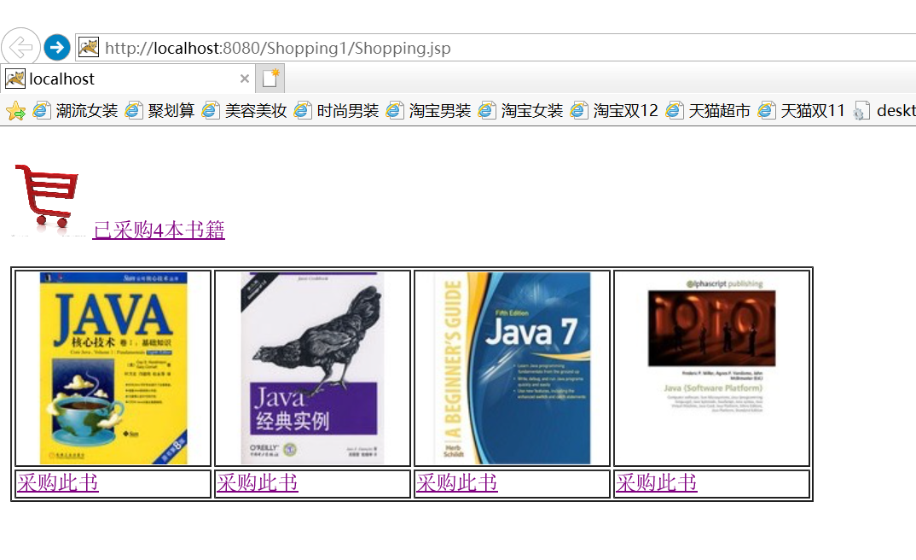

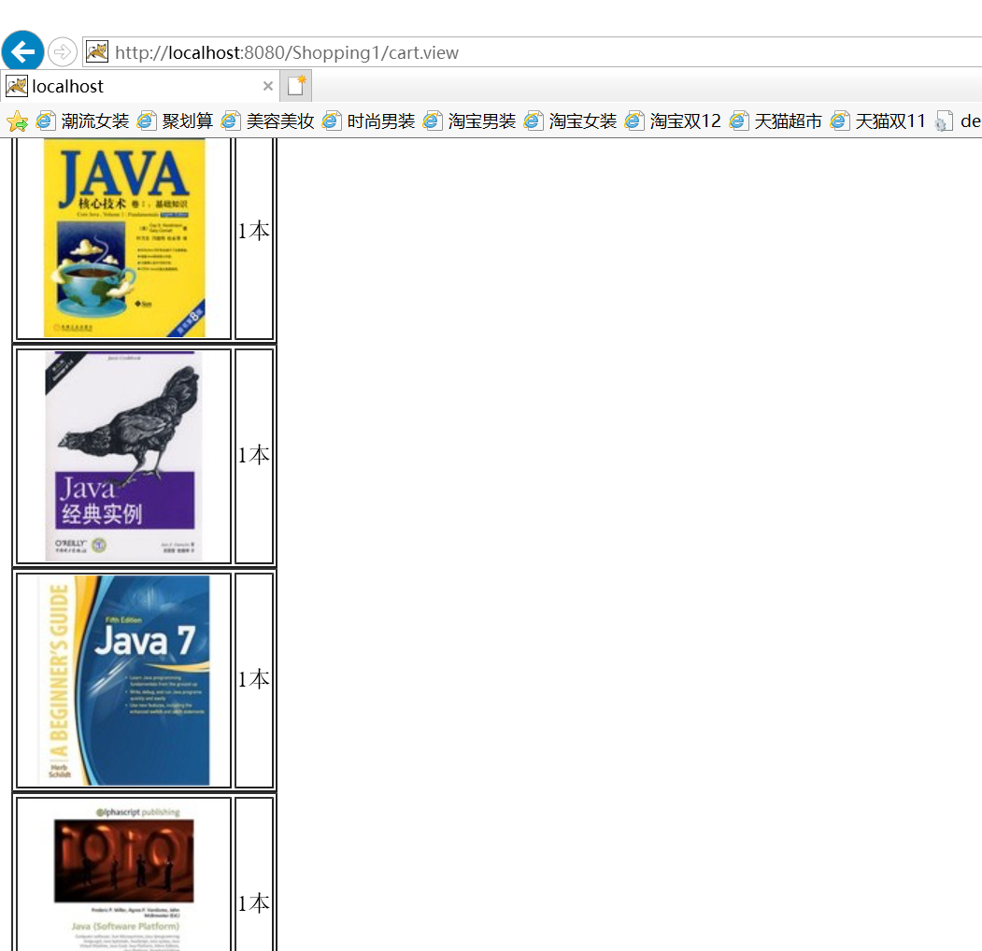

# 收获与问题

终于做出来了，不容易，我会加倍努力的！！！