**Java Web开发**

**实验五**

**作业报告**

|  |  |
| --- | --- |
| 学 院 | 计算机 |
| 所在系 班 级 | 2017软件工程系8班 |
| 学 号 姓 名 | 钟静波 |
| 指 导 教 师 | 郭晓燕 |
| 完 成 时 间 | 2019年4月5日 |

# 实验题目

# 第四章课后练习3购物车，实现一个购物车应用程序，可以购物，显示购物数量并查看购物车内容。

# 分析与设计

# 关键源码（部分）

index.jsp

<%@ page language=*"java"* import=*"java.util.*"* pageEncoding=*"UTF-8"*%>

<%@ page import=*"CLASS.*"* %>

<%String path = request.getContextPath();

String basePath = request.getScheme()+"://"+request.getServerName()+":"+request.getServerPort()+path+"/";%>

<!DOCTYPE HTML PUBLIC "-//W3C//DTD HTML 4.01 Transitional//EN"><html>

<%//当第一次访问采购网页，session对象中还没有book购物车信息时，进行初始化。

**if** (session.getAttribute("book")==**null**){ //在session对象中存储图书采购信息

Book[] BookList = **new** Book[4];

BookList[0]= **new** Book("10101", "Java核心技术", "img\10101.jpg", 0);

BookList[1] = **new** Book("10102", "Java经典实例", "img\10102.jpg", 0);

BookList[2] = **new** Book("10103", "Java7", "img\10103.jpg", 0);

BookList[3] = **new** Book("10104", "JSP&Servlet", "img\10104.jpg",0);//存入session对象中

session.setAttribute("book", BookList);}%>

<body><br><img src=*"img/cart.jpg"* height=*"60px"* width=*"60px"*>

<a href=*"cart.view"*>已采购 本书籍</a><br>

<br><table border=*"1"*><tr>

<td><img src=*"img/10101.jpg"*></td>

<td><img src=*"img/10102.jpg"*></td>

<td><img src=*"img/10103.jpg"*></td>

<td><img src=*"img/10104.jpg"*></td></tr>

<%Book[] BookList = **new** Book[4];BookList=(Book[]) session.getAttribute("book");%><tr>

<td><a href=*"shopping.view?id=10101"*>采购此书</a><br>已选择<%=BookList[0].getBookNum()%>件</td>

<td><a href=*"shopping.view?id=10102"*>采购此书</a><br>已选择<%=BookList[1].getBookNum()%>件</td>

<td><a href=*"shopping.view?id=10103"*>采购此书</a><br>已选择<%=BookList[2].getBookNum()%>件</td>

<td><a href=*"shopping.view?id=10104"*>采购此书</a><br>已选择<%=BookList[3].getBookNum()%>件</td></tr></body></html>

shoppingServlet.java

*public class shoppingServlet extends HttpServlet {*

*private HttpServletRequest request;*

*public void doGet(HttpServletRequest request, HttpServletResponse response) throws ServletException, IOException{*

*HttpSession session=request.getSession();*

*Book[] BookList = new Book[4];*

*String book_id = request.getParameter("id");//获取从Shopping.jsp传来的request对象中的ID号*

*if(book_id!=null)BookList=(Book[]) session.getAttribute("book");*

*//在ID号不为空的情况下，获取Session对象中的购物车信息，Book数组。*

*for(int i=0;i<4;i++){*

*if(BookList[i].getBookId().equals(book_id))BookList[i]=new Book(BookList[i].getBookId(),BookList[i].getBookName(),BookList[i].getBookImg(),BookList[i].getBookNum()+1);*

*}//找到数组中与ID对应的Book对象，将其属性bookNum数字加1*

*session.setAttribute("book", BookList);//将数组写回session对象中去。*

*PrintWriter out = response.getWriter();*

*out.println("<HTML><BODY><Font size=8><P>");*

*out.println(BookList[2].getBookNum()+BookList[2].getBookName());*

*out.println("</P><BR></BR></FONT></BODY></HTML>");*

*response.sendRedirect("index.jsp");//跳转回Shopping.jsp}}*

carServlet.java

*public class carServlet extends HttpServlet {*

*private HttpServletRequest request;*

*public void doGet(HttpServletRequest request, HttpServletResponse response) throws ServletException, IOException{*

*HttpSession session=request.getSession();Book[] BookList = new Book[4];*

*BookList=(Book[]) session.getAttribute("book");*

*response.setContentType("text/html;charset=GB2312");*

*PrintWriter out = response.getWriter();*

*out.println("<!DOCTYPE HTML PUBLIC \"-//W3C//DTD HTML 4.01 Transitional//EN\">");*

*out.println("<html><body><br>");*

*if(BookList[0].getBookNum()+BookList[1].getBookNum()+BookList[2].getBookNum()+BookList[3].getBookNum()==0){*

*out.println("<font size=8>请选择商品</font>");*

*out.println("<a href='index.jsp'>返回购物页面</a>");}*

*else {*

*out.println("<font size=8>购物车</font><br><table border='1'><tr>");*

*for(int i=0;i<4;i++) {*

*if(BookList[i].getBookNum()>0)*

*out.println("<td><img src='img/"+BookList[i].getBookId()+".jpg'></td>"); }*

*out.println("</tr><tr>");*

*for(int i=0;i<4;i++) {*

*if(BookList[i].getBookNum()>0)*

*out.println("<td>总共"+BookList[i].getBookNum()+"件</td>"); }*

*out.println("</tr>");}*

*out.println("</body></html>");}}*

# 运行效果图

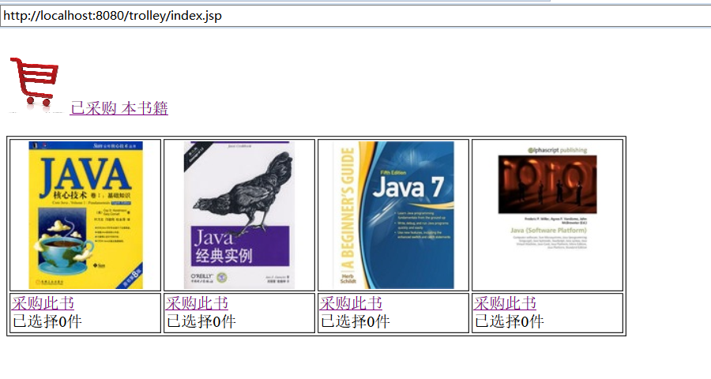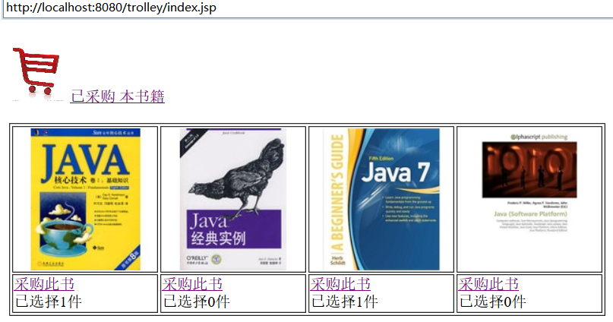

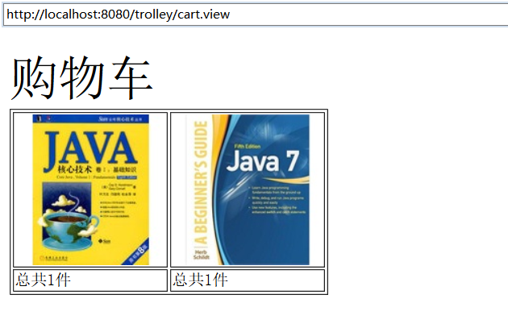

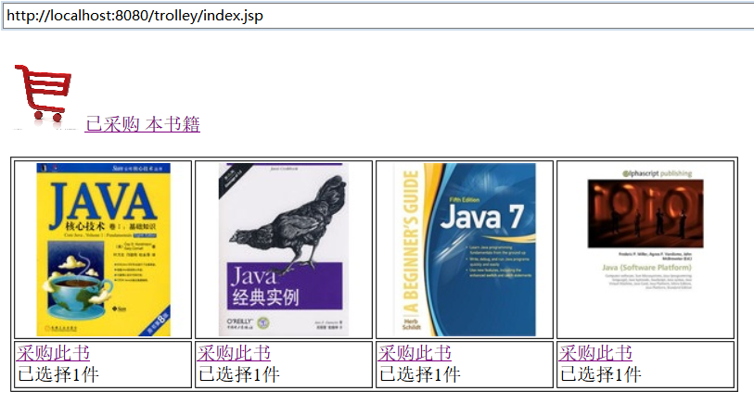

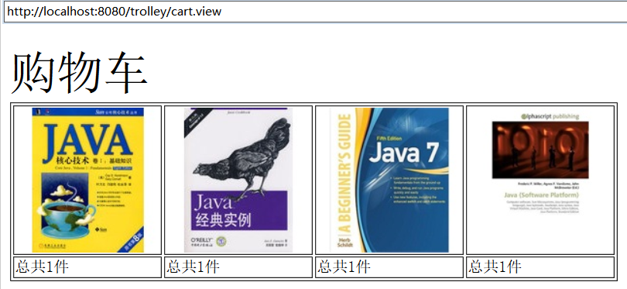

# 收获与问题