**Java Web开发**

**实验五**

**作业报告**

|  |  |
| --- | --- |
| 学 院 | 计算机 |
| 所在系 班 级 | 2017软件工程系8班 |
| 学 号 姓 名 | 陈润楷 |
| 指 导 教 师 | 郭晓燕 |
| 完 成 时 间 | 2019年4月20日 |

# 实验题目

# 第四章课后练习3购物车，实现一个购物车应用程序，可以购物，显示购物数量并查看购物车内容。

# 分析与设计

# 关键源码（部分）

Shopping.jsp

<%@ page language=*"java"* import=*"java.util.*"* pageEncoding=*"UTF-8"*%>

<%@page import=*"cc.test.vo.*"* %>

<!DOCTYPE HTML PUBLIC "-//W3C//DTD HTML 4.01 Transitional//EN">

<html>

<%

//当第一次访问采购网页，session对象中还没有book购物车信息时，进行初始化。

**if** (session.getAttribute("book")==**null**){

//在session对象中存储图书采购信息

Book[] BookList = **new** Book[4];

BookList[0] = **new** Book("10101", "稻草人手记", "img\10101.jpg", 0);

BookList[1] = **new** Book("10102", "送你一匹马", "img\10102.jpg", 0);

BookList[2] = **new** Book("10103", "撒哈拉的故事", "img\10103.jpg", 0);

BookList[3] = **new** Book("10104", "温柔的夜", "img\10104.jpg",0);

//存入session对象中

session.setAttribute("book", BookList);

}

%>

<body>

<br>

<img src=*"img/cart.jpg"* height=*"70px"* width=*"70px"*>

<img src=*"img/10101.jpg"* height=*"70px"* width=*"70px"*>

<img src=*"img/10102.jpg"* height=*"70px"* width=*"70px"*>

<img src=*"img/10103.jpg"* height=*"70px"* width=*"70px"*>

<img src=*"img/10104.jpg"* height=*"70px"* width=*"70px"*>

<a href=*"Cart.jsp"*>已采购 本书籍</a><br>

<br>

<table border=*"1"* >

<tr>

<td><img src=*"img/10101.jpg"*></td>

<td><img src=*"img/10102.jpg"*></td>

<td><img src=*"img/10103.jpg"*></td>

<td><img src=*"img/10104.jpg"*></td>

</tr>

<%Book[] BookList = **new** Book[4];BookList=(Book[]) session.getAttribute("book");%><tr>

<td><a href=*"shopping.view?id=10101"*>采购此书</a><br>已选择<%=BookList[0].getBookNum()%>件</td>

<td><a href=*"shopping.view?id=10102"*>采购此书</a><br>已选择<%=BookList[1].getBookNum()%>件</td>

<td><a href=*"shopping.view?id=10103"*>采购此书</a><br>已选择<%=BookList[2].getBookNum()%>件</td>

<td><a href=*"shopping.view?id=10104"*>采购此书</a><br>已选择<%=BookList[3].getBookNum()%>件</td></tr>

</body>

</html>

ShoppingServlet.java

package cc.test.Controller;

import java.io.IOException;

import java.io.PrintWriter;

import javax.servlet.ServletException;

import javax.servlet.http.HttpServlet;

import javax.servlet.http.HttpServletRequest;

import javax.servlet.http.HttpServletResponse;

import javax.servlet.http.HttpSession;

import cc.test.vo.Book;;

public class ShopingServlet extends HttpServlet {

private HttpServletRequest request;

public void doGet(HttpServletRequest request, HttpServletResponse response) throws ServletException, IOException{

HttpSession session=request.getSession();

Book[] BookList = new Book[4];

String book_id = request.getParameter("id");//获取从Shopping.jsp传来的request对象中的ID号

if(book_id!=null)BookList=(Book[]) session.getAttribute("book");

//在ID号不为空的情况下，获取Session对象中的购物车信息，Book数组。

for(int i=0;i<4;i++){

if(BookList[i].getBookId().equals(book_id))

BookList[i]=new Book(BookList[i].getBookId(),BookList[i].getBookName(),BookList[i].getBookImg(),BookList[i].getBookNum()+1);

}//找到数组中与ID对应的Book对象，将其属性bookNum数字加1

session.setAttribute("book", BookList);//将数组写回session对象中去。

response.sendRedirect("Shopping.jsp");//跳转回Shopping.jsp}

}

public void doPost(HttpServletRequest request, HttpServletResponse response)

throws ServletException, IOException {

doGet(request,response);

}

}

Cart.jsp

<%@ page language=*"java"* import=*"java.util.*"* pageEncoding=*"UTF-8"*%>

<%@page import=*"cc.test.vo.*"* %>

<!DOCTYPE HTML PUBLIC "-//W3C//DTD HTML 4.01 Transitional//EN">

<html>

<body>

<table border=*"1"* >

<%Book[] bookList =**new** Book[4];

bookList=(Book[])session.getAttribute("book");%>

<tr>

<%**if**(bookList[0].getBookNum()!=0) {%>

<td><img src=*"img/10101.jpg"*>已选择<%=bookList[0].getBookNum()%>件</td>

<%}%>

<%**if**(bookList[1].getBookNum()!=0) {%>

<td><img src=*"img/10102.jpg"*>已选择<%=bookList[1].getBookNum()%>件</td>

<%}%>

<%**if**(bookList[2].getBookNum()!=0) {%>

<td><img src=*"img/10103.jpg"*>已选择<%=bookList[2].getBookNum()%>件</td>

<%}%>

<%**if**(bookList[3].getBookNum()!=0) {%>

<td><img src=*"img/10104.jpg"*>已选择<%=bookList[3].getBookNum()%>件</td>

<%}%>

</tr>

</body>

</html>

# 运行效果图

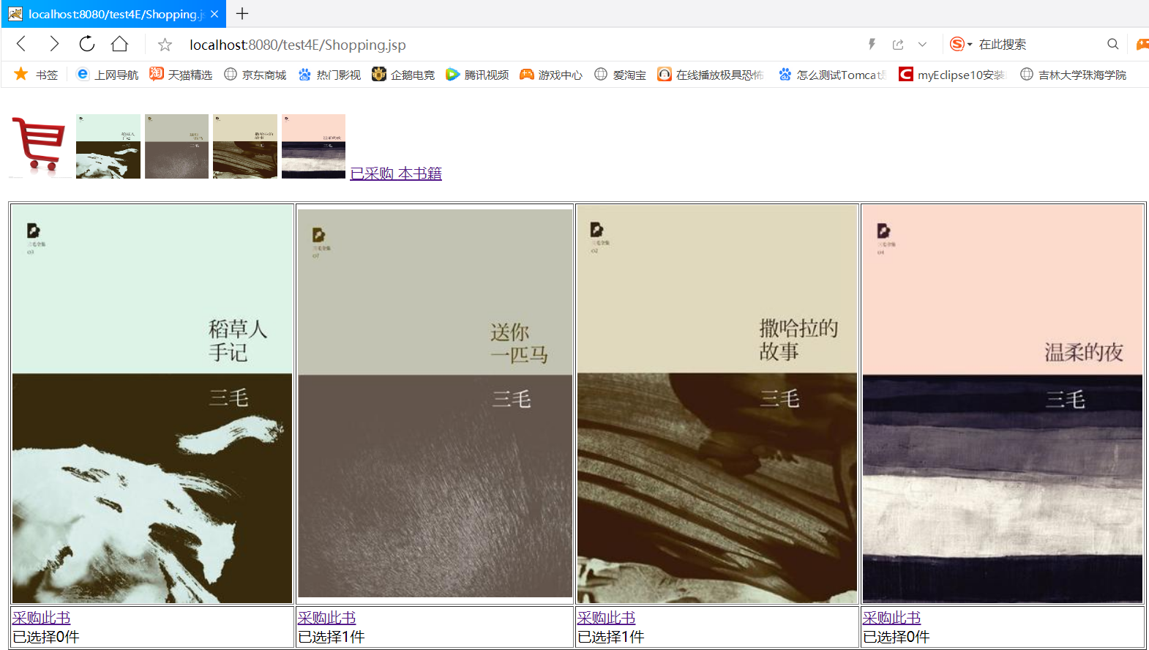

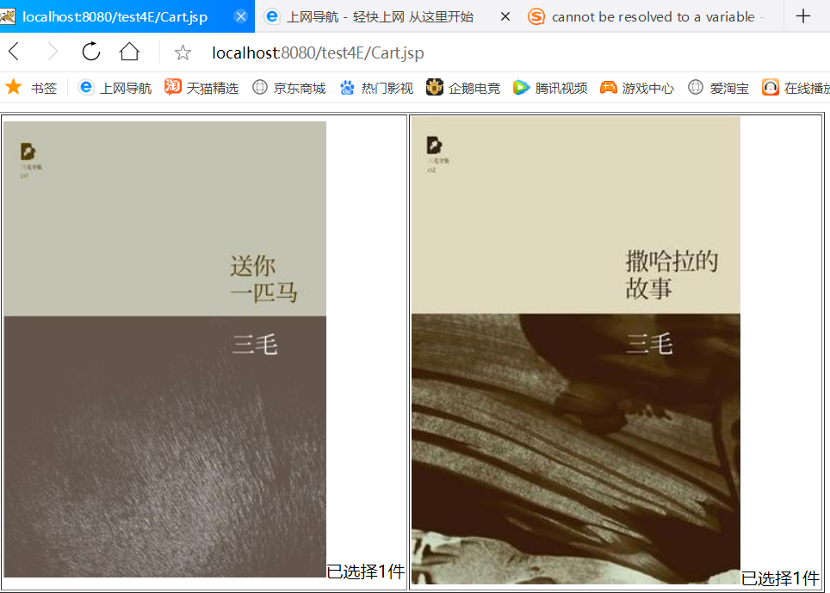

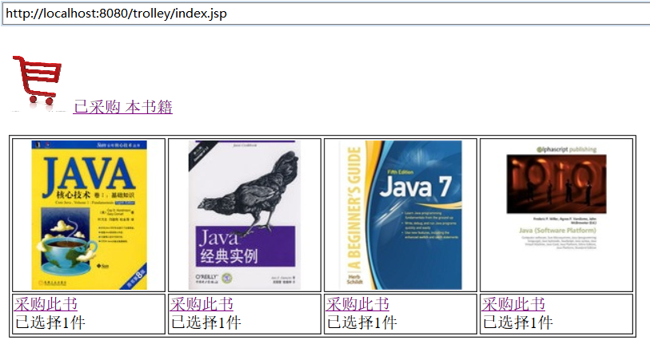

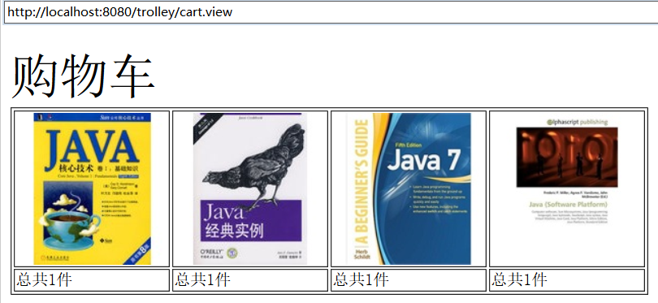

# 收获与问题