**w**

**Java Web开发**

**实验五**

**作业报告**

|  |  |
| --- | --- |
| 学 院 | 计算机 |
| 所在系 班 级 | 2017软件工程系8班 |
| 学 号 姓 名 | 04171616 林锦涛 |
| 指 导 教 师 | 郭晓燕 |
| 完 成 时 间 | 2019年4月- |

# 实验题目

第四章课后练习3购物车，实现一个购物车应用程序，可以购物，显示购物数量并查看购物车内容。（此题模版test4E，提供给大家参考。）

提示：采购此书做成超链接，并用URL重写带关键信息

a) Shopping.view?bookID=‘0001’，其中0001是你选中图书对应的ID号，每点击一次就在相应的购书数量上加一，并返回当前的选购页面。

b) 除了要保存图书的ID号、书名，还要保存购书数量，所以session对象保存的信息需要考虑清楚，最好是一个对象

数组或列表。

购物车的效果图

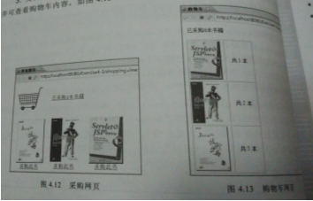

# 关键源码（部分）

Login.jsp

<%@ page language=*"java"* import=*"java.util.*"* pageEncoding=*"UTF-8"*%>

<!DOCTYPE HTML PUBLIC "-//W3C//DTD HTML 4.01 Transitional//EN">

<html>

<head>

<h1>登录页面</h1>

</head>

<body bgcolor=*"#00FFFF"*>

<form action=*"login.do"* method=*"post"* name =*"form"*>

用户名:

<input type=*"text"* name=*"name"*>

<br><br>

<input type=*"submit"* value=*"登录"*>

</form>

</body>

</html>

LoginServlet.java

package shop;

import java.io.IOException;

import javax.servlet.ServletException;

import javax.servlet.annotation.WebServlet;

import javax.servlet.http.HttpServlet;

import javax.servlet.http.HttpServletRequest;

import javax.servlet.http.HttpServletResponse;

import javax.servlet.http.HttpSession;

@WebServlet("/login.do")

public class LoginServlet extends HttpServlet {

protected void doGet(HttpServletRequest request, HttpServletResponse response) throws ServletException, IOException {

doPost(request, response);

}

protected void doPost(HttpServletRequest request, HttpServletResponse response) throws ServletException, IOException {

HttpSession session=request.getSession();

String name=request.getParameter("name");

String a="0";

if(name!=null&&name.length()>0){

Book[]book=initChart();

session.setAttribute("bookList", book);

session.setAttribute("sum", 0);

response.sendRedirect("shopping.jsp");

}else{

name="";

response.sendRedirect("Login.jsp");

}

}

public Book[] initChart() {

Book[] BookList=new Book[3];

BookList[0]=new Book("001","JSP程序设计实训与案例教程","img\\001.jpg",0);

BookList[1]=new Book("002","JSP大学实用教材","img\\002.jpg",0);

BookList[2]=new Book("003","JSP网站设计","img\\003.jpg",0);

return BookList;

}

}

Shopping.jsp

<%@ page language=*"java"* import=*"java.util.*"* pageEncoding=*"UTF-8"*%>

<%@ page import=*"shop.*"* %>

<%

String path = request.getContextPath();

String basePath = request.getScheme()+"://"+request.getServerName()+":"+request.getServerPort()+path+"/";

%>

<!DOCTYPE HTML PUBLIC "-//W3C//DTD HTML 4.01 Transitional//EN">

<html>

<body>

<img src=*"img/000.jpg"* height=*"60px"* width=*"60px"*>

<a href=*"cart.view"*>已采购<%=session.getAttribute("sum") %>本书籍</a><br>

<table border=*"3"*>

<%

Book[] bookList=(Book[])session.getAttribute("bookList");

out.println("<tr>");

**for**(Book book:bookList){

out.println("<td> <img src='"+book.getBookImg()+"'height='300px' width='260px'> </td>");

}

out.println("</tr>");

out.println("<tr>");

**for**(Book book:bookList){

out.println("<td align=center><a href='shopping.view?id="+book.getBookID()+"'>采购次数</a></td>");

}

out.println("</tr>");

%>

</table>

</body>

</html>

ShoppingServlet.java

package shop;

import java.io.IOException;

import javax.servlet.ServletException;

import javax.servlet.annotation.WebServlet;

import javax.servlet.http.HttpServlet;

import javax.servlet.http.HttpServletRequest;

import javax.servlet.http.HttpServletResponse;

import javax.servlet.http.HttpSession;

@WebServlet("/shopping.view")

public class ShoppingServlet extends HttpServlet {

protected void doGet(HttpServletRequest request, HttpServletResponse response) throws ServletException, IOException {

doPost(request, response);

}

protected void doPost(HttpServletRequest request, HttpServletResponse response) throws ServletException, IOException {

response.setContentType("text/html;charset=utf-8");

HttpSession session=request.getSession();

request.setCharacterEncoding("utf-8");

String id;

int num;

Book[]book=(Book[])session.getAttribute("bookList");

String getID=request.getParameter("id");

int a=0;

if(getID!=null){

for(int i=0;i<book.length;i++){

if(getID.equals(book[i].getBookID())){

a++;

int b=book[i].getShopNum();

b++;

book[i].setShopNum(b);

break;

}

}

}

int sum;

sum=book[0].getShopNum()+book[1].getShopNum()+book[2].getShopNum();

session.setAttribute("sum", sum);

request.getRequestDispatcher("shopping.jsp").forward(request, response);

}

}

charServlet.java

package shop;

import java.io.IOException;

import java.io.PrintWriter;

import javax.servlet.ServletException;

import javax.servlet.annotation.WebServlet;

import javax.servlet.http.HttpServlet;

import javax.servlet.http.HttpServletRequest;

import javax.servlet.http.HttpServletResponse;

import javax.servlet.http.HttpSession;

@WebServlet("/cart.view")

public class chartServlet extends HttpServlet {

protected void doGet(HttpServletRequest request, HttpServletResponse response) throws ServletException, IOException {

doPost(request, response);

}

protected void doPost(HttpServletRequest request, HttpServletResponse response) throws ServletException, IOException {

response.setContentType("text/html;charset=utf-8");

HttpSession session=request.getSession();

request.setCharacterEncoding("utf-8");

Book[]book=(Book[])session.getAttribute("bookList");

int sum=book[0].getShopNum()+book[1].getShopNum()+book[2].getShopNum();

PrintWriter out = response.getWriter();

out.println("<html><body><font size=8>");

out.println("已采购"+sum+"本书籍<br>");

out.println("<table border=1>");

for(int i=0;i<book.length;i++){

if(book[i].getShopNum()>0){

out.println("<tr>");

out.println("<td> <img src='"+book[i].getBookImg()+"'height='120px' width='80px'> </td>");

out.println("<td><a>共"+book[i].getShopNum()+"本</a></td>");

out.println("</tr>");

}

}

out.println("<a href='shopping.jsp'>返回购物</a>");

out.println("</table>");

out.println("</body>");

out.println("</html>");

}

}

Book.java

**public** **class** Book {

String bookID;

String bookName;

String bookImg;

**int** shopNum;

**public** Book(String id,String name,String img,**int** shopNum){

**this**.bookID=id;

**this**.bookName=id;

**this**.bookImg=img;

**this**.shopNum=shopNum;

}

**public** String getBookID(){

**return** bookID;

}

**public** **void** setBookID(String bookID){

**this**.bookID=bookID;

}

**public** String getBookName(){

**return** bookName;

}

**public** **void** setBookName(String bookName){

**this**.bookName=bookName;

}

**public** String getBookImg(){

**return** bookImg;

}

**public** **void** setBookImg(String bookImg){

**this**.bookImg=bookImg;

}

**public** **int** getShopNum(){

**return** shopNum;

}

**public** **void** setShopNum(**int** ShopNum){

**this**.shopNum=shopNum;

}

}

# 运行效果图

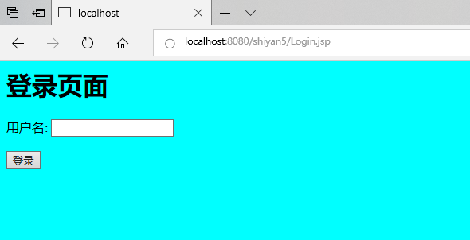

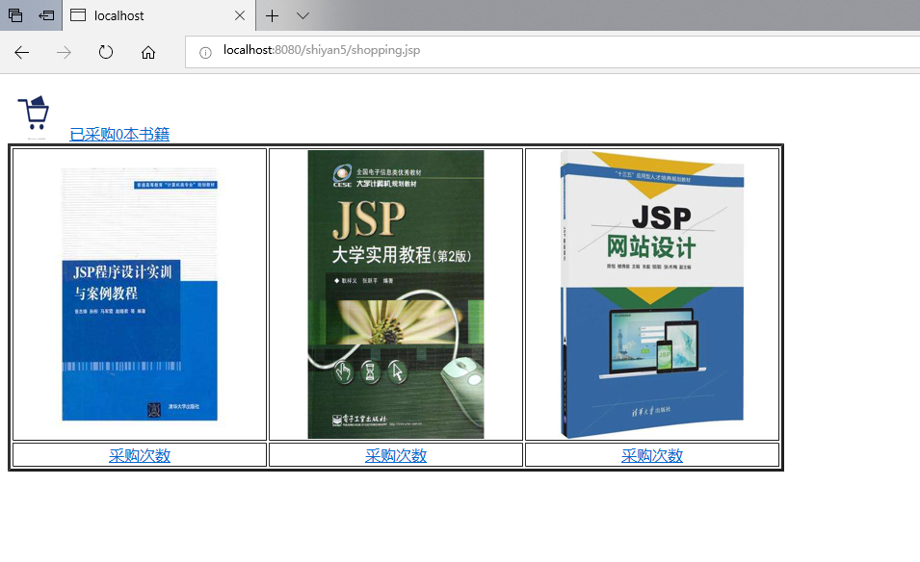

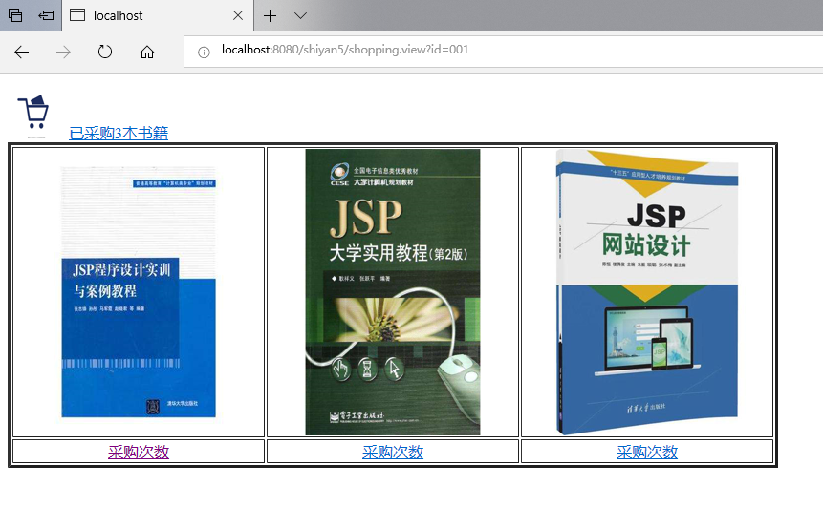

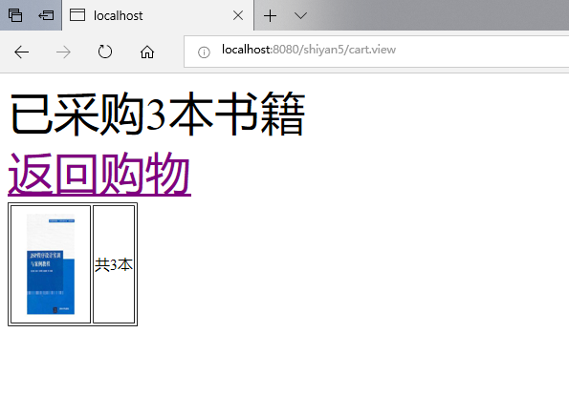

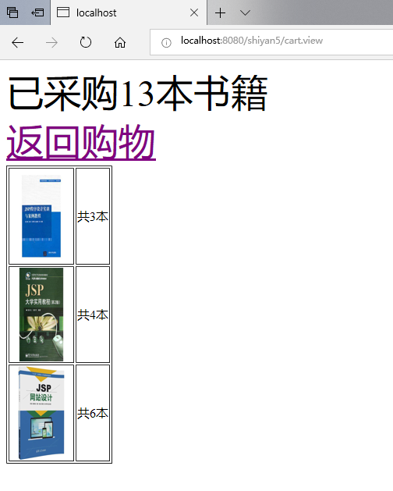



# 收获与问题

1、理解会话的原理和HttpSession会话期；

2、掌握如何使用URL重写；

3、掌握如何使用HttpSession会话管理