**Java Web开发**

**实验五**

**作业报告**

|  |  |
| --- | --- |
| 学院 | 计算机 |
| 所在系班级 | 2017软件工程系8班 |
| 学号姓名 | 04171627柯晓君 |
| 指导教师 | 郭晓燕 |
| 完成时间 | 2019年3月20日 |

# 实验题目

生成动态验证码图片进行注册

# 分析与设计

# 关键源码

**package** cc;

**public** **class** Book {

**private** String bookId; //书号

**private** String bookName;//书名

String bookImg; //书封面所在地址

**private** **int** bookNum; //购书本数

**public** Book(String bookId, String bookName, String bookImg, **int** bookNum) {

**this**.bookId = bookId;

**this**.bookName = bookName;

**this**.bookImg = bookImg;

**this**.bookNum = 0;

}

**public** String getBookId() {

**return** bookId;

}

**public** String getBookName() {

**return** bookName;

}

**public** String getBookImg() {

**return** bookImg;

}

**public** **int** getBookNum() {

**return** bookNum;

}

**public** **void** setBookId(String bookId) {

**this**.bookId = bookId;

}

**public** **void** setBookName(String bookName) {

**this**.bookName = bookName;

}

**public** **void** setBookImg(String bookImg) {

**this**.bookImg = bookImg;

}

**public** **void** setBookNum(**int** bookNum) {

**this**.bookNum = bookNum;

}

}

<%@ page language=*"java"* import=*"java.util.*"* pageEncoding=*"UTF-8"*%>

<%@page import=*"cc.Book"* %>

<!DOCTYPE HTML PUBLIC "-//W3C//DTD HTML 4.01 Transitional//EN">

<html>

<%

//当第一次访问采购网页，session对象中还没有book购物车信息时，进行初始化。

**if** (session.getAttribute("book")==**null**){

//在session对象中存储图书采购信息

Book[] BookList = **new** Book[4];

BookList[0] = **new** Book("10101", "Java核心技术", "img\10101.jpg", 0);

BookList[1] = **new** Book("10102", "Java经典实例", "img\10102.jpg", 0);

BookList[2] = **new** Book("10103", "Java7", "img\10103.jpg", 0);

BookList[3] = **new** Book("10104", "JSP&Servlet", "img\10104.jpg",0);

//存入session对象中

session.setAttribute("book", BookList);

}

%>

<body>

<br>

<img src=*"img/10105.jpg"* height=*"60px"* width=*"60px"*>

<a href=*"car"*>已采购 <%=session.getAttribute("num") %> 本书籍</a><br>

<br>

<table border=*"1"*>

<tr>

<td><img src=*"img/10101.jpg"*></td>

<td><img src=*"img/10102.jpg"*></td>

<td><img src=*"img/10103.jpg"*></td>

<td><img src=*"img/10104.jpg"*></td>

</tr>

<tr>

<td><a href=*"Shopping?id=10101"*>采购此书</a></td>

<td><a href=*"Shopping?id=10102"*>采购此书</a></td>

<td><a href=*"Shopping?id=10103"*>采购此书</a></td>

<td><a href=*"Shopping?id=10104"*>采购此书</a></td>

</tr>

</body>

</html>

package cc;

import cc.Book;

import java.io.IOException;

import java.io.PrintWriter;

import javax.servlet.ServletException;

import javax.servlet.annotation.WebServlet;

import javax.servlet.http.HttpServlet;

import javax.servlet.http.HttpServletRequest;

import javax.servlet.http.HttpServletResponse;

import javax.servlet.http.HttpSession;

@WebServlet("/Shopping")

public class ShoppingServlet extends HttpServlet{

public void doGet(HttpServletRequest request, HttpServletResponse response)

throws ServletException, IOException {

request.setCharacterEncoding("utf-8");

response.setContentType("text/html;charset=utf-8");

HttpSession session=request.getSession();

Book[] books=(Book[])session.getAttribute("book");

String ID=request.getParameter("id");

//找到数组中与ID对应的Book对象，将其属性bookNum数字加1

if(ID!=null) {

for(int k=0;k<books.length;k++)

{

if(ID.equals(books[k].getBookId())){

books[k].setBookNum(books[k].getBookNum()+1);

break;

}

}

}

response.sendRedirect("Shopping.jsp");

}

}

package cc;

import java.io.IOException;

import java.io.PrintWriter;

import javax.servlet.ServletException;

import javax.servlet.annotation.WebServlet;

import javax.servlet.http.HttpServlet;

import javax.servlet.http.HttpServletRequest;

import javax.servlet.http.HttpServletResponse;

import javax.servlet.http.HttpSession;

@WebServlet("/car")

public class CarServlet extends HttpServlet {

/*判断得到session对象中存储的book信息是否为空

不为空的前提下，读出Book数组中的内容，并将数目不为1的图书信息显示在网页上。

*/

public void doGet(HttpServletRequest request, HttpServletResponse response)

throws ServletException, IOException {

request.setCharacterEncoding("utf-8");

response.setContentType("text/html;charset=utf-8");

HttpSession session=request.getSession();

int num = 0;

PrintWriter out=response.getWriter();

out.println("<html><body><font size=8>");

out.println("<p><br>这里是结账处，您选择的商品：");

Book[] books=(Book[])session.getAttribute("book");

for(int i=0;i<books.length;i++) {

if(books[i].getBookNum()>0) {

out.println("<br>商品 ： "+books[i].getBookName()+"件数 : "+books[i].getBookNum());

num=num + books[i].getBookNum();

out.println("<br>一共有 "+num+" 本书");

}

}

out.println("<p><br>点击超级链接，继续选择书籍. ");

out.println("<a href=Shopping.jsp>欢迎去Shopping.jsp！</a>");

out.println("</font></body></html>");

}

}

# 运行效果图

Shopping;

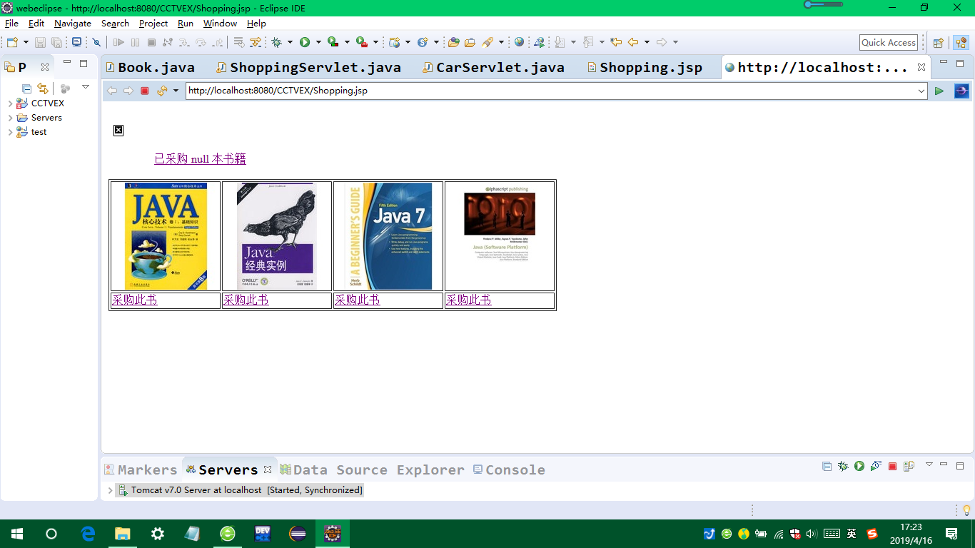

点击书本：

点击购物车：

