**Java Web开发**

**实验五**

**作业报告**

|  |  |
| --- | --- |
| 学 院 | 计算机 |
| 所在系 班 级 | 2017软件工程系8班 |
| 学 号 姓 名 | 04171628李嘉如 |
| 指 导 教 师 | 郭晓燕 |
| 完 成 时 间 | 2019年4月- |

# 实验题目

购物车

# 分析与设计

根据题目要求，计划设计几个文件来完成实验，每个文件的名字、作用。如果是类，要求写出类的变量和方法

# 关键源码（部分）

cAR。Jsp

<%@ page language=*"java"* contentType=*"text/html; charset=utf-8"*

pageEncoding=*"utf-8"* import =*"book.Book"*%>

<!DOCTYPE html PUBLIC "-//W3C//DTD HTML 4.01 Transitional//EN" "http://www.w3.org/TR/html4/loose.dtd">

<html>

<head>

<meta http-equiv=*"Content-Type"* content=*"text/html; charset=UTF-8"*">

<title>采购图书</title>

</head>

<%

**if**(session.getAttribute("sum")==**null**)

session.setAttribute("sum", 0);

%>

<%

**if**(session.getAttribute("books")==**null**){

Book[] books=**new** Book[3];

books[0]=**new** Book("1","第一本书","img/2.jpg",0);

books[1]=**new** Book("2","第二本书","img/3.jpg",0);

books[2]=**new** Book("3","第三本书","img/4.jpg",0);

//存入对象中

session.setAttribute("book", books);

}

%>

<body>

=<img src=*"img/1.jpg"* height=*"360px"* width=*"360px"*>

<a href=*"jie.jsp"*>已经采购<%=session.getAttribute("sum")%>本书</a>

<th></th>

<br>

<table >

<%

Book[] books=(Book[])session.getAttribute("book");

**if**(books!=**null**)

{

out.println("<tr>");

**for**(Book book1:books)

out.println("<td> <img src='"+book1.getTu()+"'width='300' heigth='300'></td>");

out.println("<tr>");

**for**(Book book1:books)

out.println("<td> <a href='bookS?id='"+book1.getID()+"'>采购此书</a></td>");

out.println("<tr>");

}

%>

</table>

</body>

</html>

BookS.Java

package book;

import java.io.IOException;

import javax.servlet.ServletException;

import javax.servlet.annotation.WebServlet;

import javax.servlet.http.HttpServlet;

import javax.servlet.http.HttpServletRequest;

import javax.servlet.http.HttpServletResponse;

import javax.servlet.http.HttpSession;

@WebServlet("/bookS")

public class bookS extends HttpServlet {

protected void doGet(HttpServletRequest request, HttpServletResponse response)

throws ServletException, IOException {

request.setCharacterEncoding("UTF-8");

response.setContentType("text/html;charest=UTF-8");

HttpSession session=request.getSession();

Book[] prods=(Book[])session.getAttribute("book");

String id=request.getParameter("id");

int sum1=(int)session.getAttribute("sum");

if(prods!=null) {

for(int k=0;k<prods.length;k++)

{

if(id.equals(prods[k].getID())) {

prods[k].setNum(prods[k].getNum()+1);

sum1++;

}

session.setAttribute("sum", sum1);

request.getRequestDispatcher("cAR.jsp").forward(request, response);

}

}}

}

Jie.jsp

<%@ page language=*"java"* contentType=*"text/html; charset=utf-8"*

pageEncoding=*"utf-8"* import=*"book.Book"*%>

<!DOCTYPE html PUBLIC "-//W3C//DTD HTML 4.01 Transitional//EN" "http://www.w3.org/TR/html4/loose.dtd">

<html>

<head>

<meta http-equiv=*"Content-Type"* content=*"text/html; charset=utf-8"*>

<title>结算界面</title>

</head>

<body>

<table >

<%

Book[] books=(Book[])session.getAttribute("book");

**if**(books!=**null**){

**for**(Book book1:books)

{

out.println("<tr>");

out.println("<td> <img src='"+book1.getTu()+"width='300' heigth='300''></td>");

out.println("<tr aligen='center' width='250'> <h1> "+book1.getNum()+"本书</h1></td>");

out.println("<tr>");

}}

%>

</table>

</body>

</html>

# 运行效果图

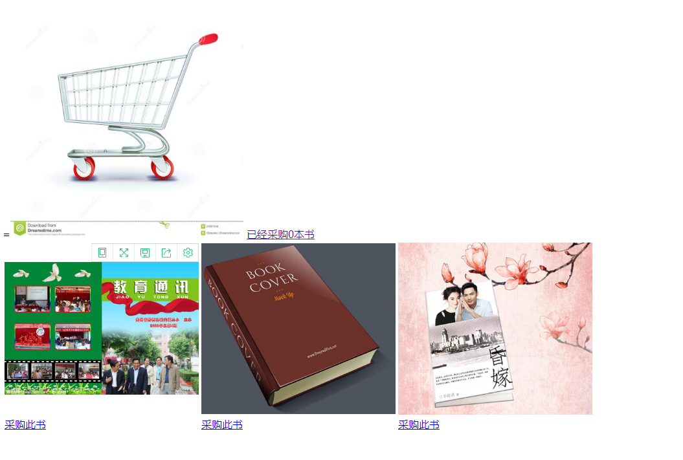

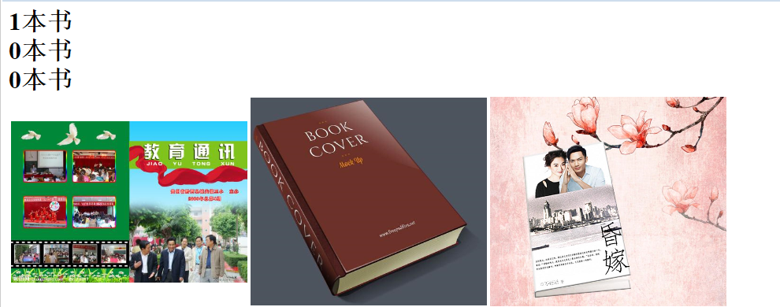

# 收获与问题