**Java Web开发**

**实验一**

**作业报告**

|  |  |
| --- | --- |
| 学 院 | 计算机 |
| 所在系 班 级 | 2017软件工程系**班 |
| 学 号 姓 名 | ******* |
| 指 导 教 师 | 郭晓燕 |
| 完 成 时 间 | 2018年5月- |

# 实验题目

1. 练习老师在理论课上演示的购物车实例，理解购物功能如何实现，理解如何利用session对象保存购物信息，如何设计封装数据类。（请参考“第四章会话管理课上的购物车实例代码.docx”文档）；

如果上课听懂了购物车的原理或者部分理解，可以参考我的实例完成第2题，此题可忽略不写。

1. 第四章课后练习3购物车，实现一个购物车应用程序，可以购物，显示购物数量并查看购物车内容。（此题模版test4E，提供给大家参考。）

提示：采购此书做成超链接，并用URL重写带关键信息

* 1. Shopping.view?bookID=‘0001’，其中0001是你选中图书对应的ID号，每点击一次就在相应的购书数量上加一，并返回当前的选购页面。
  2. 除了要保存图书的ID号、书名，还要保存购书数量，所以session对象保存的信息需要考虑清楚，最好是一个对象数组或列表。

# 分析与设计

根据题目要求，计划设计几个文件来完成实验，每个文件的名字、作用。如果是类，要求写出类的变量和方法

# 关键源码（部分）

shop.jsp

<%@ page language=*"java"* contentType=*"text/html; charset=utf-8"*

pageEncoding=*"utf-8"* import=*"sy5.Book"*%>

<!DOCTYPE html>

<html>

<head>

<meta charset=*"utf-8"*>

<title>Insert title here</title>

</head>

<%

**if**(session.getAttribute("BookList")==**null**)

{//在session对象中存储图书采购信与

Book[] BookList = **new** Book[4];

BookList[0] =**new** Book("19101","旺旺小小酥", "01.jpg", 10,0,"旺旺小小酥，旺旺公司出品的一款休闲食品，有原味、黑胡椒味、葱香鸡肉味等口味");

BookList[1] =**new** Book("19102","旺旺仙贝", "02.jpg",20, 0,"仙贝（英文senbei或sembei）一种日本米果。他们有各种形状，大小，和口味，通常咸味，但也有甜的。仙贝是经常与绿茶相伴作为休闲小吃，并提供给到访的客人作为一个礼貌的茶点");

BookList[2] =**new** Book("19103","旺旺雪饼", "03.jpg",30, 0,"雪饼是用一种用精选大米制成的膨化食品。松脆香甜、口味多样，它们大多是以精选大米等食物为原料，经过烘焙、加热等工序加工而成的");

BookList [3] =**new** Book ("10104","旺旺海苔饼", "04.jpg",40,0,"精选大米做出酥香松脆的饼，加上海苔，多了一分风味和口感");

//存入session对象中

session.setAttribute("BookList", BookList);

session.setAttribute("sum", 0);

}

%>

<body>

<img src=*"shopcar.png"* height=*"200px"* width=*"150px"*>

<a href=*"count.jsp"*>已采购<%=session.getAttribute("sum") %>包零食</a><br>

<br>

<table border=*"1"*>

<%

Book[] BookList=(Book[])session.getAttribute("BookList");

out.println("<tr>");

**for**(Book book:BookList)

{

out.println("<td> <img src='"+book.getProductImg()+"'height='300px' width='300px'> </td>");

}

out.println("</tr>");

out.println("<tr>");

**for**(Book book:BookList)

{

out.println("<td> <a href='cg?id="+book.getProductID()+"'>采购此零食</a></td>");

//System.out.print(book.getProductID());

}

out.println("</tr>");

out.println("<tr>");

**for**(Book book:BookList)

{

out.println("<td> <a href='intro.jsp?id="+book.getProductID()+"'>详情介绍</a></td>");

}

out.println("</tr>");

%>

</table>

</body>

</html>

cg.java

**package** sy5;

**import** java.io.IOException;

**import** javax.servlet.ServletException;

**import** javax.servlet.annotation.WebServlet;

**import** javax.servlet.http.HttpServlet;

**import** javax.servlet.http.HttpServletRequest;

**import** javax.servlet.http.HttpServletResponse;

**import** javax.servlet.http.HttpSession;

@WebServlet("/cg")

**public** **class** cg **extends** HttpServlet {

**protected** **void** doGet(HttpServletRequest request, HttpServletResponse response) **throws** ServletException, IOException {

HttpSession session = request.getSession();

String bid=request.getParameter("id");

**int** sum = (**int**)session.getAttribute("sum");

Book[] BookList=(Book[])session.getAttribute("BookList");

**for**(Book b:BookList)

{

**if**(b.getProductID().equals(bid))

{

b.setProductNum(b.getProductNum()+1);

sum++;

**break**;

}

}

session.setAttribute("BookList", BookList);

session.setAttribute("sum", sum);

request.getRequestDispatcher("shop.jsp").forward(request, response);

}

}

Book.java

**package** sy5;

**public** **class** Book {

**private** String ProductName;//名字

**private** String ProductImg;//

**private** String ProductID;

**private** **int** ProductNum;

**private** String Productintro;

**private** **float** ProductPrice;

**public** Book(String id,String name,String img,**double** price,**int** num,String intro)

{

**this**.ProductID=id;

**this**.ProductName=name;

**this**.ProductPrice=(**float**)price;

**this**.ProductNum = num;

**this**.ProductImg = img;

**this**.Productintro=intro;

}

**public** String getProductImg()

{

**return** **this**.ProductImg;

}

**public** **int** getProductNum()

{

**return** ProductNum;

}

**public** **void** setProductNum(**int** productNum)

{

**this**.ProductNum=productNum;

}

**public** String getProductID() {

**return** ProductID;

}

**public** **void** setProductID(String ProductID) {

**this**.ProductID=ProductID;

}

**public** String getProductName() {

**return** ProductName;

}

**public** **void** setProductName(String productName) {

**this**.ProductName=productName;

}

**public** **float** ProductPrice() {

**return** ProductPrice;

}

**public** **void** setProductPrice(**float** productPrice) {

**this**.ProductPrice=productPrice;

}

**public** String getProductintro()

{

**return** **this**.Productintro;

}

}

Shopcar.java

package sy5;

import java.io.IOException;

import java.io.PrintWriter;

import javax.servlet.ServletException;

import javax.servlet.annotation.WebServlet;

import javax.servlet.http.HttpServlet;

import javax.servlet.http.HttpServletRequest;

import javax.servlet.http.HttpServletResponse;

import javax.servlet.http.HttpSession;

/**

* Servlet implementation class shopcar

*/

@WebServlet("/shopcar")

public class shopcar extends HttpServlet {

protected void doGet(HttpServletRequest request, HttpServletResponse response)

throws ServletException, IOException {

response.setContentType("text/html;charset=utf-8");

request.setCharacterEncoding("utf-8");

HttpSession session =request.getSession();

String bid=request.getParameter("id");

String cname=request.getParameter("name");

Book[] BookList=(Book[])session.getAttribute("BookList");

for(int i=0;i<BookList.length;i++)

{

if((BookList[i].getProductID()).equals(bid))

{

if("add".equals(cname))

{

BookList[i].setProductNum(BookList[i].getProductNum()+1);

}

if("ajj".equals(cname))

{

BookList[i].setProductNum(BookList[i].getProductNum()-1);

}

}

}

request.getRequestDispatcher("count.jsp").forward(request, response);

}}

Intro.jsp

<%@ page language=*"java"* contentType=*"text/html; charset=utf-8"*

pageEncoding=*"utf-8"* import=*"sy5.Book"*%>

<!DOCTYPE html>

<html>

<head>

<meta charset=*"utf-8"*>

<title>产品详情</title>

</head>

<body>

<%

Book[] BookList=(Book[])session.getAttribute("BookList");

String bid=request.getParameter("id");

**for**(Book b:BookList)

{

**if**(b.getProductID().equals(bid))

{

out.println(" <img src='"+b.getProductImg()+"'height='300px' width='300px'> <br>");

out.println("id："+b.getProductID()+"<br>");

out.println("name："+b.getProductName()+"<br>");

out.println("Price:："+b.ProductPrice()+"<br>");

out.println("introduce:："+b.getProductintro()+"<br>");

}

}

%>

</body>

</html>

Count.jsp

<%@ page language=*"java"* contentType=*"text/html; charset=utf-8"*

pageEncoding=*"utf-8"* import=*"sy5.Book"*%>

<!DOCTYPE html>

<html>

<head>

<meta charset=*"utf-8"*>

<title>Insert title here</title>

</head><%**if**(session.getAttribute("addprice")==**null**)

session.setAttribute("addprice",0);%>

<body><font size=*8*">

<p>您选择的商品：

<%

**int** num=0;

**float** totalPrice=0;

Book[] BookList=(Book[])session.getAttribute("BookList");

out.println("<table border=1>");

**for**(**int** i=0;i<BookList.length;i++)

{

**if**(BookList[i].getProductNum()>0)

{

out.println("<tr>");

out.println("<td>"+"<img src='"+BookList[i].getProductImg()+"'height='50px' width='50px'>"+"</td>");

out.println("<td><a href='shopcar?id="+BookList[i].getProductID()+"&name=add'><input type='submit' value='+' name='add'></a>"+"件数:"+BookList[i].getProductNum()+"<a href='shopcar?id="+BookList[i].getProductID()+"&name=ajj'><input type='submit' value='-' name='ajj'> </a></td>");

out.println("</tr>");

}

num=num+BookList[i].getProductNum();

totalPrice=totalPrice+(BookList[i].ProductPrice()*BookList[i].getProductNum());

}

session.setAttribute("sum", num);

session.setAttribute("addprice", totalPrice);

%>

</table>

<p>商品总件数价<%=session.getAttribute("sum") %>

<p>商品总价<%=session.getAttribute("addprice") %>

<p>继续选购商品"

<a href=*shop.jsp*>欢迎去shop.jsp</a>

</font>

</body>

</html>

# 运行效果图

# 

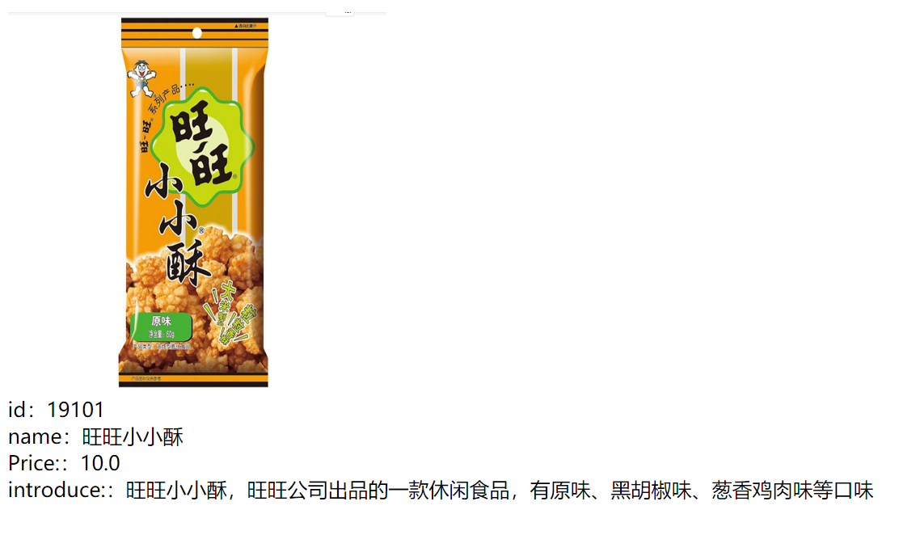

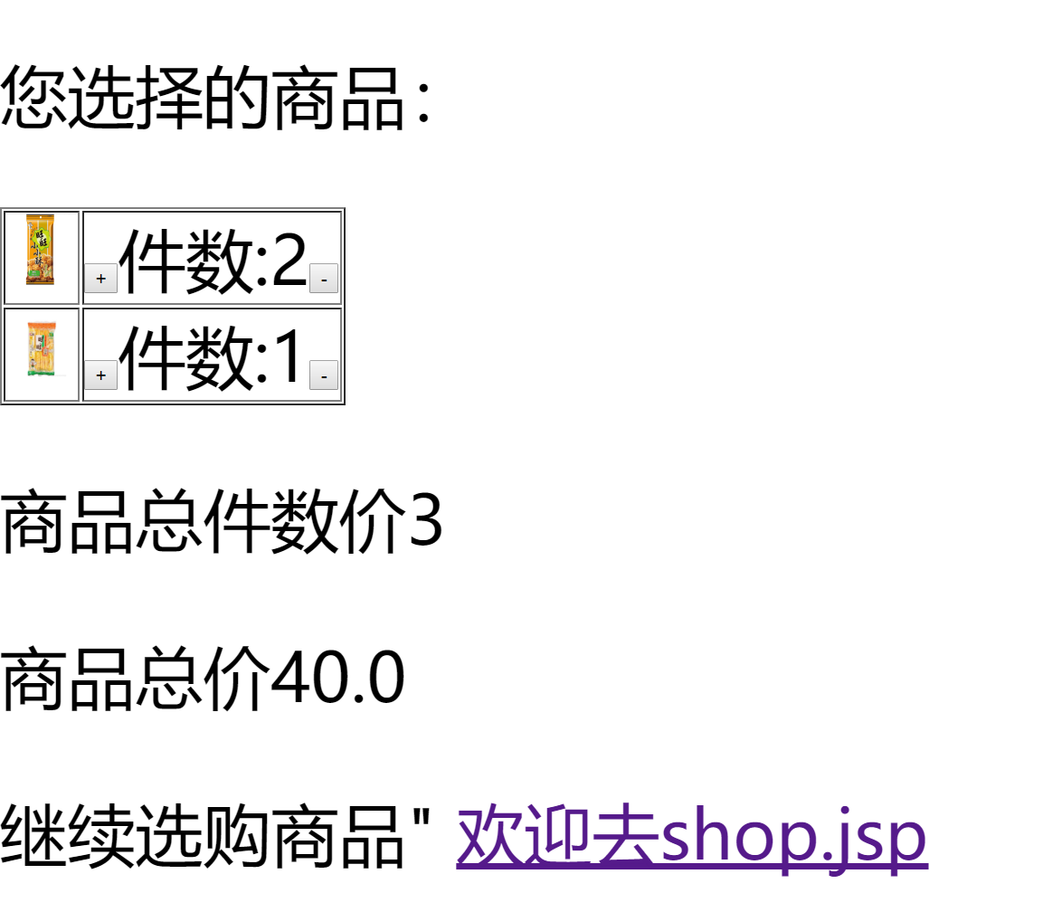

# 收获与问题

谈一谈你在本实验中所收获的内容及问题。