**Java Web开发**

**实验六**

**作业报告**

|  |  |
| --- | --- |
| 学 院 | 计算机 |
| 所在系 班 级 | 2017软件工程系5班 |
| 学 号 姓 名 | 04171306叶铭浩 |
| 指 导 教 师 | 郭晓燕 |
| 完 成 时 间 | 2019年4月6日- |

# 实验题目

参考成熟的购物系统，为购物车增加功能，完善购物车：删除商品，查看商品具体信息，计算商品总价，修改商品购买件数等等。界面尽量美观。

提示：Java文件即Book.java的设计需要重构，需要分离商品基本信息和购买信息，需要有类分别来保存单件商品的购买信息和所有商品的购买信息。所以至少要三个Java类才能完成购物的基本功能。

Servlet也需要响应更多的操作，可以在一个Servlet中也可以分多个文件响应。并在适当的地方调用Java方法。

# 分析与设计

分三个类，登入界面

# 关键源码（部分）

1. Login.jsp

<%@ **page import**="**java.lang.reflect.Parameter**" %>*<%--  
 Created by IntelliJ IDEA.  
 User: asus  
 Date: 2019/4/21  
 Time: 19:10  
 To change this template use File | Settings | File Templates.  
--%>*<%@ **page contentType**="**text/html;charset=UTF-8**" **language**="**java**" %>  
<**html**>  
<**head**>  
 <**title**>登入</**title**>  
</**head**>  
<**body**>  
<**h1 align="center"**>用户登录</**h1**>  
<**form method="post" action="login.view"** >  
 <**table bgcolor=#cccccc align="center"**>  
 <**tr**>  
 <**td**>用户名：</**td**>  
 <**td**><**input type='text' name='user' size='25' maxlength='100'**>  
 </**td**>  
 </**tr**>  
  
 <**tr**>  
 <**td**>密码：</**td**>  
 <**td**><**input type='password' name='password' size='25' maxlength='16'**>  
 </**td**>  
 </**tr**>  
  
  
 <**tr**>  
 <**td colspan='2' align='center'**><**input type='submit' value='login'**>  
 </**td**>  
 </**tr**>  
 **<% if**(request.getAttribute(**"loginError"**)!=**null**){ **%>** <**tr**>  
 <**td**>**${**loginError**}**</**td**>  
 </**tr**>  
 **<%** }  
 **%>** </**table**>  
</**form**>  
</**body**>  
</**html**>

1. Logingservlet.java( login.view)

**package** com.exl_4;  
  
**import** javax.servlet.ServletException;  
**import** javax.servlet.annotation.WebServlet;  
**import** javax.servlet.http.HttpServlet;  
**import** javax.servlet.http.HttpServletRequest;  
**import** javax.servlet.http.HttpServletResponse;  
**import** java.io.IOException;  
  
*/**  
 \** ***@author*** *U12  
 \** ***@data*** *2019/4/21 - 22:07  
 */*@WebServlet(name = **"LoginServlet"**)  
**public class** LoginServlet **extends** HttpServlet {  
 **protected void** doPost(HttpServletRequest request, HttpServletResponse response) **throws** ServletException, IOException {  
 request.setCharacterEncoding(**"UTF-8"**);  
 response.setContentType(**"text/html;charset=UTF-8"**);  
  
 String user = request.getParameter(**"user"**);  
 String pwd = request.getParameter(**"password"**);  
  
 String flag;  
 **if**(**""**.equals(user) && **""**.equals(pwd)){  
 flag=**"用户名和密码不能为空"**;  
 request.setAttribute(**"loginError"**,flag);  
 request.getRequestDispatcher(**"login.jsp"**).forward(request,response);  
 }  
  
 **if**(**"123456"**.equals(pwd)){  
 CardCar cardCar = **new** CardCar(user);  
 request.getSession().setAttribute(**"cardCar"**,cardCar);  
 request.getRequestDispatcher(**"shopping.jsp"**).forward(request,response);  
 } **else** {  
*// response.sendRedirect("login.jsp");* flag=**"密码错误"**;  
 request.setAttribute(**"loginError"**,flag);  
 request.getRequestDispatcher(**"login.jsp"**).forward(request,response);  
 }  
  
 }  
  
 **protected void** doGet(HttpServletRequest request, HttpServletResponse response) **throws** ServletException, IOException {  
  
 }  
}

*3.Book.java***package** com.exl_4;  
  
*/**  
 \** ***@author*** *U12  
 \** ***@data*** *2019/4/8 - 11:28  
 */***public class** Book {  
 **private** String **BookID**;  
  
 **private** String **BookName**;  
  
 **private** String **BookImg**;  
  
 **private** String **BookIntroduction**;  
  
 **private double BookPrice**;  
  
 **public** Book(String bookID, String bookName, String bookImg, String bookIntroduction, **double** bookPrice) {  
 **BookID** = bookID;  
 **BookName** = bookName;  
 **BookImg** = bookImg;  
 **BookIntroduction** = bookIntroduction;  
 **BookPrice** = bookPrice;  
 }  
  
 **public** String getBookID() {  
 **return BookID**;  
 }  
  
 **public void** setBookID(String bookID) {  
 **BookID** = bookID;  
 }  
  
 **public** String getBookName() {  
 **return BookName**;  
 }  
  
 **public void** setBookName(String bookName) {  
 **BookName** = bookName;  
 }  
  
 **public** String getBookImg() {  
 **return BookImg**;  
 }  
  
 **public void** setBookImg(String bookImg) {  
 **BookImg** = bookImg;  
 }  
  
 **public** String getBookIntroduction() {  
 **return BookIntroduction**;  
 }  
  
 **public void** setBookIntroduction(String bookIntroduction) {  
 **BookIntroduction** = bookIntroduction;  
 }  
  
 **public double** getBookPrice() {  
 **return BookPrice**;  
 }  
  
 **public void** setBookPrice(**double** bookPrice) {  
 **BookPrice** = bookPrice;  
 }  
}

4.CartItem.java

**package** com.exl_4;  
  
*/**  
 \** ***@author*** *U12  
 \** ***@data*** *2019/4/18 - 16:16  
 */***public class** CartItem {  
 **private** Book **book**;  
 **private int book_sum**;  
 **private double discount**;  
 **private double prices**;  
  
 **public** CartItem(Book book, **int** book_sum, **double** discount) {  
 **this**.**book** = book;  
 **this**.**book_sum** = book_sum;  
 **this**.**discount** = discount;  
  
 calPrices();  
*// this.prices = book.getBookPrice()*book_sum*discount;* }  
  
 **public void** calPrices(){  
 **double** Prices = **book**.getBookPrice()\***book_sum**\***discount**;  
 setPrices(Prices);  
 }  
  
 **public void** add_book(){  
 **book_sum**++;  
 }  
  
 **public void** reduce_book(){  
 **book_sum**--;  
 }  
 **public double** getPrices() {  
 **return prices**;  
 }  
  
 **public void** setPrices(**double** prices) {  
 **this**.**prices** = prices;  
 }  
  
 **public double** getDiscount() {  
 **return discount**;  
 }  
  
 **public void** setDiscount(**double** discount) {  
 **this**.**discount** = discount;  
 }  
  
 **public int** getBook_sum() {  
 **return book_sum**;  
 }  
  
 **public void** setBook_sum(**int** book_sum) {  
 **this**.**book_sum** = book_sum;  
 }  
  
 **public** Book getBook() {  
 **return book**;  
 }  
  
 **public void** setBook(Book book) {  
 **this**.**book** = book;  
 }  
}

5.CardCar.java

**package** com.exl_4;  
  
*/**  
 \** ***@author*** *U12  
 \** ***@data*** *2019/4/15 - 10:26  
 */***public class** CardCar {  
 **private** String **User**;  
  
 **private double CardPrice** ;  
  
 **private int CardSum** ;  
  
 **private** Book[] **bookList**;  
  
*// private ArrayList<CartItem> carts;* **private** CartItem[] **carts**;  
  
 **public** CardCar(String user){  
 setUser(user);  
 **bookList** = **new** Book[3];  
 **bookList**[0] = **new** Book(**"0001"**,**"演员的自我修养"**,**"img\\book1.jpg"**,**"戏精的升华之路"**,69.3);  
 **bookList**[1] = **new** Book(**"0002"**,**"大头儿子和小头爸爸"**,**"img\\book2.jpg"**,**"隔壁老王的未知之谜"**,20.4);  
 **bookList**[2] = **new** Book(**"0003"**,**"javaweb技术"**,**"img\\book3.jpg"**,**"javaweb学的更好"**,56.7);  
  
  
 **carts** = **new** CartItem[3];  
 **carts**[0] = **new** CartItem(**bookList**[0],0,1);  
 **carts**[1] = **new** CartItem(**bookList**[1],0,1);  
 **carts**[2] = **new** CartItem(**bookList**[2],0,1);  
  
 setCardPrice(0);  
 setCardSum(0);  
 }  
  
 **public void** add_cartItem(CartItem cartItem){  
 cartItem.add_book();  
 **CardSum**++;  
 }  
  
 **public void** reduce_cartItem(CartItem cartItem){  
 cartItem.reduce_book();  
 **CardSum**--;  
 }  
  
 **public** String getUser() {  
 **return User**;  
 }  
  
 **public void** setUser(String user) {  
 **User** = user;  
 }  
  
 **public int** getCardSum() {  
 **return CardSum**;  
 }  
  
 **public void** setCardSum(**int** cardSum) {  
 **CardSum** = cardSum;  
 }  
  
 **public** Book[] getBookList() {  
 **return bookList**;  
 }  
  
 **public void** setBookList(Book[] bookList) {  
 **this**.**bookList** = bookList;  
 }  
  
 **public double** getCardPrice() {  
 **return CardPrice**;  
 }  
  
 **public void** setCardPrice(**double** cardPrice) {  
 **CardPrice** = cardPrice;  
 }  
  
 **public** CartItem[] getCarts() {  
 **return carts**;  
 }  
  
 **public void** setCarts(CartItem[] carts) {  
 **this**.**carts** = carts;  
 }  
  
*// public ArrayList<CartItem> getCarts() {  
// return carts;  
// }  
//  
// public void setCarts(ArrayList<CartItem> carts) {  
// this.carts = carts;  
// }*}

6.shopping.jsp

*<%--  
 Created by IntelliJ IDEA.  
 User: asus  
 Date: 2019/4/8  
 Time: 8:30  
 To change this template use File | Settings | File Templates.  
--%>*<%@ **page contentType**="**text/html;charset=UTF-8**" **language**="**java**" %>  
<%@ **page import**="**com.exl_4.Book**" %>  
<%@ **page import**="**com.exl_4.CardCar**" %>  
<%@ **page import**="**com.exl_4.CartItem**" %>  
  
<**html**>  
<**head**>  
 <**title**>二狗子的书店</**title**>  
</**head**>  
  
<**body**>  
 **<%  
 if**(session.getAttribute(**"cardCar"**)==**null**){  
 response.sendRedirect(**"login.jsp"**);  
 }  
 CardCar cardCar =(CardCar) session.getAttribute(**"cardCar"**);  
  
  
 **%>** <**div id="Container"**>  
 <**div id="header"**>  
 *<%--<div id="left">--%>  
 <%--<img src="img\ShopCar.jpg" height="60px" width="60px">--%>  
 <%--</div>--%>* <**div id="right"**>  
 <**img src="img\ShopCar.jpg" height="120px" width="120px"**>  
 <**a href="card.jsp"**>已采购**<%=**cardCar.getCardSum()**%>**本书籍</**a**>  
 </**div**>  
 </**div**>  
 <**div id="main"**>  
 <**table border="1" img width="25"**>  
 **<%** CartItem[] cartItems = cardCar.getCarts();  
 **for** (CartItem item : cartItems) {  
 out.println(**"<tr>"**);  
 out.println(**"<td> <img width='240px' height='240px' src='"**+item.getBook().getBookImg()+**"'></td>"**);  
*// out.println("<td> <a href='shopping.view?id=\"0001\"'>采购此书</a></td>");* out.println(**"<td> <a href='shopping.view?id="**+item.getBook().getBookID()+**"'>采购此书</a></td>"**);  
 out.println(**"</tr>"**);  
 }  
 **%>** </**table**>  
 </**div**>  
 </**div**>  
  
</**body**>  
</**html**>

7.ShoppingServlet.java（shopping.view）

**package** com.exl_4;  
  
**import** javax.servlet.ServletException;  
**import** javax.servlet.annotation.WebServlet;  
**import** javax.servlet.http.HttpServlet;  
**import** javax.servlet.http.HttpServletRequest;  
**import** javax.servlet.http.HttpServletResponse;  
**import** javax.servlet.http.HttpSession;  
**import** java.io.IOException;  
**import** java.io.PrintWriter;  
  
*/**  
 \** ***@author*** *U12  
 \** ***@data*** *2019/4/8 - 11:30  
 */*@WebServlet(name = **"ShoppingServlet"**)  
**public class** ShoppingServlet **extends** HttpServlet {  
 **protected void** doPost(HttpServletRequest request, HttpServletResponse response) **throws** ServletException, IOException {  
 doGet(request,response);  
 }  
  
 **protected void** doGet(HttpServletRequest request, HttpServletResponse response) **throws** ServletException, IOException {  
 response.setContentType(**"text/html;charset=UTF-8"**);  
 String id=(String) request.getParameter(**"id"**);  
 HttpSession session=request.getSession();  
  
 PrintWriter out = response.getWriter();  
  
 CardCar cardCar = (CardCar) session.getAttribute(**"cardCar"**);  
  
  
 **for** (CartItem item : cardCar.getCarts()) {  
 **if**(item.getBook().getBookID().equals(id)){  
 cardCar.add_cartItem(item);  
*//  
// out.println("<html>");  
// out.println("<head>");  
// out.println("<title>Hello Severt</title>");  
// out.println("</head>");  
// out.println("<body>");  
// out.println("<h1> Hello! " + item.getBook().getBookName()+ "!</h1>");  
// out.println("<h1> sum: " + cardCar.getCardSum()+ "!</h1>");  
// out.println("</body>");  
// out.println("</html>");* }  
 }  
  
 session.setAttribute(**"cardCar"**,cardCar);  
 request.getRequestDispatcher(**"shopping.jsp"**).forward(request,response);  
*// response.sendRedirect("shopping.jsp");* }  
}

8.card.jsp

<%@ **page import**="**com.exl_4.Book**" %>  
<%@ **page import**="**com.exl_4.CardCar**" %>  
<%@ **page import**="**com.exl_4.CartItem**" %>  
*<%--  
 Created by IntelliJ IDEA.  
 User: asus  
 Date: 2019/4/8  
 Time: 10:26  
 To change this template use File | Settings | File Templates.  
--%>*<%@ **page contentType**="**text/html;charset=UTF-8**" **language**="**java**" %>  
<**html**>  
<**head**>  
 <**title**>购物车</**title**>  
</**head**>  
<**body**>  
 **<%  
 if**(session.getAttribute(**"cardCar"**)==**null**){  
 response.sendRedirect(**"login.jsp"**);  
 }  
  
 CardCar cardCar =(CardCar) session.getAttribute(**"cardCar"**);  
 CartItem[] cartItems = cardCar.getCarts();  
  
 **%>**<**div id="Container"**>  
 <**div id="header"**>  
 <**div id="right"**>  
 <**a href="shopping.jsp"**>已采购**<%=**cardCar.getCardSum()**%>**本书籍</**a**>  
 </**div**>  
 </**div**>  
 <**div id="main"**>  
 <**table border="1"**>  
 **<%  
 for** (CartItem item : cartItems) {  
 **if**(item.getBook_sum()!=0){  
 out.println(**"<tr>"**);  
 out.println(**"<td> <img width='240px' height='240px' src='"**+item.getBook().getBookImg()+**"'></td>"**);  
 out.println(**"<td> <p>共"**+ item.getBook_sum() +**"本</td>"**);  
*// out.println("<td> <a href='shopping.view?id=\"0001\"'>采购此书</a></td>");* out.println(**"<td> <a href='card.view?id="**+item.getBook().getBookID()+**"'>减少一本</a></td>"**);  
 out.println(**"</tr>"**);  
 }  
 }  
 **%>** </**table**>  
 </**div**>  
</**body**>  
</**html**>

9.CardServlet.java(Card.view)

**package** com.exl_4;  
  
**import** javax.servlet.ServletException;  
**import** javax.servlet.annotation.WebServlet;  
**import** javax.servlet.http.HttpServlet;  
**import** javax.servlet.http.HttpServletRequest;  
**import** javax.servlet.http.HttpServletResponse;  
**import** javax.servlet.http.HttpSession;  
**import** java.io.IOException;  
**import** java.io.PrintWriter;  
  
*/**  
 \** ***@author*** *U12  
 \** ***@data*** *2019/4/8 - 11:31  
 */*@WebServlet(name = **"CardServlet"**)  
**public class** CardServlet **extends** HttpServlet {  
 **protected void** doPost(HttpServletRequest request, HttpServletResponse response) **throws** ServletException, IOException {  
 doGet(request,response);  
 }  
  
 **protected void** doGet(HttpServletRequest request, HttpServletResponse response) **throws** ServletException, IOException {  
 response.setContentType(**"text/html;charset=UTF-8"**);  
 String id=(String) request.getParameter(**"id"**);  
 HttpSession session=request.getSession();  
  
 PrintWriter out = response.getWriter();  
  
 CardCar cardCar = (CardCar) session.getAttribute(**"cardCar"**);  
  
  
 **for** (CartItem item : cardCar.getCarts()) {  
 **if**(item.getBook().getBookID().equals(id)){  
 cardCar.reduce_cartItem(item);  
 }  
 }  
  
 session.setAttribute(**"cardCar"**,cardCar);  
  
 request.getRequestDispatcher(**"card.jsp"**).forward(request,response);  
  
*// response.sendRedirect("card.jsp");* }  
}

10.web.xml

*<?***xml version="1.0" encoding="UTF-8"***?>*<**web-app xmlns="http://xmlns.jcp.org/xml/ns/javaee"  
 xmlns:xsi="http://www.w3.org/2001/XMLSchema-instance"  
 xsi:schemaLocation="http://xmlns.jcp.org/xml/ns/javaee http://xmlns.jcp.org/xml/ns/javaee/web-app_4_0.xsd"  
 version="4.0"**>  
 <**servlet**>  
 <**servlet-name**>shop</**servlet-name**>  
 <**servlet-class**>com.exl_4.ShoppingServlet</**servlet-class**>  
 <**load-on-startup**>1</**load-on-startup**>  
 </**servlet**>  
 <**servlet-mapping**>  
 <**servlet-name**>shop</**servlet-name**>  
 <**url-pattern**>/shopping.view</**url-pattern**>  
 </**servlet-mapping**>  
  
  
  
 <**servlet**>  
 <**servlet-name**>card</**servlet-name**>  
 <**servlet-class**>com.exl_4.CardServlet</**servlet-class**>  
 <**load-on-startup**>1</**load-on-startup**>  
 </**servlet**>  
 <**servlet-mapping**>  
 <**servlet-name**>card</**servlet-name**>  
 <**url-pattern**>/card.view</**url-pattern**>  
 </**servlet-mapping**>  
  
 <**servlet**>  
 <**servlet-name**>login</**servlet-name**>  
 <**servlet-class**>com.exl_4.LoginServlet</**servlet-class**>  
 <**load-on-startup**>1</**load-on-startup**>  
 </**servlet**>  
 <**servlet-mapping**>  
 <**servlet-name**>login</**servlet-name**>  
 <**url-pattern**>/login.view</**url-pattern**>  
 </**servlet-mapping**>  
</**web-app**>

# 运行效果图

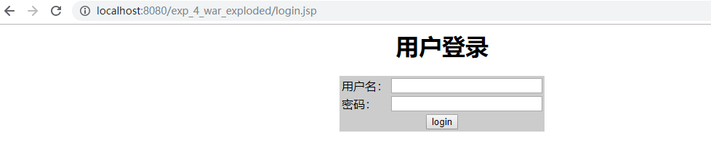

对登入进行检查

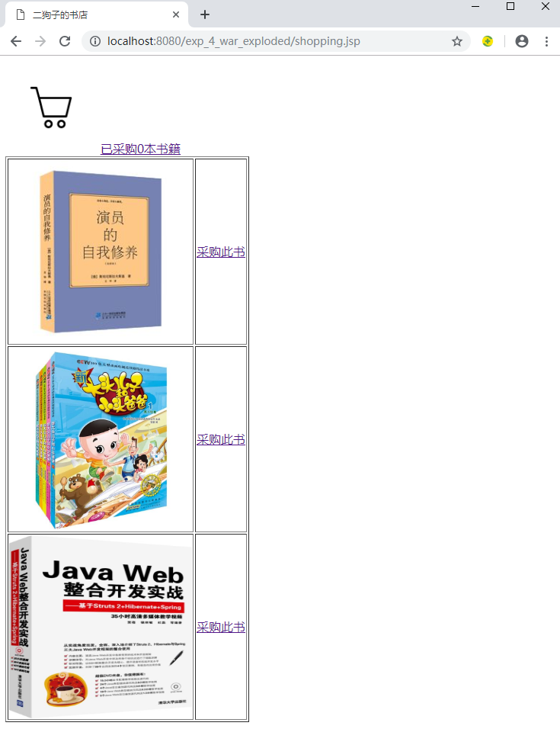

点击采购此书，session中存储的booklist数组中对应的book的booksum--，并且session存储的全部书数量的sum也--

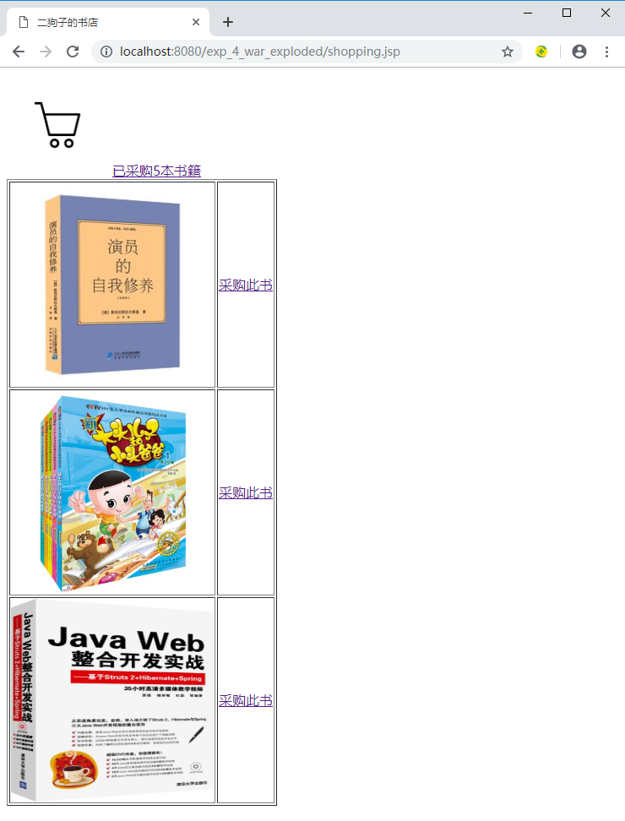

点击购物车，显示购买的书的数量以及购买的总数

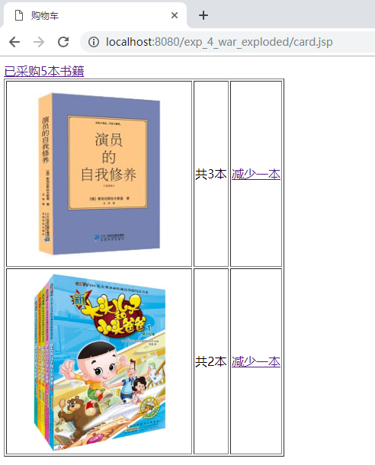

点击减少一本，session中存储的booklist数组中对应的book的booksum--，并且session存储的全部书数量的sum也--

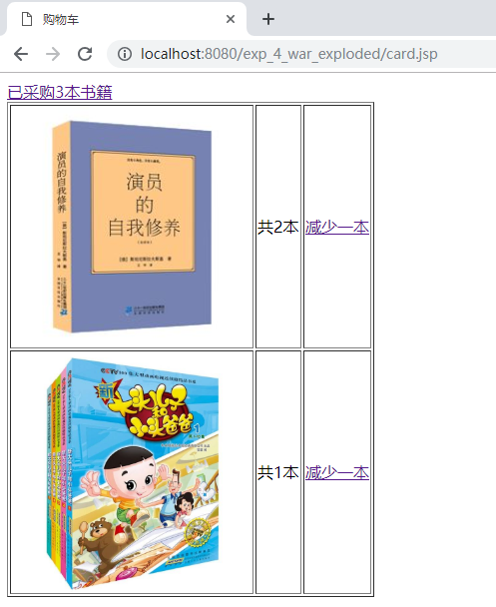

最后可以点击最上面的超链接回到原来的页面

# 收获与问题

学会了session中存储数据，延长了数据的生命周期。实现了页面的互动。