**Java Web开发**

**实验一**

**作业报告**

|  |  |
| --- | --- |
| 学 院 | 计算机 |
| 所在系 班 级 | 2017软件工程系软工5班 |
| 学 号 姓 名 | 04171320唐文超 |
| 指 导 教 师 | 郭晓燕 |
| 完 成 时 间 | 2019年4月-7 |

# 实验题目

实现一个购物车应用程序，可以购物，显示购物数量并查看购物车内容。

# 分析与设计

根据题目要求，设计一个购物车功能，通过登陆或注册来到商品信息页面，选择购买商品数量，最后有几一个页面计算价格。

# 关键源码（部分）

**注册界面设置：**

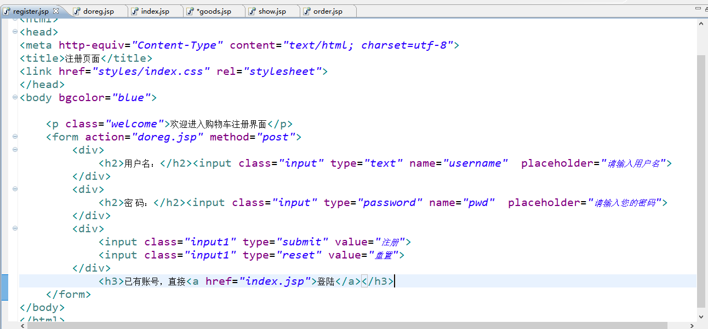

**直接登陆页面：**

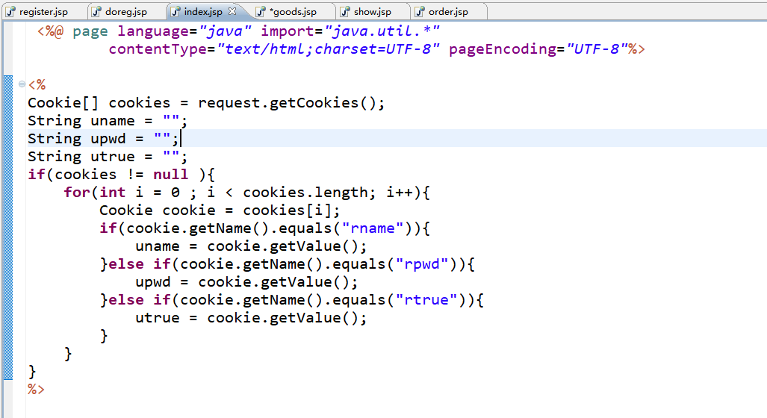

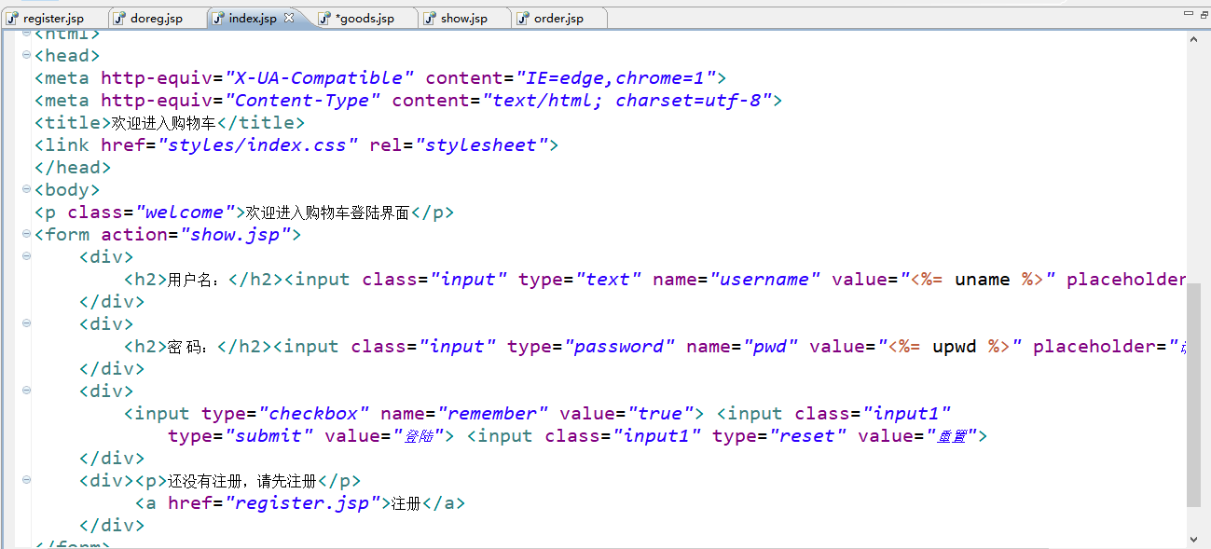

**商品及其他界面：**

<%@ page language=*"java"* contentType=*"text/html; charset=utf-8"*

pageEncoding=*"GB18030"*%>

<!DOCTYPE html>

<html>

<head>

<meta http-equiv=*"Content-Type"* content=*"text/html; charset=utf-8"*>

<title>购物页面</title>

<style>

**td**{border:*1px solid green*;}

</style>

</head>

<body>

<p>欢迎用户:

<%=

session.getAttribute("userName")

%>

</p>

<form action=*"order.jsp"* method=*"post"*><center>

<table>

<caption >欢迎来购物</caption>

<thead>

<tr>

<th>编号</th>

<th>商品名</th>

<th>单价</th>

<th>购买数量</th>

</tr>

</thead>

<tr>

<td>商品1</td>

<td><img src=*"C:\Users\阿超\Desktop\JavaWeb\书素材/01.jpg"*/>计算机信息检索</td>

<td>￥25.0</td>

<td>

<input type=*"button"* value=*"+"* onclick="this.form.book1.value++"/>

<input type=*"text"* name=*"book1"* value=*0* size=*"4"*>

<input type=*"button"* value=*"-"* onclick="this.form.book1.value--"/>

</td>

</tr>

<tr>

<td>商品2</td>

<td><img src=*"C:\Users\阿超\Desktop\JavaWeb\书素材/02.jpg"*/>Enterprise album</td>

<td>￥30.0</td>

<td>

<input type=*"button"* value=*"+"* onclick="this.form.book2.value++"/>

<input type=*"text"* name=*"book2"* value=*0* size=*"4"*>

<input type=*"button"* value=*"-"* onclick="this.form.book2.value--"/>

</td>

</tr>

<tr>

<td>商品3</td>

<td><img src=*"C:\Users\阿超\Desktop\JavaWeb\书素材/03.jpg"*/>大学计算机</td>

<td>￥27.0</td>

<td>

<input type=*"button"* value=*"+"* onclick="this.form.book3.value++"/>

<input type=*"text"* name=*"book3"* value=*0* size=*"4"*>

<input type=*"button"* value=*"-"* onclick="this.form.book3.value--"/>

</td>

</tr>

<tr>

<td>商品4</td>

<td><img src=*"C:\Users\阿超\Desktop\JavaWeb\书素材/04.jpg"*/>软件工程</td>

<td>￥46.5</td>

<td>

<input type=*"button"* value=*"+"* onclick="this.form.book4.value++"/>

<input type=*"text"* name=*"book4"* value=*0* size=*"4"*>

<input type=*"button"* value=*"-"* onclick="this.form.book4.value--"/>

</td>

</tr>

<tr>

<td>商品5</td>

<td><img src=*"C:\Users\阿超\Desktop\JavaWeb\书素材/05.jpg"*/>计算机应用基础</td>

<td>￥52.5</td>

<td>

<input type=*"button"* value=*"+"* onclick="this.form.book5.value++"/>

<input type=*"text"* name=*"book5"* value=*0* size=*"4"*>

<input type=*"button"* value=*"-"* onclick="this.form.book5.value--"/>

</td>

</tr>

</table>

<input type=*"submit"* value=*"提交订单"*>

<!-- <button type="submit">提交订单</button> -->

</form>

</body>

</html>

**商JavaBeen的计算代码ShopCar.CountPrice:**

**public** **class** CountPrice {

**private** **double** num_book1;

**private** **double** num_book2;

**private** **double** num_book3;

**private** **double** num_book4;

**private** **double** num_book5;

**private** **double** pri_book1;

**private** **double** pri_book2;

**private** **double** pri_book3;

**private** **double** pri_book4;

**private** **double** pri_book5;

**private** **double** total_price;

**public** **double** getNum_book1() {

**return** num_book1;

}

**public** **void** setNum_book1(**double** num_book1) {

**this**.num_book1 = num_book1;

**this**.setPri_book1(num_book1 * 25.0);

}

**public** **double** getNum_book2() {

**return** num_book2;

}

**public** **void** setNum_book2(**double** num_book2) {

**this**.num_book2 = num_book2;

**this**.setPri_book2(num_book2 * 30.0);

}

**public** **double** getNum_book3() {

**return** num_book3;

}

**public** **void** setNum_book3(**double** num_book3) {

**this**.num_book3 = num_book3;

**this**.setPri_book3(num_book3 * 27.0);

}

**public** **double** getNum_book4() {

**return** num_book4;

}

**public** **void** setNum_book4(**double** num_book4) {

**this**.num_book4 = num_book4;

**this**.setPri_book4(num_book4 * 46.5);

}

**public** **double** getNum_book5() {

**return** num_book5;

}

**public** **void** setNum_book5(**double** num_book5) {

**this**.num_book5 = num_book5;

**this**.setPri_book5(num_book5 * 52.5);

}

**public** **double** getPri_book1() {

**return** pri_book1;

}

**public** **void** setPri_book1(**double** pri_book1) {

**this**.pri_book1 = pri_book1;

}

**public** **double** getPri_book2() {

**return** pri_book2;

}

**public** **void** setPri_book2(**double** pri_book2) {

**this**.pri_book2 = pri_book2;

}

**public** **double** getPri_book3() {

**return** pri_book3;

}

**public** **void** setPri_book3(**double** pri_book3) {

**this**.pri_book3 = pri_book3;

}

**public** **double** getPri_book4() {

**return** pri_book4;

}

**public** **void** setPri_book4(**double** book4) {

**this**.pri_book4 = pri_book4;

}

**public** **double** getPri_book5() {

**return** pri_book5;

}

**public** **void** setPri_book5(**double** pri_book5) {

**this**.pri_book5 = pri_book5;

}

**public** **double** getTotal_price() {

**this**.total_price = **this**.getPri_book1() + **this**.getPri_book2()

+ **this**.getPri_book3() + **this**.getPri_book4()

+ **this**.getPri_book5();

**return** total_price;

}

}

# 运行效果图

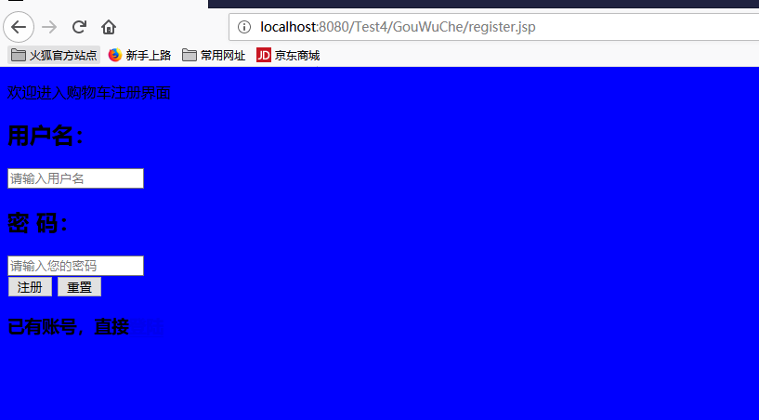

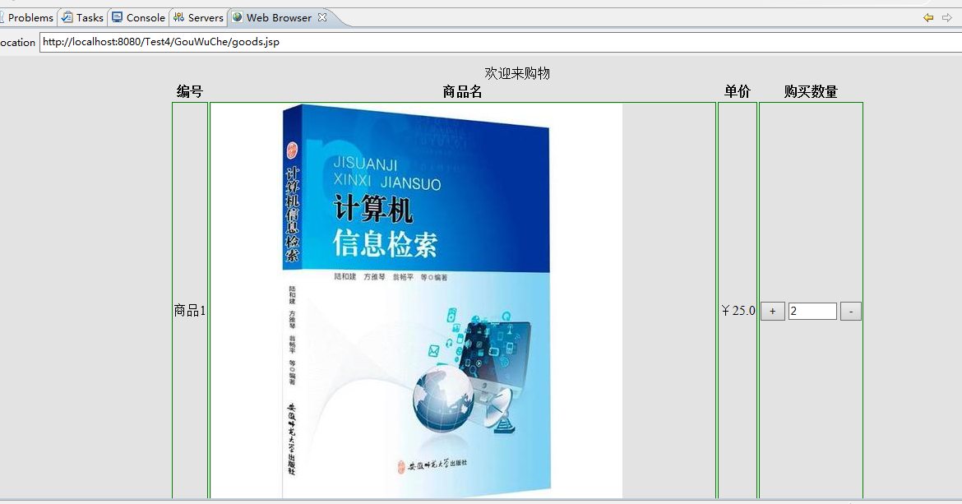

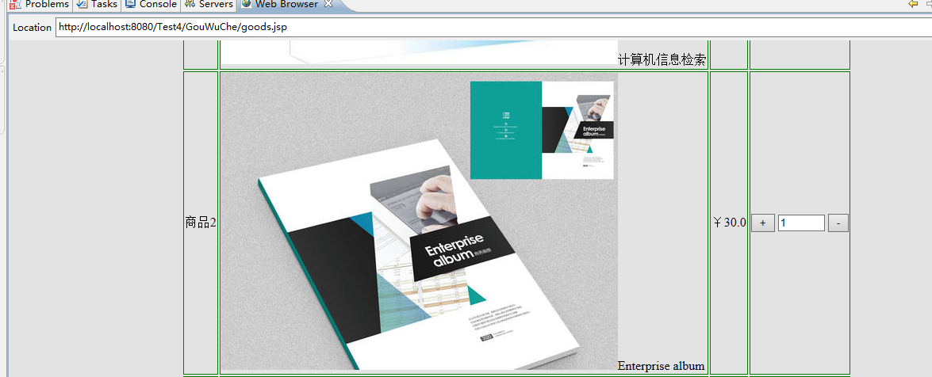





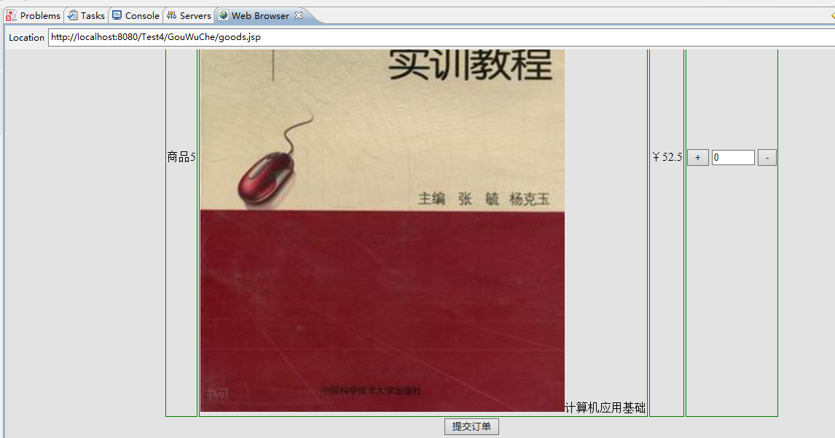

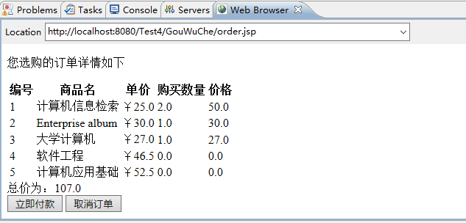

# 收获与问题

谈一谈你在本实验中所收获的内容及问题。