**Java Web开发**

**实验六**

**作业报告**

|  |  |
| --- | --- |
| 学 院 | 计算机 |
| 所在系 班 级 | 2017软件工程系06班 |
| 学 号 姓 名 | 04171417刘泽峰 |
| 指 导 教 师 | 罗永升 |
| 完 成 时 间 | 2018年4月8日 |

# 实验题目

1、上周没有完成作业的同学请继续完成，完成了作业的同学请为购物车增加功能：

2、参考成熟的购物系统，为购物车增加功能，完善购物车：删除商品，查看商品具体信息，计算商品总价，修改商品购买件数等等。界面尽量美观。

提示：Java文件即Book.java的设计需要重构，需要分离商品基本信息和购买信息，需要有类分别来保存单件商品的购买信息和所有商品的购买信息。所以至少要三个Java类才能完成购物的基本功能。

Servlet也需要响应更多的操作，可以在一个Servlet中也可以分多个文件响应。并在适当的地方调用Java方法。

# 分析与设计

**Book.java**:数据类，用来保存图书的基本信息（ID、书名、价格、图片地址）

**Mybook.java**:Book的子类，用来保存单件商品的购买信息,单件图书的数量，金额

**Totalbook.java**:用来保存所有商品的购买信息,所购图书的总数，价格

**Shopping.jsp**:购书页面，通过此页面用户选购图书

**ShoppingServlet.java**：获取到用户所点击的ID号（即书号），同时从Session对象中将图书数组取出来。

**CarServlet.java**：从Session对象中取出图书数组，对其进行遍历，计算数量及价格并写入session。

**removeServlet.java**:对所购图书数量减一

**Car.jsp**:我的购物车页面

**Code.jsp**:验证码页面

**Checkcode.Java**:检查验证码是否正确

**ServletImage.java**：生成验证码图片

# 关键源码（部分）

**Shopping.java**

<%@ page language=*"java"* import=*"java.util.*"* pageEncoding=*"UTF-8"* isELIgnored=*"false"* contentType=*"text/html;charset=UTF-8"*%>

<%@ page import=*"cc.test.vo.*"* import=*"java.text.DecimalFormat"* %>

<!DOCTYPE HTML PUBLIC "-//W3C//DTD HTML 4.01 Transitional//EN">

<html>

<head>

<meta charset=*"utf-8"*>

<title>我的书城</title>

<meta name=*"viewport"* content=*"width=device-width,initial-scale=1,user-scalable=no"*>

<!-- 新 Bootstrap 核心 CSS 文件 -->

<link href=*"https://cdn.staticfile.org/twitter-bootstrap/4.3.1/css/bootstrap.min.css"* rel=*"stylesheet"*>

<!-- font-awesome 文件 -->

<link rel=*"stylesheet"* href=*"https://cdn.staticfile.org/font-awesome/4.7.0/css/font-awesome.css"*>

<!-- jQuery文件。务必在bootstrap.min.js 之前引入 -->

<script src=*"https://cdn.staticfile.org/jquery/2.1.1/jquery.min.js"*></script>

<!-- 最新的 Bootstrap 核心 JavaScript 文件 -->

<script src=*"https://cdn.staticfile.org/twitter-bootstrap/4.3.1/js/bootstrap.min.js"*></script>

</head>

<%

DecimalFormat df = **new** DecimalFormat("#.00");

**if** (session.getAttribute("bookList")==**null**){

mybook[] BookList=**new** mybook[4];

String[] id={"10101","10102","10103","10104"};

String[] names={"Java核心技术","Java经典实例","Java7","JSP&Servlet"};

String[] imgs={"img\\10101.jpg", "img\\10102.jpg", "img\\10103.jpg", "img\\10104.jpg"};

**double**[] prices={95.20,74.00,78.20,73.90};

**for**(**int** i=0;i<4;i++){

BookList[i] = **new** mybook();

BookList[i].setBookId(id[i]);

BookList[i].setBookName(names[i]);

BookList[i].setBookPrice(prices[i]);

BookList[i].setBookImg(imgs[i]);

}

session.setAttribute("bookList", BookList);

session.setAttribute("sum", 0);

session.setAttribute("totalprice", 0);

}

%>

<body>

<nav class=*"navbar navbar-default"* role=*"navigation"* style="background-color: *#261F1F*">

<div class=*"container-fluid"* style="padding:*10px*">

<div class=*"navbar-header"* style="width:*30%*" align=*"center"*>

<h2 style="color: *aliceblue*">我的书城</h2>

</div>

<form class=*"navbar-form"* role=*"search"* style="width:*45%*; top: *50%*">

<input type=*"text"* class=*"form-control"* placeholder=*"Search"* style="width: *60%*;display: *inline*">

<button type=*"submit"* class=*"btn btn-default"*><span style="color: *aliceblue*"><i class=*"fa fa-search"* aria-hidden=*"true"*></i> 搜索</span></button>

</form>

<div class=*"navbar-header"* style="width:*15%*" align=*"left"*>

<a style="color: *aliceblue*" href=*"#"*>登录</a>

</div>

</div>

</nav>

<div class=*"container"* style="padding: *82*">

<br>

<div class=*"row"*>

<%

mybook[] bookList=(mybook[])session.getAttribute("bookList");

**for**(mybook book:bookList){

out.println("<div class='col-sm-6 col-md-3'>");

out.println("<div class='thumbnail' align='center'>");

out.println("<p><img src='"+book.getBookImg()+"'></p>");

out.println("<div class='caption'>");

out.println("<h5 align='center'>"+book.getBookName()+"</h5>");

out.println("<p>"+df.format(book.getBookPrice())+"</p>");

out.println("<p><a href=\"shopping.view?id="+book.getBookId()+"\"class='btn btn-primary' role='button'>采购此书</a> </p>");

out.println("</div>");

out.println("</div>");

out.println("</div>");

}

%>

</div>

<div class=*"content_footer"* style="background-color:*powderblue*; height:*60px*; padding:*10px*; width:*100%*; position:*fixed*; bottom:*0*; left:*0*;">

<table align=*"center"*>

<tr valign=*"middle"*>

<td align=*"center"* valign=*"middle"* width=*"300"*><h3>已购<%=session.getAttribute("sum")%>本</h3></td>

<td align=*"center"* valign=*"middle"* width=*"200"*>

<a href=*"cart.view"* class=*"btn btn-primary"* role=*"button"* style="background: *#372324*">我的购物车</a>

</td>

</tr>

</table>

</div>

</div>

</body>

</html>

**ShoppingServlet.java**

package cc.test.Controller;

import java.io.IOException;

import java.io.PrintWriter;

import javax.servlet.ServletException;

import javax.servlet.annotation.WebServlet;

import javax.servlet.http.HttpServlet;

import javax.servlet.http.HttpServletRequest;

import javax.servlet.http.HttpServletResponse;

import javax.servlet.http.HttpSession;

import cc.test.vo.*;

@WebServlet(urlPatterns={"/shopping.view"})

public class ShopingServlet extends HttpServlet {

public void doGet(HttpServletRequest request, HttpServletResponse response)

throws ServletException, IOException {

int booknum = 0;

//获取从Shopping.jsp传来的request对象中的ID号

HttpSession session=request.getSession();

String id=request.getParameter("id");

//在ID号不为空的情况下，获取Session对象中的购物车信息，Book数组。

mybook[] bookList=(mybook[])session.getAttribute("bookList");

if(id!=null){

for(mybook book:bookList){

if(id.equals(book.getBookId())){

booknum=book.getBooknum();

booknum++;

book.setBooknum(booknum);

}

}

}

int sum=0;

for(mybook book:bookList){

int num=book.getBooknum();

sum+=num;

}

totalbook b=new totalbook();

b.setSum(sum);

session.setAttribute("sum", sum);

//将数组写回session对象中去。

session.setAttribute("tb", b);

session.setAttribute("bookList", bookList);

//跳转回Shopping.jsp

response.sendRedirect("Shopping.jsp");

}

public void doPost(HttpServletRequest request, HttpServletResponse response)

throws ServletException, IOException {

doGet(request,response);

}

}

**CarServlet.java**

**package** cc.test.Controller;

**import** java.io.IOException;

**import** java.io.PrintWriter;

**import** java.text.DecimalFormat;

**import** javax.servlet.ServletException;

**import** javax.servlet.annotation.WebServlet;

**import** javax.servlet.http.HttpServlet;

**import** javax.servlet.http.HttpServletRequest;

**import** javax.servlet.http.HttpServletResponse;

**import** javax.servlet.http.HttpSession;

**import** cc.test.vo.Book;

**import** cc.test.vo.mybook;

**import** cc.test.vo.totalbook;

@WebServlet("/cart.view")

**public** **class** CarServlet **extends** HttpServlet {

**public** **void** doGet(HttpServletRequest request, HttpServletResponse response)

**throws** ServletException, IOException {

/*判断得到session对象中存储的book信息是否为空

不为空的前提下，读出Book数组中的内容，并将数目大于0的图书信息显示在网页上。

*/

HttpSession session=request.getSession();

mybook[] bookList=(mybook[])session.getAttribute("bookList");

**int** a=(Integer) session.getAttribute("sum");

**if** (a!=0){

totalbook b=(totalbook) session.getAttribute("tb");

**int** sum=0;

**double** totalprice=0;

DecimalFormat df = **new** DecimalFormat("#.00");

**for**(mybook book:bookList){

**int** num=book.getBooknum();

**double** price=book.getBookPrice();

totalprice+=price*num;

sum+=num;

}

b.setTotalprice(totalprice);

session.setAttribute("sum", sum);

session.setAttribute("totalprice", df.format(totalprice));

response.sendRedirect("car.jsp");

}**else**{

response.sendRedirect("car.jsp");

}

}

**public** **void** doPost(HttpServletRequest request, HttpServletResponse response)

**throws** ServletException, IOException {

doGet(request,response);

}

}

**Car.jsp**

<%@ page language=*"java"* import=*"java.util.*"* pageEncoding=*"UTF-8"* %>

<%@page import=*"cc.test.vo.*"* import=*"java.text.DecimalFormat"*%>

<%

String path = request.getContextPath();

String basePath = request.getScheme()+"://"+request.getServerName()+":"+request.getServerPort()+path+"/";

%>

<!DOCTYPE HTML PUBLIC "-//W3C//DTD HTML 4.01 Transitional//EN">

<html>

<%

mybook[] bookList=(mybook[])session.getAttribute("bookList");

DecimalFormat df = **new** DecimalFormat("#.00");

%>

<head>

<meta charset=*"utf-8"*>

<title>我的书城</title>

<meta name=*"viewport"* content=*"width=device-width,initial-scale=1,user-scalable=no"*>

<!-- 新 Bootstrap 核心 CSS 文件 -->

<link href=*"https://cdn.staticfile.org/twitter-bootstrap/4.3.1/css/bootstrap.min.css"* rel=*"stylesheet"*>

<!-- font-awesome 文件 -->

<link rel=*"stylesheet"* href=*"https://cdn.staticfile.org/font-awesome/4.7.0/css/font-awesome.css"*>

<!-- jQuery文件。务必在bootstrap.min.js 之前引入 -->

<script src=*"https://cdn.staticfile.org/jquery/2.1.1/jquery.min.js"*></script>

<!-- 最新的 Bootstrap 核心 JavaScript 文件 -->

<script src=*"https://cdn.staticfile.org/twitter-bootstrap/4.3.1/js/bootstrap.min.js"*></script>

</head>

<body>

<nav class=*"navbar navbar-default"* role=*"navigation"* style="background-color: *#261F1F*">

<div class=*"container-fluid"* style="padding:*10px*">

<div class=*"navbar-header"* style="width:*30%*" align=*"center"*>

<h2 style="color: *aliceblue*">我的购物车</h2>

</div>

<form class=*"navbar-form"* role=*"search"* style="width:*45%*; top: *50%*">

<input type=*"text"* class=*"form-control"* placeholder=*"Search"* style="width: *60%*;display: *inline*">

<button type=*"submit"* class=*"btn btn-default"*><span style="color: *aliceblue*"><i class=*"fa fa-search"* aria-hidden=*"true"*></i> 搜索</span></button>

</form>

<div class=*"navbar-header"* style="width:*15%*" align=*"left"*>

<a style="color: *aliceblue*" href=*"#"*>登录</a>

</div>

</div>

</nav>

<div class=*"container"* style="padding: *20px*">

<a href=*"Shopping.jsp"*>返回书城</a>

<table style=" width: *100%*; border-collapse: *collapse*; background-color:*azure*; border: *thin inset*">

<tr height=*"50px"*>

<td width=*"20%"* align=*"center"*>图片</td>

<td width=*"22%"* align=*"center"*>商品信息</td>

<td width=*"16%"* align=*"center"*>单价（元）</td>

<td width=*"10%"* align=*"center"*>数量</td>

<td width=*"16%"* align=*"center"*>金额（元）</td>

<td width=*"16%"* align=*"center"*>操作</td>

</tr>

<%

**for**(mybook book:bookList){

**if**(book.getBooknum()!=0){

out.println("<tr height='150px'>");

out.println("<td align='center'><img src='"+book.getBookImg()+"' width='130px' height='130px' alt='通用的占位符缩略图'></td>");

out.println("<td align='center'>"+book.getBookName()+"</td>");

out.println("<td align='center'>"+df.format(book.getBookPrice())+"</td>");

out.println("<td align='center'><a>"+book.getBooknum()+"</a></td>");

out.println("<td align='center'>"+df.format(book.getBookPrice()*book.getBooknum())+"</td>");

out.println("<td width='16%' align='center'>");

out.println("<p><a href=\"remove.view?id="+book.getBookId()+"\">减一</a></p>");

out.println("</td>");

out.println("</tr>");

}

}

%>

</table>

<br><br>

<div class=*"content_footer"* style="background-color:*powderblue*; height:*60px*; padding:*10px*; width:*100%*; position:*fixed*; bottom:*0*; left:*0*;">

<table align=*"center"*>

<tr valign=*"middle"*>

<td align=*"center"* valign=*"middle"* width=*"300"*><h3>共<%=session.getAttribute("totalprice") %>元</h3></td>

<td align=*"center"* valign=*"middle"* width=*"200"*>

<a href=*"code.jsp"* class=*"btn btn-primary"* role=*"button"* style="background: *#372324*">结算</a>

</td>

</tr>

</table>

</div>

</div>

</body>

</html>

**removeServlet.java**

package cc.test.Controller;

import java.io.IOException;

import java.io.PrintWriter;

import java.text.DecimalFormat;

import javax.servlet.ServletException;

import javax.servlet.annotation.WebServlet;

import javax.servlet.http.HttpServlet;

import javax.servlet.http.HttpServletRequest;

import javax.servlet.http.HttpServletResponse;

import javax.servlet.http.HttpSession;

import cc.test.vo.*;

@WebServlet(urlPatterns={"/remove.view"})

public class removeServlet extends HttpServlet {

public void doGet(HttpServletRequest request, HttpServletResponse response)

throws ServletException, IOException {

String bookid = null;

int booknum = 0;

double totalprice=0;

DecimalFormat df = new DecimalFormat("#.00");

//获取从Shopping.jsp传来的request对象中的ID号

HttpSession session=request.getSession();

String id=request.getParameter("id");

//在ID号不为空的情况下，获取Session对象中的购物车信息，Book数组。

mybook[] bookList=(mybook[])session.getAttribute("bookList");

if(id!=null){

for(mybook book:bookList){

if(id.equals(book.getBookId())){

booknum=book.getBooknum();

booknum--;

book.setBooknum(booknum);

}

}

}

int sum=0;

for(mybook book:bookList){

int num=book.getBooknum();

sum+=num;

}

session.setAttribute("sum", sum);

for(mybook book:bookList){

int num=book.getBooknum();

double price=book.getBookPrice();

totalprice+=price*num;

sum+=num;

}

session.setAttribute("totalprice", df.format(totalprice));

//将数组写回session对象中去。

session.setAttribute("bookList", bookList);

//跳转回Shopping.jsp

response.sendRedirect("car.jsp");

}

public void doPost(HttpServletRequest request, HttpServletResponse response)

throws ServletException, IOException {

doGet(request,response);

}

}

**Book.java**

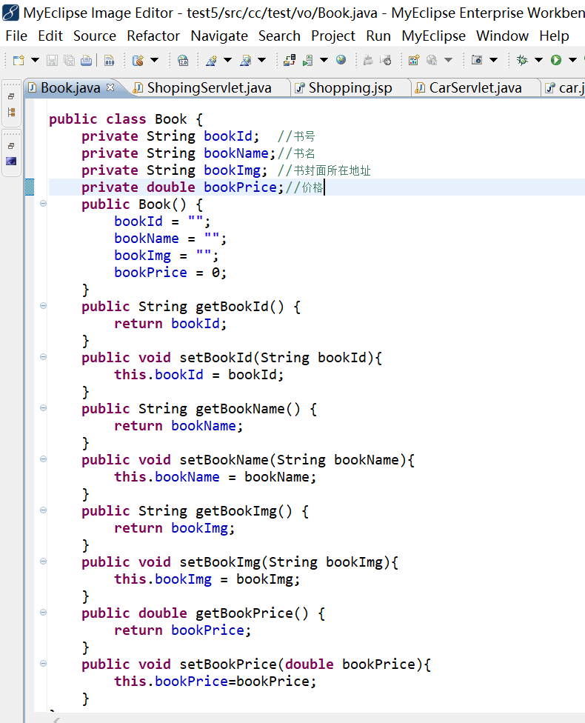

**Mybook.java**

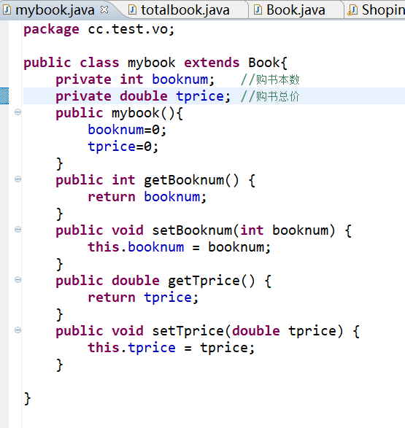

**Totalbook.java**

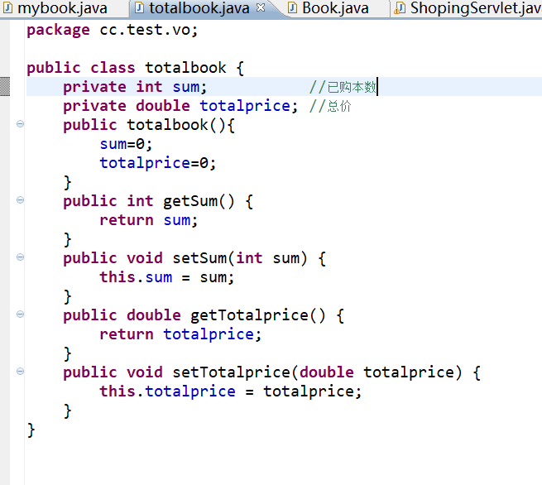

# 运行效果图

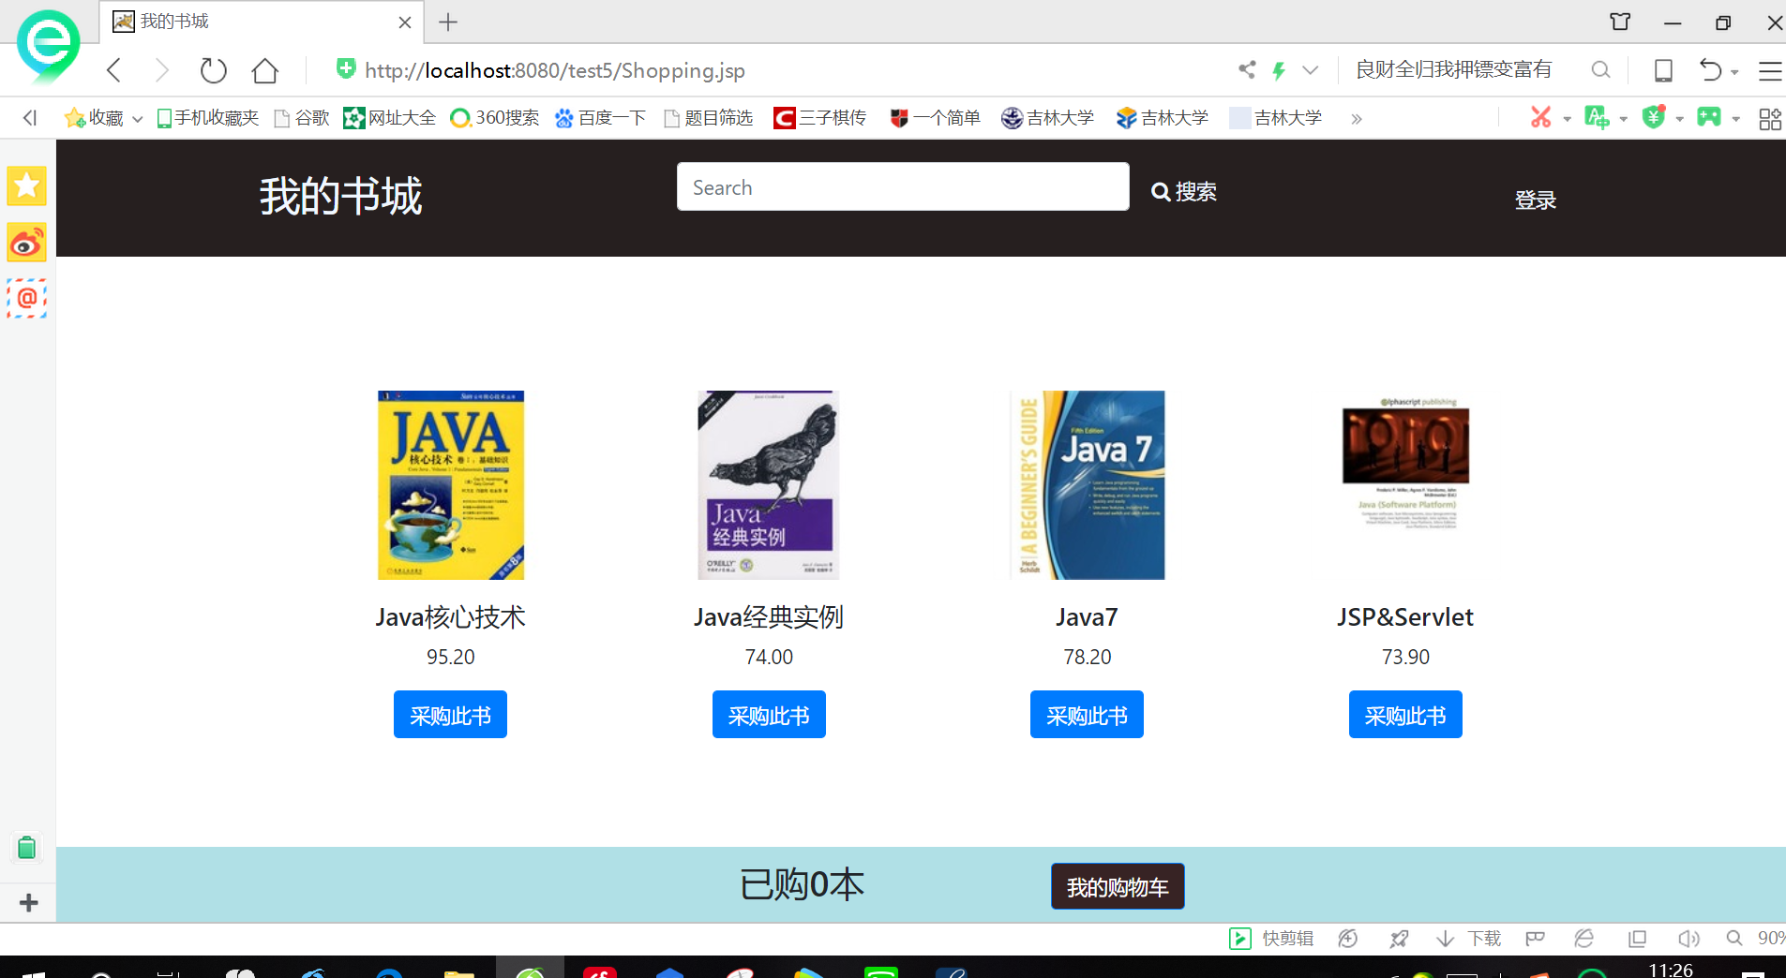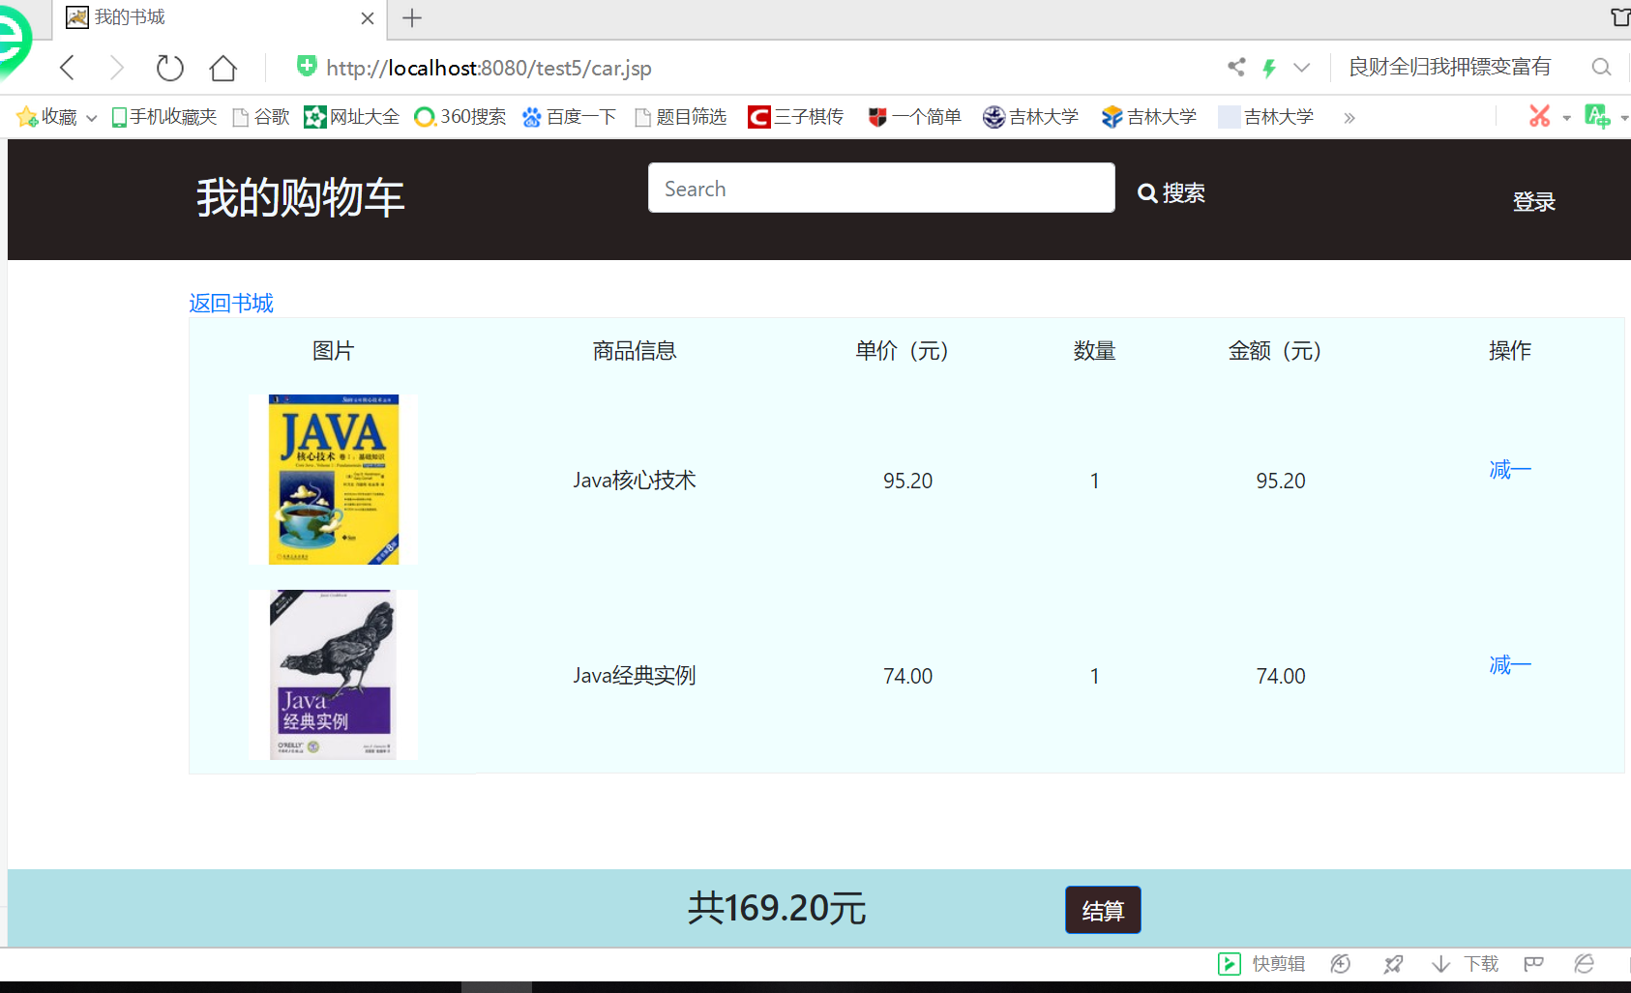

# 收获与问题

1. 学习更好的设计Java类。从而灵活使用session对象；
2. 完善购物车的功能；
3. 优化购物车的结构。