**Java Web开发**

**实验六**

**作业报告**

|  |  |
| --- | --- |
| 学 院 | 计算机 |
| 所在系 班 级 | 2017软件工程系6班 |
| 学 号 姓 名 | 04171418孙熠程 |
| 指 导 教 师 | 郭晓燕 |
| 完 成 时 间 | 2019年4月- |

1. 第四章课后练习3购物车，实现一个购物车应用程序，可以购物，显示购物数量并查看购物车内容。（此题模版test4E，提供给大家参考。）参考成熟的购物系统，为购物车增加功能，完善购物车：删除商品，查看商品具体信息，计算商品总价，修改商品购买件数等等。界面尽量美观。

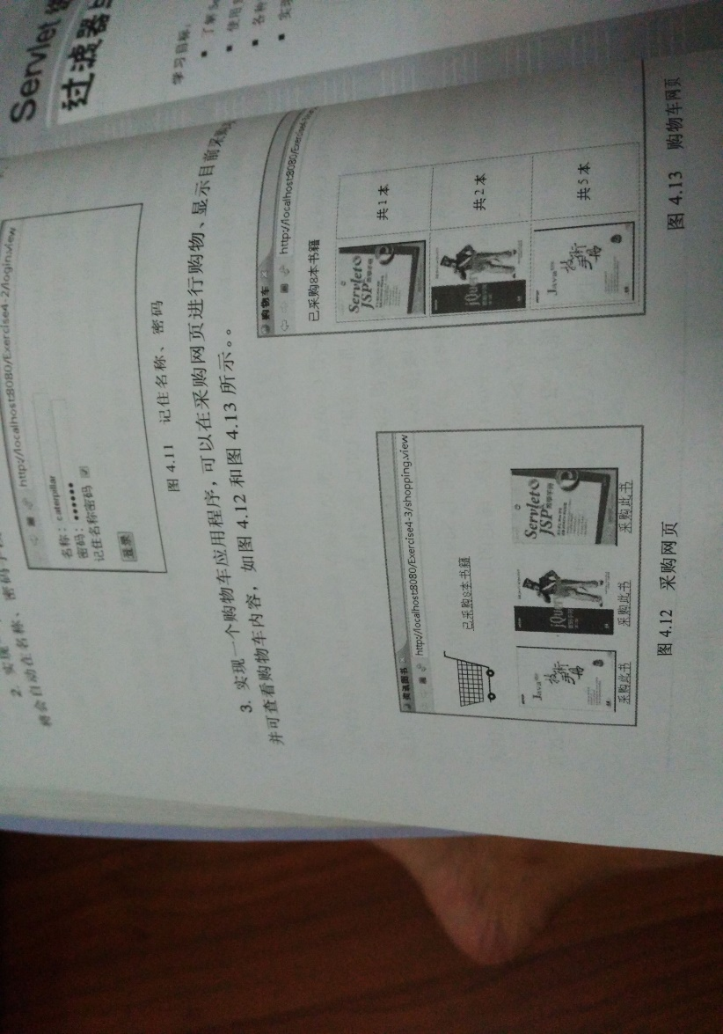

效果图：

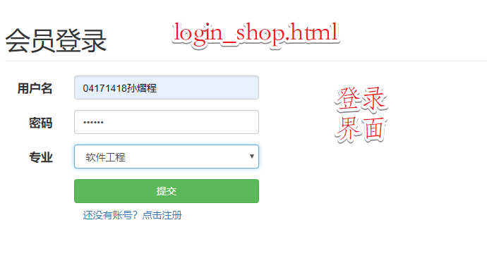

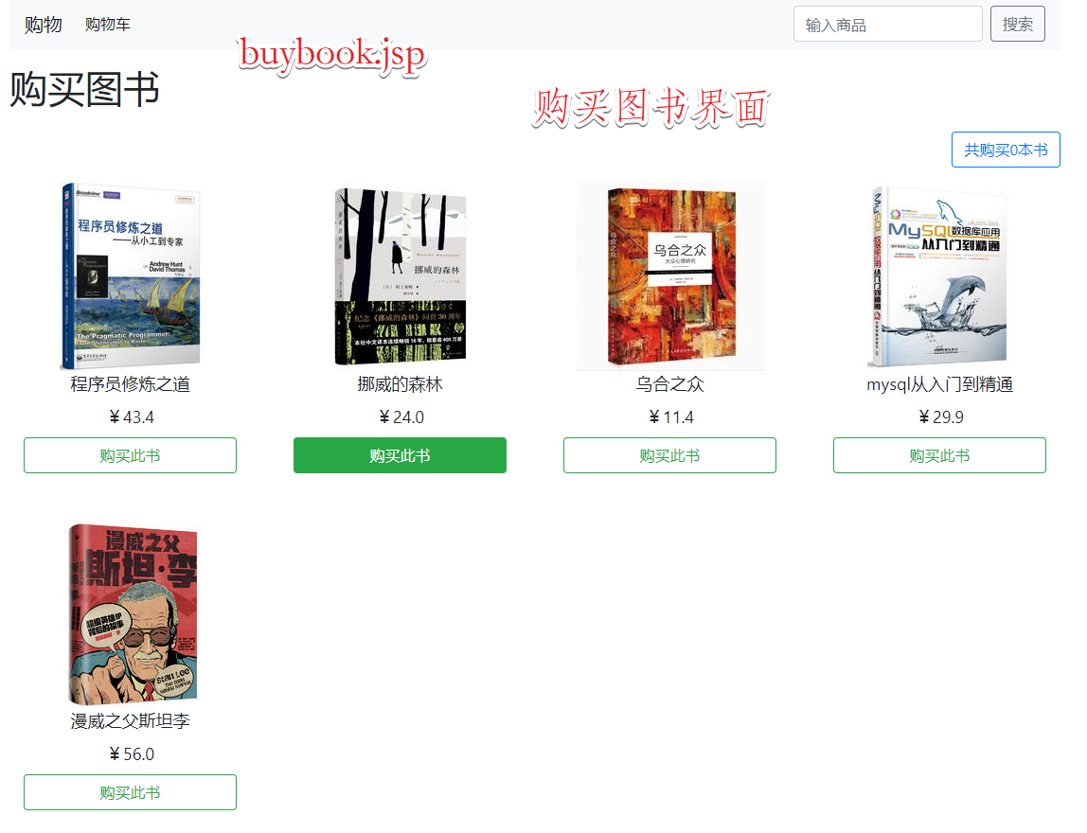

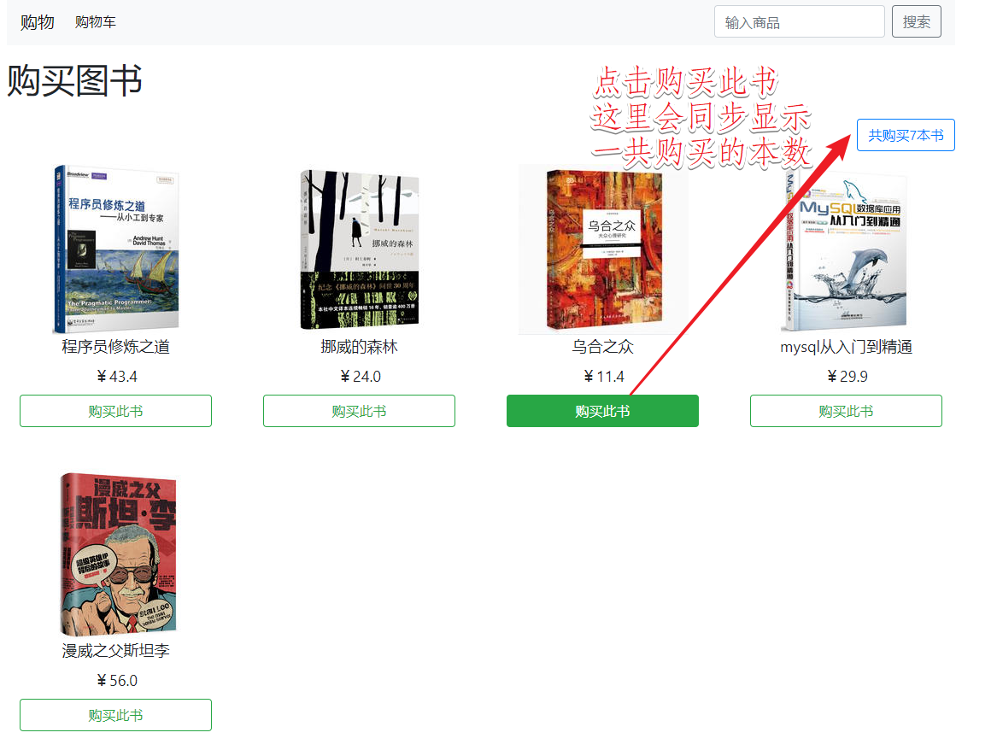

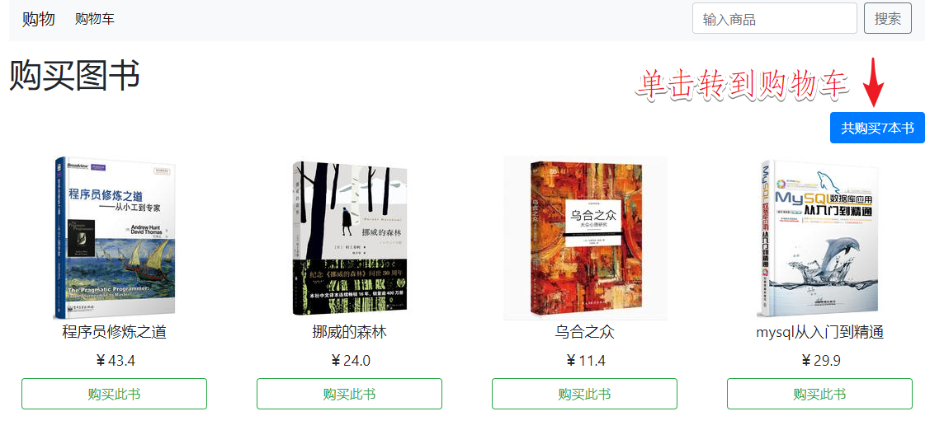

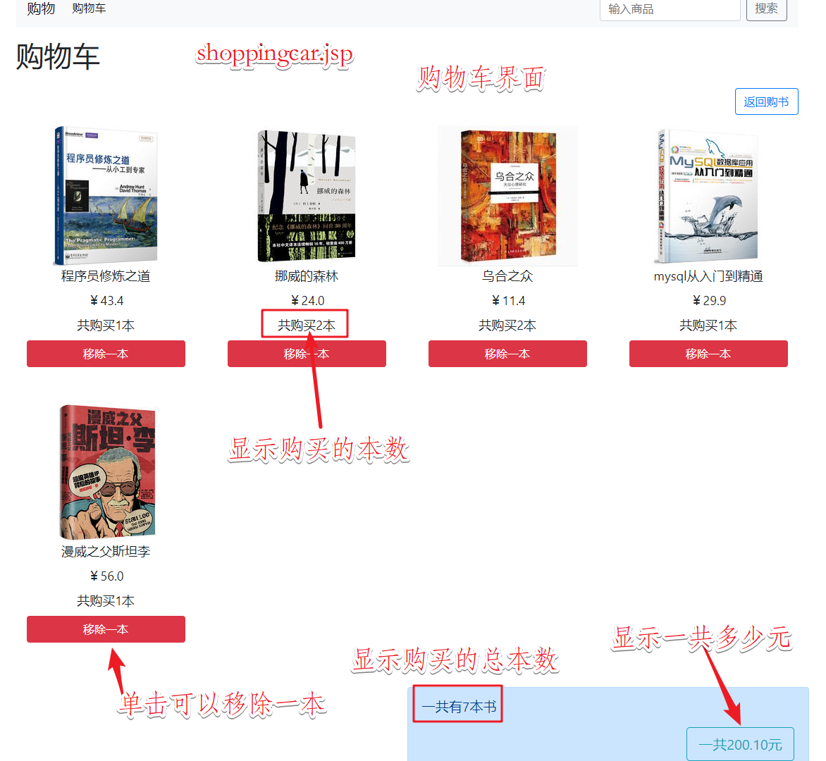

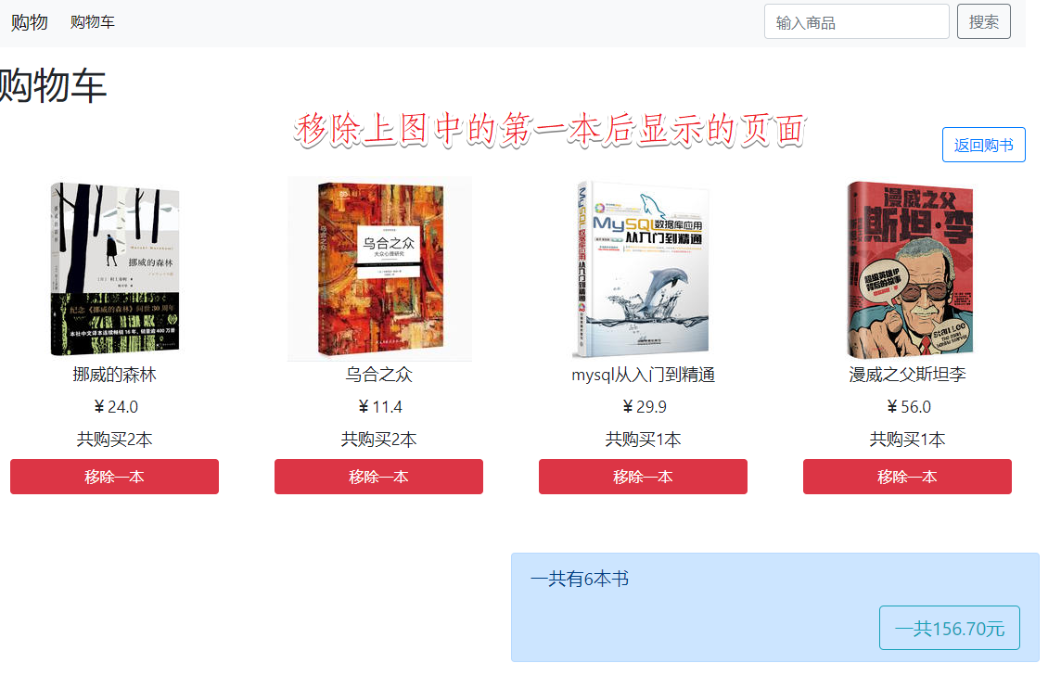

代码：

buybook.jsp

<head>

<meta charset=*"UTF-8"*>

<meta name=*"viewport"* content=*"width=device-width, initial-scale=1, shrink-to-fit=no"*>

<link rel=*"stylesheet"* type=*"text/css"* href=*"https://stackpath.bootstrapcdn.com/bootstrap/4.3.1/css/bootstrap.min.css"*>

<script src=*"https://code.jquery.com/jquery-3.3.1.slim.min.js"*></script>

<script src=*"https://cdnjs.cloudflare.com/ajax/libs/popper.js/1.14.7/umd/popper.min.js"*></script>

<script src=*"https://stackpath.bootstrapcdn.com/bootstrap/4.3.1/js/bootstrap.min.js"*></script>

<title>购物车系统</title>

<style type=*"text/css"*>

*.row*{

margin-top: *15px*;

margin-bottom: *15px*;

}

</style>

</head>

<body>

<%

Book[] BookList = (Book[])session.getAttribute("bookList");

**int** total = (**int**)session.getAttribute("total");

%>

<div class=*"container"*>

<div class=*"row"*>

<%

**for**(**int** i=0;i<BookList.length;i++){

out.print("<div class=\"col-md-3 text-center\">");

**for**(**int** j=0;j<4;j++){

out.print("<div class=\"col-md-12 text-center\">");

**if**(j==0)

out.print("<img src=\""+BookList[i].getAddress()+"\">");

**if**(j==1)

out.print("<label style=\"font-size: large;\">"+BookList[i].getBookname()+"</label>");

**if**(j==2)

out.print("<label style=\"font-size: large;\">￥"+BookList[i].getPrice()+"</label>");

**if**(j==3)

out.print("<a style=\"text-decoration:none\" href=\"Shoppingcar.do?action=buy&id="+BookList[i].getId()+

"\"><button name=\""+BookList[i].getId()+" id=\""+BookList[i].getId()+

" class=\"btn btn-outline-success btn-block\">购买此书</button></a><br><br>");

out.print("</div>");

}

out.print("</div>");

}

%>

</div>

</div>

</body>

shoppingcar.jsp

<body>

<%

Book[] BookList = (Book[])session.getAttribute("bookList");

**int** total = (**int**)session.getAttribute("total");

**double** money = (**double**)session.getAttribute("money");

DecimalFormat df = **new** DecimalFormat("0.00");

%>

<div class=*"container"*>

<div class=*"row"*>

<%

**for**(**int** i=0;i<BookList.length;i++){

**if**(BookList[i].getBuynum()!=0){

out.print("<div class=\"col-md-3 text-center\">");

**for**(**int** j=0;j<5;j++){

out.print("<div class=\"col-md-12 text-center\">");

**if**(j==0)

out.print("<img src=\""+BookList[i].getAddress()+"\">");

**if**(j==1)

out.print("<label style=\"font-size: large;\">"+BookList[i].getBookname()+"</label>");

**if**(j==2)

out.print("<label style=\"font-size: large;\">￥"+BookList[i].getPrice()+"</label>");

**if**(j==3)

out.print("<label style=\"font-size: large;\">"+"共购买"+BookList[i].getBuynum()+"本</label>");

**if**(j==4)

out.print("<a style=\"text-decoration:none\" href=\"Shoppingcar.do?action=remove&id="+BookList[i].getId()+"\"><button name=\""+BookList[i].getId()+"\" id=\""+BookList[i].getId()+

"\" class=\"btn btn-block btn-danger\">移除一本</button></a><br><br>");

out.print("</div>");

}

out.print("</div>");

}

}

%>

</div>

<div class=*"row"*>

<div class=*"alert-primary alert offset-6 col-sm-6"* role=*"alert"*>

<p style="font-size: *larger*;">一共有<%=total%>本书</p>

<button class=*"btn btn-lg float-right btn-outline-info"*>一共<%=df.format(money)%>元</button>

</div>

</div>

</div>

</body>

Loginbool.java(初始化的关键代码)

HttpSession session=request.getSession();

Book[] bookList=initBooks();

**int** total=0;**double** money=0;

session.setAttribute("bookList", bookList);

session.setAttribute("total", total);

session.setAttribute("money", money);

response.sendRedirect("buybook.jsp");

**public** Book[] initBooks() {

Book[] BookList = **new** Book[5];

BookList[0]=**new** Book("10001","程序员修炼之道",43.4,"img/程序员修炼之道.jpg",0);

BookList[1]=**new** Book("10002","挪威的森林",24,"img/挪威的森林.jpg",0);

BookList[2]=**new** Book("10003","乌合之众",11.4,"img/乌合之众.jpg",0);

BookList[3]=**new** Book("10004","mysql从入门到精通",29.9,"img/mysql从入门到精通.jpg",0);

BookList[4]=**new** Book("10005","漫威之父斯坦李",56,"img/漫威之父斯坦李.jpg",0);

**return** BookList;

}

ShoppingCar.java

**protected** **void** doPost(HttpServletRequest request, HttpServletResponse response) **throws** ServletException, IOException {

response.setCharacterEncoding("utf-8");

request.setCharacterEncoding("UTF-8");

response.setContentType("text/html;charset=UTF-8");

String action=request.getParameter("action"); //获取action参数值

**if**(action==**null**)

action="";

**if**(action.equals("buy")) //触发了“购买”请求

buy(request,response); //调用buy()方法实现商品的购买

**if**(action.equals("remove")) //触发了“移除”请求

remove(request,response); //调用remove()方法实现商品的移除

}

**private** **void** buy(HttpServletRequest request, HttpServletResponse response) **throws** IOException {

HttpSession session=request.getSession();

String Id=request.getParameter("id");

Book[] books=(Book[])session.getAttribute("bookList");

**int** total=(**int**)session.getAttribute("total");

**double** money=(**double**)session.getAttribute("money");

**for**(**int** i=0;i<books.length;i++) {

**if**(books[i].getId().equals(Id)) {

books[i].setBuynum(books[i].getBuynum()+1);

total++;

money+=books[i].getPrice();

}

}

session.setAttribute("bookList", books);

session.setAttribute("total", total);

session.setAttribute("money", money);

response.sendRedirect("buybook.jsp");

}

**private** **void** remove(HttpServletRequest request, HttpServletResponse response) **throws** IOException {

HttpSession session=request.getSession();

String Id=request.getParameter("id");

Book[] books=(Book[])session.getAttribute("bookList");

**int** total=(**int**)session.getAttribute("total");

**double** money=(**double**)session.getAttribute("money");

**for**(**int** i=0;i<books.length;i++) {

**if**(books[i].getId().equals(Id)) {

books[i].setBuynum(books[i].getBuynum()-1);

total--;

money-=books[i].getPrice();

}

}

session.setAttribute("bookList", books);

session.setAttribute("total", total);

session.setAttribute("money", money);

response.sendRedirect("shopcar.jsp");

}

分析过程：

在loginbool.java中登录成功就初始化session和book数据并压缩好session，然后在之后的所有操作中就都可以获取session解压之后进行相应的操作，然后再压缩。最后转发到相应的页面。然后jsp获取session里的数据，再配合<%%>写入java代码，动态显示不同的内容。

收获：

起初真的不知道session是个什么写法，看了老师的代码又似懂非懂的样子，然后去找网课，找了些资料，再看书学习session的写法，之后就基本掌握了session的原理和实现过程。写代码也轻松很多。Bootstrap框架可很好看很好用，官方文档用起来很舒服。