**Java Web开发**

**实验六**

**作业报告**

|  |  |
| --- | --- |
| 学 院 | 计算机 |
| 所在系 班 级 | 2017软件工程系06班 |
| 学 号 姓 名 | 04171419刘银升 |
| 指 导 教 师 | 郭晓燕 |
| 完 成 时 间 | 2019年4月- |

# 实验题目

实验目标：

学习更好的设计Java类。从而灵活使用session对象；

完善购物车的功能；

优化购物车的结构。

# 分析与设计

根据题目要求，计划设计几个文件来完成实验，每个文件的名字、作用。如果是类，要求写出类的变量和方法

# 关键源码（部分）

package com.session;

import java.io.IOException;

import javax.servlet.ServletException;

import javax.servlet.annotation.WebServlet;

import javax.servlet.http.HttpServlet;

import javax.servlet.http.HttpServletRequest;

import javax.servlet.http.HttpServletResponse;

import javax.servlet.http.HttpSession;

/**

* Servlet implementation class ShoppingServlet

*/

@WebServlet(urlPatterns= {"/Shopping.view"})

public class ShoppingServlet extends HttpServlet {

private static final long serialVersionUID = 1L;

protected void doGet(HttpServletRequest request, HttpServletResponse response) throws ServletException, IOException {

doPost(request, response);

}

protected void doPost(HttpServletRequest request, HttpServletResponse response) throws ServletException, IOException {

response.setContentType("text/html;charset=UTF-8");

int booknum=0;

HttpSession session=request.getSession();

String id=(String) request.getParameter("id");

System.out.println(id);

Book[] booklist=(Book[]) session.getAttribute("booklist");

if(id!=null) {

for (Book book:booklist) {

if(id.equals(book.getBookId())) {

booknum=book.getBookNum();

booknum++;

book.setBookNum(booknum);

}

}

}

int booksum=0;

for(Book book:booklist) {

booksum+=book.getBookNum();

}

session.setAttribute("booksum", booksum);

// session.setAttribute("booklist", booklist);

response.sendRedirect("Shopping.jsp");

}

}

<%@ page language=*"java"* import=*"java.util.*"* pageEncoding=*"UTF-8"*%>

<%@page import=*"com.session.*"* %>

<!DOCTYPE HTML PUBLIC "-//W3C//DTD HTML 4.01 Transitional//EN">

<html>

<%

//当第一次访问采购网页，session对象中还没有book购物车信息时，进行初始化。

**if** (session.getAttribute("booklist")==**null**){

//在session对象中存储图书采购信息

Book[] BookList = **new** Book[4];

BookList[0] = **new** Book("10101", "Java核心技术", "img\\10101.jpg", 0,11.1);

BookList[1] = **new** Book("10102", "Java经典实例", "img\\10102.jpg", 0,22.2);

BookList[2] = **new** Book("10103", "Java7", "img\\10103.jpg", 0,33.3);

BookList[3] = **new** Book("10104", "JSP&Servlet", "img\\10104.jpg",0,44.4);

//存入session对象中

session.setAttribute("booklist", BookList);

session.setAttribute("booksum", 0);

}

%>

<body>

<br>

<a href=*"ShoppingCar.jsp"*>

<img src=*"img/cart.jpg"* height=*"60px"* width=*"60px"*>

</a>

已采购<%=session.getAttribute("booksum") %> 本书籍<br>

<br>

<table border=*"1"*>

<%

Book[] booklist=(Book[])session.getAttribute("booklist");

out.println("<tr>");

**if**(booklist!=**null**)

**for**(Book book:booklist){

out.println("<td><img src='"+book.getBookImg()+"'></td>");

}

out.println("</tr>");

out.println("<tr>");

**for**(Book book:booklist){

out.println("<td><p>"+book.getBookName()+"</td>");

}

out.println("</tr>");

out.println("<tr>");

**for**(Book book:booklist){

out.println("<td><p>"+book.getBookPrice()+"</td>");

}

out.println("</tr>");

out.println("<tr>");

**for**(Book book:booklist){

out.println("<td><a href=\"Shopping.view?id="+book.getBookId()+"\">加入购物车</a></td>");

}

out.println("</tr>");

%>

</body>

</html>

**package** com.session;

**public** **class** Book {

**private** String bookId; //书号

**private** String bookName;//书名

String bookImg; //书封面所在地址

**private** **int** bookNum; //购书本数

**double** bookPrice;

**public** Book(String bookId, String bookName, String bookImg, **int** bookNum,**double** bookPrice) {

**this**.bookId = bookId;

**this**.bookName = bookName;

**this**.bookImg = bookImg;

**this**.bookNum = 0;

**this**.bookPrice=bookPrice;

}

**public** **double** getBookPrice() {

**return** bookPrice;

}

**public** **void** setBookPrice(**double** bookPrice) {

**this**.bookPrice = bookPrice;

}

**public** String getBookId() {

**return** bookId;

}

**public** **void** setBookId(String bookId) {

**this**.bookId = bookId;

}

**public** String getBookName() {

**return** bookName;

}

**public** **void** setBookName(String bookName) {

**this**.bookName = bookName;

}

**public** String getBookImg() {

**return** bookImg;

}

**public** **void** setBookImg(String bookImg) {

**this**.bookImg = bookImg;

}

**public** **int** getBookNum() {

**return** bookNum;

}

**public** **void** setBookNum(**int** bookNum) {

**this**.bookNum = bookNum;

}

}

package com.session;

import java.io.IOException;

import javax.servlet.ServletException;

import javax.servlet.annotation.WebServlet;

import javax.servlet.http.HttpServlet;

import javax.servlet.http.HttpServletRequest;

import javax.servlet.http.HttpServletResponse;

import javax.servlet.http.HttpSession;

import javax.websocket.Session;

@WebServlet("/ShoppingCar.view")

public class CarServlet extends HttpServlet {

private static final long serialVersionUID = 1L;

protected void doGet(HttpServletRequest request, HttpServletResponse response) throws ServletException, IOException {

doPost(request, response);

}

protected void doPost(HttpServletRequest request, HttpServletResponse response) throws ServletException, IOException {

response.setContentType("text/html;charset=UTF-8");

HttpSession session=request.getSession();

String id1=(String) request.getParameter("id");

Book[] booklist=(Book[]) session.getAttribute("booklist");

if(booklist!=null)

if(id1!=null) {

for (Book book:booklist) {

int sum=(int) session.getAttribute("booksum");

int num =book.getBookNum();

if(id1.equals(book.getBookId())) {

num=book.getBookNum();

num--;

book.setBookNum(num);

sum--;

session.setAttribute("booksum", sum);

}

}

// session.setAttribute("booklist", booklist);

response.sendRedirect("ShoppingCar.jsp");

}

}

}

<%@ page language=*"java"* contentType=*"text/html; charset=UTF-8"*

pageEncoding=*"UTF-8"*%>

<%@page import=*"com.session.*"* %>

<%

String path = request.getContextPath();

String basePath = request.getScheme()+"://"+request.getServerName()+":"+request.getServerPort()+path+"/";

%>

<!DOCTYPE html>

<html>

<head>

<meta charset=*"UTF-8"*>

<title>购物车</title>

</head>

<%

Book[] booklist=(Book[])session.getAttribute("booklist");

**double** totalprice=(Double)session.getAttribute("totalPrice");

%>

<body>

<img src=*"img/cart.jpg"*  height=*"60px"* width=*"60px"* >

<a>已采购<%=session.getAttribute("booksum")%>本书籍</a>

<a href=*"Shopping.jsp"*>回到首页</a>

<br>

<table border=*"1"*>

<tr>

<%

**double** sum=0;

**if**(session.getAttribute("booklist")!=**null**){

**for**(**int** i=0;i<booklist.length;i++){

out.println("<tr>");

**if**(booklist[i].getBookNum()!=0){

out.println("<td><img src='"+booklist[i].getBookImg()+"'></td>");

out.println("<td><p>"+booklist[i].getBookName()+"</td>");

out.println("<td><p>"+booklist[i].getBookPrice()*booklist[i].getBookNum()+"（元）</td>");

out.println("<td><a>已购"+booklist[i].getBookNum()+"本</a></td>");

out.println("<td><a href=\"ShoppingCar.view?id="+booklist[i].getBookId()+"\">减少该商品</a></td>");

sum+=booklist[i].getBookNum()*booklist[i].getBookPrice();

}

out.println("</tr>");

}

out.println("<td><a>合计"+sum+"元</a></td>");

}

%>

</tr>

</table>

</body>

</html>

# 运行效果图

实验在浏览器下运行的结果截图，并进行解释。

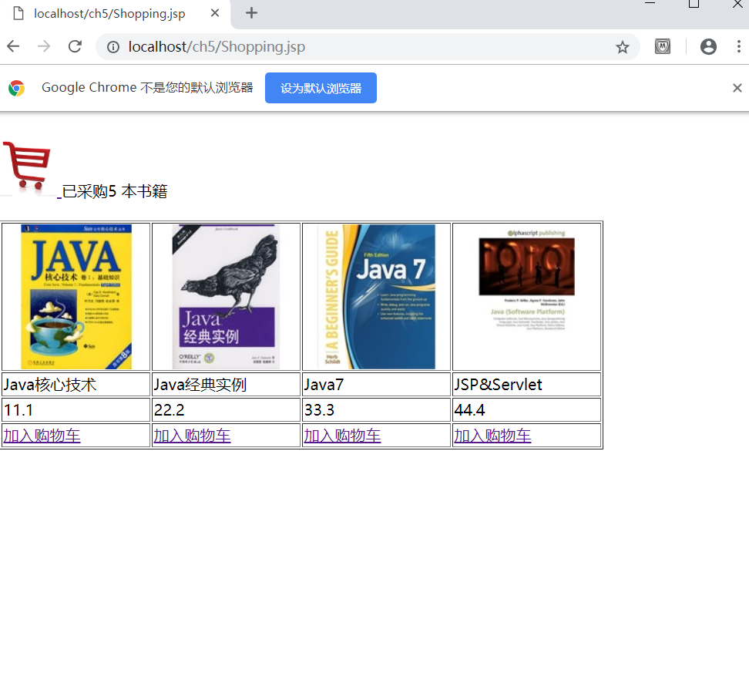

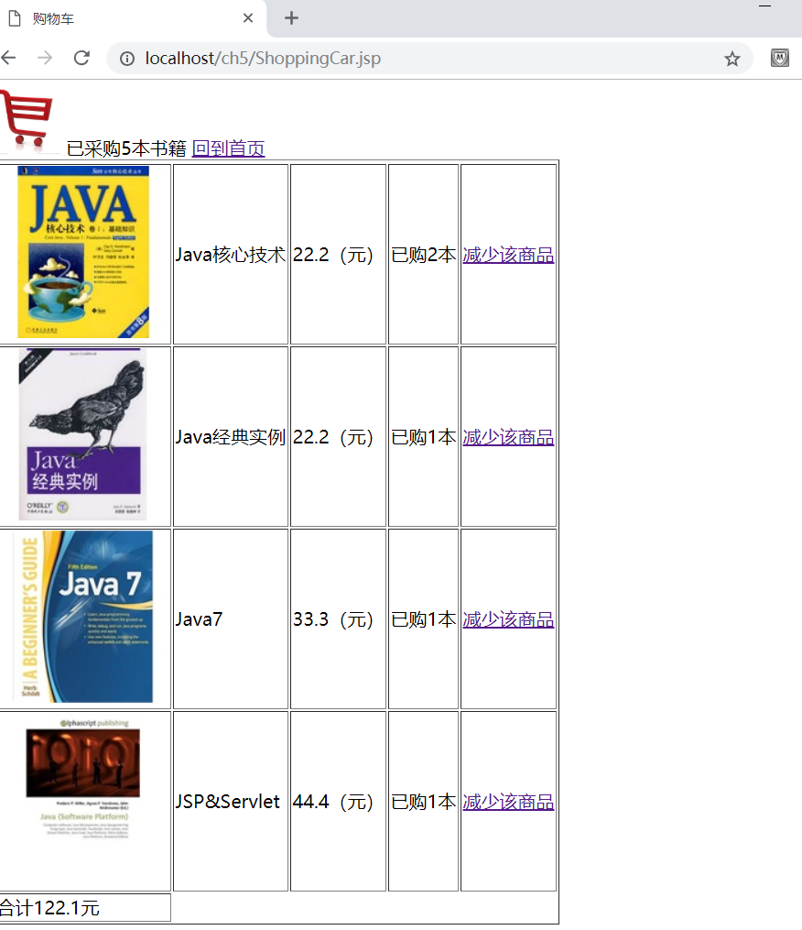

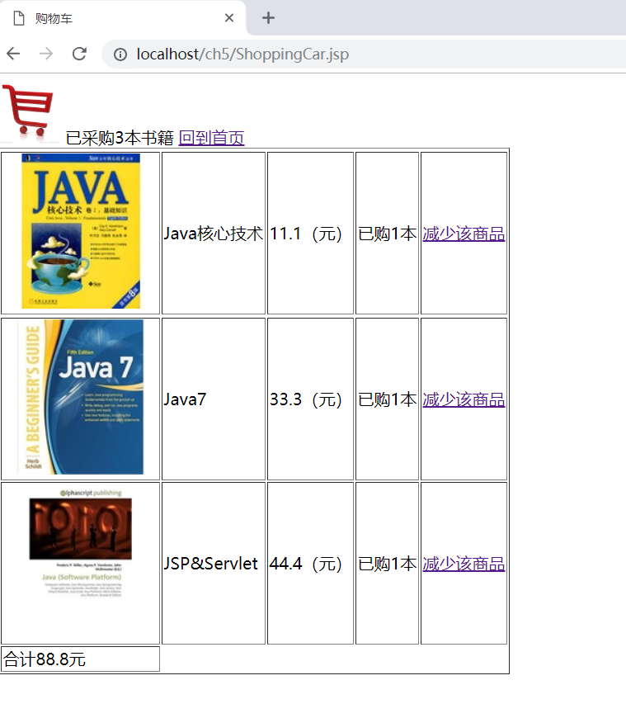

# 收获与问题

谈一谈你在本实验中所收获的内容及问题。