**Java Web开发**

**实验一**

**作业报告**

|  |  |
| --- | --- |
| 学 院 | 计算机 |
| 所在系 班 级 | 2017软件工程系6班 |
| 学 号 姓 名 | 蔡文强 |
| 指 导 教 师 | 郭晓燕 |
| 完 成 时 间 | 2018年5月- |

# 实验题目

将题目贴上去1、上周没有完成作业的同学请继续完成，完成了作业的同学请为购物车增加功能：

2、参考成熟的购物系统，为购物车增加功能，完善购物车：删除商品，查看商品具体信息，计算商品总价，修改商品购买件数等等。界面尽量美观。

提示：Java文件即Book.java的设计需要重构，需要分离商品基本信息和购买信息，需要有类分别来保存单件商品的购买信息和所有商品的购买信息。所以至少要三个Java类才能完成购物的基本功能。

Servlet也需要响应更多的操作，可以在一个Servlet中也可以分多个文件响应。并在适当的地方调用Java方法。

# 分析与设计

通过两个servlet来完成功能

# 关键源码（部分）

package cc.test.Controller;

import java.io.IOException;

import java.io.PrintWriter;

import javax.servlet.ServletException;

import javax.servlet.http.HttpServlet;

import javax.servlet.http.HttpServletRequest;

import javax.servlet.http.HttpServletResponse;

import javax.servlet.http.HttpSession;

import cc.test.vo.Book;

public class CarServlet extends HttpServlet {

public void doGet(HttpServletRequest request, HttpServletResponse response)

throws ServletException, IOException {

String id = request.getParameter("id");

HttpSession hs = request.getSession();

Book[] bookList = (Book[]) hs.getAttribute("book");

for(Book book : bookList) {

if(book.getBookId().equals(id)) {

book.setBookNum(0);

}

}

response.sendRedirect("shoppingItem.jsp");

}

public void doPost(HttpServletRequest request, HttpServletResponse response)

throws ServletException, IOException {

doGet(request,response);

}

}

package cc.test.Controller;

import java.io.IOException;

import java.io.PrintWriter;

import javax.servlet.ServletException;

import javax.servlet.http.HttpServlet;

import javax.servlet.http.HttpServletRequest;

import javax.servlet.http.HttpServletResponse;

import javax.servlet.http.HttpSession;

import cc.test.vo.Book;

public class ShopingServlet extends HttpServlet {

public void doGet(HttpServletRequest request, HttpServletResponse response)

throws ServletException, IOException {

HttpSession hs = request.getSession();

String id = request.getParameter("id");

Book[] bookList = (Book[]) hs.getAttribute("book");

for(Book book : bookList) {

if(id.equals(book.getBookId())) {

book.setBookNum(book.getBookNum()+1);

}

}

response.sendRedirect("shoppingItem.jsp");

}

public void doPost(HttpServletRequest request, HttpServletResponse response)

throws ServletException, IOException {

doGet(request,response);

}

}

package cc.test.vo;

public class Book {

private String bookId;

private String bookName;

String bookImg;

private int bookNum;

private int Price;

public Book(String bookId, String bookName, String bookImg, int bookNum, int price) {

this.bookId = bookId;

this.bookName = bookName;

this.bookImg = bookImg;

this.bookNum = 0;

this.Price = price;

}

public void setBookNum(int bookNum) {

this.bookNum = bookNum;

}

public int getPrice() {

return Price;

}

public String getBookId() {

return bookId;

}

public String getBookName() {

return bookName;

}

public String getBookImg() {

return bookImg;

}

public int getBookNum() {

return bookNum;

}

}

<%@ **page** language=*"java"* import=*"java.util.*"* pageEncoding=*"UTF-8"*%>

<%@**page** import=*"cc.test.vo.*"* %>

<!**DOCTYPE** HTML PUBLIC "-//W3C//DTD HTML 4.01 Transitional//EN">

<**html**>

<%

//当第一次访问采购网页，session对象中还没有book购物车信息时，进行初始化。

if (session.getAttribute("book")==null){

//在session对象中存储图书采购信息

Book[] BookList = new Book[4];

BookList[0] = new Book("10101", "Java核心技术", "img\10101.jpg", 0, 50);

BookList[1] = new Book("10102", "Java经典实例", "img\10102.jpg", 0, 100);

BookList[2] = new Book("10103", "Java7", "img\10103.jpg", 0, 60);

BookList[3] = new Book("10104", "JSP&Servlet", "img\10104.jpg",0, 80);

//存入session对象中

session.setAttribute("book", BookList);

}

%>

<**body**>

<**br**>

<**img** src=*"img/cart.jpg"* height=*"60px"* width=*"60px"*>

<**a** href=*"shoppingItem.jsp"*>已采购 本书籍</**a**><**br**>

<**br**>

<**table** border=*"1"*>

<**tr**>

<**td**><**img** src=*"img/10101.jpg"*></**td**>

<**td**><**img** src=*"img/10102.jpg"*></**td**>

<**td**><**img** src=*"img/10103.jpg"*></**td**>

<**td**><**img** src=*"img/10104.jpg"*></**td**>

</**tr**>

<**tr**>

<**td**><**a** href=*"shopping.view?id=10101"*>采购此书</**a**></**td**>

<**td**><**a** href=*"shopping.view?id=10102"*>采购此书</**a**></**td**>

<**td**><**a** href=*"shopping.view?id=10103"*>采购此书</**a**></**td**>

<**td**><**a** href=*"shopping.view?id=10104"*>采购此书</**a**></**td**>

</**tr**>

</**body**>

</**html**>

<%@**page** import=*"cc.test.vo.Book"*%>

<%@ **page** language=*"java"* contentType=*"text/html; charset=UTF-8"*

pageEncoding=*"UTF-8"*%>

<!**DOCTYPE** html>

<**html**>

<**head**>

<**meta** charset=*"UTF-8"*>

<**title**>购物车</**title**>

</**head**>

<**body**>

<**table** border=*"1"*>

<**tr**>

<**td**>书名</**td**>

<**td**>数量</**td**>

<**td**>单价</**td**>

</**tr**>

<%

HttpSession hs = request.getSession();

Book[] bookList = (Book[])hs.getAttribute("book");

int total = 0;

for(Book book : bookList ){

if(book.getBookNum()!=0){

total+=book.getPrice();

%>

<**tr**>

<**td**><%=book.getBookName() %></**td**>

<**td**><%=book.getBookNum() %></**td**>

<**td**><%=book.getPrice() %></**td**>

<**td**><**a** href=*"cart.view?id=*<%=book.getBookId()%>*"*>删除</**a**></**td**>

</**tr**>

<%

}

}

%>

<**tr**>

<**td**>总价：<%=total %></**td**>

</**tr**>

<**tr**>

<**td**><**a** href=*"Shopping.jsp"*>返回</**a**></**td**>

</**tr**>

</**table**>

</**body**>

</**html**>

# 运行效果图

实验在浏览器下运行的结果截图，并进行解释。

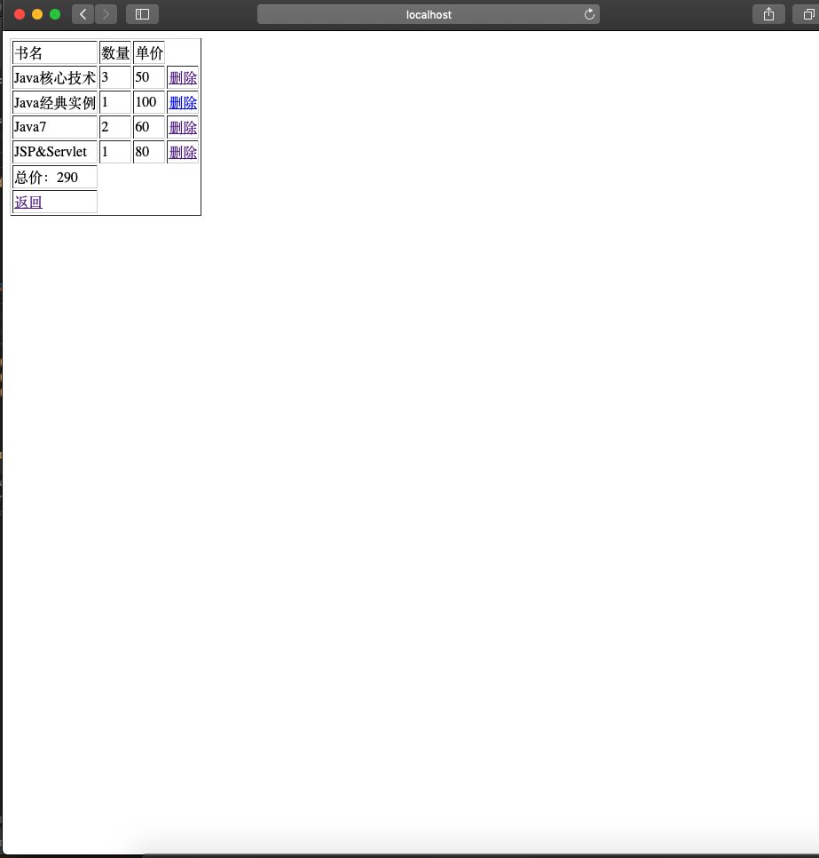

# 收获与问题

熟练掌握session用法