**Java Web开发**

**实验六**

**作业报告**

|  |  |
| --- | --- |
| 学 院 | 计算机 |
| 所在系 班 级 | 2017软件工程系6班 |
| 学 号 姓 名 | 04171424柯海扬 |
| 指 导 教 师 | 罗永升 |
| 完 成 时 间 | 2019年4月15日 |

# 实验题目

1、上周没有完成作业的同学请继续完成，完成了作业的同学请为购物车增加功能：

# 关键源码（部分）

#Shopping.jsp

<%@ page language=*"java"* import=*"java.util.*"* pageEncoding=*"UTF-8"*%>

<%@page import=*"cc.*"* %>

<!DOCTYPE HTML PUBLIC "-//W3C//DTD HTML 4.01 Transitional//EN">

<html>

<%

//当第一次访问采购网页，session对象中还没有book购物车信息时，进行初始化。

**int** num;

**if** (session.getAttribute("num") == **null**) {

num = 0;

session.setAttribute("num", num);

}

**else**

{

num= (Integer) session.getAttribute("num");

}

**if** (session.getAttribute("book") == **null**) {

//在session对象中存储图书采购信息

book[] BookList = **new** book[4];

BookList[0] = **new** book("10101", "Java核心技术", "./img/10101.jpg", 0,30);

BookList[1] = **new** book("10102", "Java经典实例", "./img/10102.jpg", 0,30);

BookList[2] = **new** book("10103", "Java7", "./img/10103.jpg", 0,30);

BookList[3] = **new** book("10104", "JSP&Servlet", "./img/10104.jpg", 0,30);

//存入session对象中

session.setAttribute("book", BookList);

}

%>

<body>

<br>

<img src=*"img/cart.PNG"* height=*"250px"* width=*"250px"*>

<a href=*"cart.view"*>已采购<%=num %>本书籍</a><br>

<br>

<table border=*"1"*>

<tr>

<td><img src=*"./img/10101.jpg"*></td>

<td><img src=*"./img/10102.jpg"*></td>

<td><img src=*"./img/10103.jpg"*></td>

<td><img src=*"./img/10104.jpg"*></td>

</tr>

<tr>

<td><a href=*"book10101.jsp"*>采购此书</a></td>

<td><a href=*"book10102.jsp"*>采购此书</a></td>

<td><a href=*"book10103.jsp"*>采购此书</a></td>

<td><a href=*"book10104.jsp"*>采购此书</a></td>

</tr>

</body>

</html>

#book10101.jsp

<%@ page language=*"java"* import=*"java.util.*"* pageEncoding=*"UTF-8"*%>

<%@page import=*"cc.*"* %>

<!DOCTYPE HTML PUBLIC "-//W3C//DTD HTML 4.01 Transitional//EN">

<html>

<head>

<title>Java核心技术</title>

</head>

<body>

<% request.setCharacterEncoding("utf-8");

book[] BookList=(book[])session.getAttribute("book");

%>

<FORM action=*"shopping.view"* method=*post* name=*form*>

<table border=*"1"*>

<tr>

<td><img src=*"./img/10101.jpg"*></td>

<td>价格：<%=BookList[0].getMoney() %></td>

<td>请输入需要的本数：<INPUT type=*"text"* name=*"booknum"* value=*"0"*>

<INPUT TYPE=*"hidden"* value=*"10101"* name=*"types"*></td>

<td><INPUT TYPE=*"submit"* value=*"提交"* name=*"submit"*></td>

</tr>

</table>

</FORM>

</body>

</html>

#book10102.jsp

<%@ page language=*"java"* import=*"java.util.*"* pageEncoding=*"UTF-8"*%>

<%@page import=*"cc.*"* %>

<!DOCTYPE HTML PUBLIC "-//W3C//DTD HTML 4.01 Transitional//EN">

<html>

<head>

<title>Java经典实例</title>

</head>

<body>

<% request.setCharacterEncoding("utf-8");

book[] BookList=(book[])session.getAttribute("book");

%>

<FORM action=*"shopping.view"* method=*post* name=*form*>

<table border=*"1"*>

<tr>

<td><img src=*"./img/10102.jpg"*></td>

<td>价格：<%=BookList[1].getMoney() %></td>

<td>请输入需要的本数：<INPUT type=*"text"* name=*"booknum"* value=*"0"*>

<INPUT TYPE=*"hidden"* value=*"10102"* name=*"types"*></td>

<td><INPUT TYPE=*"submit"* value=*"提交"* name=*"submit"*></td>

</tr>

</table>

</FORM>

</body>

</html>

#book10103.jsp

<%@ page language=*"java"* import=*"java.util.*"* pageEncoding=*"UTF-8"*%>

<%@page import=*"cc.*"* %>

<!DOCTYPE HTML PUBLIC "-//W3C//DTD HTML 4.01 Transitional//EN">

<html>

<head>

<title>Java7</title>

</head>

<body>

<% request.setCharacterEncoding("utf-8");

book[] BookList=(book[])session.getAttribute("book");

%>

<FORM action=*"shopping.view"* method=*post* name=*form*>

<table border=*"1"*>

<tr>

<td><img src=*"./img/10103.jpg"*></td>

<td>价格：<%=BookList[2].getMoney() %></td>

<td>请输入需要的本数：<INPUT type=*"text"* name=*"booknum"* value=*"0"*>

<INPUT TYPE=*"hidden"* value=*"10103"* name=*"types"*></td>

<td><INPUT TYPE=*"submit"* value=*"提交"* name=*"submit"*></td>

</tr>

</table>

</FORM>

</body>

</html>

#book10104.jsp

<%@ page language=*"java"* import=*"java.util.*"* pageEncoding=*"UTF-8"*%>

<%@page import=*"cc.*"* %>

<!DOCTYPE HTML PUBLIC "-//W3C//DTD HTML 4.01 Transitional//EN">

<html>

<head>

<title>JSP&Servlet</title>

</head>

<body>

<% request.setCharacterEncoding("utf-8");

book[] BookList=(book[])session.getAttribute("book");

%>

<FORM action=*"shopping.view"* method=*post* name=*form*>

<table border=*"1"*>

<tr>

<td><img src=*"./img/10104.jpg"*></td>

<td>价格：<%=BookList[3].getMoney() %></td>

<td>请输入需要的本数：<INPUT type=*"text"* name=*"booknum"* value=*"0"*>

<INPUT TYPE=*"hidden"* value=*"10104"* name=*"types"*></td>

<td><INPUT TYPE=*"submit"* value=*"提交"* name=*"submit"*></td>

</tr>

</table>

</FORM>

</body>

</html>

#shopping.java

import java.io.IOException;

import javax.servlet.ServletException;

import javax.servlet.annotation.WebServlet;

import javax.servlet.http.HttpServlet;

import javax.servlet.http.HttpServletRequest;

import javax.servlet.http.HttpServletResponse;

import javax.servlet.http.HttpSession;

@WebServlet(name = "shopping", urlPatterns = { "/shopping.view" })

public class shopping extends HttpServlet {

protected void doGet(HttpServletRequest request, HttpServletResponse response) throws ServletException, IOException {

// TODO Auto-generated method stub

request.setCharacterEncoding("UTF-8");

HttpSession session = request.getSession();

Buy_Book[] BookList=(Buy_Book[])session.getAttribute("book");

String id=request.getParameter("id");

int num=(Integer) session.getAttribute("num");

num=num+1;

session.setAttribute("num", num);

if(id.equals("10101"))

{

BookList[0].setNumber(BookList[0].getNumber()+1);

}

else if(id.equals("10102"))

{

BookList[1].setNumber(BookList[1].getNumber()+1);

}

else if(id.equals("10103"))

{

BookList[2].setNumber(BookList[2].getNumber()+1);

}

else if(id.equals("10104"))

{

BookList[3].setNumber(BookList[3].getNumber()+1);

}

session.setAttribute("book", BookList);

response.sendRedirect("Shopping.jsp");

}

protected void doPost(HttpServletRequest request, HttpServletResponse response) throws ServletException, IOException {

request.setCharacterEncoding("UTF-8");

HttpSession session = request.getSession();

book[] BookList=(book[])session.getAttribute("book");

String id=request.getParameter("types");

int num=(Integer) session.getAttribute("num");

int booknum=Integer.parseInt(request.getParameter("booknum"));

num=num+booknum;

session.setAttribute("num", num);

if(id.equals("10101"))

{

BookList[0].setNumber(BookList[0].getNumber()+booknum);

}

else if(id.equals("10102"))

{

BookList[1].setNumber(BookList[1].getNumber()+booknum);

}

else if(id.equals("10103"))

{

BookList[2].setNumber(BookList[2].getNumber()+booknum);

}

else if(id.equals("10104"))

{

BookList[3].setNumber(BookList[3].getNumber()+booknum);

}

session.setAttribute("book", BookList);

response.sendRedirect("Shopping.jsp");

}

}

#cart.java

import java.io.IOException;

import java.io.PrintWriter;

import javax.servlet.ServletException;

import javax.servlet.annotation.WebServlet;

import javax.servlet.http.HttpServlet;

import javax.servlet.http.HttpServletRequest;

import javax.servlet.http.HttpServletResponse;

import javax.servlet.http.HttpSession;

@WebServlet(name = "cart", urlPatterns = { "/cart.view" })

public class cart extends HttpServlet {

protected void doGet(HttpServletRequest request, HttpServletResponse response)

throws ServletException, IOException {

// TODO Auto-generated method stub

request.setCharacterEncoding("UTF-8");

HttpSession session = request.getSession();

session.getAttribute("book");

book[] BookList=(book[])session.getAttribute("book");

session.setAttribute("book", BookList);

response.setContentType("text/html;charset=UTF-8");

PrintWriter out = response.getWriter();

int num=(Integer) session.getAttribute("num");

out.println("<html>");

out.println("<head>");

out.println("<title>购物车</title>");

out.println("</head>");

out.println("<body>");

out.println("<a href='Shopping.jsp'>返回主页</a><br>");

out.println("已购书"+num+"本<br>");

out.println("<br> ");

out.println("<table border='1'>");

out.println("<tr>");

out.println("<td><img src='./img/10101.jpg'></td>");

out.println("<td><img src='./img/10102.jpg'></td>");

out.println("<td><img src='./img/10103.jpg'></td>");

out.println("<td><img src='./img/10104.jpg'></td>");

out.println("</tr>");

out.println("<tr>");

out.println("<td>共"+BookList[0].getNumber()+"本</td>");

out.println("<td>共"+BookList[1].getNumber()+"本</td>");

out.println("<td>共"+BookList[2].getNumber()+"本</td>");

out.println("<td>共"+BookList[3].getNumber()+"本</td>");

out.println("</tr>");

out.println("</body>");

out.println("</html>");

out.close();

session.setAttribute("num",0);

}

/**

* @see HttpServlet#doPost(HttpServletRequest request, HttpServletResponse

* response)

*/

protected void doPost(HttpServletRequest request, HttpServletResponse response)

throws ServletException, IOException {

// TODO Auto-generated method stub

doGet(request, response);

}

}

# 运行效果图

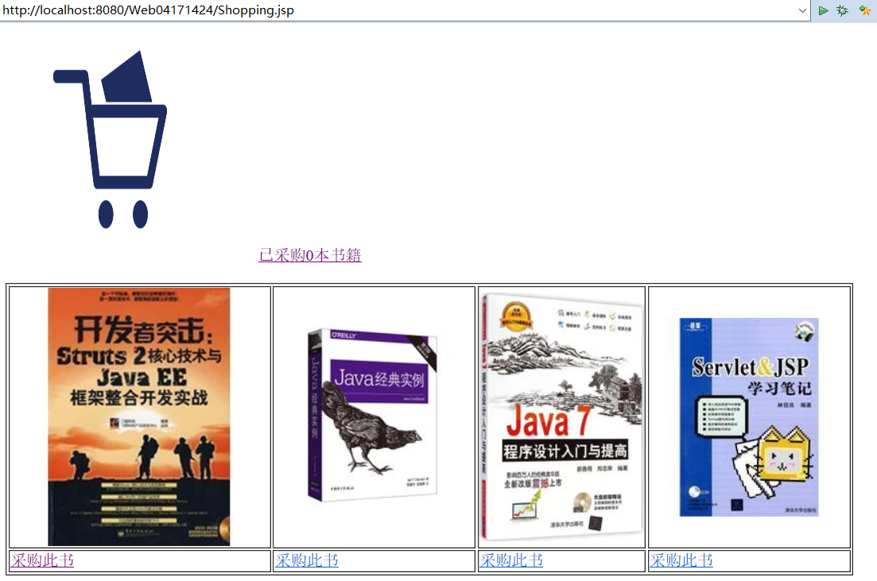

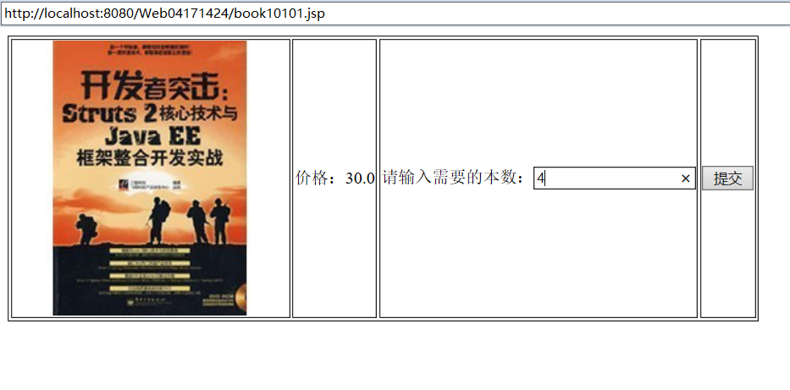

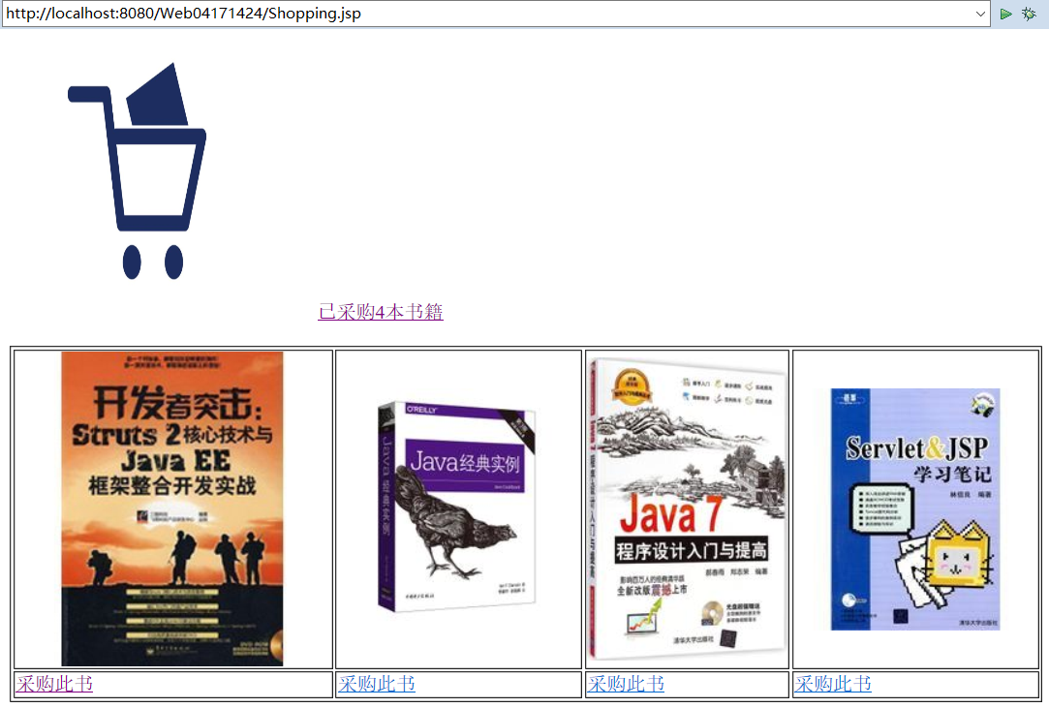

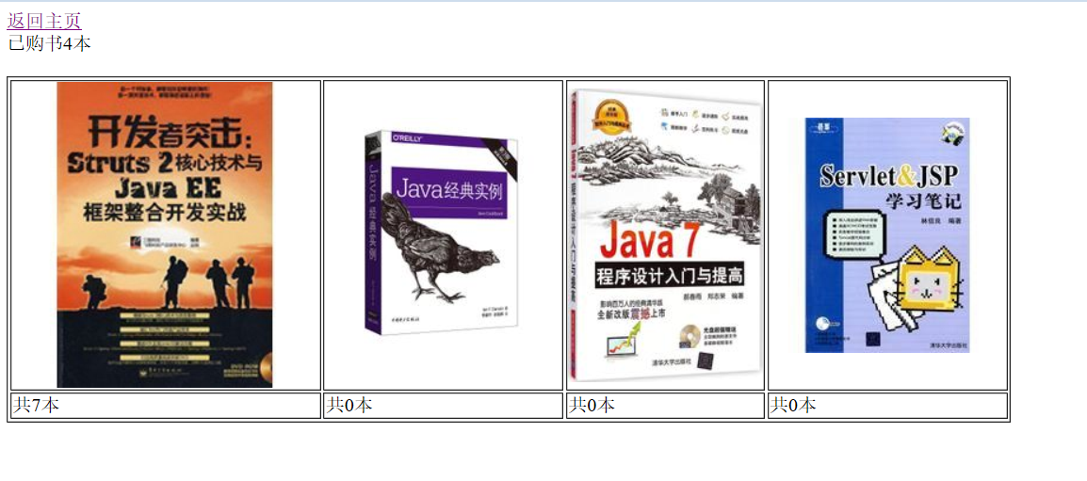

# 收获与问题