**Java Web开发**

**实验六**

**作业报告**

|  |  |
| --- | --- |
| 学 院 | 计算机 |
| 所在系 班 级 | 2017软件工程系15班 |
| 学 号 姓 名 | 04171427 |
| 指 导 教 师 | 郭晓燕 |
| 完 成 时 间 | 2019年4月- |

# 实验题目

参考成熟的购物系统，为购物车增加功能，完善购物车：删除商品，查看商品具体信息，计算商品总价，修改商品购买件数等等。界面尽量美观。

# 分析与设计

java文件即Book.java的设计需要重构，需要分离商品基本信息和购买信息，需要有类分别来保存单件商品的购买信息和所有商品的购买信息。所以至少要三个Java类才能完成购物的基本功能。

Servlet也需要响应更多的操作，可以在一个Servlet中也可以分多个文件响应。并在适当的地方调用Java方法。

# 关键源码（部分）

1.index.jsp

<%@ page language=*"java"* import=*"java.util.*"* pageEncoding=*"utf-8"*%>

<%@ page import=*"lin.chi.two.*"* %>

<!DOCTYPE HTML PUBLIC "-//W3C//DTD HTML 4.01 Transitional//EN">

<html>

<head>

<title>购书首页</title>

</head>

<body>

<%

CartBook cartBook;

**if**(session.getAttribute("cartbook")==**null**){

cartBook=InitCartBook.init();

session.setAttribute("cartbook", cartBook);

}**else**{

cartBook=(CartBook)session.getAttribute("cartbook");

}

%>

<div style="background-color:*#F5F5F5*;padding:*5px*;border-bottom:*1px solid #ff0000*;">

<img src=*"image/shopCart.jpg"* width=*"100px"* height=*"100px"* style="vertical-align:*middle*;"/>

<a href=*"showCart.jsp"* style="margin:*10px*">已购买<%= cartBook.getSumCount() %>本书</a>

</div>

<%

Book book;

**for**(BookList bookList:cartBook.getBookLists()){

book=bookList.getBook();

%>

<div style="background-color:*#F5F5F5*;padding:*5px*;margin:*10px*;">

<img src=<%= book.getImgsrc() %> height=*"100px"* style="vertical-align:*bottom*;"/>

<div style="display:*inline-block*;">

《<%= book.getName() %>》<br>

作者：<%= book.getAuthor() %><br>

价格：<span style="color:*#FF4500*;">￥<%= book.getPrice() %>元</span><br>

<a href=*"addbook.jsp?id=*<%= book.getId() %>*"* style="margin:*5px*">添加</a>

<a href=*"delbook.jsp?id=*<%= book.getId() %>*"* style="margin:*5px*">删除</a>

</div>

</div>

<%

}

%>

</body>

</html>

2.addbook.jsp:

<%@ page language=*"java"* import=*"java.util.*"* pageEncoding=*"utf-8"* %>

<%@ page import=*"lin.chi.two.*"* %>

<!DOCTYPE HTML PUBLIC "-//W3C//DTD HTML 4.01 Transitional//EN">

<html>

<head>

<title>添加购物车</title>

</head>

<body>

<p>确认添加这本书进购物车吗？<a href=*"index.jsp"*>取消</a></p>

<%

CartBook cartBook;

**if**(session.getAttribute("cartbook")==**null**){

cartBook=InitCartBook.init();

session.setAttribute("cartbook", cartBook);

}**else**{

cartBook=(CartBook)session.getAttribute("cartbook");

}

Book book;

**for**(BookList bookList:cartBook.getBookLists()){

book=bookList.getBook();

**if**((book.getId()).equals(request.getParameter("id"))){

session.setAttribute("addid",book.getId());

%>

<div style="background-color:*#F5F5F5*;padding:*5px*;margin:*10px*;">

<img src=<%= book.getImgsrc() %> height=*"100px"* style="vertical-align:*bottom*;"/>

<div style="display:*inline-block*;">

《<%= book.getName() %>》<br>

作者：<%= book.getAuthor() %><br>

价格：<span style="color:*#FF4500*;">￥<%= book.getPrice() %>元</span><br>

书号：<%= book.getId() %><br>

你买了<%= bookList.getCount() %>本这个书,共<%= bookList.getAmount() %>元.<br>

<form method=*"post"* action=*"shopping.do"*>

添加<input type=*"text"* name=*"add"* value=*"1"* size=*"1"*>本.

<input type=*"submit"* value=*"确认"*>

</form>

</div>

</div>

<%

}

}

%>

</body>

</html>

3.shoppingsuccess.jsp:

<%@ page language=*"java"* import=*"java.util.*"* pageEncoding=*"utf-8"*%>

<!DOCTYPE HTML PUBLIC "-//W3C//DTD HTML 4.01 Transitional//EN">

<html>

<head>

<title>操作成功</title>

</head>

<body>

<p style="font-size:*16px*;">操作成功！</p>

<a href=*"index.jsp"*>返回购物首页</a><br>

<a href=*"showCart.jsp"*>返回购物车</a>

</body>

</html>

4.showcart.jsp:

<%@ page language=*"java"* import=*"java.util.*"* pageEncoding=*"utf-8"*%>

<%@ page import=*"lin.chi.two.*"* %>

<!DOCTYPE HTML PUBLIC "-//W3C//DTD HTML 4.01 Transitional//EN">

<html>

<head>

<title>购物车</title>

</head>

<body>

<%

CartBook cartBook;

**if**(session.getAttribute("cartbook")==**null**){

cartBook=InitCartBook.init();

session.setAttribute("cartbook", cartBook);

}**else**{

cartBook=(CartBook)session.getAttribute("cartbook");

}

%>

<p>已经购买了<%= cartBook.getSumCount() %>本书,共<%= cartBook.getSumAmount() %>元。

<a href=*"index.jsp"*>点击返回购物页面</a>

</p>

<%

Book book;

**for**(BookList bookList:cartBook.getBookLists()){

book=bookList.getBook();

**if**(bookList.getCount()!=0){

%>

<div style="background-color:*#F5F5F5*;padding:*5px*;margin:*10px*;">

<img src=<%= book.getImgsrc() %> height=*"100px"* style="vertical-align:*bottom*;"/>

<div style="display:*inline-block*;">

《<%= book.getName() %>》<br>

作者：<%= book.getAuthor() %><br>

价格：<span style="color:*#FF4500*;">￥<%= book.getPrice() %>元</span><br>

书号：<%= book.getId() %><br>

你买了<%= bookList.getCount() %>本这个书,共<%= bookList.getAmount() %>元.<br>

<a href=*"addbook.jsp?id=*<%= book.getId() %>*"* style="margin:*5px*">添加</a>

<a href=*"delbook.jsp?id=*<%= book.getId() %>*"* style="margin:*5px*">删除</a>

</div>

</div>

<%

}

}

%>

</body>

</html>

5.delbook.jsp:

<%@ page language=*"java"* import=*"java.util.*"* pageEncoding=*"utf-8"*%>

<%@ page import=*"lin.chi.two.*"* %>

<!DOCTYPE HTML PUBLIC "-//W3C//DTD HTML 4.01 Transitional//EN">

<html>

<head>

<title>删除购物车</title>

</head>

<body>

<p>确定要删除这本书吗？<a href=*"index.jsp"*>取消</a></p>

<%

CartBook cartBook;

**if**(session.getAttribute("cartbook")==**null**){

cartBook=InitCartBook.init();

session.setAttribute("cartbook", cartBook);

}**else**{

cartBook=(CartBook)session.getAttribute("cartbook");

}

Book book;

**for**(BookList bookList:cartBook.getBookLists()){

book=bookList.getBook();

**if**((book.getId()).equals(request.getParameter("id"))){

session.setAttribute("delid",book.getId());

%>

<div style="background-color:*#F5F5F5*;padding:*5px*;margin:*10px*;">

<img src=<%= book.getImgsrc() %> height=*"100px"* style="vertical-align:*bottom*;"/>

<div style="display:*inline-block*;">

《<%= book.getName() %>》<br>

作者：<%= book.getAuthor() %><br>

价格：<span style="color:*#FF4500*;">￥<%= book.getPrice() %>元</span><br>

书号：<%= book.getId() %><br>

你买了<%= bookList.getCount() %>本这个书,共<%= bookList.getAmount() %>元.<br>

<form method=*"post"* action=*"shopping.do"*>

删除<input type=*"text"* name=*"del"* value=*"1"* size=*"1"*>本.

<input type=*"submit"* value=*"确认"*>

</form>

</div>

</div>

<%

}

}

%>

</body>

</html>

5.BookList.java:

**package** cc.openhome;

**import** java.io.Serializable;

**public** **class** BookList **implements** Serializable {

**private** Book book=**new** Book();

**private** **int** count;

**private** **double** amount;

**public** **void** setBook(Book book){

**this**.book=book;

}

**public** **void** setCount(**int** count){

**this**.count=count;

}

**public** **void** setAmount(**double** amount){

**this**.amount=amount;

}

**public** Book getBook(){

**return** **this**.book;

}

**public** **int** getCount(){

**return** **this**.count;

}

**public** **double** getAmount(){

**return** **this**.amount;

}

**public** **double** calcAmount(){

**double** am;

am=count*book.getPrice();

**return** am;

}

}

7.add.java:

package cc.openhome;

import java.io.IOException;

import java.io.PrintWriter;

import java.util.ArrayList;

import javax.servlet.ServletException;

import javax.servlet.http.HttpServlet;

import javax.servlet.http.HttpServletRequest;

import javax.servlet.http.HttpServletResponse;

import javax.servlet.http.HttpSession;

public class Add extends HttpServlet {

private void processRequest(HttpServletRequest request, HttpServletResponse response)

throws ServletException, IOException {

request.setCharacterEncoding("utf-8");

response.setContentType("text/html;charset=utf-8");

HttpSession session=request.getSession();

CartBook cartBook=(CartBook)session.getAttribute("cartbook");

String addid=(String)session.getAttribute("addid");

int addnum=Integer.parseInt((String) session.getAttribute("add"));

Book book;

BookList bl=new BookList();

BookList temp=new BookList();

ArrayList<BookList> bookLists=cartBook.getBookLists();

for(BookList bookList:bookLists){

book=bookList.getBook();

if(book.getId().equals(addid)){

temp=bookList;

bl.setBook(book);

bl.setCount(bookList.getCount()+addnum);

bl.setAmount(bl.calcAmount());

}

}

bookLists.remove(temp);

bookLists.add(bl);

cartBook.setBookLists(bookLists);

cartBook.setSumCount(cartBook.calcSumCount());

cartBook.setSumAmount(cartBook.calcSumAmount());

session.setAttribute("cartbook",cartBook);

response.sendRedirect("shoppingSuccess.jsp");

}

public void doGet(HttpServletRequest request, HttpServletResponse response)

throws ServletException, IOException {

processRequest(request,response);

}

public void doPost(HttpServletRequest request, HttpServletResponse response)

throws ServletException, IOException {

processRequest(request,response);

}

}

9.book.java:

**package** cc.openhome;

**import** java.io.Serializable;

**public** **class** Book **implements** Serializable {

**private** String id;

**private** String name;

**private** String author;

**private** String imgsrc;

**private** **double** price;

**public** **void** setId(String id){

**this**.id=id;

}

**public** **void** setName(String name){

**this**.name=name;

}

**public** **void** setAuthor(String author){

**this**.author=author;

}

**public** **void** setImgsrc(String imgsrc){

**this**.imgsrc=imgsrc;

}

**public** **void** setPrice(**double** price){

**this**.price=price;

}

**public** String getId(){

**return** **this**.id;

}

**public** String getName(){

**return** **this**.name;

}

**public** String getAuthor(){

**return** **this**.author;

}

**public** String getImgsrc(){

**return** **this**.imgsrc;

}

**public** **double** getPrice(){

**return** **this**.price;

}

}

10.cartbook.java:

package cc.openhome;

import java.io.Serializable;

import java.util.ArrayList;

import java.util.List;

public class CartBook implements Serializable {

private ArrayList<BookList> bookLists=new ArrayList<BookList>();

private int sumCount;

private double sumAmount;

public void setBookLists(ArrayList<BookList> bookLists){

this.bookLists=bookLists;

}

public void setSumCount(int sumCount){

this.sumCount=sumCount;

}

public void setSumAmount(double sumAmount){

this.sumAmount=sumAmount;

}

public ArrayList<BookList> getBookLists(){

return this.bookLists;

}

public int getSumCount(){

return this.sumCount;

}

public double getSumAmount(){

return this.sumAmount;

}

public int calcSumCount(){

int sc=0;

for(BookList bookList:bookLists){

sc+=bookList.getCount();

}

return sc;

}

public double calcSumAmount(){

double sa=0;

for(BookList bookList:bookLists){

sa+=bookList.getAmount();

}

return sa;

}

}

11.del.java:

package cc.openhome;

import java.io.IOException;

import java.io.PrintWriter;

import java.util.ArrayList;

import javax.servlet.ServletException;

import javax.servlet.http.HttpServlet;

import javax.servlet.http.HttpServletRequest;

import javax.servlet.http.HttpServletResponse;

import javax.servlet.http.HttpSession;

public class Del extends HttpServlet {

private void processRequest(HttpServletRequest request, HttpServletResponse response)

throws ServletException, IOException {

request.setCharacterEncoding("utf-8");

response.setContentType("text/html;charset=utf-8");

HttpSession session=request.getSession();

CartBook cartBook=(CartBook)session.getAttribute("cartbook");

String delid=(String)session.getAttribute("delid");

int delnum=Integer.parseInt((String) session.getAttribute("del"));

Book book;

BookList bl=new BookList();

BookList temp=new BookList();

ArrayList<BookList> bookLists=cartBook.getBookLists();

for(BookList bookList:bookLists){

book=bookList.getBook();

if(book.getId().equals(delid)){

temp=bookList;

bl.setBook(book);

if(delnum>=bookList.getCount()){

bl.setCount(0);

}else{

bl.setCount(bookList.getCount()-delnum);

}

bl.setAmount(bl.calcAmount());

}

}

bookLists.remove(temp);

bookLists.add(bl);

cartBook.setBookLists(bookLists);

cartBook.setSumCount(cartBook.calcSumCount());

cartBook.setSumAmount(cartBook.calcSumAmount());

session.setAttribute("cartbook",cartBook);

response.sendRedirect("shoppingSuccess.jsp");

}

public void doGet(HttpServletRequest request, HttpServletResponse response)

throws ServletException, IOException {

processRequest(request,response);

}

public void doPost(HttpServletRequest request, HttpServletResponse response)

throws ServletException, IOException {

processRequest(request,response);

}

}

12.initcartbook.jaba

**package** cc.openhome;

**import** java.util.ArrayList;

**public** **class** InitCartBook{

**static** CartBook *carBook*;

**static** ArrayList<BookList> *bookLists*;

**static** BookList *bookList*;

**static** Book *book*;

**public** **static** CartBook init(){

*carBook*=**new** CartBook();

*bookLists*=**new** ArrayList<BookList>();

*book*=**new** Book();

*book*.setId("0001");

*book*.setName("java");

*book*.setAuthor("xx老师");

*book*.setImgsrc("image/java.jpg");

*book*.setPrice(75);

*bookList*=**new** BookList();

*bookList*.setBook(*book*);

*bookList*.setCount(0);

*bookList*.setAmount(0);

*bookLists*.add(*bookList*);

*book*=**new** Book();

*book*.setId("0002");

*book*.setName("jsp&servlet");

*book*.setAuthor("xxx老师");

*book*.setImgsrc("image/jsp_servlet.jpg");

*book*.setPrice(58);

*bookList*=**new** BookList();

*bookList*.setBook(*book*);

*bookList*.setCount(0);

*bookList*.setAmount(0);

*bookLists*.add(*bookList*);

*book*=**new** Book();

*book*.setId("0003");

*book*.setName("jQuery");

*book*.setAuthor("xxxx老师");

*book*.setImgsrc("image/jquery.jpg");

*book*.setPrice(65);

*bookList*=**new** BookList();

*bookList*.setBook(*book*);

*bookList*.setCount(0);

*bookList*.setAmount(0);

*bookLists*.add(*bookList*);

*carBook*.setBookLists(*bookLists*);

*carBook*.setSumCount(0);

*carBook*.setSumAmount(0);

**return** *carBook*;

}

}

12.shooping.java:

package cc.openhome;

import java.io.IOException;

import java.io.PrintWriter;

import javax.servlet.ServletException;

import javax.servlet.http.HttpServlet;

import javax.servlet.http.HttpServletRequest;

import javax.servlet.http.HttpServletResponse;

import javax.servlet.http.HttpSession;

public class Shopping extends HttpServlet {

private void processRequest(HttpServletRequest request, HttpServletResponse response)

throws ServletException, IOException {

request.setCharacterEncoding("utf-8");

response.setContentType("text/html;charset=utf-8");

HttpSession session=request.getSession();

String add=request.getParameter("add");

String del=request.getParameter("del");

if(add!=null){

session.setAttribute("add", add);

response.sendRedirect("add.do");

}

if(del!=null){

session.setAttribute("del", del);

response.sendRedirect("del.do");

}

}

public void doGet(HttpServletRequest request, HttpServletResponse response)

throws ServletException, IOException {

processRequest(request,response);

}

public void doPost(HttpServletRequest request, HttpServletResponse response)

throws ServletException, IOException {

processRequest(request,response);

}

}

# 运行效果图

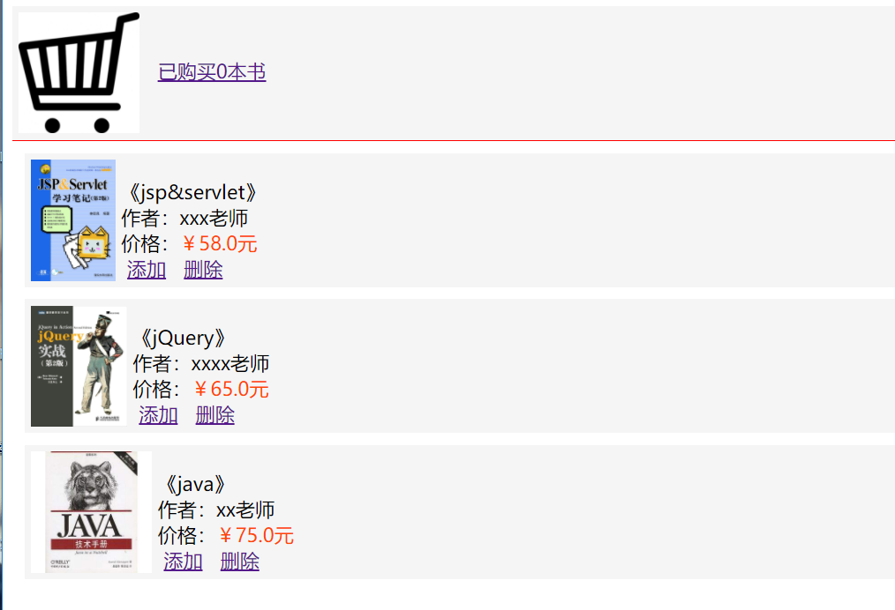

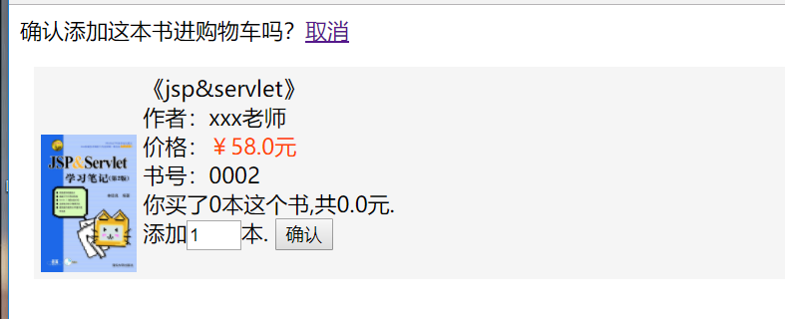



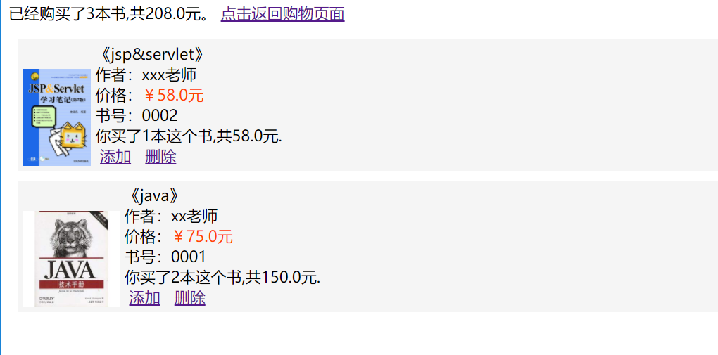

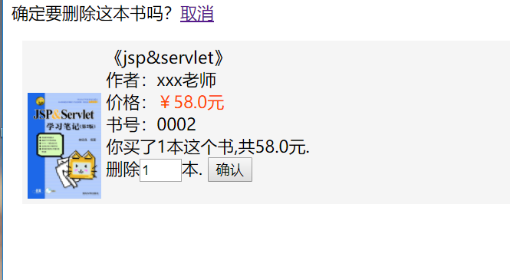

# 收获与问题

实验6相对实验5还是难了很多，没有头绪的时候问了很多厉害的人，百度寻找问题的过程中也学了很多课堂没教过的东西，这道题也算是很多人帮助我，最终完成的相对还行的成果，接下来想学习一下BoortStrap框架。