**Java Web开发**

**实验六**

**作业报告**

|  |  |
| --- | --- |
| 学 院 | 计算机 |
| 所在系 班 级 | 2017软件工程系07班 |
| 学 号 姓 名 | 04171503刘建超 |
| 指 导 教 师 | 郭晓燕 |
| 完 成 时 间 | 2018年4月-11 |

# 实验题目

实验内容：

1、上周没有完成作业的同学请继续完成，完成了作业的同学请为购物车增加功能：

2、参考成熟的购物系统，为购物车增加功能，完善购物车：删除商品，查看商品具体信息，计算商品总价，修改商品购买件数等等。界面尽量美观。

提示：Java文件即Book.java的设计需要重构，需要分离商品基本信息和购买信息，需要有类分别来保存单件商品的购买信息和所有商品的购买信息。所以至少要三个Java类才能完成购物的基本功能。

Servlet也需要响应更多的操作，可以在一个Servlet中也可以分多个文件响应。并在适当的地方调用Java方法。

# 分析与设计

根据题目要求，计划设计几个文件来完成实验，每个文件的名字、作用。如果是类，要求写出类的变量和方法

# 关键源码（部分）

Login.jsp

<%@ page language=*"java"* contentType=*"text/html; charset=UTF-8"*

pageEncoding=*"UTF-8"*%>

<html>

<body>

<form action=*"Shopping.jsp"* method=*"post"*>

<table align=*"center"* border=*"1"* weight=*"200"* height=*"200"*>

<tr align=*"center"*><td>请填写注册信息</td></tr>

<tr><td>帐号：<input type=*"text"* name=*"zh"*></td></tr>

<tr><td>密码：<input type=*"text"* name=*"mima"*></td></tr>

<tr align=*"center"*><td><input type=*"submit"* value=*"提交信息"*></td></tr>

</table>

</form>

</body>

</html>

Shopping.jsp

<%@ page language=*"java"* import=*"java.util.*"* pageEncoding=*"UTF-8"*%>

<%@page import=*"cc.test.vo.*"* %>

<!DOCTYPE HTML PUBLIC "-//W3C//DTD HTML 4.01 Transitional//EN">

<html>

<%

//当第一次访问采购网页，session对象中还没有book购物车信息时，进行初始化。

**if** (session.getAttribute("booklist")==**null**){

//在session对象中存储图书采购信息

Book[] BookList = **new** Book[4];

BookList[0] = **new** Book("10101", "Java核心技术", "img/10101.jpg",100,55.5);

BookList[1] = **new** Book("10102", "Java经典实例", "img/10102.jpg",150,66.5);

BookList[2] = **new** Book("10103", "Java7", "img/10103.jpg",200,77.5);

BookList[3] = **new** Book("10104", "JSP&Servlet", "img/10104.jpg",77,88.0);

//存入session对象中

session.setAttribute("booklist", BookList);

session.setAttribute("sum",0);

}

%>

<body>

<br>

<img src=*"img/cart.jpg"* height=*"60px"* width=*"60px"*>

<a href=*"cart.view"*>已采购<%= session.getAttribute("sum") %>本书籍</a><br>

<br>

<table border=*"1"*>

<%

Book[] booklist=(Book[])session.getAttribute("booklist");

**for** (Book book:booklist){

out.println("<tr>");

out.println("<td> <img src='"+book.getBookImg()+"'></td>");

out.println("<td> <a href='shopping.view?id="+book.getBookId()+"'>采购此书</a></td>");

out.println("<td> <a href='delet.view?id="+book.getBookId()+"'>删除此书</a></td>");

out.println("<td>"+"单价为:"+book.getPrice()+"</td>");

out.println("</tr>");

}

%>

</body>

</html>

Book.java

**package** cc.test.vo;

**public** **class** Book {

**private** String bookId; //书号

**private** String bookName;//书名

String bookImg; //书封面所在地址

**private** **int** bookNum; //购书本数

**private** **double** price;

**private** **double** totalprice;

**public** Book(String bookId, String bookName, String bookImg, **int** bookNum,**double** price) {

**this**.bookId = bookId;

**this**.bookName = bookName;

**this**.bookImg = bookImg;

**this**.bookNum = 0;

**this**.price=price;

}

**public** String getBookId() {

**return** bookId;

}

**public** String getBookName() {

**return** bookName;

}

**public** String getBookImg() {

**return** bookImg;

}

**public** **int** getBookNum() {

**return** bookNum;

}

**public** **void** setBookNum(**int** num)

{

**this**.bookNum=num;

}

**public** **double** getPrice() {

**return** price;

}

**public** **void** setPrice(**double** price) {

**this**.price = price;

}

**public** **double** getTotalprice() {

**return** bookNum*price;

}

**public** **void** setTotalprice(**double** totalprice) {

**this**.totalprice = totalprice;

}

}

ShopingServket.java

package cc.test.Controller;

import cc.test.vo.Book;

import java.io.IOException;

import java.io.PrintWriter;

import javax.servlet.RequestDispatcher;

import javax.servlet.ServletException;

import javax.servlet.http.HttpServlet;

import javax.servlet.http.HttpServletRequest;

import javax.servlet.http.HttpServletResponse;

import javax.servlet.http.HttpSession;

public class ShopingServlet extends HttpServlet {

public void doGet(HttpServletRequest request, HttpServletResponse response)

throws ServletException, IOException {

//获取从Shopping.jsp传来的request对象中的ID号

//在ID号不为空的情况下，获取Session对象中的购物车信息，Book数组。

//找到数组中与ID对应的Book对象，将其属性bookNum数字加1

//将数组写回session对象中去。

//跳转回Shopping.jsp

request.setCharacterEncoding("gb2312");

String id=request.getParameter("id");

HttpSession session=request.getSession(true);

Book[] books;

int sum=Integer.parseInt(session.getAttribute("sum").toString());

if (id!=null)

{

books=(Book[])session.getAttribute("booklist");

for (Book book:books)

{

int booknum = book.getBookNum();

if (id.equals(book.getBookId()))

{

book.setBookNum(booknum + 1);

sum++;

session.setAttribute("booklist", books);

session.setAttribute("sum", sum);

RequestDispatcher dispatcher = request.getRequestDispatcher("Shopping.jsp");

dispatcher.forward(request, response);

}

}

}

else{

RequestDispatcher dispatcher=request.getRequestDispatcher("Shopping.jsp");

dispatcher.forward(request,response);

}

}

public void doPost(HttpServletRequest request, HttpServletResponse response)

throws ServletException, IOException {

doGet(request,response);

}

}

CarServlet.java

package cc.test.Controller;

import cc.test.vo.Book;

import java.io.IOException;

import java.io.PrintWriter;

import javax.net.ssl.HttpsURLConnection;

import javax.servlet.ServletException;

import javax.servlet.http.HttpServlet;

import javax.servlet.http.HttpServletRequest;

import javax.servlet.http.HttpServletResponse;

import javax.servlet.http.HttpSession;

public class CarServlet extends HttpServlet {

public void doGet(HttpServletRequest request, HttpServletResponse response)

throws ServletException, IOException {

/*判断得到session对象中存储的book信息是否为空

不为空的前提下，读出Book数组中的内容，并将数目不为1的图书信息显示在网页上。

*/

double zongqian=0;

request.setCharacterEncoding("gb2312");//设置请求的编码格式为GB2312

response.setContentType("text/html;charset=gb2312");

PrintWriter out=response.getWriter();

HttpSession session=request.getSession(true);

Book[] books;

if (session.getAttribute("booklist")!=null){

out.println("<html><body>");

out.println("已采购"+session.getAttribute("sum")+"本书籍");

books=(Book[])session.getAttribute("booklist");

out.println("<table>");

for (Book book:books){

if (book.getBookNum()>0){

out.println("<tr>");

out.println("<td> <img src='"+book.getBookImg()+"'></td>");

out.println("<td>共"+book.getBookNum()+"书</td>");

out.println("<td>共"+book.getTotalprice()+"元</td>");

zongqian=zongqian+book.getTotalprice();

}

}

out.println("</table></body></html>");

out.println("<br>您好，您总共消费："+zongqian+"元</br>");

}

}

public void doPost(HttpServletRequest request, HttpServletResponse response)

throws ServletException, IOException {

doGet(request,response);

}

}

deletServlet.java

package cc.test.Controller;

import cc.test.vo.Book;

import java.io.IOException;

import java.io.PrintWriter;

import javax.servlet.RequestDispatcher;

import javax.servlet.ServletException;

import javax.servlet.http.HttpServlet;

import javax.servlet.http.HttpServletRequest;

import javax.servlet.http.HttpServletResponse;

import javax.servlet.http.HttpSession;

public class deletServlet extends HttpServlet {

public void doGet(HttpServletRequest request, HttpServletResponse response)

throws ServletException, IOException {

//获取从Shopping.jsp传来的request对象中的ID号

//在ID号不为空的情况下，获取Session对象中的购物车信息，Book数组。

//找到数组中与ID对应的Book对象，将其属性bookNum数字加1

//将数组写回session对象中去。

//跳转回Shopping.jsp

request.setCharacterEncoding("gb2312");

String id=request.getParameter("id");

HttpSession session=request.getSession(true);

Book[] books;

int sum=Integer.parseInt(session.getAttribute("sum").toString());

if (id!=null)

{

books=(Book[])session.getAttribute("booklist");

for (Book book:books)

{

int booknum = book.getBookNum();

if (id.equals(book.getBookId()))

{

book.setBookNum(booknum - 1);

sum--;

session.setAttribute("booklist", books);

session.setAttribute("sum", sum);

RequestDispatcher dispatcher = request.getRequestDispatcher("Shopping.jsp");

dispatcher.forward(request, response);

}

}

}

else{

RequestDispatcher dispatcher=request.getRequestDispatcher("Shopping.jsp");

dispatcher.forward(request,response);

}

}

public void doPost(HttpServletRequest request, HttpServletResponse response)

throws ServletException, IOException {

doGet(request,response);

}

}

# 运行效果图

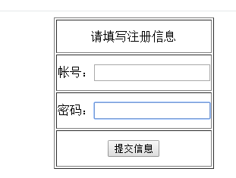

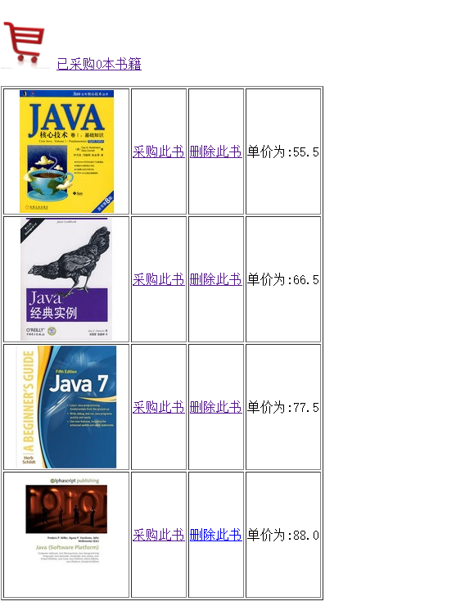

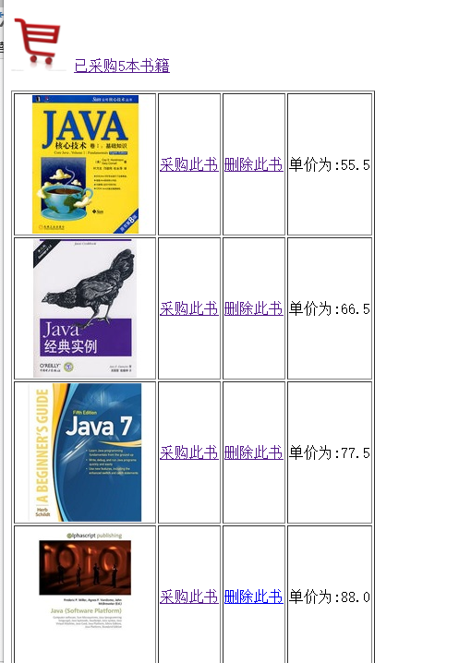

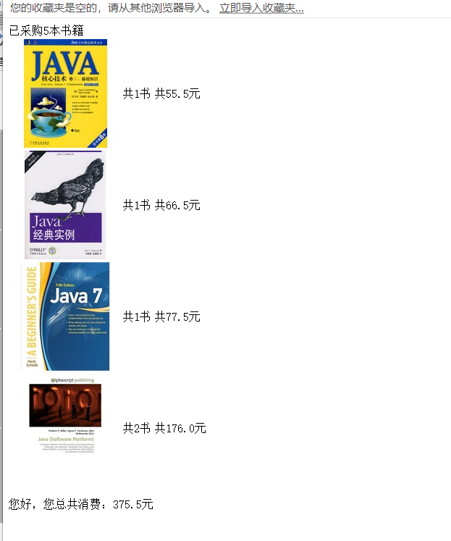

# 收获与问题

1. 学习更好的设计Java类。从而灵活使用session对象；
2. 完善购物车的功能；
3. 优化购物车的结构。