**Java Web开发**

**实验六**

**作业报告**

|  |  |
| --- | --- |
| 学 院 | 计算机 |
| 所在系 班 级 | 2017软件工程系7班 |
| 学 号 姓 名 | 周卓逸 |
| 指 导 教 师 | 郭晓燕 |
| 完 成 时 间 | 2018年5月-13日 |

# 实验题目

参考成熟的购物系统，为购物车增加功能，完善购物车：删除商品，查看商品具体信息，计算商品总价，修改商品购买件数等等。界面尽量美观。

提示：Java文件即Book.java的设计需要重构，需要分离商品基本信息和购买信息，需要有类分别来保存单件商品的购买信息和所有商品的购买信息。所以至少要三个Java类才能完成购物的基本功能。

Servlet也需要响应更多的操作，可以在一个Servlet中也可以分多个文件响应。并在适当的地方调用Java方法。

# 关键源码

newcartServlet.java

package cc.home;

import cc.home.Book;

import java.io.IOException;

import java.io.PrintWriter;

import javax.servlet.ServletException;

import javax.servlet.annotation.WebServlet;

import javax.servlet.http.HttpServlet;

import javax.servlet.http.HttpServletRequest;

import javax.servlet.http.HttpServletResponse;

import javax.servlet.http.HttpSession;

@WebServlet("/cart.view")

public class newcartServlet extends HttpServlet {

public void doGet(HttpServletRequest request, HttpServletResponse response)

throws ServletException, IOException {

/*判断得到session对象中存储的book信息是否为空

不为空的前提下，读出Book数组中的内容，并将数目不为1的图书信息显示在网页上。

*/

response.setContentType("text/html; charset=UTF-8");

HttpSession session=request.getSession();

PrintWriter out =response.getWriter();

int sum=(Integer)session.getAttribute("sum");

if(sum<=0)

{

out.println("<h1 align=center>您的购物车是空的哦!</h1>");

}

else

{

response.sendRedirect("bycar.jsp");

return;

}

}

}

ShoppingServlet.java

package cc.home;

import cc.home.*;

import java.io.IOException;

import java.io.PrintWriter;

import javax.servlet.ServletException;

import javax.servlet.ServletRequest;

import javax.servlet.annotation.WebServlet;

import javax.servlet.http.HttpServlet;

import javax.servlet.http.HttpServletRequest;

import javax.servlet.http.HttpServletResponse;

import javax.servlet.http.HttpSession;

@WebServlet("/shopping.view")

public class ShoppingServlet extends HttpServlet {

public void doGet(HttpServletRequest request, HttpServletResponse response)

throws ServletException, IOException {

//获取从Shopping.jsp传来的request对象中的ID号

String id=request.getParameter("id");

HttpSession session=request.getSession();

int sum=(Integer)session.getAttribute("sum");

Book[] books=(Book[])session.getAttribute("bookList");

//在ID号不为空的情况下，获取Session对象中的购物车信息，Book数组。

if(id!=null)

{

for(int i=0;i<books.length;i++)

{

if(id.equals(books[i].getBookId()))

{

books[i].addSum();

sum++;

//books[i].setBookNum(books[i].getBookNum()+1);

}

}

session.setAttribute("sum", sum);

session.setAttribute("bookList", books);

}

//跳转回Shopping.jsp

response.sendRedirect("Shopping.jsp");

return;

}

public void doPost(HttpServletRequest request, HttpServletResponse response)

throws ServletException, IOException {

doGet(request,response);

}

}

Book.java

package cc.home;

import cc.home.*;

import javax.servlet.http.HttpServletRequest;

public class Book{

private String bookId;

private String bookName;

String bookImg;

private int bookNum;

private int Price;

public Book(String bookId, String bookName, String bookImg,int bookNum,int Price) {

this.bookId = bookId;

this.bookName = bookName;

this.bookImg = bookImg;

this.Price=Price;

this.bookNum=0;

}

public String getBookId() {

return bookId;

}

public String getBookName() {

return bookName;

}

public String getBookImg() {

return bookImg;

}

public int getBookNum() {

return bookNum;

}

public int getNum()

{

return bookNum;

}

public void addSum()

{

++bookNum;

}

public void reduceSum()

{

--bookNum;

}

public int getPrice()

{

return Price;

}

public void clearNum(){

bookNum =0;

}

}

Delete.java

package cc.home;

import java.io.IOException;

import javax.servlet.ServletException;

import javax.servlet.annotation.WebServlet;

import javax.servlet.http.HttpServlet;

import javax.servlet.http.HttpServletRequest;

import javax.servlet.http.HttpServletResponse;

import javax.servlet.http.HttpSession;

@WebServlet("/Delete")

public class Delete extends HttpServlet {

protected void doGet(HttpServletRequest request, HttpServletResponse response) throws ServletException, IOException {

response.setContentType("text/html");

String BookId=(String)request.getParameter("id");

HttpSession session=request.getSession();

int sum =(Integer)session.getAttribute("sum");

Book[] books=(Book [])session.getAttribute("bookList");

if(BookId.length()>5)

{

String op=BookId.substring(5);

BookId =BookId.substring(0,5);

if(op.equals("a"))

{

for(int i=0;i<books.length;i++)

{

if(BookId.equals(books[i].getBookId()))

{

++sum;

books[i].addSum();

session.setAttribute("bookList", books);

session.setAttribute("sum", sum);

}

}

response.sendRedirect("cart.view");

return;

}

if(op.equals("-"))

{

for(int i=0;i<books.length;i++)

{

if(BookId.equals(books[i].getBookId()))

{

if(sum<=0)

{

response.sendRedirect("cart.view");

return;

}

--sum;

books[i].reduceSum();

session.setAttribute("bookList", books);

session.setAttribute("sum", sum);

}

}

response.sendRedirect("cart.view");

return;

}

}

else

{

for(int i=0;i<books.length;i++)

{

if(BookId.equals(books[i].getBookId()))

{

sum-=books[i].getBookNum();

books[i].clearNum();

session.setAttribute("bookList", books);

session.setAttribute("sum", sum);

}

}

response.sendRedirect("cart.view");

return;

}

}

}

Shopping.jsp

<%@ page language=*"java"* import=*"java.util.*"* pageEncoding=*"UTF-8"*%>

<%@page import=*"cc.home.*"* %>

<!DOCTYPE HTML PUBLIC "-//W3C//DTD HTML 4.01 Transitional//EN">

<html>

<%

//当第一次访问采购网页，session对象中还没有book购物车信息时，进行初始化。

//在session对象中存储图书基本信息

**if**(session.getAttribute("bookList")==**null**){

Book[] BookList = **new** Book[4];

BookList[0] = **new** Book("10101", "Java核心技术", "img/10101.jpg",0,10);

BookList[1] = **new** Book("10102", "Java经典实例", "img/10102.jpg",0,20);

BookList[2] = **new** Book("10103", "Java7", "img/10103.jpg",0,30);

BookList[3] = **new** Book("10104", "JSP&Servlet", "img/10104.jpg",0,40);

//存入session对象中

**int** sum=0;

session.setAttribute("bookList",BookList);

session.setAttribute("sum",sum);

}

%>

<body>

<br>

<img src=*"img/cart.jpg"* height=*"60px"* width=*"60px"*>

<a href=*"cart.view"*>已采购<%=session.getAttribute("sum")%>本书籍</a><br>

<br>

<table border=*"1"*>

<tr>

<td><img src=*"img/10101.jpg"*></td>

<td><img src=*"img/10102.jpg"*></td>

<td><img src=*"img/10103.jpg"*></td>

<td><img src=*"img/10104.jpg"*></td>

</tr>

<tr>

<td><a href=*"shopping.view?id=10101"*>采购此书</a></td>

<td><a href=*"shopping.view?id=10102"*>采购此书</a></td>

<td><a href=*"shopping.view?id=10103"*>采购此书</a></td>

<td><a href=*"shopping.view?id=10104"*>采购此书</a></td>

</tr>

</body>

</html>

bycar.jsp

<%@ page language=*"java"* import=*"java.util.*"* pageEncoding=*"UTF-8"*%>

<%@page import=*"cc.home.*"* %>

<!DOCTYPE html PUBLIC "-//W3C//DTD HTML 4.01 Transitional//EN" "http://www.w3.org/TR/html4/loose.dtd">

<html>

<head>

<meta http-equiv=*"Content-Type"* content=*"text/html; charset=ISO-8859-1"*>

<title>欢迎您！</title>

</head>

<body>

<table align=*center*>

<%

Book[] books=(Book [])session.getAttribute("bookList");

//HttpSession session=request.getSession();

**int** Tprice=0;

**for**(**int** i=0;i<books.length;i++)

{

**if**(books[i].getNum()>0)

{

Tprice+=books[i].getPrice()*books[i].getNum();

out.print("<tr>");

out.print("<td><img src='img/"+books[i].getBookId()+".jpg'></td>");

out.print("<td><a href=Delete?id="+books[i].getBookId()+"a>+</a></td>");

out.print("<td>"+Math.round(books[i].getNum())+"本</td>");

out.print("<td><a href=Delete?id="+books[i].getBookId()+"->-</a></td>");

out.print("<td>"+books[i].getPrice()*books[i].getNum()+"元</td>");

out.print("<td><a href=Delete?id="+books[i].getBookId()+">删除</a></td>");

out.print("<tr>");

}

}

%>

</table>

<h1 align=*center*>总价为:<% out.print(Tprice);%></h1>;

</body>

</html>

# 运行效果图

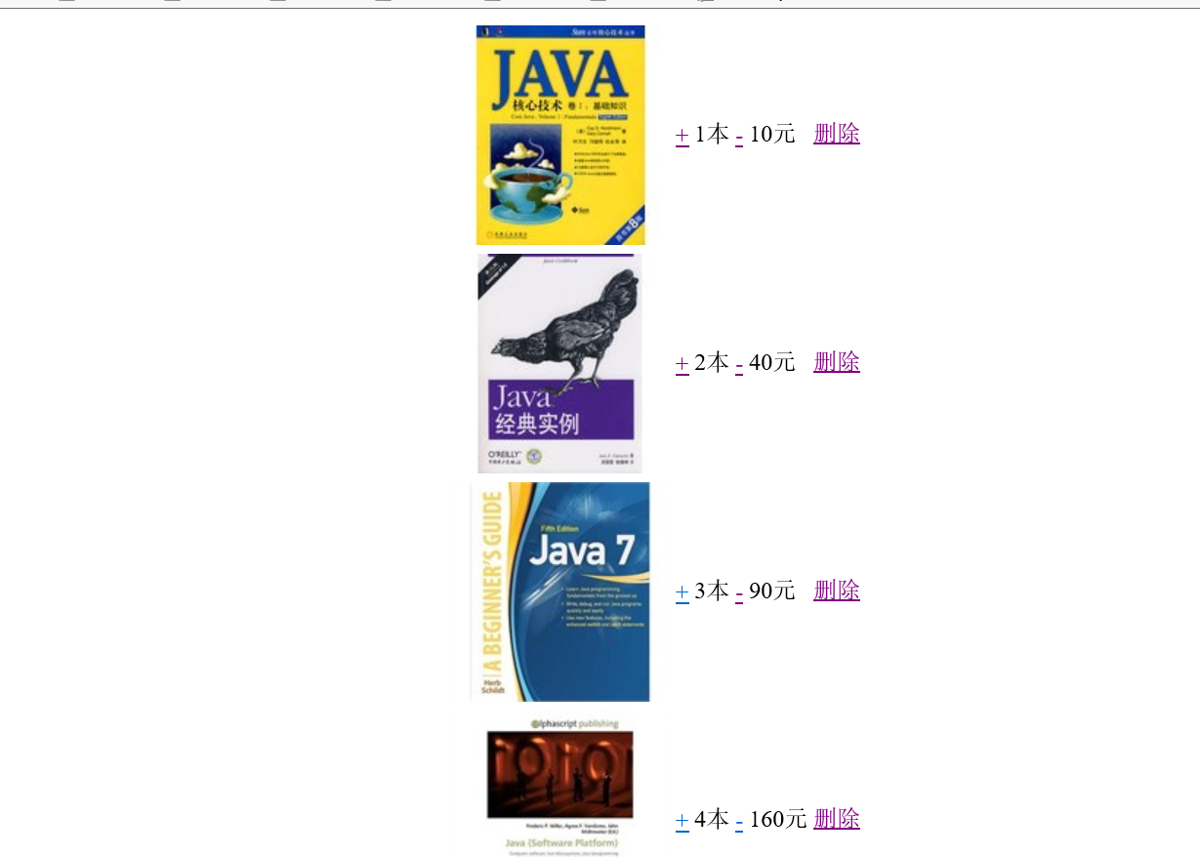

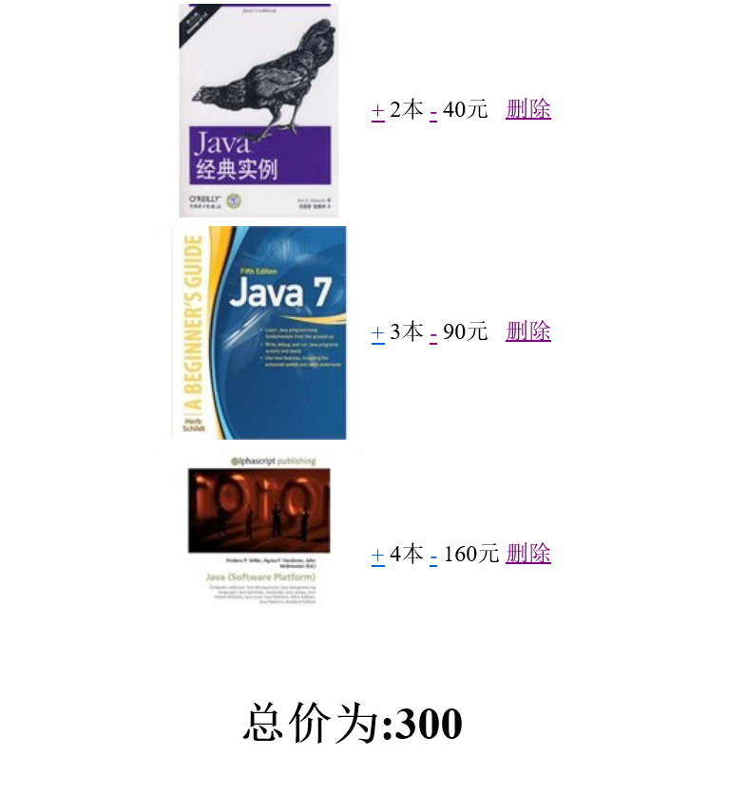

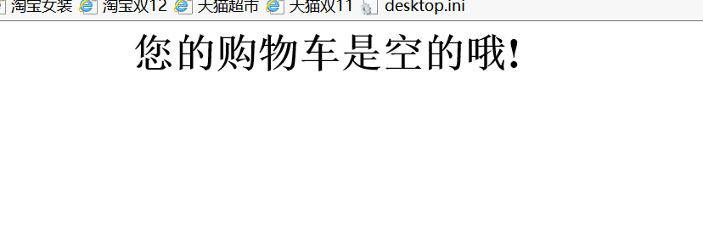

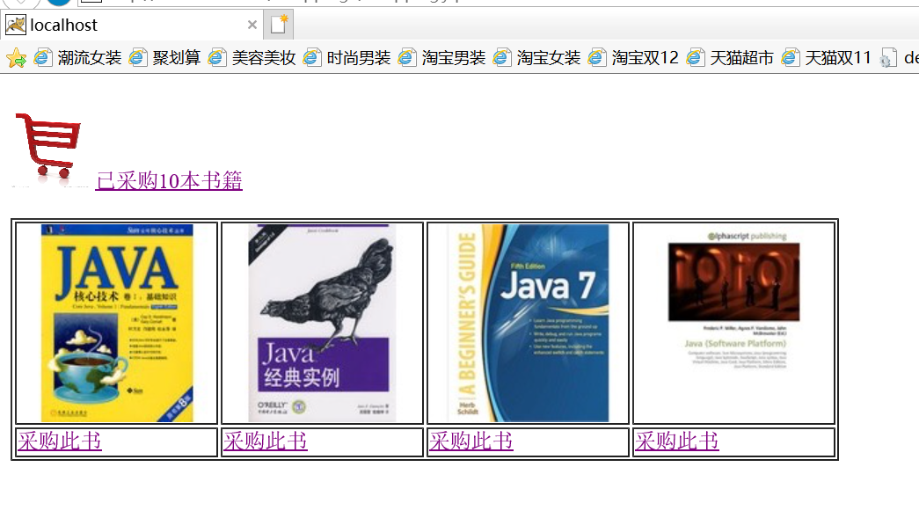

# 收获与问题

终于弄好了，通过自己的不断努力，敲代码的水平与耐心有了一定的提升