**Java Web开发**

**实验六**

**作业报告**

|  |  |
| --- | --- |
| 学 院 | 计算机学院 |
| 所在系 班 级 | 2017软工7班 |
| 学 号 姓 名 | 04171520童煜东 |
| 指 导 教 师 | 郭晓燕 |
| 完 成 时 间 | 2019年4月10 |

# 实验题目

1、上周没有完成作业的同学请继续完成，完成了作业的同学请为购物车增加功能：

2、参考成熟的购物系统，为购物车增加功能，完善购物车：删除商品，查看商品具体信息，计算商品总价，修改商品购买件数等等。界面尽量美观。

# 分析与设计

按照Text4E文件中的代码改的，用session对象保存购买的书名，URL重写购买的书本数目。和实验4一样定义一个类来获取参数，以便传参。

# 关键源码（部分）

**以下是loginServlet.java**

**public** **void** doPost(HttpServletRequest request, HttpServletResponse response)

**throws** ServletException, IOException {

request.setCharacterEncoding("UTF-8");

HttpSession session=request.getSession();

String name=request.getParameter("name");

**if**(name==**null**)

{ name="";

response.sendRedirect("main.jsp");

}

**else**

{

session.setAttribute("customerName",name);

response.sendRedirect("Books.jsp");

}

}

**以下是BookCount.java**

**public** **void** doPost(HttpServletRequest request, HttpServletResponse response)

**throws** ServletException, IOException {

response.setContentType("text/html;charset=utf-8");

PrintWriter out = response.getWriter();

HttpSession session=request.getSession();

request.setCharacterEncoding("utf-8");

**int** maxint;

**if** (session.getAttribute("max")!=**null**)

maxint=Integer.*parseInt*(

(String)session.getAttribute("max"));

**else**

maxint=0;

**for** (**int** i=0;i<=maxint;i++){

**if** (session.getAttribute(""+i)!=**null**)

session.removeAttribute(""+i);

}

String foodName[]=request.getParameterValues("choice");

**if**(foodName!=**null**)

{ **for**(**int** k=0;k<foodName.length;k++)

{

**if** (k>maxint) maxint=k;

session.setAttribute(""+k,foodName[k]);

}

session.setAttribute("max", String.*valueOf*(maxint));

}

String amount1=request.getParameter("amount1");

String amount2=request.getParameter("amount2");

String amount3=request.getParameter("amount3");

String amount4=request.getParameter("amount4");

Chart c=**new** Chart();

c.setAmount1();

c.setAmount2();

c.setAmount3();

c.setAmount4();

request.getRequestDispatcher("cart.jsp").forward(request, response);

}

**以下是Chart.java**

**public** **class** Chart{

**private** **int** amount1;

**private** **int** amount2;

**private** **int** amount3;

**private** **int** amount4;

**public** **int** getAmount1(){

**return** amount1;

}

**public** **void** setAmount1(){

**this**.amount1=amount1;

}

**public** **int** getAmount2(){

**return** amount1;

}

**public** **void** setAmount2(){

**this**.amount1=amount1;

}

**public** **int** getAmount3(){

**return** amount1;

}

**public** **void** setAmount3(){

**this**.amount1=amount1;

}

**public** **int** getAmount4(){

**return** amount1;

}

**public** **void** setAmount4(){

**this**.amount1=amount1;

}

}

**以下是Books.jsp**

<%@ page contentType=*"text/html;charset=utf-8"* pageEncoding=*"utf-8"* %>

<HTML><BODY><FONT Size=*5*>

<%

String name=(String)session.getAttribute("customerName");

%>

欢迎你，<%=name %>

已采购<input type=*"text"* name=*"total"* value=*"0"* id=*"number"* size=*"2"*>本图书

<P>这里是图书柜台，请选择您要购买的图书：

<FORM action=*"BookCount.do "* method=*post* name=*form*>

<img src=*"img/镜湖.jpg"*>镜湖 单价：21.90</img>

<br><br>

<input type=*"button"* name=*"minus"* value=*"-"* onclick="jian1()">

<input type=*"text"* name=*"amount1"* value=*"0"* id=*"shang1"*>

<input type=*"button"* name=*"plus"* value=*"+"* onclick="jia1()">

合计：

<input type=*"text"* name=*"price1"* value=*"21.90"* id=*"001"*>

<br><br>

<img src=*"img/朱自清散文集.jpg"*>朱自清散文集 单价：24.00</img>

<br><br>

<input type=*"button"* name=*"minus"* value=*"-"* onclick="jian2()">

<input type=*"text"* name=*"amount2"* value=*"0"* id=*"shang2"*>

<input type=*"button"* name=*"plus"* value=*"+"* onclick="jia2()">

合计：

<input type=*"text"* name=*"price2"* value=*"24.00"* id=*"002"*>

<br><br>

<img src=*"img/汪曾祺散文集：人间世相.jpg"*>汪曾祺散文集：人间世相 单价：25.00</img>

<br><br>

<input type=*"button"* name=*"minus"* value=*"-"* onclick="jian3()">

<input type=*"test"* name=*"amount3"* value=*"0"* id=*"shang3"*>

<input type=*"button"* name=*"plus"* value=*"+"* onclick="jia3()">

合计：

<input type=*"text"* name=*"price3"* value=*"25.00"* id=*"003"*>

<br><br>

<img src=*"img/汪曾祺散文集：人间知味.jpg"*>汪曾祺散文集：人间知味 单价：15.90</img>

<br><br>

<input type=*"button"* name=*"minus"* value=*"-"* onclick="jian4()">

<input type=*"test"* name=*"amount4"* value=*"0"* id=*"shang4"*>

<input type=*"button"* name=*"plus"* value=*"+"* onclick="jia4()">

合计：

<input type=*"text"* name=*"price4"* value=*"15.90"* id=*"004"*>

<input type=*"hidden"* name=*"name"* value=<%=name%> >

</BR>

<INPUT TYPE=*"submit"* value=*"提交"* name=*"submit"*>

<script>

**var** price1=0.00;

**var** price2=0.00;

**var** price3=0.00;

**var** price4=0.00;

**function** jian1(){

**var** i =parseInt(document.getElementById("shang1").valueOf().value) - 1;

**var** j =parseInt(document.getElementById("number").valueOf().value) - 1;

**if**(i<=0){

i=0;

}

**if**(j<=0){

j=0;

}

document.getElementById("shang1").valueOf().value=i;

document.getElementById("number").valueOf().value=j;

price1 = 21.90*i;

document.getElementById("001").value=suan(price1);

total();

}

**function** jia1() {

**var** i = parseInt(document.getElementById("shang1").valueOf().value) + 1;

**var** j = parseInt(document.getElementById("number").valueOf().value) + 1;

document.getElementById("shang1").valueOf().value = i;

document.getElementById("number").valueOf().value = j;

price1 = 21.90 * i;

document.getElementById("001").value=suan(price1);

total();

}

**function** jian2(){

**var** i =parseInt(document.getElementById("shang2").valueOf().value) - 1;

**var** j =parseInt(document.getElementById("number").valueOf().value) - 1;

**if**(i<=0){

i=0;

}

**if**(j<=0){

j=0;

}

document.getElementById("shang2").valueOf().value=i;

document.getElementById("number").valueOf().value=j;

price2 = 24.00*i;

document.getElementById("002").value=suan(price2);

total();

}

**function** jia2() {

**var** i = parseInt(document.getElementById("shang2").valueOf().value) + 1;

**var** j = parseInt(document.getElementById("number").valueOf().value) + 1;

document.getElementById("shang2").valueOf().value = i;

document.getElementById("number").valueOf().value = j;

price2 = 24.00 * i;

document.getElementById("002").value=suan(price2);

total();

}

**function** jian3(){

**var** i =parseInt(document.getElementById("shang3").valueOf().value) - 1;

**var** j =parseInt(document.getElementById("number").valueOf().value) - 1;

**if**(i<=0){

i=0;

}

**if**(j<=0){

j=0;

}

document.getElementById("shang3").valueOf().value=i;

document.getElementById("number").valueOf().value=j;

price3 = 25.00*i;

document.getElementById("003").value=suan(price3);

total();

}

**function** jia3() {

**var** i = parseInt(document.getElementById("shang3").valueOf().value) + 1;

**var** j = parseInt(document.getElementById("number").valueOf().value) + 1;

document.getElementById("shang3").valueOf().value = i;

document.getElementById("number").valueOf().value = j;

price3 = 25.00 * i;

document.getElementById("003").value=suan(price3);

total();

}

**function** jian4(){

**var** i =parseInt(document.getElementById("shang4").valueOf().value) - 1;

**var** j =parseInt(document.getElementById("number").valueOf().value) - 1;

**if**(i<=0){

i=0;

}

**if**(j<=0){

j=0;

}

document.getElementById("shang4").valueOf().value=i;

document.getElementById("number").valueOf().value=j;

price4 = 15.90*i;

document.getElementById("004").value=suan(price4);

total();

}

**function** jia4() {

**var** i = parseInt(document.getElementById("shang4").valueOf().value) + 1;

**var** j = parseInt(document.getElementById("number").valueOf().value) + 1;

document.getElementById("shang4").valueOf().value = i;

document.getElementById("number").valueOf().value = j;

price4 = 15.90 * i;

document.getElementById("004").value=suan(price4);

total();

}

**function** suan(number) {

price = price1 + price2 + price3 + price4;

**if** (isNaN(number)) {

**return false**;

}

number = Math.round(number * 100) / 100;

**var** s = number.toString();

**var** rs = s.indexOf(".");

**if** (rs < 0) {

rs = s.length;

s += ".";

}

**while** (s.length <= rs + 2) {

s += "0";

}

**return** s;

}

**function** total() {

price = price1 + price2 + price3 + price4;

**if** (isNaN(price)) {

**return false**;

}

price = Math.round(price * 100) / 100;

**var** s = price.toString();

**var** rs = s.indexOf(".");

**if** (rs < 0) {

rs = s.length;

s += ".";

}

**while** (s.length <= rs + 2) {

s += "0";

}

document.getElementById("totalPrice").innerHTML=s;

}

</script> </FORM> </FONT>

</BODY></HTML>

**以下是cart.jsp**

<%@ page language=*"java"* import=*"java.util.*"* pageEncoding=*"UTF-8"*%>

<!DOCTYPE HTML PUBLIC "-//W3C//DTD HTML 4.01 Transitional//EN">

<html><body>

<P>这里是结帐处,您的姓名以及选择的商品：</P>

<%String ID=(String)session.getId(); %>

<%String personName=request.getParameter("name"); %>

<br>您的姓名：<%=personName%>

<br>购物车中的商品：<br>

<img src=*"img/镜湖.jpg"*>镜湖</img>

<br>

<%=request.getParameter("amount1") %>本<br><br>

<img src=*"img/朱自清散文集.jpg"*>朱自清散文集</img>

<br>

<%=request.getParameter("amount2") %>本<br><br>

<img src=*"img/汪曾祺散文集：人间世相.jpg"*>汪曾祺散文集：人间世相</img>

<br>

<%=request.getParameter("amount3") %>本<br><br>

<img src=*"img/汪曾祺散文集：人间知味.jpg"*>汪曾祺散文集：人间知味</img>

<br>

<%=request.getParameter("amount4") %>本<br><br>

<P>点击超链接，重新选购商品。

<A HREF=*Books.jsp*> 返回购买界面</A>

<A HREF=*main.jsp*> 返回登陆界面</A>

</body></html>

**以下是main.jsp**

<%@ page contentType=*"text/html;charset=utf-8"* pageEncoding=*"utf-8"*%>

<%@ page import=*"javax.servlet.http.HttpSession"* %>

<HTML><BODY ><FONT Size=*7*>

<P>请输入用户名进行登录

<FORM action=*"login.view"* method=*post* name=*form*>

<br><INPUT type=*"text"* name=*"name"*>

<br> <INPUT TYPE=*"submit"* value=*"登陆"* name=*submit*>

</FORM>

<%

String name=(String)session.getAttribute("customerName");

%>

<FONT></BODY></HTML>

# 效果运行图

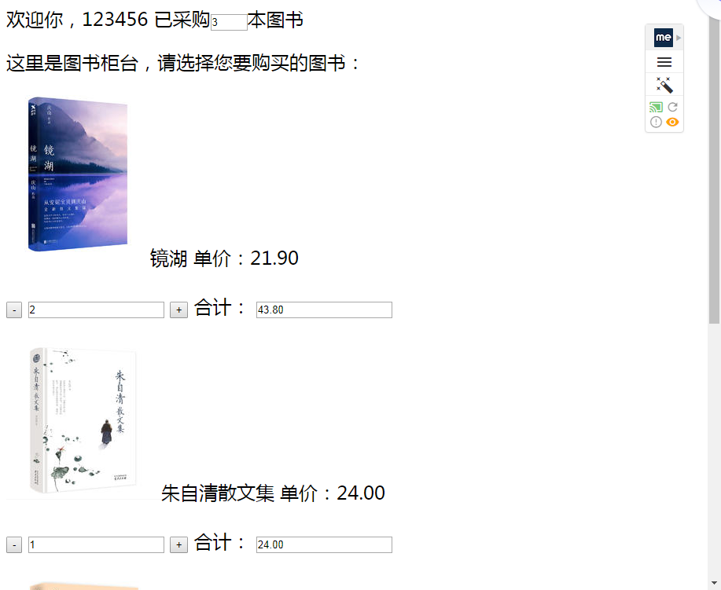

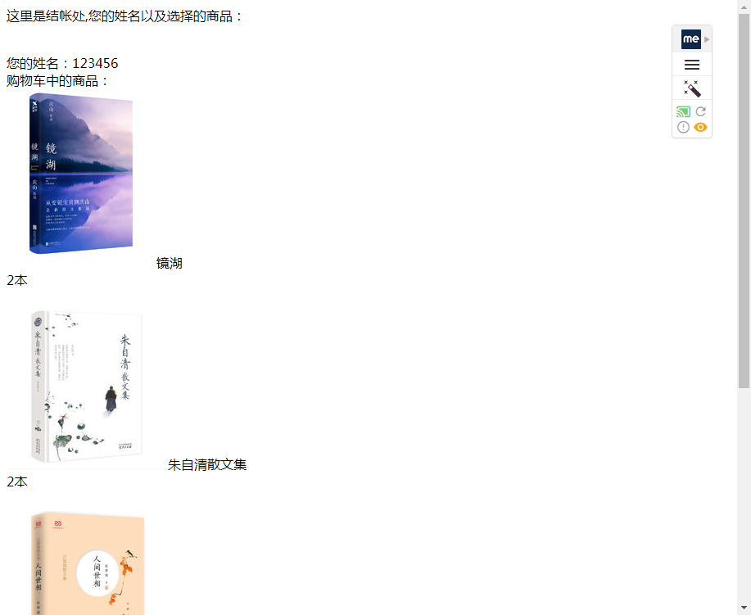

**五、收获与问题**

理解会话的原理和HttpSession会话期,以及掌握了如何使用URL重写。