**Java Web开发**

**实验六**

**作业报告**

|  |  |
| --- | --- |
| 学 院 | 计算机 |
| 所在系 班 级 | 2017软件工程系8班 |
| 学 号 姓 名 | 陈荣 |
| 指 导 教 师 | 郭晓燕 |
| 完 成 时 间 | 2019年4月20日 |

# 实验题目

# 参考成熟的购物系统，为购物车增加功能，完善购物车：删除商品，查看商品具体信息，计算商品总价，修改商品购买件数等等。界面尽量美观。

# 分析与设计

# 关键源码（部分）

ShoppingProduct.jsp

<body bgcolor=*"#ffffff"*>

<%

Map products = **new** HashMap();

products.put("1612001", **new** Product("1612001", "Java","", 29.00));

products.put("1612002", **new** Product("1612002", "c++", "",28.00));

products.put("1612003", **new** Product("1612003", "数据结构","", 27.00));

products.put("1612004", **new** Product("1612004", "操作系统","", 56.00));

products.put("1612005", **new** Product("1612005", "软件工程","", 34.00));

products.put("1612006", **new** Product("1612006", "编译原理","",46.00));

session.setAttribute("products", products); %>

<H1>产品显示</H1>

<form name=*"productForm"* action=*""* method=*"POST"*>

<input type=*"hidden"* name=*"action"* value=*"purchase"*>

<table border=*"1"* cellspacing=*"0"*>

<tr bgcolor=*"#CCCCCC"*>

<tr bgcolor=*"#CCCCCC"*>

<td>序号</td>

<td>产品名称</td>

<td>产品描述</td>

<td>产品单价（￥）</td>

<td>添加到购物车 </td>

</tr>

<%

Set productIdSet = products.keySet();

Iterator it = productIdSet.iterator();

**int** number = 1;

**while** (it.hasNext())

{

String id = (String) it.next();

Product product = (Product) products.get(id);

%>

<tr>

<td><%=number++%></td>

<td><%=product.getName()%></td>

<td><%=product.getDescription()%></td>

<td><%=product.getPrice()%></td>

<td><a href=*"Buy.jsp?id=*<%=product.getId()%>*&action=add"* target=*"cart"*>我要购买</a></td>

</tr>

<%

}

%>

</table>

<p></p>

</form>

</body>

Buy.jsp

<%@ page language=*"java"* import=*"java.util.*"* pageEncoding=*"UTF-8"*%>

<%@ page import=*"shopping.cart.*"* %>

<%

Cart c = (Cart)session.getAttribute("cart");

**if**(c == **null**)

{

c = **new** Cart();

session.setAttribute("cart", c);

}

**double** totalPrice = c.getTotalPrice();

request.setCharacterEncoding("GBK");

String action = request.getParameter("action");

Map products = (HashMap)session.getAttribute("products");

**if**(action != **null** && action.trim().equals("add"))

{

String id = request.getParameter("id");

Product p = (Product)products.get(id);

CartItem ci = **new** CartItem();

ci.setProduct(p);

ci.setCount(1);

c.add(ci);

}

**if**(action != **null** && action.trim().equals("delete"))

{

String id = request.getParameter("id");

c.deleteItemById(id);

}

**if**(action != **null** && action.trim().equals("update"))

{

**for**(**int** i=0; i<c.getItems().size(); i++)

{

CartItem ci = c.getItems().get(i);

**int** count = Integer.parseInt(request.getParameter("p" + ci.getProduct().getId()));

ci.setCount(count);

}

}

%>

<%

String path = request.getContextPath();

String basePath = request.getScheme()+"://"+request.getServerName()+":"+request.getServerPort()+path+"/"; %>

<% List<CartItem> items = c.getItems(); %>

<!DOCTYPE html PUBLIC "-//W3C//DTD HTML 4.01 Transitional//EN" "http://www.w3.org/TR/html4/loose.dtd">

<html>

<head>

<meta http-equiv=*"Content-Type"* content=*"text/html; charset=GB18030"*>

<title>购物车</title>

</head>

<body>

<!-- c的值是：<%=(c == **null**) %> items的值是：<%=(items == **null**) %> -->

<form action=*"Buy.jsp"* method=*"get"*>

<input type=*"hidden"* name=*"action"* value=*"update"*/>

<table align=*"center"* border=*"1"*>

<tr>

<td>产品ID</td>

<td>产品名称</td>

<td>购买数量</td>

<td>单价</td>

<td>总价</td>

<td>处理</td>

</tr>

<%

**for**(Iterator<CartItem> it = items.iterator(); it.hasNext(); )

{

CartItem ci = it.next();

%>

<tr>

<td><%=ci.getProduct().getId() %></td>

<td><%=ci.getProduct().getName() %></td>

<td>

<input type=*"text"* size=*3* name=*"*<%="p" + ci.getProduct().getId() %>*"* value=*"*<%=ci.getCount() %>*"*

onkeypress=*"if (event.keyCode* < *45 || event.keyCode > 57) event.returnValue = false;"*

onchange=*"document.forms[0].submit()"*>

</td>

<td><%=ci.getProduct().getPrice() %></td>

<td><%=ci.getProduct().getPrice()*ci.getCount() %></td>

<td>

<a href=*"Buy.jsp?action=delete&id=*<%=ci.getProduct().getId() %>*"*>删除</a>

</td>

</tr>

<% } %>

<tr>

<td colspan=*3* align=*"right"*>所有商品总价格为：</td>

<td colspan=*3*><%=c.getTotalPrice() %></td>

</tr> <tr>

<!-- <td colspan=3>

<a href="javascript:document.forms[0].submit()">修改</a>

</td> -->

<td colspan=*6* align=*"right"*><a href=*""*>下单</a></td>

</tr>

</table>

</form>

</body>

</html>

Cart.java

package shopping.cart;

import java.util.ArrayList;

import java.util.Iterator;

import java.util.List;

public class Cart

{

List<CartItem> items = new ArrayList<CartItem>();

public List<CartItem> getItems()

{

return items;

}

public void setItems(List<CartItem> items)

{

this.items = items;

}

public void add(CartItem ci)

{

for (Iterator<CartItem> iter = items.iterator(); iter.hasNext();)

{

CartItem item = iter.next();

if(item.getProduct().getId() == ci.getProduct().getId())

{

item.setCount(item.getCount() + 1);

return;

}

}

items.add(ci);

}

public double getTotalPrice()

{

double d = 0.0;

for(Iterator<CartItem> it = items.iterator(); it.hasNext(); )

{

CartItem current = it.next();

d += current.getProduct().getPrice() * current.getCount();

}

return d;

}

public void deleteItemById(String productId)

{

for (Iterator<CartItem> iter = items.iterator(); iter.hasNext();)

{

CartItem item = iter.next();

if(item.getProduct().getId().equals(productId))

{

iter.remove();

return;

}

}

}

}

*CartItem.java*

**package** shopping.cart;

**public** **class** CartItem

{

**private** Product product;

**private** **int** count;

**public** **int** getCount()

{

**return** count;

}

**public** **void** setCount(**int** count)

{

**this**.count = count;

}

**public** Product getProduct()

{

**return** product;

}

**public** **void** setProduct(Product product)

{

**this**.product = product;

}

}

Product.java

**package** shopping.cart;

**import** java.io.Serializable;

@SuppressWarnings("serial")

**public** **class** Product **implements** Serializable

{

**private** String id;

**private** String name;

**private** String description;

**private** **double** price;

**public** Product(){}

**public** Product(String id,String name,String description,**double** price)

{

**this**.id = id;

**this**.name = name;

**this**.description = description;

**this**.price = price;

}

**public** **void** setId(String id)

{

**this**.id = id;

}

**public** **void** setName(String name)

{

**this**.name = name;

}

**public** **void** setDescription(String description)

{

**this**.description = description;

}

**public** **void** setPrice(**double** price)

{

**this**.price = price;

}

**public** String getId()

{

**return** **this**.id;

}

**public** String getName()

{

**return** **this**.name;

}

**public** String getDescription()

{

**return** **this**.description;

}

**public** **double** getPrice()

{

**return** **this**.price;

}

}

# 运行效果图

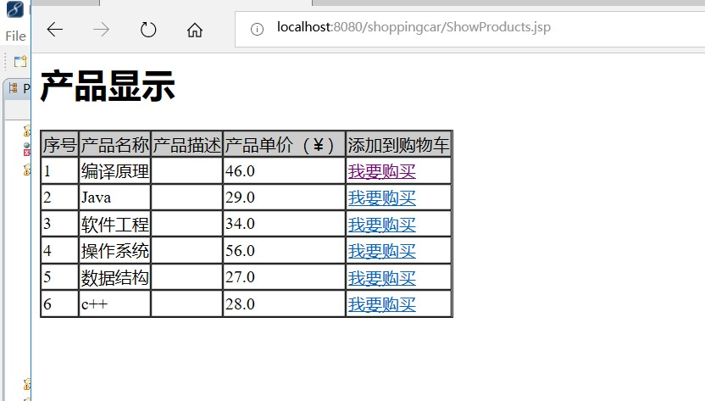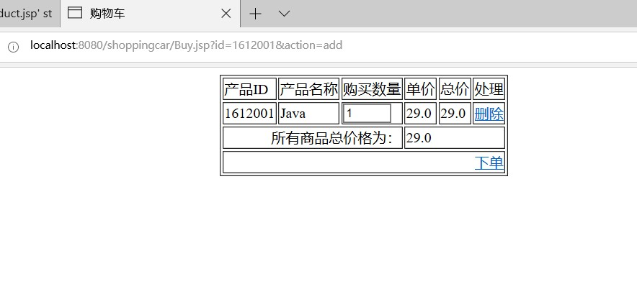

# 收获与问题