**Java Web开发**

**实验六**

**作业报告**

|  |  |
| --- | --- |
| 学 院 | 计算机 |
| 所在系 班 级 | 2017软件工程系8班 |
| 学 号 姓 名 | 钟静波 |
| 指 导 教 师 | 郭晓燕 |
| 完 成 时 间 | 2019年4月12日 |

# 实验题目

# 参考成熟的购物系统，为购物车增加功能，完善购物车：删除商品，查看商品具体信息，计算商品总价，修改商品购买件数等等。界面尽量美观。

# 分析与设计

# 关键源码（部分）

index.jsp

*<%@ page language="java" import="java.util.*" pageEncoding="UTF-8"%>*

*<%@ page import="CLASS.*" %>*

*<%*

*String path = request.getContextPath();*

*String basePath = request.getScheme()+"://"+request.getServerName()+":"+request.getServerPort()+path+"/";*

*%>*

*<!DOCTYPE HTML PUBLIC "-//W3C//DTD HTML 4.01 Transitional//EN">*

*<html>*

*<%*

*//当第一次访问采购网页，session对象中还没有book购物车信息时，进行初始化。*

*if (session.getAttribute("book")==null){*

*//在session对象中存储图书采购信息*

*Book[] BookList = new Book[4];*

*BookList[0]= new Book("10101", "Java核心技术", "img/10101.jpg", 0,165);*

*BookList[1] = new Book("10102", "Java经典实例", "img/10102.jpg", 0,102);*

*BookList[2] = new Book("10103", "Java7", "img/10103.jpg", 0,50);*

*BookList[3] = new Book("10104", "JSP&Servlet", "img/10104.jpg",0,70);*

*//存入session对象中*

*session.setAttribute("book", BookList);*

*}*

*%>*

*<body>*

*<br>*

*<img src="img/cart.jpg" height="60px" width="60px">*

*<a href="accounts.view"><button>已采购书籍</button></a><br>*

*<br>*

*<table border="1">*

*<tr>*

*<td><img src="img/10101.jpg"></td>*

*<td><img src="img/10102.jpg"></td>*

*<td><img src="img/10103.jpg"></td>*

*<td><img src="img/10104.jpg"></td>*

*</tr>*

*<%Book[] BookList = new Book[4];*

*BookList=(Book[]) session.getAttribute("book");%>*

*<tr>*

*<td><a href="shopping.view?id=10101"><button>采购此书</button></a><br><%=BookList[0].getbookMessage()%></td>*

*<td><a href="shopping.view?id=10102"><button>采购此书</button></a><br><%=BookList[1].getbookMessage()%></td>*

*<td><a href="shopping.view?id=10103"><button>采购此书</button></a><br><%=BookList[2].getbookMessage()%></td>*

*<td><a href="shopping.view?id=10104"><button>采购此书</button></a><br><%=BookList[3].getbookMessage()%></td>*

*</tr>*

*</body>*

*</html>*

shoppingServlet.java

*package SERVLET;*

*import java.io.IOException;*

*import java.io.PrintWriter;*

*import javax.servlet.ServletException;*

*import javax.servlet.http.HttpServlet;*

*import javax.servlet.http.HttpServletRequest;*

*import javax.servlet.http.HttpServletResponse;*

*import javax.servlet.http.HttpSession;*

*import CLASS.Book;*

*public class shoppingServlet extends HttpServlet {*

*public void doGet(HttpServletRequest request, HttpServletResponse response) throws ServletException, IOException {*

*HttpSession session=request.getSession();*

*Book[] BookList = new Book[4];*

*String book_id = request.getParameter("id");//获取从Shopping.jsp传来的request对象中的ID号*

*if(book_id!=null)*

*BookList=(Book[]) session.getAttribute("book");*

*//在ID号不为空的情况下，获取Session对象中的购物车信息，Book数组。*

*for(int i=0;i<4;i++){*

*if(BookList[i].getBookId().equals(book_id))*

*BookList[i]=new Book(BookList[i].getBookId(),BookList[i].getBookName(),BookList[i].getBookImg(),1,BookList[i].bookPrice());*

*}//找到数组中与ID对应的Book对象，将其属性bookNum数字为1*

*session.setAttribute("book", BookList);//将数组写回session对象中去。*

*response.sendRedirect("index.jsp");//跳转回Shopping.jsp*

*}*

*} }*

shoppingCar.jsp

*<%@ page language="java" import="java.util.*" pageEncoding="UTF-8"%>*

*<%@ page import="CLASS.*" %>*

*<%*

*String path = request.getContextPath();*

*String basePath = request.getScheme()+"://"+request.getServerName()+":"+request.getServerPort()+path+"/";*

*%>*

*<!DOCTYPE HTML PUBLIC "-//W3C//DTD HTML 4.01 Transitional//EN">*

*<html>*

*<body>*

*<br>*

*<%*

*Book[] BookList = new Book[4];*

*BookList=(Book[]) session.getAttribute("book");*

*int count=(Integer)session.getAttribute("count");*

*if(BookList[0].getBookNum()+BookList[1].getBookNum()+BookList[2].getBookNum()+BookList[3].getBookNum()==0)*

*{*

*out.println("<font size=8>请选择商品</font>");*

*out.println("<a href='index.jsp'>返回购物页面</a>");*

*}*

*else {*

*out.println("<font size=8>购物车</font><br><table border='1'><tr>");*

*for(int i=0;i<4;i++) {*

*if(BookList[i].getBookNum()>0)*

*out.println("<td><img src='img/"+BookList[i].getBookId()+".jpg'></td>");*

*}*

*out.println("</tr><tr>");*

*for(int i=0;i<4;i++) {*

*if(BookList[i].getBookNum()>0){*

*out.println("<td><a href='add.view?id="+BookList[i].getBookId()+"'><button>+</button></a>");*

*out.println("总共"+BookList[i].getBookNum()+"件");*

*out.println("<a href='minus.view?id="+BookList[i].getBookId()+"'><button>-</button></a>");*

*out.println("<br><a href='delete.view?id="+BookList[i].getBookId()+"'><button>删除此书</button></a></td>");*

*}*

*}*

*out.println("<p>总共"+count+"元</p>");*

*out.println("</tr><br><a href='index.jsp'><button>继续购物</button></a>");*

*}*

*%>*

*</body>*

*</html>*

addNum.java

*package SERVLET;*

*import java.io.IOException;*

*import java.io.PrintWriter;*

*import javax.servlet.ServletException;*

*import javax.servlet.http.HttpServlet;*

*import javax.servlet.http.HttpServletRequest;*

*import javax.servlet.http.HttpServletResponse;*

*import javax.servlet.http.HttpSession;*

*import CLASS.Book;*

*public class addNum extends HttpServlet {*

*public void doGet(HttpServletRequest request, HttpServletResponse response) throws ServletException, IOException {*

*HttpSession session=request.getSession();*

*Book[] BookList = new Book[4];*

*String book_id = request.getParameter("id");//获取从Shopping.jsp传来的request对象中的ID号*

*if(book_id!=null)*

*BookList=(Book[]) session.getAttribute("book");*

*//在ID号不为空的情况下，获取Session对象中的购物车信息，Book数组。*

*for(int i=0;i<4;i++){*

*if(BookList[i].getBookId().equals(book_id))*

*BookList[i]=new Book(BookList[i].getBookId(),BookList[i].getBookName(),BookList[i].getBookImg(),BookList[i].getBookNum()+1,BookList[i].bookPrice());*

*}//找到数组中与ID对应的Book对象，将其属性bookNum数字加1*

*session.setAttribute("book", BookList);//将数组写回session对象中去。*

*response.sendRedirect("accounts.view");//跳转回Shopping.jsp*

*}*

*}*

deleteBook.java

*package SERVLET;*

*import java.io.IOException;*

*import java.io.PrintWriter;*

*import javax.servlet.ServletException;*

*import javax.servlet.http.HttpServlet;*

*import javax.servlet.http.HttpServletRequest;*

*import javax.servlet.http.HttpServletResponse;*

*import javax.servlet.http.HttpSession;*

*import CLASS.Book;*

*public class deleteBook extends HttpServlet {*

*public void doGet(HttpServletRequest request, HttpServletResponse response) throws ServletException, IOException {*

*HttpSession session=request.getSession();*

*Book[] BookList = new Book[4];*

*String book_id = request.getParameter("id");//获取从Shopping.jsp传来的request对象中的ID号*

*if(book_id!=null)*

*BookList=(Book[]) session.getAttribute("book");*

*//在ID号不为空的情况下，获取Session对象中的购物车信息，Book数组。*

*for(int i=0;i<4;i++){*

*if(BookList[i].getBookId().equals(book_id))*

*BookList[i]=new Book(BookList[i].getBookId(),BookList[i].getBookName(),BookList[i].getBookImg(),0,BookList[i].bookPrice());*

*}//找到数组中与ID对应的Book对象，将其属性bookNum置为0*

*session.setAttribute("book", BookList);//将数组写回session对象中去。*

*response.sendRedirect("accounts.view");//跳转回Shopping.jsp*

*}*

*}*

minusNum.java

*package SERVLET;*

*import java.io.IOException;*

*import java.io.PrintWriter;*

*import javax.servlet.ServletException;*

*import javax.servlet.http.HttpServlet;*

*import javax.servlet.http.HttpServletRequest;*

*import javax.servlet.http.HttpServletResponse;*

*import javax.servlet.http.HttpSession;*

*import CLASS.Book;*

*public class minusNum extends HttpServlet {*

*public void doGet(HttpServletRequest request, HttpServletResponse response) throws ServletException, IOException {*

*HttpSession session=request.getSession();*

*Book[] BookList = new Book[4];*

*String book_id = request.getParameter("id");//获取从Shopping.jsp传来的request对象中的ID号*

*if(book_id!=null)*

*BookList=(Book[]) session.getAttribute("book");*

*//在ID号不为空的情况下，获取Session对象中的购物车信息，Book数组。*

*for(int i=0;i<4;i++){*

*if(BookList[i].getBookId().equals(book_id))*

*BookList[i]=new Book(BookList[i].getBookId(),BookList[i].getBookName(),BookList[i].getBookImg(),BookList[i].getBookNum()-1,BookList[i].bookPrice());*

*}//找到数组中与ID对应的Book对象，将其属性bookNum数字加1*

*session.setAttribute("book", BookList);//将数组写回session对象中去。*

*response.sendRedirect("accounts.view");//跳转回Shopping.jsp*

*}*

*}*

settleAccounts.java

*package SERVLET;*

*import java.io.IOException;*

*import java.io.PrintWriter;*

*import javax.servlet.ServletException;*

*import javax.servlet.http.HttpServlet;*

*import javax.servlet.http.HttpServletRequest;*

*import javax.servlet.http.HttpServletResponse;*

*import javax.servlet.http.HttpSession;*

*import CLASS.Book;*

*public class settleAccounts extends HttpServlet {*

*public void doGet(HttpServletRequest request, HttpServletResponse response)*

*throws ServletException, IOException {*

*HttpSession session=request.getSession();*

*Book[] BookList = new Book[4];*

*BookList=(Book[]) session.getAttribute("book");*

*int count=0;*

*for(int i=0;i<4;i++){*

*count=count+BookList[i].bookPrice()*BookList[i].getBookNum();*

*}*

*session.setAttribute("count",count);*

*response.sendRedirect("shoppingCar.jsp");//跳转回Shopping.jsp*

*}*

*}*

# 运行效果图

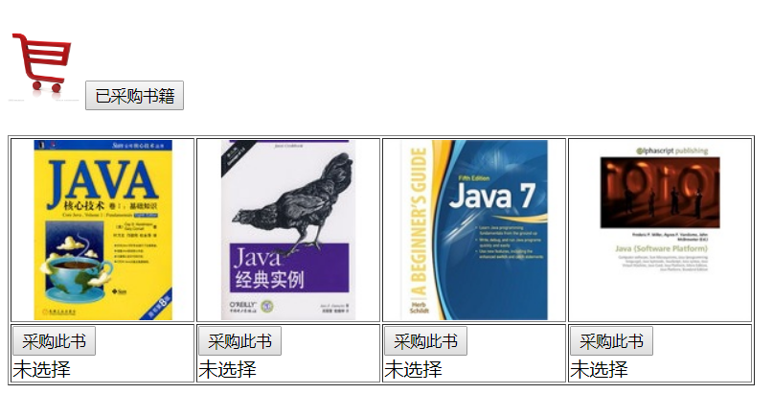

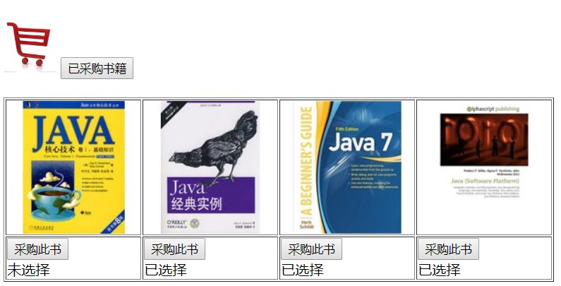

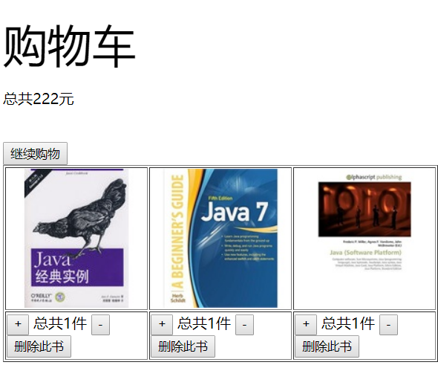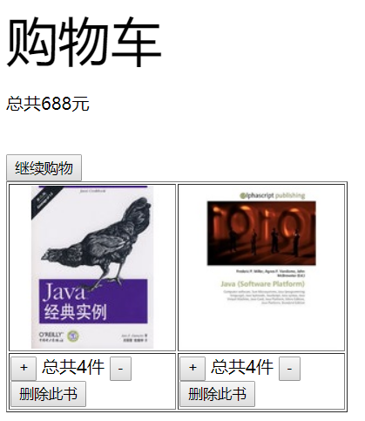

# 收获与问题