**Java Web开发**

**实验六**

**作业报告**

|  |  |
| --- | --- |
| 学院 | 计算机 |
| 所在系班级 | 2017软件工程系8班 |
| 学号姓名 | 陈润楷 |
| 指导教师 | 郭晓燕 |
| 完成时间 | 2019年5月12日 |

# 实验题目

# 参考成熟的购物系统，为购物车增加功能，完善购物车：删除商品，查看商品具体信息，计算商品总价，修改商品购买件数等等。界面尽量美观。

# 分析与设计

# 关键源码（部分）

Shopping.jsp

<%@ page language=*"java"* import=*"java.util.*"* pageEncoding=*"UTF-8"*%>

<%@page import=*"cc.test.vo.*"* %>

<!DOCTYPE HTML PUBLIC "-//W3C//DTD HTML 4.01 Transitional//EN">

<html>

<%

//当第一次访问采购网页，session对象中还没有book购物车信息时，进行初始化。

**if** (session.getAttribute("book")==**null**){

//在session对象中存储图书采购信息

Book[] BookList = **new** Book[4];

BookList[0] = **new** Book("10101", "稻草人手记", "img\10101.jpg", 0,25,0);

BookList[1] = **new** Book("10102", "送你一匹马", "img\10102.jpg", 0,30,0);

BookList[2] = **new** Book("10103", "撒哈拉的故事", "img\10103.jpg", 0,35,0);

BookList[3] = **new** Book("10104", "温柔的夜", "img\10104.jpg",0,40,0);

//存入session对象中

session.setAttribute("book", BookList);

}

%>

<body>

<br>

<img src=*"img/cart.jpg"* height=*"70px"* width=*"70px"*>

<img src=*"img/10101.jpg"* height=*"70px"* width=*"70px"*>

<img src=*"img/10102.jpg"* height=*"70px"* width=*"70px"*>

<img src=*"img/10103.jpg"* height=*"70px"* width=*"70px"*>

<img src=*"img/10104.jpg"* height=*"70px"* width=*"70px"*>

<a href=*"Cart.jsp"*><button>加入购物车</button></a><br>

<br>

<table border=*"1"* >

<tr>

<td><img src=*"img/10101.jpg"*></td>

<td><img src=*"img/10102.jpg"*></td>

<td><img src=*"img/10103.jpg"*></td>

<td><img src=*"img/10104.jpg"*></td>

</tr>

<%Book[] BookList = **new** Book[4];BookList=(Book[]) session.getAttribute("book");%><tr>

<td><a href=*"shopping.view?id=10101"*><button>加购此书</button></a>

<br><a href=*"delete.view?id=10101"*><button>减购此书</button></a>

<br>已选择<%=BookList[0].getBookNum()%>件</td>

<td><a href=*"shopping.view?id=10102"*><button>加购此书</button></a>

<br><a href=*"delete.view?id=10102"*><button>减购此书</button></a>

<br>已选择<%=BookList[1].getBookNum()%>件</td>

<td><a href=*"shopping.view?id=10103"*><button>加购此书</button></a>

<br><a href=*"delete.view?id=10103"*><button>减购此书</button></a>

<br>已选择<%=BookList[2].getBookNum()%>件</td>

<td><a href=*"shopping.view?id=10104"*><button>加购此书</button></a>

<br><a href=*"delete.view?id=10104"*><button>减购此书</button></a>

<br>已选择<%=BookList[3].getBookNum()%>件

</td></tr>

</body>

</html>

ShoppingServlet.java

*package cc.test.Controller;*

*import java.io.IOException;*

*import java.io.PrintWriter;*

*import javax.servlet.ServletException;*

*import javax.servlet.http.HttpServlet;*

*import javax.servlet.http.HttpServletRequest;*

*import javax.servlet.http.HttpServletResponse;*

*import javax.servlet.http.HttpSession;*

*import cc.test.vo.Book;;*

*public class ShopingServlet extends HttpServlet {*

*private HttpServletRequest request;*

*public void doGet(HttpServletRequest request, HttpServletResponse response) throws ServletException, IOException{*

*HttpSession session=request.getSession();*

*Book[] BookList = new Book[4];*

*String book_id = request.getParameter("id");//获取从Shopping.jsp传来的request对象中的ID号*

*if(book_id!=null)BookList=(Book[]) session.getAttribute("book");*

*//在ID号不为空的情况下，获取Session对象中的购物车信息，Book数组。*

*for(int i=0;i<4;i++){*

*if(BookList[i].getBookId().equals(book_id))*

*BookList[i]=new Book(BookList[i].getBookId(),BookList[i].getBookName(),BookList[i].getBookImg(),BookList[i].getBookNum()+1,BookList[i].getBookPrice(),BookList[i].getTotalPrice());*

*}//找到数组中与ID对应的Book对象，将其属性bookNum数字加1*

*session.setAttribute("book", BookList);//将数组写回session对象中去。*

*response.sendRedirect("Shopping.jsp");//跳转回Shopping.jsp}*

*}*

*public void doPost(HttpServletRequest request, HttpServletResponse response)*

*throws ServletException, IOException {*

*doGet(request,response);}*

*}*

DeleteServlet.java

*package cc.test.Controller;*

*import java.io.IOException;*

*import java.io.PrintWriter;*

*import javax.servlet.ServletException;*

*import javax.servlet.http.HttpServlet;*

*import javax.servlet.http.HttpServletRequest;*

*import javax.servlet.http.HttpServletResponse;*

*import javax.servlet.http.HttpSession;*

*import cc.test.vo.Book;;*

*public class DeleteServlet extends HttpServlet {*

*private HttpServletRequest request;*

*public void doGet(HttpServletRequest request, HttpServletResponse response) throws ServletException, IOException{*

*HttpSession session=request.getSession();*

*Book[] BookList = new Book[4];*

*String book_id = request.getParameter("id");//获取从Shopping.jsp传来的request对象中的ID号*

*if(book_id!=null)BookList=(Book[]) session.getAttribute("book");*

*//在ID号不为空的情况下，获取Session对象中的购物车信息，Book数组。*

*for(int i=0;i<4;i++){*

*if(BookList[i].getBookId().equals(book_id))*

*BookList[i]=new Book(BookList[i].getBookId(),BookList[i].getBookName(),BookList[i].getBookImg(),BookList[i].getBookNum()-1,BookList[i].getBookPrice(),BookList[i].getTotalPrice());*

*}//找到数组中与ID对应的Book对象，将其属性bookNum数字减1*

*session.setAttribute("book", BookList);//将数组写回session对象中去。*

*response.sendRedirect("Shopping.jsp");//跳转回Shopping.jsp}*

*}*

*public void doPost(HttpServletRequest request, HttpServletResponse response)*

*throws ServletException, IOException {*

*doGet(request,response);*

*}*

*}*

Book.java

**package** cc.test.vo;

**public** **class** Book {

**private** String bookId; //书号

**private** String bookName;//书名

String bookImg; //书封面所在地址

**private** **int** bookNum; //购书本数

**private** **int** bookPrice; //购书的单价

**private** **int** totalPrice; //购单本书的总价

**public** Book(String bookId, String bookName, String bookImg, **int** bookNum,**int** bookPrice,**int** totalPrice) {

**this**.bookId = bookId;

**this**.bookName = bookName;

**this**.bookImg = bookImg;

**this**.bookNum =bookNum;

**this**.bookPrice=bookPrice;

**this**.totalPrice=totalPrice;

}

**public** String getBookId() {

**return** bookId;

}

**public** String getBookName() {

**return** bookName;

}

**public** String getBookImg() {

**return** bookImg;

}

**public** **int** getBookNum() {

**return** bookNum;

}

**public** **int** getBookPrice() {

**return** bookPrice;

}

**public** **int** getTotalPrice() {

**return** totalPrice=bookNum*bookPrice;

}

}

Cart.jsp

<%@ page language=*"java"* import=*"java.util.*"* pageEncoding=*"UTF-8"*%>

<%@page import=*"cc.test.vo.*"* %>

<!DOCTYPE HTML PUBLIC "-//W3C//DTD HTML 4.01 Transitional//EN">

<html>

<body>

<table border=*"1"* >

<%Book[] bookList =**new** Book[4];

bookList=(Book[])session.getAttribute("book");%>

<tr>

<%**if**(bookList[0].getBookNum()!=0) {%>

<td><img src=*"img/10101.jpg"*>已选择<%=bookList[0].getBookNum()%>件</td>

<%}%>

<%**if**(bookList[1].getBookNum()!=0) {%>

<td><img src=*"img/10102.jpg"*>已选择<%=bookList[1].getBookNum()%>件</td>

<%}%>

<%**if**(bookList[2].getBookNum()!=0) {%>

<td><img src=*"img/10103.jpg"*>已选择<%=bookList[2].getBookNum()%>件</td>

<%}%>

<%**if**(bookList[3].getBookNum()!=0) {%>

<td><img src=*"img/10104.jpg"*>已选择<%=bookList[3].getBookNum()%>件</td>

<%}%>

<br><td>总价是<%=bookList[0].getTotalPrice()+bookList[1].getTotalPrice()+bookList[2].getTotalPrice()+bookList[3].getTotalPrice()%>元</td>

</tr>

</body>

</html>

# 运行效果图

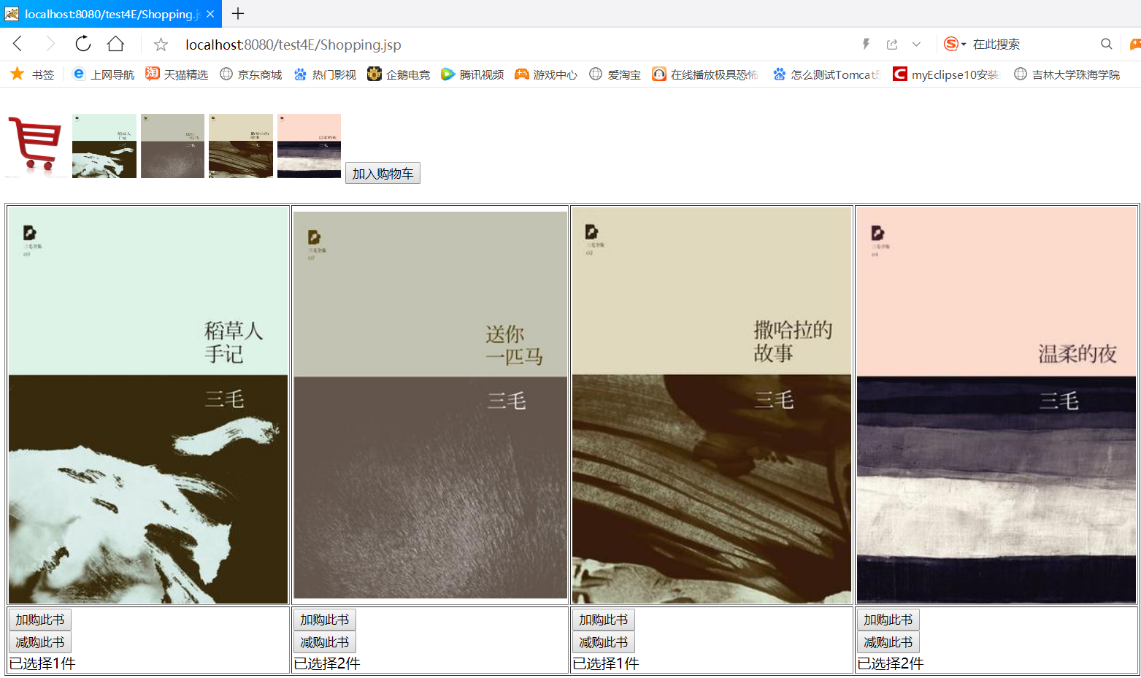

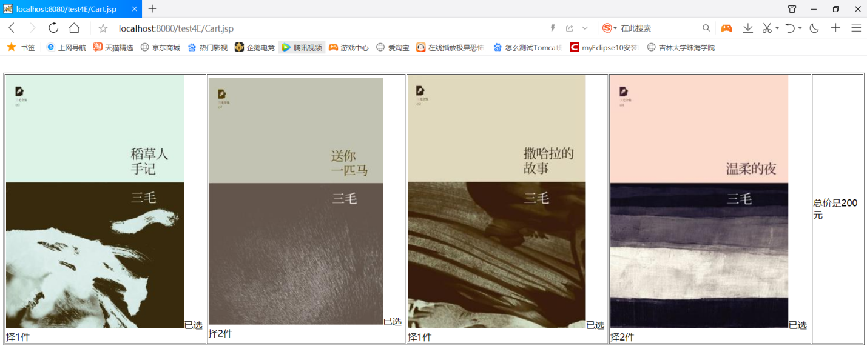

# 收获与问题