**Java Web开发**

**实验六**

**作业报告**

|  |  |
| --- | --- |
| 学 院 | 计算机 |
| 所在系 班 级 | 2017软件工程系8班 |
| 学 号 姓 名 | 04171615 梁峰源 |
| 指 导 教 师 | 郭晓燕 |
| 完 成 时 间 |  |

# 实验题目

第四章课后练习3购物车，实现一个购物车应用程序，可以购物，显示购物数量并查看购物车内容。（此题模版test4E，提供给大家参考。）

提示：采购此书做成超链接，并用URL重写带关键信息

（a) Shopping.view?bookID=‘0001’，其中0001是你选中图书对应的ID号，每点击一次就在相应的购书数量上加一，并返回当前的选购页面。

（b) 除了要保存图书的ID号、书名，还要保存购书数量，所以session对象保存的信息需要考虑清楚，最好是一个对象

数组或列表。

购物车的效果图

# 关键源码（部分）

Main.jsp

<%@ page language=*"java"* import=*"java.util.*"* pageEncoding=*"utf-8"*%>

<%

String path = request.getContextPath();

String basePath = request.getScheme()+"://"+request.getServerName()+":"+request.getServerPort()+path+"/";

%>

<!DOCTYPE HTML PUBLIC "-//W3C//DTD HTML 4.01 Transitional//EN">

<html>

<body><FONT Size=*7*>

<p>请输入用户名进行登录

<FORM action=*"ShopLogin.view"* method=*"post"* name=*"form"*>

<input type=*"text"* name=*"username"*>

<input type=*"submit"* value=*"提交"* name=*"submit"*>

</form>

</FONT>

</body>

</html>

ShopLogin.java

package com.session;

import java.io.IOException;

import javax.servlet.ServletException;

import javax.servlet.annotation.WebServlet;

import javax.servlet.http.HttpServlet;

import javax.servlet.http.HttpServletRequest;

import javax.servlet.http.HttpServletResponse;

import javax.servlet.http.HttpSession;

@WebServlet("/ShopLogin.view")

public class ShopLogin extends HttpServlet {

protected void doPost(HttpServletRequest request, HttpServletResponse response)

throws ServletException, IOException {

request.setCharacterEncoding("UTF-8");

HttpSession session=request.getSession();

String username=request.getParameter("username");

if(username.length()==0)

{

response.sendRedirect("main.jsp");

}

else

{

session.setAttribute("customerName", "username");

response.sendRedirect("Shopping.jsp");

}

}

}

Shopping.jsp

<%@ page language=*"java"* import=*"java.util.*"* import=*"com.session.Book"* pageEncoding=*"utf-8"*%>

<%

String path = request.getContextPath();

String basePath = request.getScheme()+"://"+request.getServerName()+":"+request.getServerPort()+path+"/";

%>

<!DOCTYPE HTML PUBLIC "-//W3C//DTD HTML 4.01 Transitional//EN">

<html>

<%

**if**(session.getAttribute("bookList")==**null**)

{

Book[] BookList=**new** Book[4];

BookList[0]=**new** Book("10101","Java核心技术","image\\1.jpg",0,20,"这是java核心技术的简介");

BookList[1]=**new** Book("10102","软件工程","image\\4.jpg",0,21,"这是软件工程的简介");

BookList[2]=**new** Book("10103","数据库概论","image\\2.jpg",0,22,"这是数据库的简介");

BookList[3]=**new** Book("10104","Java7","image\\3.jpg",0,23,"这是java7的简介");

session.setAttribute("bookList", BookList);

session.setAttribute("sum", 0);

session.setAttribute("totalPrice",0);

}

%>

<body>

<img src=*"image/car.jpg"* height=*"60px"* width=*"60px"*>

<a href=*"car.view"*>已采购<%=session.getAttribute("sum") %>本书 </a>

<h1>已花费<%=session.getAttribute("totalPrice") %></h1>

<br>

<table border=*"1"*>

<%

Book[] bookList=(Book[])session.getAttribute("bookList");

**for**(Book book:bookList)

{

out.println("<tr>");

out.println("<td><img src='"+book.getbookImg()+"'height=200px width=150px></td>");

out.println("<td>商品价格为："+book.getbookPrice()+"</td>");

out.println("<td><a href='shopping.view?id="+book.getbookID()+"'> 采购此书</a></td>");

out.println("<td><a href='im.jsp?id2="+book.getbookID()+"'>查看书本信息</a></td>");

out.println("</tr>");

}

%>

</table>

</body>

</html>

ShoppingServlet.java

package com.session;

import java.io.IOException;

import java.io.PrintWriter;

import javax.servlet.ServletException;

import javax.servlet.annotation.WebServlet;

import javax.servlet.http.HttpServlet;

import javax.servlet.http.HttpServletRequest;

import javax.servlet.http.HttpServletResponse;

import javax.servlet.http.HttpSession;

import com.session.Book;

/**

* Servlet implementation class ShoppingServlet

*/

@WebServlet("/shopping.view")

public class ShoppingServlet extends HttpServlet {

protected void doGet(HttpServletRequest request, HttpServletResponse response)

throws ServletException, IOException {

request.setCharacterEncoding("UTF-8");

HttpSession session=request.getSession();

String ID3="";

String ID4="";

String iD="";

String ID5="";

int num=0;

int totalPrice=0;

Book[] chart=(Book[])session.getAttribute("bookList");

PrintWriter out=response.getWriter();

ID3=request.getParameter("id3");//+

ID4=request.getParameter("id4");//-

iD=request.getParameter("id");//buy

ID5=request.getParameter("id5");//del

if(ID5!=null)

{

for(int i=0;i<chart.length;i++)

{

if(ID5.equals(chart[i].getbookID()))

{

chart[i].setshopNum(0);

}

}

for(int i=0;i<chart.length;i++)

{

num=num+chart[i].getshopNum();

}

for(int i=0;i<chart.length;i++)

{

totalPrice=totalPrice+ (chart[i].getshopNum()*chart[i].getbookPrice());

}

session.setAttribute("totalPrice", totalPrice);

session.setAttribute("sum", num);

session.setAttribute("bookList", chart);

response.sendRedirect("car.view");

}

if(ID3!=null)

{

for(int i=0;i<chart.length;i++)

{

if(ID3.equals(chart[i].getbookID()))

{

chart[i].setshopNum(chart[i].getshopNum()+1);

}

}

for(int i=0;i<chart.length;i++)

{

num=num+chart[i].getshopNum();

}

for(int i=0;i<chart.length;i++)

{

totalPrice=totalPrice+ (chart[i].getshopNum()*chart[i].getbookPrice());

}

session.setAttribute("totalPrice", totalPrice);

session.setAttribute("sum", num);

session.setAttribute("bookList", chart);

response.sendRedirect("car.view");

}

else if(ID4!=null)

{

for(int i=0;i<chart.length;i++)

{

if(ID4.equals(chart[i].getbookID())&&chart[i].getshopNum()>0)

{

chart[i].setshopNum(chart[i].getshopNum()-1);

}

}

for(int i=0;i<chart.length;i++)

{

num=num+chart[i].getshopNum();

}

for(int i=0;i<chart.length;i++)

{

totalPrice=totalPrice+ (chart[i].getshopNum()*chart[i].getbookPrice());

}

session.setAttribute("totalPrice", totalPrice);

session.setAttribute("sum", num);

session.setAttribute("bookList", chart);

response.sendRedirect("car.view");

}

if(iD!=null)

{

for(int i=0;i<chart.length;i++)

{

if(iD.equals(chart[i].getbookID()))

{

chart[i].setshopNum(chart[i].getshopNum()+1);

}

}

for(int i=0;i<chart.length;i++)

{

num=num+chart[i].getshopNum();

}

for(int i=0;i<chart.length;i++)

{

totalPrice=totalPrice+ (chart[i].getshopNum()*chart[i].getbookPrice());

}

session.setAttribute("totalPrice", totalPrice);

session.setAttribute("sum", num);

session.setAttribute("bookList", chart);

response.sendRedirect("Shopping.jsp");

}

}

}

CarServlet.java

package com.session;

import java.io.IOException;

import java.io.PrintWriter;

import javax.servlet.ServletException;

import javax.servlet.annotation.WebServlet;

import javax.servlet.http.HttpServlet;

import javax.servlet.http.HttpServletRequest;

import javax.servlet.http.HttpServletResponse;

import javax.servlet.http.HttpSession;

/**

* Servlet implementation class CarServlet

*/

@WebServlet("/car.view")

public class CarServlet extends HttpServlet {

protected void doGet(HttpServletRequest request, HttpServletResponse response)

throws ServletException, IOException {

request.setCharacterEncoding("UTF-8");

response.setContentType("text/html;charset=UTF-8");

PrintWriter out=response.getWriter();

HttpSession session=request.getSession();

Book[] carList=(Book[])session.getAttribute("bookList");

out.println("<html>");

out.println("<body>");

out.println("<p>");

out.println("已购买"+session.getAttribute("sum")+"本书籍");

out.println();

out.println("已花费"+session.getAttribute("totalPrice")+"元");

out.println("</p>");

out.println("<table border='1'>");

out.println();

out.println("<a href='Shopping.jsp'>返回购物页面</a>");

for(Book show:carList)

{

if(show.getshopNum()>0){

out.println("<tr>");

out.println("<td><img src='"+show.getbookImg()+"'height=200px width=150px></td>");

out.println("<td><a href='im.jsp?id2="+show.getbookID()+"'>查看书本信息</a></td>");

out.println("<td>已购买"+show.getshopNum()+"本</td>");

out.println("<td>共"+show.getshopNum()*show.getbookPrice()+"元</td>");

out.println("<td><a href='shopping.view?id3="+show.getbookID()+"'>增加</a></td>");

out.println("<td><a href='shopping.view?id4="+show.getbookID()+"'>减少</a></td>");

out.println("<td><a href='shopping.view?id5="+show.getbookID()+"'>删除</a></td>");

out.println("</tr>");

}

}

out.println("</table>");

out.println("</body>");

out.println("</html>");

out.close();

}

}

Book.java

**package** com.session;

**public** **class** Book {

String bookID;

String bookName;

String bookImg;

**int** shopNum;

**int** bookPrice;

String imformation;

**public** Book(String id,String name,String img,**int** num,**int** bookPrice,String imformation)

{

**this**.bookID=id;

**this**.bookName=name;

**this**.bookImg=img;

**this**.shopNum=num;

**this**.bookPrice=bookPrice;

**this**.imformation=imformation;

}

**public** String getbookID()

{

**return** bookID;

}

**public** **void** setbookId(String bookID)

{

**this**.bookID=bookID;

}

**public** String getbookName()

{

**return** bookName;

}

**public** **void** setbookName(String bookName)

{

**this**.bookName=bookName;

}

**public** String getbookImg()

{

**return** bookImg;

}

**public** **void** setbookImg(String setbookImg)

{

**this**.bookImg=setbookImg;

}

**public** **int** getshopNum()

{

**return** shopNum;

}

**public** **void** setshopNum(**int** shopNum)

{

**this**.shopNum=shopNum;

}

**public** **int** getbookPrice(){

**return** bookPrice;

}

**public** **void** setbookPrice(**int** bookPrice){

**this**.bookPrice=bookPrice;

}

**public** String getimformation(){

**return** imformation;

}

**public** **void** setimformation(){

**this**.imformation=imformation;

}

}

Im.jsp

<%@ page language=*"java"* import=*"java.util.*"* pageEncoding=*"utf-8"*%>

<%@ page import=*"com.session.Book"*%>

<%

String path = request.getContextPath();

String basePath = request.getScheme()+"://"+request.getServerName()+":"+request.getServerPort()+path+"/";

%>

<!DOCTYPE HTML PUBLIC "-//W3C//DTD HTML 4.01 Transitional//EN">

<html>

<body>

<a href=*"car.view"*>返回购物车</a>

<a href=*"Shopping.jsp"*>返回购物页面</a>

<%

String id=request.getParameter("id2");

Book[] List=(Book[])session.getAttribute("bookList");

**for**(**int** i=0;i<List.length;i++)

{

**if**(id.equals(List[i].getbookID()))

{

%>

<h1 class=*"text-center"*><% List[i].getbookName(); %>简介 </h1>

<p><%=List[i].getimformation()%></p>

<p>价格：<%=List[i].getbookPrice()%>元</p>

<%

}

}

%>

</body>

</html>

# 运行效果图

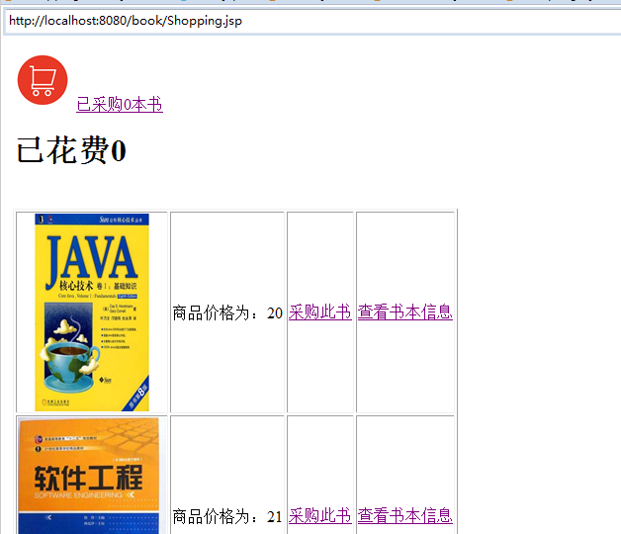

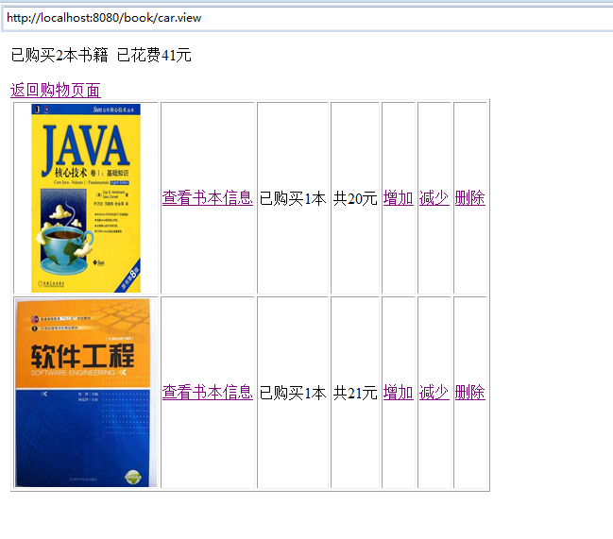

# 收获与问题

谈一谈你在本实验中所收获的内容及问题。