**Java Web开发**

**实验六**

**实验报告**

|  |  |
| --- | --- |
| 学 院 | 计算机 |
| 所在系 班 级 | 2017软件工程系8班 |
| 学 号 姓 名 |  |
| 指 导 教 师 | 郭晓燕 |
| 完 成 时 间 |  |

# 实验题目

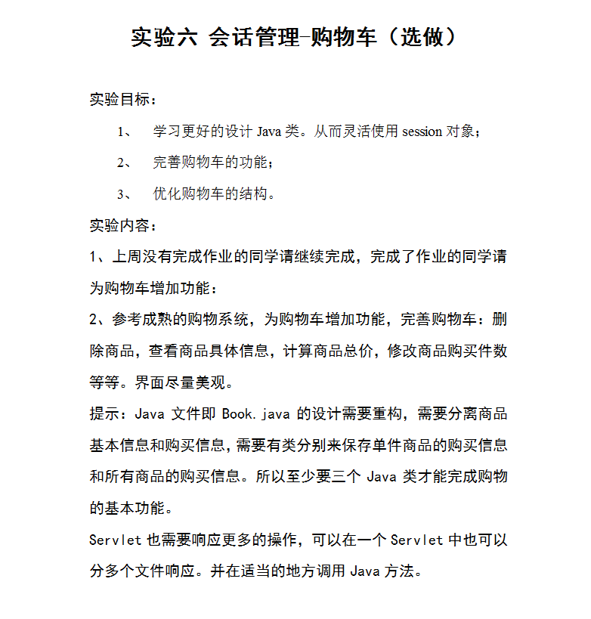

# 关键源码（部分）

Book.java

**package** cc;

**public** **class** Book {

String bookID;

String bookName;

String bookImg;

**int** shopNum=0;

**public** Book(String id,String name,String img,**int** num){

**this**.bookID=id;

**this**.bookName=name;

**this**.bookImg=img;

**this**.shopNum=num;

}

**public** String getBookID(){

**return** bookID;

}

**public** **void** setBookID(String bookID){

**this**.bookID=bookID;

}

**public** String getBookName(){

**return** bookName;

}

**public** **void** setBookName(String bookName){

**this**.bookName=bookName;

}

**public** **int** getShopNum(){

**return** shopNum;

}

**public** **void** setShopNum(**int** shopNum){

**this**.shopNum=shopNum;

}

**public** String getBookImg(){

**return** bookImg;

}

**public** **void** setBookImg(String bookImg){

**this**.bookImg=bookImg;

}

**public** **void** delete(){

**this**.shopNum=0;

}

}

chartServlet.java

**package** cc;

**import** java.io.IOException;

**import** java.io.PrintWriter;

**import** javax.servlet.ServletException;

**import** javax.servlet.annotation.WebServlet;

**import** javax.servlet.http.HttpServlet;

**import** javax.servlet.http.HttpServletRequest;

**import** javax.servlet.http.HttpServletResponse;

**import** javax.servlet.http.HttpSession;

@WebServlet("/cart.view")

**public** **class** chartServlet **extends** HttpServlet {

**protected** **void** doGet(HttpServletRequest request, HttpServletResponse response) **throws** ServletException, IOException {

doPost(request, response);

}

**protected** **void** doPost(HttpServletRequest request, HttpServletResponse response) **throws** ServletException, IOException {

response.setContentType("text/html;charset=utf-8");

HttpSession session=request.getSession();

request.setCharacterEncoding("utf-8");

Book[]book=(Book[])session.getAttribute("bookList");

**int** sum=book[0].getShopNum()+book[1].getShopNum()+book[2].getShopNum();

**int** bb=book[0].getShopNum()*70+book[1].getShopNum()*50+book[2].getShopNum()*80;

PrintWriter out = response.getWriter();

out.println("<html><body><font size=8>");

out.println("已采购"+sum+"本书籍<br>");

out.println("<td><a>共"+bb+"元</a></td>");

out.println("<table border=11>");

**for**(**int** i=0;i<book.length;i++){

**if**(book[i].getShopNum()>0){

out.println("<tr>");

out.println("<td> <img src='"+book[i].getBookImg()+"'height='220px' width='280px'> </td>");

out.println("<td><a>"+book[i].getBookName()+"共"+book[i].getShopNum()+"本</a></td>");

out.println("</tr>");

}

}

out.println("<a href='Shopping.jsp'>返回修改购物</a>");

out.println("</table>");

out.println("</body>");

out.println("</html>");

}

}

Delete.java

**package** cc;

**import** java.io.IOException;

**import** java.io.PrintWriter;

**import** javax.servlet.ServletException;

**import** javax.servlet.annotation.WebServlet;

**import** javax.servlet.http.HttpServlet;

**import** javax.servlet.http.HttpServletRequest;

**import** javax.servlet.http.HttpServletResponse;

**import** javax.servlet.http.HttpSession;

@WebServlet("/delete.view")

**public** **class** Delete **extends** HttpServlet {

**public** **void** doGet(HttpServletRequest request, HttpServletResponse response)

**throws** ServletException, IOException {

doPost(request, response);

}

**public** **void** doPost(HttpServletRequest request, HttpServletResponse response)

**throws** ServletException, IOException {

response.setContentType("text/html;charset=utf-8");

HttpSession session=request.getSession();

request.setCharacterEncoding("utf-8");

Book[]book=(Book[])session.getAttribute("bookList");

String getID=request.getParameter("id");

**if**(getID!=**null**){

**for**(**int** i=0;i<book.length;i++){

**if**(getID.equals(book[i].getBookID())){

book[i].delete();

**break**;

}

}

}

**int** sum;

sum=book[0].getShopNum()+book[1].getShopNum()+book[2].getShopNum();

session.setAttribute("sum", sum);

request.getRequestDispatcher("Shopping.jsp").forward(request, response);

}

**public** **void** init() **throws** ServletException {

// Put your code here

}

}

Introduce.java

**package** cc;

**import** java.io.IOException;

**import** java.io.PrintWriter;

**import** javax.servlet.ServletException;

**import** javax.servlet.annotation.WebServlet;

**import** javax.servlet.http.HttpServlet;

**import** javax.servlet.http.HttpServletRequest;

**import** javax.servlet.http.HttpServletResponse;

**import** javax.servlet.http.HttpSession;

@WebServlet("/introduce.view")

**public** **class** Introduce **extends** HttpServlet {

**public** **void** doGet(HttpServletRequest request, HttpServletResponse response)

**throws** ServletException, IOException {

doPost(request, response);

}

**public** **void** doPost(HttpServletRequest request, HttpServletResponse response)

**throws** ServletException, IOException {

response.setContentType("text/html;charset=utf-8");

HttpSession session=request.getSession();

request.setCharacterEncoding("utf-8");

Book[]book=(Book[])session.getAttribute("bookList");

String getID=request.getParameter("id");

PrintWriter out = response.getWriter();

String bookName = **null**;

**if**(getID!=**null**){

**for**(**int** i=0;i<book.length;i++){

**if**(getID.equals(book[i].getBookID())){

out.println(bookName=book[i].getBookName());

**break**;

}

}

}

session.setAttribute("bookName", bookName);

request.getRequestDispatcher("Shopping.jsp").forward(request, response);

}

**public** **void** init() **throws** ServletException {

// Put your code here

}

}

LoginServlet.java

**package** cc;

**import** java.io.IOException;

**import** javax.servlet.ServletException;

**import** javax.servlet.annotation.WebServlet;

**import** javax.servlet.http.HttpServlet;

**import** javax.servlet.http.HttpServletRequest;

**import** javax.servlet.http.HttpServletResponse;

**import** javax.servlet.http.HttpSession;

@WebServlet("/login.do")

**public** **class** LoginServlet **extends** HttpServlet {

**protected** **void** doGet(HttpServletRequest request, HttpServletResponse response) **throws** ServletException, IOException {

doPost(request, response);

}

**protected** **void** doPost(HttpServletRequest request, HttpServletResponse response) **throws** ServletException, IOException {

HttpSession session=request.getSession();

String name=request.getParameter("name");

String a="0";

**if**(name==**null**&&name.length()<1){

name="";

response.sendRedirect("Login.jsp");

}**else**{

Book[]book=initChart();

String bookName = "--------------------------------";

session.setAttribute("bookList", book);

session.setAttribute("sum", 0);

session.setAttribute("bookName", bookName);

response.sendRedirect("Shopping.jsp");

}

}

**public** Book[] initChart() {

Book[] BookList=**new** Book[3];

BookList[0]=**new** Book("001","为美好的世界献上祝福(每本70元)","img\\01.jpg",0);

BookList[1]=**new** Book("002","村民(每本50元)","img\\02.jpg",0);

BookList[2]=**new** Book("003","史莱姆(每本80元)","img\\03.jpg",0);

**return** BookList;

}

}

ShoppingServlet.java

**package** cc;

**import** java.io.IOException;

**import** javax.servlet.ServletException;

**import** javax.servlet.annotation.WebServlet;

**import** javax.servlet.http.HttpServlet;

**import** javax.servlet.http.HttpServletRequest;

**import** javax.servlet.http.HttpServletResponse;

**import** javax.servlet.http.HttpSession;

@WebServlet("/shopping.view")

**public** **class** ShoppingServlet **extends** HttpServlet {

**protected** **void** doGet(HttpServletRequest request, HttpServletResponse response) **throws** ServletException, IOException {

doPost(request, response);

}

**protected** **void** doPost(HttpServletRequest request, HttpServletResponse response) **throws** ServletException, IOException {

response.setContentType("text/html;charset=utf-8");

HttpSession session=request.getSession();

request.setCharacterEncoding("utf-8");

String id;

**int** num;

Book[] book=(Book[])session.getAttribute("bookList");

String getID=request.getParameter("id");

**int** a=0;

**if**(getID!=**null**){

**for**(**int** i=0;i<book.length;i++){

**if**(getID.equals(book[i].getBookID())){

a++;

**int** b=book[i].getShopNum();

b++;

book[i].setShopNum(b);

**break**;

}

}

}

**int** sum;

sum=book[0].getShopNum()+book[1].getShopNum()+book[2].getShopNum();

session.setAttribute("sum", sum);

request.getRequestDispatcher("Shopping.jsp").forward(request, response);

}

}

Login.jsp

<%@ page language=*"java"* import=*"java.util.*"* pageEncoding=*"UTF-8"*%>

<!DOCTYPE HTML PUBLIC "-//W3C//DTD HTML 4.01 Transitional//EN">

<html>

<head>

<h1>登录页面</h1>

</head>

<body>

<form action=*"login.do"* method=*"post"* name =*"form"*>

用户名:

<input type=*"text"* name=*"name"*>

<br><br>

<input type=*"submit"* value=*"登录"*>

</form>

</body>

</html>

Shopping.jsp

<%@ page language=*"java"* import=*"java.util.*"* pageEncoding=*"UTF-8"*%>

<%@ page import=*"cc.*"* %>

<%

String path = request.getContextPath();

String basePath = request.getScheme()+"://"+request.getServerName()+":"+request.getServerPort()+path+"/";

%>

<!DOCTYPE HTML PUBLIC "-//W3C//DTD HTML 4.01 Transitional//EN">

<html>

<body>

<img src=*"img/00.jpg"* height=*"160px"* width=*"160px"*>

<a href=*"cart.view"*>已采购<%=session.getAttribute("sum") %>本书籍，点击确定</a>

<br><br><br>

<a action=*"introduce.view"* method=*"post"*><%=session.getAttribute("bookName") %></a><br><br><br>

<table border=*"13"*>

<%

Book[] bookList=(Book[])session.getAttribute("bookList");

**for**(Book book:bookList){

out.println("<tr>");

out.println("<td> <img src='"+book.getBookImg()+"'height='220px' width='380px'><a href='introduce.view?id="+book.getBookID()+"'>点此查看信息</a></td>");

out.println("<td><a href='shopping.view?id="+book.getBookID()+"'>采购此书</a></td>");

out.println("<td><a href='delete.view?id="+book.getBookID()+"'>删除购买</a></td>");

out.println("</tr>");

}

%>

</table>

</body>

</html>

# 运行效果图

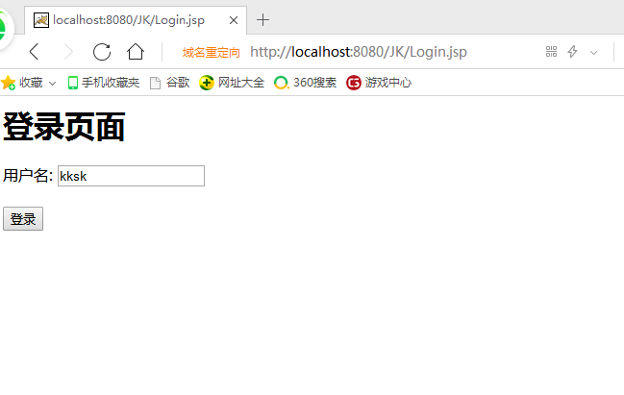

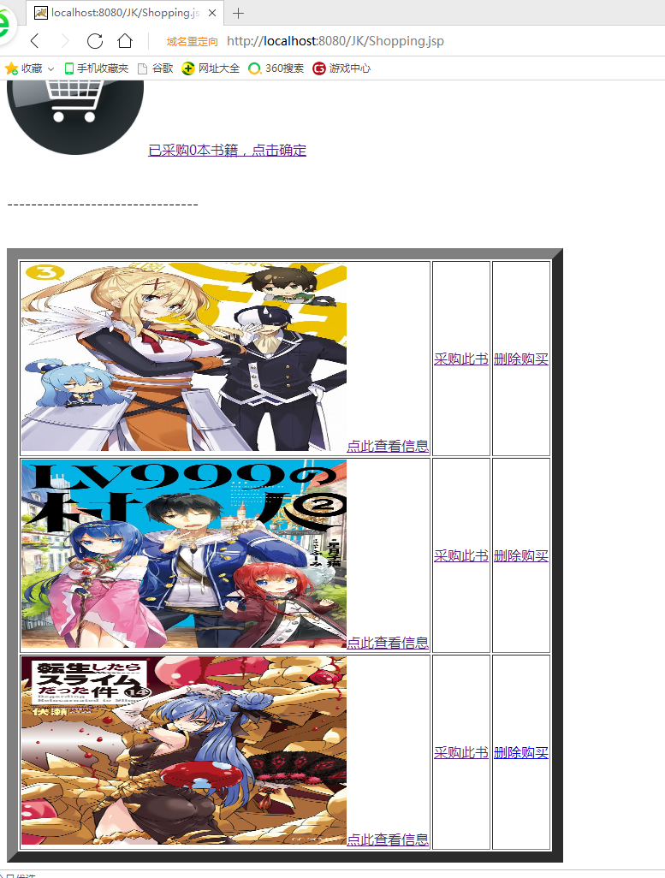

查看第一本书的信息

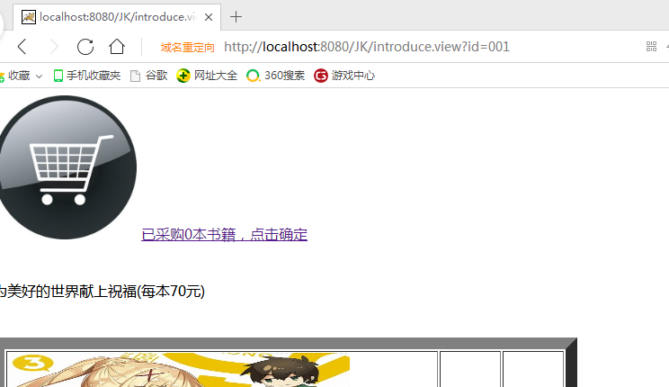

查看第二本书的信息

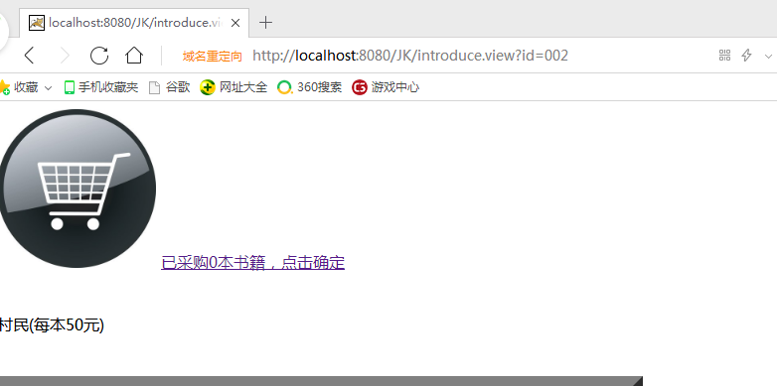

查看第三本书的信息

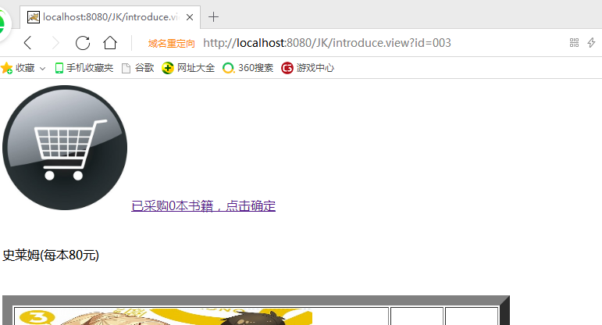

购买书籍的总价钱

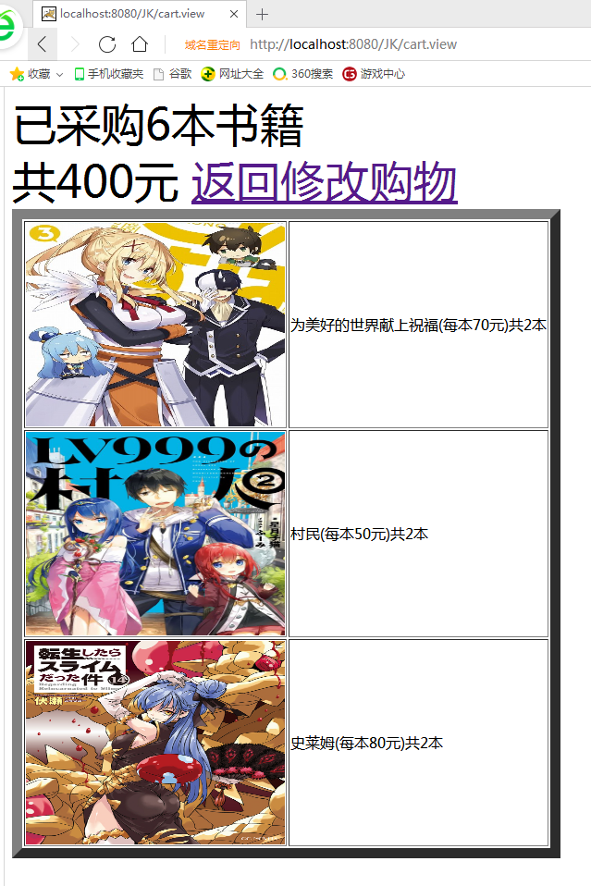

修改购买书籍数目后的总价钱

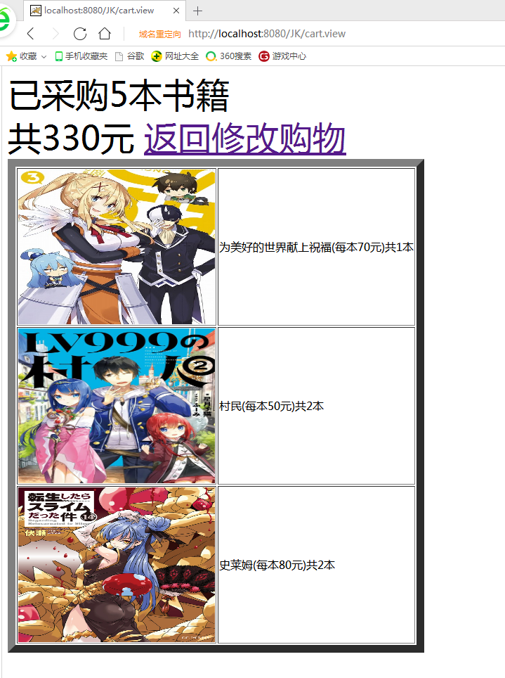

# 收获与问题