**Java Web开发**

**实验六**

**作业报告**

|  |  |
| --- | --- |
| 学 院 | 计算机 |
| 所在系 班 级 | 2017软件工程系八班 |
| 学 号 姓 名 | 04171622陈珂洁 |
| 指 导 教 师 | 郭晓燕 |
| 完 成 时 间 | 2018年4月28日 |

# 实验题目

1、上周没有完成作业的同学请继续完成，完成了作业的同学请为购物车增加功能：

2、参考成熟的购物系统，为购物车增加功能，完善购物车：删除商品，查看商品具体信息，计算商品总价，修改商品购买件数等等。界面尽量美观。

提示：Java文件即Book.java的设计需要重构，需要分离商品基本信息和购买信息，需要有类分别来保存单件商品的购买信息和所有商品的购买信息。所以至少要三个Java类才能完成购物的基本功能。

Servlet也需要响应更多的操作，可以在一个Servlet中也可以分多个文件响应。并在适当的地方调用Java方法。

# ；分析与设计

Shopping.jsp显示购书页面，Book.java用来存储购书信息，ShoppingServlet.java用来处理增加购书的数量，CarServlet.java用来显示最终的购书信息，Message.jsp用来显示商品信息,Car.jsp用来显示购物车页面，addele.java用来处理对商品执行增减，删除的操作。

# 关键源码（部分）

Shopping.jsp:

<%@ page language=*"java"* import=*"java.util.*"* pageEncoding=*"UTF-8"*%>

<%@page import=*"cc.test.vo.*"* %>

<!DOCTYPE HTML PUBLIC "-//W3C//DTD HTML 4.01 Transitional//EN">

<html>

<%

//当第一次访问采购网页，session对象中还没有book购物车信息时，进行初始化。

**if** (session.getAttribute("book")==**null**){

//在session对象中存储图书基本信息

Book[] BookList = **new** Book[4];

BookList[0] = **new** Book("10101", "Java核心技术", "img/10101.jpg",28.80);

BookList[1] = **new** Book("10102", "Java经典实例", "img/10102.jpg",30.20);

BookList[2] = **new** Book("10103", "Java7", "img/10103.jpg",32.60);

BookList[3] = **new** Book("10104", "JSP&Servletq", "img/10104.jpg",34.70);

//存入session对象中

session.setAttribute("book", BookList);

//在session对象中存储图书的购买信息

Book[] BookInfo = **new** Book[4];

BookInfo[0] = **new** Book("10101",0,28.8,0.00,"img/10101.jpg", "Java核心技术");

BookInfo[1] = **new** Book("10102",0,30.20,0.00,"img/10102.jpg", "Java经典实例");

BookInfo[2] = **new** Book("10103",0,32.60,0.00,"img/10103.jpg", "Java7");

BookInfo[3] = **new** Book("10104",0,34.70,0.00, "img/10104.jpg", "JSP&Servlet");

//存入session对象中

session.setAttribute("bookInfo", BookInfo);

//在session对象中存储图书的最终费用

Book pay = **new** Book(0.00);

//存入session对象中

session.setAttribute("pay", pay);

**int**[] k=**new** **int**[5];

session.setAttribute("k",k);

}

Book[] Books=(Book [])session.getAttribute("bookInfo"); //显示类型定义必须有

**int**[] ks=(**int**[])session.getAttribute("k");

%>

<body>

<br>

<img src=*"img/cart.jpg"* height=*"60px"* width=*"60px"*>

<a href=*"cart.view"*>已采购<%=ks[4] %>本书籍</a><br><%//跳转到购物车页面 %>

<br>

<table border=*"1"*>

<tr>

<td><img src=*"img/10101.jpg"*></td>

<td><img src=*"img/10102.jpg"*></td>

<td><img src=*"img/10103.jpg"*></td>

<td><img src=*"img/10104.jpg"*></td>

</tr>

<tr>

<td><a href=*"Message.jsp?id=10101&l=0"*>查看信息</a></td>

<td><a href=*"Message.jsp?id=10102&l=1"*>查看信息</a></td>

<td><a href=*"Message.jsp?id=10103&l=2"*>查看信息</a></td>

<td><a href=*"Message.jsp?id=10104&l=3"*>查看信息</a></td>

</tr>

<tr>

<td><a href=*"shopping.view?id=10101"*>采购此书</a></td>

<td><a href=*"shopping.view?id=10102"*>采购此书</a></td>

<td><a href=*"shopping.view?id=10103"*>采购此书</a></td>

<td><a href=*"shopping.view?id=10104"*>采购此书</a></td>

</tr>

</body>

</html>

ShopingServlet.java:

**package** cc.test.Controller;

**import** java.io.IOException;

**import** java.io.PrintWriter;

**import** javax.mail.Session;

**import** javax.servlet.ServletException;

**import** javax.servlet.ServletRequest;

**import** javax.servlet.http.HttpServlet;

**import** javax.servlet.http.HttpServletRequest;

**import** javax.servlet.http.HttpServletResponse;

**import** javax.servlet.http.HttpSession;

**import** cc.test.vo.Book;

**public** **class** ShopingServlet **extends** HttpServlet {

**public** **void** doGet(HttpServletRequest request, HttpServletResponse response)

**throws** ServletException, IOException {

//获取从Shopping.jsp传来的request对象中的ID号

String id=request.getParameter("id");

HttpSession session=request.getSession();

Book[] books=(Book [])session.getAttribute("bookInfo");

**int**[] ks=(**int**[])session.getAttribute("k");

**if**(id!=**null**)

{

//ks[4]=0;//总本数初始化

**for**(**int** i=0;i<books.length;i++)

{

books[i].addOne(id,books,i,ks);

// ks[4]=ks[4]+books[i].getBookNum();//计算总本数

}

}

/*

//在ID号不为空的情况下，获取Session对象中的购物车信息，Book数组。

if(id!=null)

{

Book[] books=(Book [])session.getAttribute("bookInfo");

//找到数组中与ID对应的Book对象，将其属性bookNum数字加1

for(int i=0;i<books.length;i++)

{

if(id.equals(books[i].getBookId()))

{

books[i].setBookNum(books[i].getBookNum()+1);

}

}

*/

//将数组写回session对象中去。

session.setAttribute("k", ks);

//将数组写回session对象中去。

session.setAttribute("bookInfo", books);

//跳转回Shopping.jsp

response.sendRedirect("Shopping.jsp");

}

**public** **void** doPost(HttpServletRequest request, HttpServletResponse response)

**throws** ServletException, IOException {

doGet(request,response);

}

}

Book.java:

**package** cc.test.vo;

**import** javax.servlet.http.HttpSession;

**import** javax.servlet.http.HttpServletRequest;

**public** **class** Book {

**private** String bookId; //书号

**private** String bookName; //书名

String bookImg; //书封面所在地址

**private** **int** bookNum; //购书本数

**private** **int** allbook; //总购书本数

**private** **double** bookPrice; //书价

**private** **double** totalPrice;//总价

**private** **double** finalPay; //最终价格

**public** Book(String bookId, String bookName,String bookImg,**double** bookPrice) {

**this**.bookId = bookId;

**this**.bookName = bookName;

**this**.bookImg = bookImg;

**this**.bookPrice = bookPrice;

}

**public** Book(String bookId,**int** bookNum,**double** bookPrice,**double** totalPrice,String bookImg,String bookName)

{

**this**.bookImg = bookImg;

**this**.bookId = bookId;

**this**.bookNum = 0;

**this**.bookPrice = bookPrice;

**this**.totalPrice = totalPrice;

**this**.bookName = bookName;

}

**public** Book(**double** finalPay)

{

**this**.finalPay=finalPay;

}

**public** String getBookId() {

**return** bookId;

}

**public** **void** setBookId(String bookId){

**this**.bookId =bookId;

}

**public** String getBookName() {

**return** bookName;

}

**public** **void** setBookName(String bookName){

**this**.bookName =bookName;

}

**public** String getBookImg() {

**return** bookImg;

}

**public** **void** setBookImg(String bookImg){

**this**.bookImg =bookImg;

}

**public** **int** getBookNum() {

**return** bookNum;

}

**public** **void** setBookNum(**int** bookNum){

**this**.bookNum =bookNum;

}

**public** **double** getBookPrice() {

**return** bookPrice;

}

**public** **void** setBookPrice(**double** bookPrice){

**this**.bookPrice =bookPrice;

}

**public** **double** getTotalPrice() {

**return** totalPrice;

}

**public** **void** setTotalPrice(**double** totalPrice){

**this**.totalPrice =totalPrice;

}

**public** **double** getFinalPay() {

**return** finalPay;

}

**public** **void** setFinalPay(**double** finalPay){

**this**.finalPay =finalPay;

}

**public** **void** addOne(String id,Book[] books,**int** i,**int**[] ks)

{

//找到数组中与ID对应的Book对象，将其属性bookNum数字加1

**if**(id.equals(books[i].getBookId()))

{

ks[i]=1;

books[i].setBookNum(books[i].getBookNum()+1);

ks[4]=ks[4]+1;

}

}

**public** **void** deleteOne(String id,Book[] books,**int** i,**int**[] ks)

{

**if**(id.equals(books[i].getBookId()))

{

books[i].setBookNum(books[i].getBookNum()-1);

ks[4]=ks[4]-1;

}

**if**(books[i].getBookNum()==0)

{

ks[i]=0;

}

}

**public** **void** clear(String id,Book[] books, **int** i,**int**[] ks)

{

**if**(id.equals(books[i].getBookId()))

{

ks[4]=ks[4]-(books[i].getBookNum());

books[i].setBookNum(0);

ks[i]=0;

}

}

**public** **void** calculate(Book pay,Book[] books)

{

**double** j=0;

**for**(**int** i=0;i<books.length;i++)

{

j=j+books[i].getTotalPrice();

}

pay.setFinalPay(j);

}

}

CarServlet.java:

package cc.test.Controller;

import java.io.IOException;

import java.io.PrintWriter;

import javax.servlet.ServletException;

import javax.servlet.http.HttpServlet;

import javax.servlet.http.HttpServletRequest;

import javax.servlet.http.HttpServletResponse;

import javax.servlet.http.HttpSession;

import cc.test.vo.Book;

public class CarServlet extends HttpServlet {

public void doGet(HttpServletRequest request, HttpServletResponse response)

throws ServletException, IOException {

/*判断得到session对象中存储的book信息是否为空

不为空的前提下，读出Book数组中的内容，并将数目不为1的图书信息显示在网页上。

*/

response.setContentType("text/html; charset=UTF-8");

HttpSession session=request.getSession();

PrintWriter out =response.getWriter();

Book[] Books=(Book[])session.getAttribute("bookInfo");

Book bs=(Book)session.getAttribute("pay");

if(Books!=null)

{

for(int i=0;i<Books.length;i++)

{

if(Books[i].getBookNum()>0)

{

Books[i].setTotalPrice(Books[i].getBookPrice()*Books[i].getBookNum());//计算每种书本的总价格

}

}

bs.calculate(bs,Books);

}

session.setAttribute("bookInfo", Books);

response.sendRedirect("Car.jsp");

}

public void doPost(HttpServletRequest request, HttpServletResponse response)

throws ServletException, IOException {

doGet(request,response);

}

}

Car.jsp:

<%@ page language=*"java"* import=*"java.util.*"* pageEncoding=*"UTF-8"*%>

<%@page import=*"cc.test.vo.*"* %>

<html>

<%

Book[] Books=(Book [])session.getAttribute("bookInfo"); //显示类型定义必须有

**int**[] ks=(**int**[])session.getAttribute("k");

Book pay=(Book)session.getAttribute("pay");%>

<body>

<%**for**(**int** i=0;i<4;i++)

{

**if**(ks[i]==1)//判断有无购买此商品

{

%>

<table border=*1*>

<tr>

<td>编号：<%=Books[i].getBookId()%></td>

<td><img src=<%=Books[i].getBookImg() %>></td>

<td>书名：<%=Books[i].getBookName() %></td>

<td>已购买<%=Books[i].getBookNum() %>本</td>

<td>共<%=Books[i].getTotalPrice() %>元</td>

<td><a href=*"addele.view?m=1&id=*<%=Books[i].getBookId()%>*"*>数量+1</a></td>

<td><a href=*"addele.view?m=2&id=*<%=Books[i].getBookId()%>*"*>数量-1</a></td>

<td><a href=*"addele.view?m=3&id=*<%=Books[i].getBookId()%>*"*>删除该商品</a></td>

</tr>

</table>

<% }

}%>

<table border=*1*>

<tr>

<td>总共买了<%=ks[4] %>本</td>

<td>总共需<%=pay.getFinalPay()%>

</tr>

</table>

<a href=*"shopping.view"*>回到首页</a>

</body>

</html>

Message.jsp:

<%@ page language=*"java"* import=*"java.util.*"* pageEncoding=*"UTF-8"*%>

<%@page import=*"cc.test.vo.*"* %>

<!DOCTYPE HTML PUBLIC "-//W3C//DTD HTML 4.01 Transitional//EN">

<html>

<%

Book[] Books=(Book [])session.getAttribute("bookInfo"); //显示类型定义必须有

**int** l=Integer.parseInt(request.getParameter("l"));%>

<body>

<table border=*1*>

<tr>

<td>编号：<%=Books[l].getBookId()%></td>

<td><img src=<%=Books[l].getBookImg() %>></td>

<td>书名：<%=Books[l].getBookName() %></td>

<td>每本<%=Books[l].getBookPrice() %>元</td>

</tr>

</table>

<a href=*"shopping.view"*>回到首页</a>

</body>

</html>

addele.java:

**package** cc.test.Controller;

**import** java.io.IOException;

**import** java.io.PrintWriter;

**import** javax.jws.WebService;

**import** javax.servlet.ServletException;

**import** javax.servlet.http.HttpServlet;

**import** javax.servlet.http.HttpServletRequest;

**import** javax.servlet.http.HttpServletResponse;

**import** javax.servlet.http.HttpSession;

**import** cc.test.vo.Book;

**public** **class** addele **extends** HttpServlet {

**public** **void** doGet(HttpServletRequest request, HttpServletResponse response)

**throws** ServletException, IOException {

String id=request.getParameter("id");

String m=request.getParameter("m");

HttpSession session=request.getSession();

Book[] books=(Book [])session.getAttribute("bookInfo");

**int**[] ks=(**int**[])session.getAttribute("k");

Book bs=(Book)session.getAttribute("pay");

**if**(("1".equals(m))&&(id!=**null**))

{

**for**(**int** i=0;i<books.length;i++)

{

**if**(id.equals(books[i].getBookId()))

{

books[i].addOne(id,books,i,ks);

books[i].setTotalPrice(books[i].getBookPrice()*books[i].getBookNum());//计算每种书本的总价格(重置刷新)

bs.calculate(bs,books);

}

}

}

**else** **if**((m.equals("2"))&&(id!=**null**))

{

**for**(**int** i=0;i<books.length;i++)

{

**if**(id.equals(books[i].getBookId()))

{

books[i].deleteOne(id, books, i,ks);

books[i].setTotalPrice(books[i].getBookPrice()*books[i].getBookNum());//计算每种书本的总价格（重置刷新）

bs.calculate(bs,books);

}

}

}

**else** **if**((m.equals("3"))&&(id!=**null**))

{

**for**(**int** i=0;i<books.length;i++)

{

**if**(id.equals(books[i].getBookId()))

{

books[i].clear(id, books, i,ks);

books[i].setTotalPrice(books[i].getBookPrice()*books[i].getBookNum());

bs.calculate(bs,books);

}

}

}

//将数组写回session对象中去。

session.setAttribute("bookInfo", books);

//跳转回Shopping.jsp

response.sendRedirect("Car.jsp");

}

**public** **void** doPost(HttpServletRequest request, HttpServletResponse response)

**throws** ServletException, IOException {

doGet(request,response);

}

}

# 运行效果图

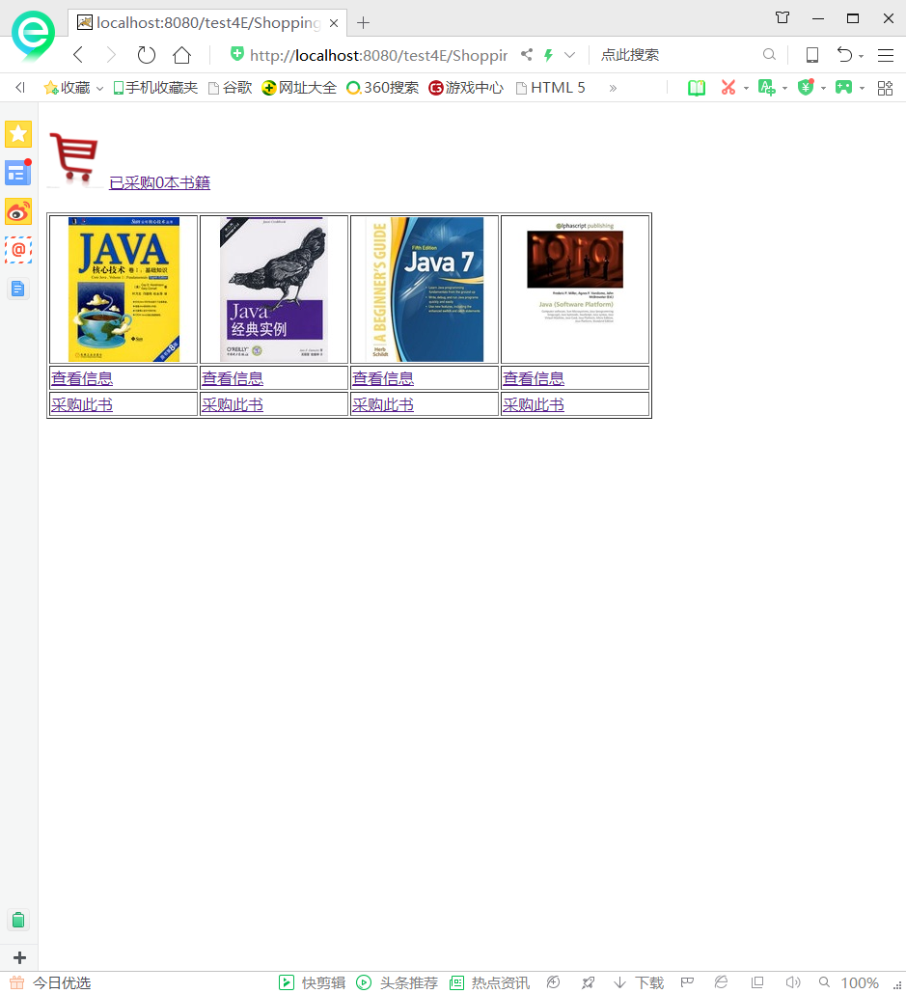

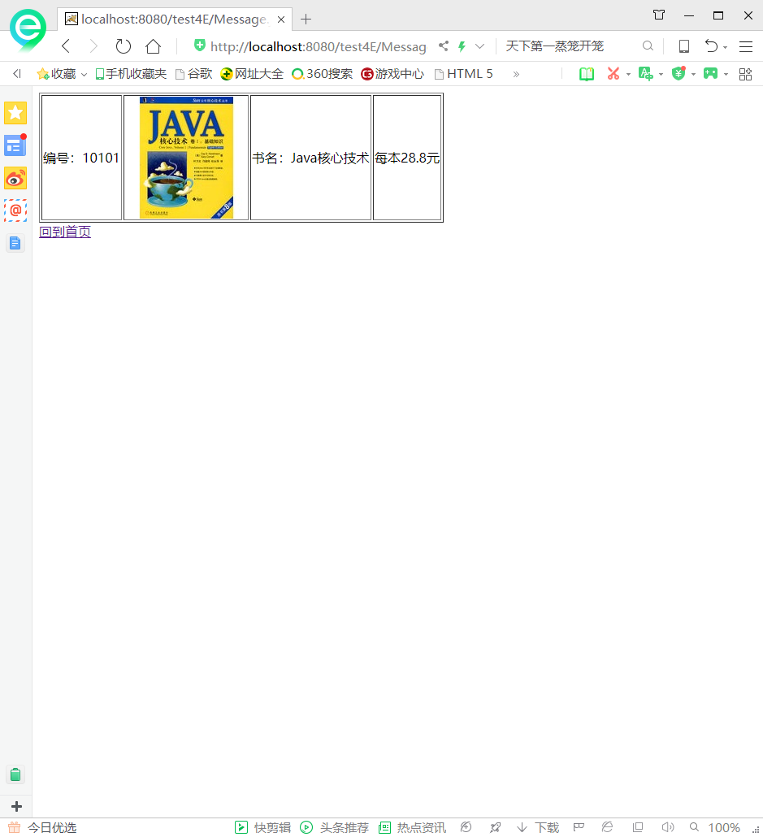

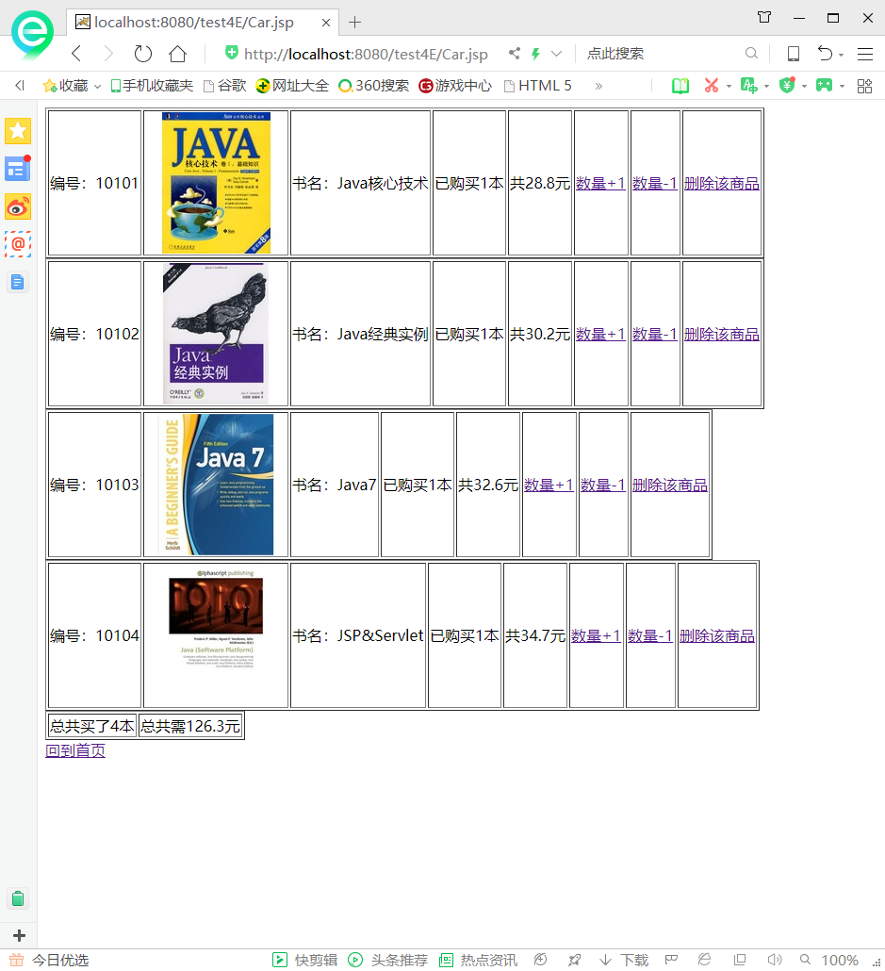

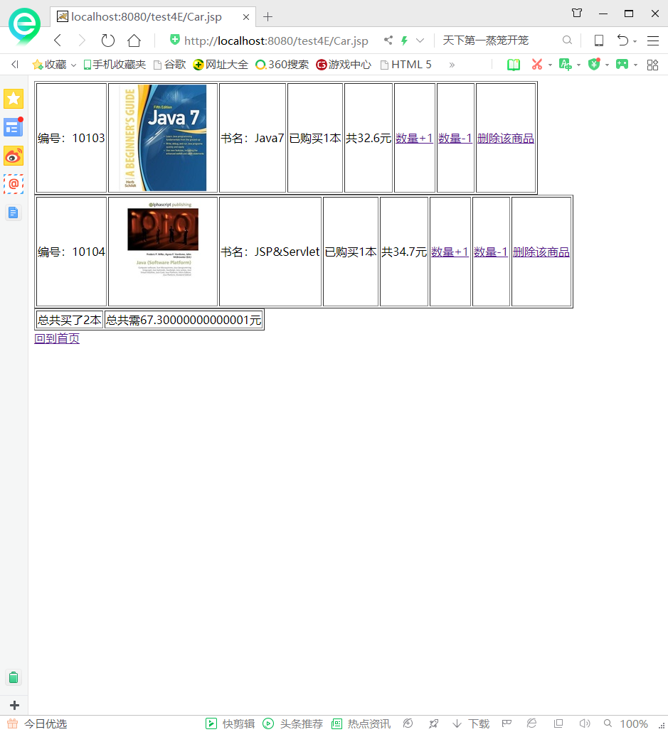

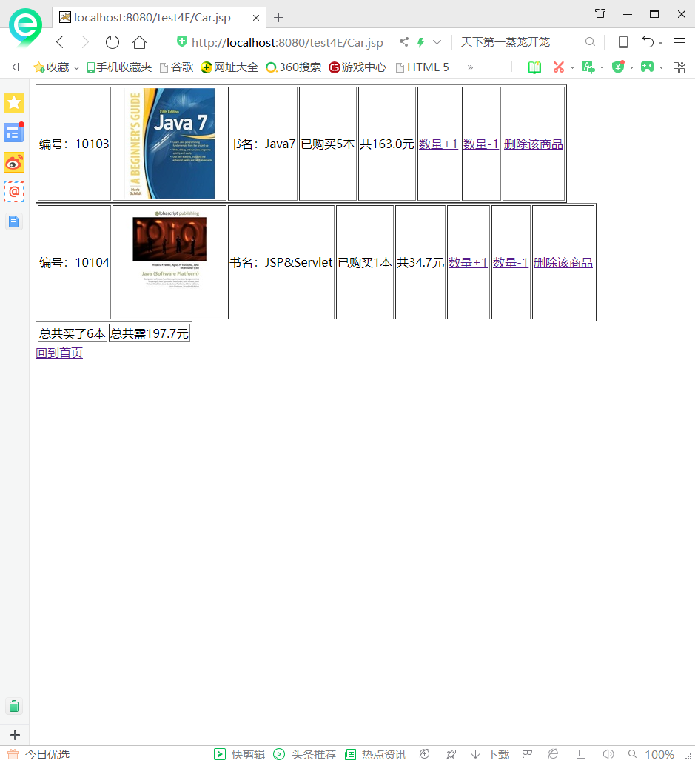

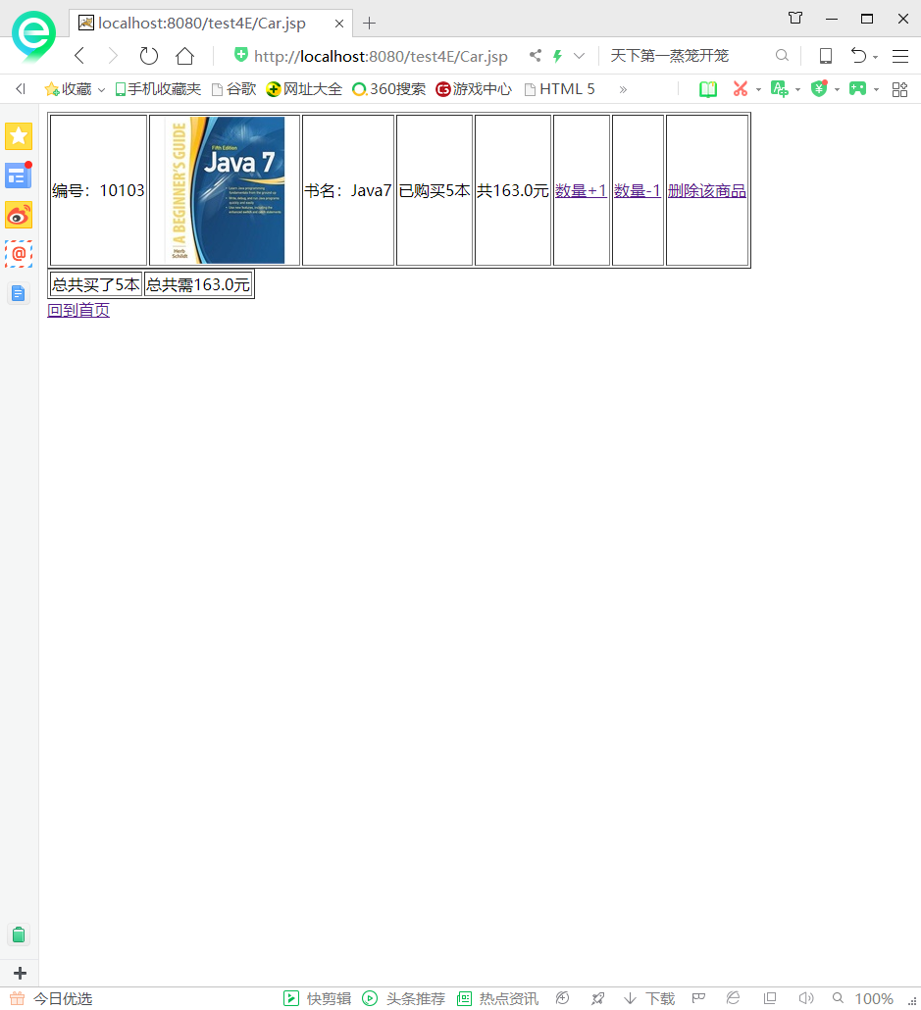

# 收获与问题

了解了会话的运用，最后在显示购书总件数时，它总会出现在最后一个表格的上面。