**Java Web开发**

**实验七**

**作业报告**

|  |  |
| --- | --- |
| 学 院 | 计算机 |
| 所在系 班 级 | 2017软件工程系软工5班 |
| 学 号 姓 名 | 04171320唐文超 |
| 指 导 教 师 | 郭晓燕 |
| 完 成 时 间 | 2019年4月-20 |

# 实验题目

页面输入收入，得到相应的缴纳税收

要求：Jsp提交收入，显示结果（可一个页面也可两个页面）。编写一个JavaBean计算税收，并在JSP页面输出结果。

# 分析与设计

jsp页面获得收入，JavaBean提供运算，servlet进行调用。

input.jsp获得工资，然后将工资的值传到call.java中。再将工资传到RevenueCheck.java中判断工资是否大于零，如果大于零，则调用revenue.java计算税收，并将结果传到success.jsp中输出。如果工资小于零，则自动返回input.jsp页面重新输入工资。

关键源码（部分）

input.jsp

<%@ page language=*"java"* pageEncoding=*"UTF-8"*%>

<!DOCTYPE><html>

<head>

<title>工资</title>

</head>

<body>

<form action=*"ss.view"* method=*"get"*>

请输入您的工资：<input name=*"salary"*><br><br>

<input type=*submit* value=*"提交"*>

</form>

</body>

2.call.java

package Call;

import java.io.IOException;

import javax.servlet.RequestDispatcher;

import javax.servlet.ServletException;

import javax.servlet.annotation.WebServlet;

import javax.servlet.http.HttpServlet;

import javax.servlet.http.HttpServletRequest;

import javax.servlet.http.HttpServletResponse;

import service.RevenuecCheck;

import Revenue.revenue;

@WebServlet("/ss.view")

public class call extends HttpServlet {

private static final long serialVersionUID = 1L;

public void doGet(HttpServletRequest request, HttpServletResponse response)

throws ServletException, IOException {

doPost(request, response);

}

public void doPost(HttpServletRequest request, HttpServletResponse response)

throws ServletException, IOException {

request.setCharacterEncoding("UTF-8");

//double salary =request.getParameter(salary);

double salary = Double.parseDouble(request.getParameter("salary"));

revenue rvn = new revenue();

rvn.setSalary(salary);

RevenuecCheck rc = new RevenuecCheck();

if(rc.validate(salary)) {

request.setAttribute("rvn", rvn);

RequestDispatcher dis =request.getRequestDispatcher("success.jsp");

dis.forward(request, response);

}else {

response.sendRedirect("input.jsp");

}

}

1. revenue.java

**package** service;

**public** **class** RevenuecCheck {

**public** **boolean** validate(**double** salary) {

**if**(salary>0)

**return** **true**;

**else**

**return** **false**;

}

}

1. revenue.java

**package** Revenue;

**public** **class** revenue {

**private** **double** salary;

**private** **double** result;

**public** **double** getSalary(){

**return** salary;

}

**public** **void** setSalary(**double** salary){

**this**.salary = salary;

}

**public** **double** getResult(){

**double** sum=salary-1600;

**if**(sum<=500 && sum>0){

result = sum*0.05-0;

}**else** **if**(sum>500 && sum<=3000){

result = sum*0.1-25;

}**else** **if**(sum>3000 && sum<=5000){

result = sum*0.15-125;

}**else** **if**(sum>5000 && sum<=20000){

result = sum*0.20-375;

}**else** **if**(sum>20000 && sum<=40000){

result = sum*0.25-1375;

}**else** **if**(sum>40000 && sum<=60000){

result = sum*0.30-3375;

}**else** **if**(sum>60000 && sum<=80000){

result = sum*0.35-6375;

}**else** **if**(sum>80000 && sum<=100000){

result = sum*0.40-10375;

}**else** **if**(sum>100000){

result = sum*0.45-15375;

}

**return** result;

}

}

1. success.jsp

<%@ page language=*"java"* import=*"java.util.*"* pageEncoding=*"UTF-8"*%>

<%@page import=*"Revenue.revenue"* %>

<!DOCTYPE HTML PUBLIC "-//W3C//DTD HTML 4.01 Transitional//EN">

<html>

<head>

<meta http-equiv=*"Content-Type"* content=*"text/html; charset=UTF-8"*>

<title>success.jsp</title>

</head>

<body>

<jsp:useBean id=*"rvn"* type=*"Revenue.revenue"* scope=*"request"*/>

<jsp:getProperty property=*"result"* name=*"rvn"*/>

</body>

</html>

运行效果图：

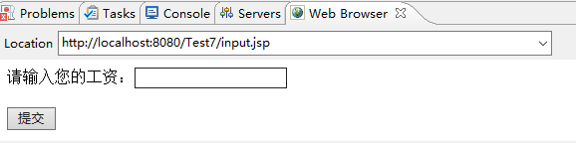

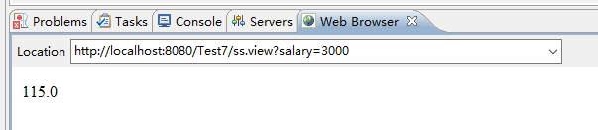

# 收获与问题

谈一谈你在本实验中所收获的内容及问题。